“Lets us Teach the New Testament”

First Epistle of John
Lesson 1: 1 John 1:1-4

With Dr Galen Currah
1john.currah.download August 2019

Introduction
In this first of 15 lessons on the New Testament Book of 1 John, we shall look at the following matters.
1. The English Standard Version text of 1 John 1:1-4.
2. The Greek text of the passage, noting variant readings from ancient manuscripts.
3. A sample outline of the passage for preachers and teachers.
4. Some phrases in the passage that have parallels in the Gospel of John.
5. Some important words from the passages and their historical meaning.
6. Some teachable observations and summaries that you might find helpful.
7. Some historical Christian doctrines that the passage contains.
8. And some suggestions for Christians who want to apply the passage in their life.

You may download this lesson as a written document at 1john.currah.download

1. The English text of 1 John 1:1-4
That which was from the beginning, which we have heard, which we have seen with our eyes, which we looked upon and have touched with our hands, concerning the word of life— the life was made manifest, and we have seen it, and testify to it and proclaim to you the eternal life, which was with the Father and was made manifest to us— that which we have seen and heard we proclaim also to you, so that you too may have fellowship with us; and indeed our fellowship is with the Father and with his Son Jesus Christ. And we are writing these things so that our joy may be complete. (English Standard Version, 2016)

2.The ancient Greek text of 1 John 1:1-4
Ὃ ἦν ἀπ’ ἀρχῆς, ὃ ἀκηκόαμεν, ὃ ἑωράκαμεν τοῖς ὀφθαλμοῖς ἡμῶν, ὃ ἐθεασάμεθα καὶ αἱ χεῖρες ἡμῶν ἐψηλάφησαν, περὶ τοῦ λόγου τῆς ζωῆς — καὶ ἡ ζωὴ ἐφανερώθη, καὶ ἑωράκαμεν καὶ μαρτυροῦμεν καὶ ἀπαγγέλλομεν ὑμῖν τὴν ζωὴν τὴν αἰώνιον ἥτις ἦν πρὸς τὸν πατέρα καὶ ἐφανερώθη ἡμῖν — ὃ ἑωράκαμεν καὶ ἀκηκόαμεν ἀπαγγέλλομεν καὶ ὑμῖν, ἵνα καὶ ὑμεῖς κοινωνίαν ἔχητε μεθ’ ἡμῶν· καὶ ἡ κοινωνία δὲ ἡ ἡμετέρα μετὰ τοῦ πατρὸς καὶ μετὰ τοῦ υἱοῦ αὐτοῦ Ἰησοῦ Χριστοῦ· καὶ ταῦτα γράφομεν ἡμεῖς ἵνα ἡ χαρὰ ἡμῶν ᾖ πεπληρωμένη. (SBL 2010)

Variant readings
1 John 1:1-4 was well preserved through 20 centuries of copying, being attested by scores of Greek manuscripts. Nevertheless, a few scribes made tiny changes. These include the following.
- In verse 1:2, in the 4th and 10th centuries, a scribe inserted “that which” before “we have seen”.
- In verse 1:3, from the 10th century, some scribes omitted “also” from “we proclaim also to you”.
- From the 5th century, some others omitted “and” from “and indeed”.
- In verse 1:4 From the 4th century, some scribes modified “we are writing” to read “we are writing to you.”
- By the 4th century, some scribes wrote ”that our joy” whilst others wrote “that your joy.”
Those who wrote “our joy” may have recalled the promise that Jesus made to his apostles in John 15:11, “These things I have spoken to you [apostles], … that your joy may be full.”
Those who wrote “your joy” may have recalled Jesus’ promise in John 16:24, “Ask, and you will receive, that your joy may be full,” which employs the exact same Greek words and grammar.

3. Teaching outline of 1 John for preachers, teachers and groups leaders.

This outline reflect a ‘discourse analysis’ that takes into account recurring words, themes, linguistic markers and internal logic.

Part 1: Our Fellowship with God 1.1 - 2.17

I. The Word of Life 1.1-4

A. Origin of the Living Word 1.1

1. Evidence: tangible revelation

2. Subject: the Logos that gives Life

B. Proclamation of the message 1.2

1. Life everlasting

2. From the Father

C. The apostolic message 1.3-4

1. The Spoken Word 1.3

a. For Christian fellowship

b. For fellowship with God

(1) With the Father (God invisible)

(2) With the Son (Christ visible)

2. The written Word 1.4

a. Purpose: Complete joy

b. Result: This epistle

4. Parallels between this passage and the Gospel of John
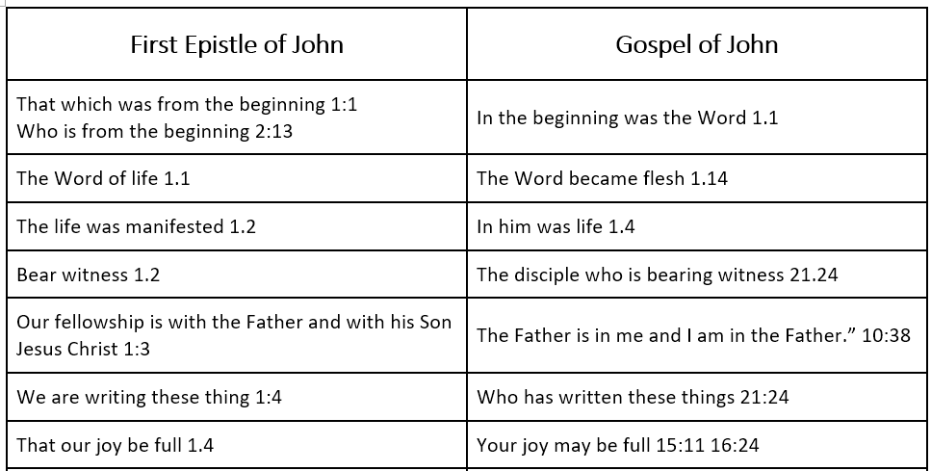

The first recipients and readers of this epistle of 1 John knew John and his teaching. They were so familiar with the Gospel of John, that they understood what he meant by the terms Beginning, Word, Life, witness, and joy, along with the titles Father and Son.

5. This passage’s special vocabulary
John wrote about “that which,” instead of “He who,” referring to what Jesus was, before talking about who he was.

The “beginning” refers back to creation, the beginning of the world and therefore to Jesus’ eternality.

ἀρχή, arché. Beginning, origin in the absolute sense … ἀπ̓ ἀρχῆς from the very beginning … Is 43:13; Mt 19:4, 8; J 8:44; 1J 1:1. — A Greek-English Lexicon of the New Testament and Other Early Christian Literature (3d ed.) Eds., Bauer, Arndt, Gingrich and Danker

The “Word” refers to who Jesus was, God’s eternal Mind (logos) that became human when God spoke it.

λόγος, logos. The independent personified expression of God, the Logos. … A way of thinking that was widespread in contemporary syncretism, as well as in Jewish wisdom literatre and Philo, the most prominent feature of which is the concept of the Logos, the independent, personified ‘Word’ (of God) J 1:1, 14. It is the distinctive teaching of the Fourth Gospel that this divine ‘Word’ took on human form in a historical person, that is, in Jesus. —Bauer, Arndt, Gingrich and Danker

The “Life” refers to Jesus, who lives eternally as God and can give his life to human beings.

ζωή, zōé. Of Christ, who received life from God J 5:26b. [in him was life]1:4a; cp. 1J 5:11b. He is the [Author of life] Ac 3:15, the [Word of life] 1J 1:1— Bauer, Arndt, Gingrich and Danker

“Everlasting (eternal) life,” also refers to Jesus who has existed eternally as God and can enable humans to live forever with him.

αἰώνιος, aiōnios. Pertaining to a period of unending duration, without end … of eternal life ... in the Reign of God ... 1J 1:2; 2:25; 3:15; 5:11, 13, 20 — Bauer, Arndt, Gingrich and Danker

“The Father” (πατήρ, patér) refers to God who exists eternally, invisible, powerful, just and loving.

“The Son” (υἱός, huios) refers to God who exist eternally, became human, and conquered human death.
The pronoun “we,” in this passage, refers to the eye-witnesses who had spent three or four years with Jesus before his death, and 40 days with him after his resurrection.

In this passage, “fellowship” consists of all that Jesus shared from God with his apostles, and which the apostles were able to share with us as we learn their scriptures.

κοινωνία, koinōnia. Close association involving mutual interests and sharing, association, communion, fellowship, close relationship. 1J 1:3b, 6 — Bauer, Arndt, Gingrich and Danker

6. Teachable observations from 1 John 1:1-4
The apostles experience of the historical Jesus:
“We have heard.” We remember what Jesus said and taught.
“We have seen.” We remember his kind acts and miraculous deeds.
“We looked upon.” We heard God’s voice and we beheld Jesus’ transfiguration.
“Our hands touched.” We felt Jesus’ physical body after he rose from death.

Jesus’ career: how God revealed Jesus to the world:
1. He was with the Father (forever). 2
2. He was from the beginning (creating the world). 1
3. He was made manifest. (his incarnation, becoming a human being).
4. We heard him (teach). 1, 3
5. We saw his miracles. 1, 3
6. We looked upon him (at his baptism, and at his transfiguration). 1
7. We touched him with our hands (following his resurrection, his return to life). 1
8. We have fellowship with Jesus the Son and with the Father.3

How the apostles made Jesus widely known:
“We testify to it.” They recount exactly what they heard and saw. John wrote the Gospel of John.
“We proclaim to you.” They kept on talking about it as long as they lived.
“We are writing these things.” The Book of 1 John has become part of the New Testament.

What we do with Scripture:
1. Compare the ancient Greek manuscript copies.
2. Translate the Greek text into our languages.
3. Make Bible translations widely available to everyone.
4. Read, study and understand each part of the Bible.
5. Believes Jesus’ promises and obey his commandments.
6. Preach, teach and explain the Bible to those who want to learn.
7. Defend the Bible against liars and religions that deny it.

7. Seven Doctrines to draw from 1 John 1:1-4
Divine revelation. God has chosen to reveal himself to human beings in many ways: through the creation, through conscience, through meditation, and through visions. More importantly, God has revealed himself through Jesus Christ, and through his apostles’ testimony about him.

Unity of God. The One True God exists eternally as the Father and as the Son. The Father and the Son have spoken to each other forever, and when the Son came into the world as a human being, they continued to speak to each other.

Incarnation of God. The Son of God was manifested to human beings, that his, he was born as a human being, whilst remaining God.

Apostolic testimony. The apostles followed Jesus for three years, saw his miracles, watched him die on a cross, and spent 40 days with him after he rose back to life.

The apostles of Jesus did not:
- have a dream about angels or demons that talked to them.
- borrow from other religions their traditions, myths or scriptures.
- sit alone, meditating and thinking up new ideas.
- conspire or plot together to start a new religion.

Holy Scripture. The apostle John eventually wrote down his testimony in the Gospel of John, and he wrote 1 John to Christians. These books are now part of the New Testament of the Bible. Christians accept these writings as having authority in all that they believe and do.

Fellowship with God. John had received from God, all that God had to give, and John wrote 1 John so that we, too, may receive all that God has to give.

Spiritual joy. Jesus had promised joy to his apostles, and John found even more joy in sharing with fellow Christians. Generous Christians become the most joyful Christians.

8. Suggested applications for Christians
Pose to learners queries such as these:
What have you learnt from this passage about God?
What have you learnt from this passage about Jesus?
What have you learnt from this passage about the Bible?
What promise has God made to us who learn from 1 John?

Hold a regular time with family members, to learn from 1 John and to pray one for another.

Teach to others what you are learning from 1 John.

Lead a small group or house church, to learn from 1 John.

Make plans together to provide Gospels, New Testaments or Bibles to those who have none.

Explain to non-Christians that faith in Jesus comes through eyewitnesses whose testimony about Jesus is better than what men say who never saw or heard Jesus.

Conclusion
- Download this document from 1john.currah.download.
- Read five times 1 John 1:5 through 2:2 before you view the next video lesson
- Please leave comments or queries below, or write to me at the download site. I shall try to reply to you by email or here on line.

