“Let us teach the New Testament!”

First Epistle of John
Lesson 3, 1 John 2:3-11

1john.currah.download August 2019

Introduction

In this third of 15 lessons on the New Testament Book of 1 John, we shall look at the following ten matters.

1. 1 John 2:3-11 from the English Standard Version (2016)
2. 1 John 2:3-11 from the SBL Greek New Testament (2010)
3. Greek textual variants
4. An outline of 1 John 2:3-11 for preachers and teachers
5. Parallel phrases between 1 John 2:3-11 and the Gospel of John
6. Important words and their historical meaning
7. Notes on Greek grammar: a connective, verb tenses, “by this”
8. Teaching summaries that you might find helpful
9. Three historical Christian doctrines that you can teach
10. Practical applications of 1 John 2:3-11 for Christians

1. The English Standard Version text of 1 John 2:3-11

³ And by this we know that we have come to know him, if we keep his commandments. ⁴ Whoever says “I know him” but does not keep his commandments is a liar, and the truth is not in him, ⁵ but whoever keeps his word, in him truly the love of God is perfected. By this we may know that we are in him: ⁶ whoever says he abides in him ought to walk in the same way in which he walked.
⁷ Beloved, I am writing you no new commandment, but an old commandment that you had from the beginning. The old commandment is the word that you have heard. ⁸ At the same time, it is a new commandment that I am writing to you, which is true in him and in you, because the darkness is passing away and the true light is already shining. ⁹ Whoever says he is in the light and hates his brother is still in darkness.
¹⁰ Whoever loves his brother abides in the light, and in him there is no cause for stumbling. ¹¹ But whoever hates his brother is in the darkness and walks in the darkness, and does not know where he is going, because the darkness has blinded his eyes.

2. The ancient Greek text of 1 John 2:3-11

³ Καὶ ἐν τούτῳ γινώσκομεν ὅτι ἐγνώκαμεν αὐτόν, ἐὰν τὰς ἐντολὰς αὐτοῦ τηρῶμεν. ⁴ ὁ λέγων ὅτι Ἔγνωκα αὐτὸν καὶ τὰς ἐντολὰς αὐτοῦ μὴ τηρῶν ψεύστης ἐστίν, καὶ ἐν τούτῳ ἡ ἀλήθεια οὐκ ἔστιν· ⁵ ὃς δ’ ἂν τηρῇ αὐτοῦ τὸν λόγον, ἀληθῶς ἐν τούτῳ ἡ ἀγάπη τοῦ θεοῦ τετελείωται. ἐν τούτῳ γινώσκομεν ὅτι ἐν αὐτῷ ἐσμεν· ⁶ ὁ λέγων ἐν αὐτῷ μένειν ὀφείλει καθὼς ἐκεῖνος περιεπάτησεν καὶ αὐτὸς περιπατεῖν.
⁷ Ἀγαπητοί, οὐκ ἐντολὴν καινὴν γράφω ὑμῖν, ἀλλ’ ἐντολὴν παλαιὰν ἣν εἴχετε ἀπ’ ἀρχῆς· ἡ ἐντολὴ ἡ παλαιά ἐστιν ὁ λόγος ὃν ἠκούσατε. ⁸ πάλιν ἐντολὴν καινὴν γράφω ὑμῖν, ὅ ἐστιν ἀληθὲς ἐν αὐτῷ καὶ ἐν ὑμῖν, ὅτι ἡ σκοτία παράγεται καὶ τὸ φῶς τὸ ἀληθινὸν ἤδη φαίνει. ⁹ ὁ λέγων ἐν τῷ φωτὶ εἶναι καὶ τὸν ἀδελφὸν αὐτοῦ μισῶν ἐν τῇ σκοτίᾳ ἐστὶν ἕως ἄρτι.
¹⁰ ὁ ἀγαπῶν τὸν ἀδελφὸν αὐτοῦ ἐν τῷ φωτὶ μένει, καὶ σκάνδαλον ἐν αὐτῷ οὐκ ἔστιν· ¹¹ ὁ δὲ μισῶν τὸν ἀδελφὸν αὐτοῦ ἐν τῇ σκοτίᾳ ἐστὶν καὶ ἐν τῇ σκοτίᾳ περιπατεῖ, καὶ οὐκ οἶδεν ποῦ ὑπάγει, ὅτι ἡ σκοτία ἐτύφλωσεν τοὺς ὀφθαλμοὺς αὐτοῦ.

3. Greek textual variants
In 1 John 2:6, some early manuscripts read, “… ought to walk in the same way in which he walked,” whilst others read, more simply, “… ought to walk as he walked.”
The first reading inserts an emphatic adverb (οὕτως houtôs “thusly”). Did a scribe supply this adverb for emphasis? Or did a scribe omit it by mistake, because it sounds like the preceding pronoun (αὐτὸς autos “he”)?
Although it remains hard to know which was original, the meaning of the sentence remains the same. Download from 1john.currah.download a list of eleven minor variants from 1 John 2:3-11.

4. An outline of 1 John 2:3-11 for preachers and teachers
III. The New Commandment 2.3-11
A. To know Jesus Christ 2.3-6
1. We obey him 2.3
2. We profess him
a. Those who profess without obeying 2.4
b. Those who keep his Word 2.5
c. Those who follow his example 2.6
B. The original commandment 2.7-11
1. We have had it from the beginning 2.7
2. We obey it
a. Truth is advancing 2.8
b. Deceit is passing away 2.9
C. Two responses to the commandment 2.10-11
1. Love Christians 2.10
2. Hate (disregard) Christians 2.11

5. Parallel phrases in the Gospel of John
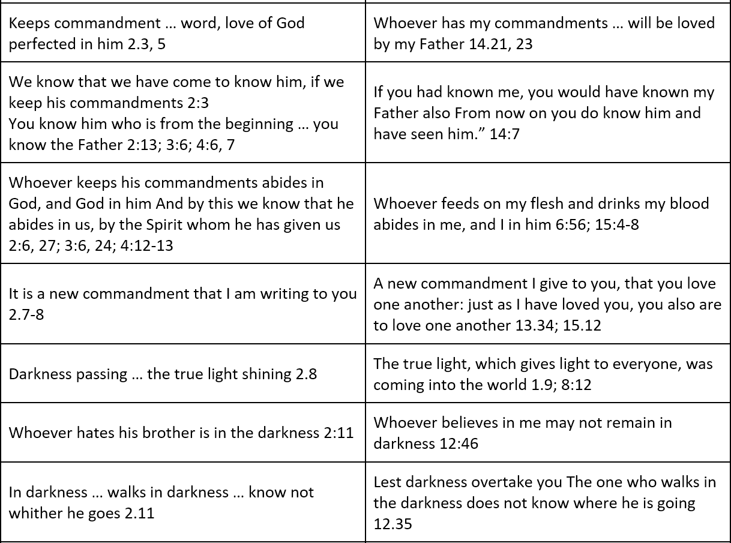

6. Important words and their historical meaning
brother ἀδελφός adelphos
Used by Christians in their relations with each other as members in the Christian community.

to hate μισέω miseô
The English term ‘hate’ generally suggests strong, personal feelings, whereas in traditional society, this word has a sense of ‘hold in disfavor, be disinclined to, have relatively little regard for’, hence may be translated ‘disfavor, disregard’ in contrast to preferential treatment.

to know
1 John employs the verb γινώσκω ginôskô 14 times. This verb normally relates to familiarity acquired through experience or association with persons or things.
1 John employs the verb οἶδα oida 12 times. This verb normally relates to information that one has acquired from others.
Download from 1john.currah.download a list of all the verses containing these verbs
to perfect τελειόω teleioô
This word does not mean to attain a total mastery or sinless perfection, but to complete an activity, to finish, or to accomplish a purpose.
Download from 1john.currah.download a fuller list of definitions of terms.

7. Notes on Greek grammar: a connective, verb tenses

The Greek text of 1 John 2:3-11 begins with the connective word και kai “and.” Although this is the most common Greek connector or conjunction, when it occurs at the start of a new section, as it does at 2:3, it connects the entire section to a previous one. Thus, 2:3-11 connects with 1:5-2:2, continuing the theme “God is light, and in him is no darkness at all” (1:5). Compare 2:8-11.
The phrase ἐν τούτῳ (en toutô) “by this” occurs 11 times in 1 John. It signals to readers that the sentence consists of an effect and its cause. The Greek pattern = “by his” + an effect (to know, to manifest) + its cause (a clause, sometimes conditional). That is, the cause is in the following clause or sentence.
The phrase ἐκ τούτου (ek toutou) “by that” occurs once in 1 John. It signals to readers that the cause is found in the preceding sentence. Since some versions translate ek toutou the same as en toutô, some readers have been confused about what was the cause of a sentence’s effect.
Download from 1john.currah.download a complete list of these verses containing en toutô and ek toutou.
Greek Verb ‘Tenses’ in 1 John
Greek verb tenses seldom describe time (past, present or future). Rather they express ‘aspect’, that is, how speakers or writers viewed actions or states in relation to themselves or to their readers. 1 John employs the following tenses:
The “aorist” tense describes an action or a state as a whole, saying nothing about when it did, does or will happen. “the darkness has blinded [or blinds] his eyes” 2:11
The “present” tense describes an action or a state that is on-going or habitual. “if we [habitually] keep his commandments” 2:3
The “perfect” tense describes lasting effects of an action that has happened. “we have come to know him [and still know him]” 2:3
The “imperfect” tense describes an action or a state that was happening or habitual “an old commandment that you had [or have had] from the beginning” 2:7
The “future” tense describes an action or state that follows after another action. “when he appears we shall be like him” 3:2
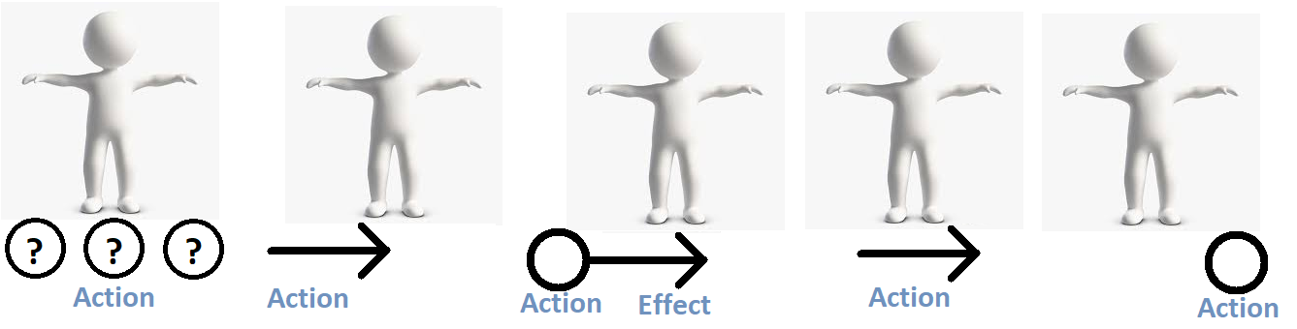
Aorist Imperfect Perfect Present Future
Bringing together word meanings and grammar
“And by this we know that we have come to know him, if we keep his commandments” (1 John 2:3) brings together several of the points made earlier in this lesson and previous lessons.
“And” signals that this verse starts a new section by connecting it back to 1:5–2:2, continuing the theme of light and darkness.
“By this we know” signals that the effect “we know” results from its cause, “if we keep his commandments.”
The verb “to know” (γινώσκω ginôskô) occurs twice in the same clause: “we know” in the present tense,” and “we have come to know” in the perfect tense.
γινώσκω ginôskô is the verb of knowing by experience. Thus, John is reminding readers that they know God by experiencing him and his promises, which include the new birth, communion with God, assurance, the indwelling Holy Spirit, and over-coming evil.
“If we keep.” The strength of our knowing that we have come to know God remains conditional on our obedience to his commandments, as signaled by the second-class conditional particle εαν ean followed by a present-tense, subjunctive verb: “if we should (keep on) keep(ing) his commandments.” Obedience remains a choice, a choice that brings satisfying results.
John’s teaching harkens back to Jesus’ own promise recorded in the Gospel of John 14:21, “Whoever has my commandments and keeps them, he it is who loves me. And he who loves me will be loved by my Father, and I will love him and manifest myself to him.”

8. Teaching summaries that you might find helpful
Ask the Holy Spirit to show you truths, principles and patterns in 1 John 2:3-11 that can help you and those whom you teach. For example…

Proofs of who are true Christians
- They keep Jesus’ commandments 4, 5
- The keep his teaching, his Word 5
- They walk in the way in which Jesus walked 8
- They show love one for another 8

The New Commandment: “Love one another” Jn 13:34 15:12-13, 17
- It is the ‘old’ commandment 7 (it came from the Old Testament, Lv 19:18, 19)
- They had it from the beginning 7 (they learned it from Jesus, Jn 13:14)
- It is also a new commandment 7, 8 (it is for them also, not only for apostles)
- It was true of Jesus 8 (“as I have loved you” Jn 15:12)
- It is true of all Christians 8 (“we ought to give our lives for our friends” Jn 15:13)
- It enhances our knowing God 3, 8

Seven basic commandments of Jesus
- Love God, love your neighbour, love the brethren, love your enemies
- Repent, believe the good news, and receive the Holy Spirit
- Baptise new believes in the Name of the Father, the Son and the Holy Spirit
- Pray to God in my Name
- Remember my death
- Give freely
- Go make disciples of every nation

Dangers for fake ‘Christians’:
  - They have not come to know God 3
  - They disobey Jesus’ commandments 4
  - They are liars who do not have the truth 4
  - They despise other Christians 9, 11
  - They are in darkness, walk in darkness, are blinded 9, 11
  - They do not know were they are going 11

What is knowing God:
1. We experience God 2:3 2:14 4:15, 16
2. We are born again 3:9 4:7 5:1
3. We enjoy communion with God 1:3 1:7 5:20
4. We have assurance before God 3:21 4:17 5:14
5. The Holy Spirit dwells with us 3:24 4:13 5:6
6. We overcome evil 4:4 5:18
7. We take pleasure in obeying God 4:7, 12 5:3
Download from 1john.currah.download an expanded version of this list.

9. Three historical Christian doctrines that you can teach

The Word of God. God has spoken words through angels, prophets, and whispers; God has spoken as the Son in human flesh; Jesus spoke the Father’s words; his apostles have written his words in the New Testament; and Christians preach and teach from God’s Word, the Bible.

The Law of God. God spoke individual commandments to Adam, to Noah, and to Abraham. To Moses, God revealed his Ten Commandments. God gave to Israel 613 commandments, called the Law of God. When Jesus came, he said, "If you love me, you will obey my commandments." Keeping God’s Law brings blessing to a nation, but does not earn eternal life.

Imitation of Christ. Mature Christians lead their life by imitating Jesus. They seek to please God, to remain joyful, to show kindness to others, to pray often, to speak truth, to serve freely, to suffer willingly, to forgive enemies, and to die with hope.

10. Practical applications of 1 John 2:3-11 for Christians

In small groups and house churches, after someone or several read 1 John 2:3-11, pose the following queries and allow anyone to reply.

- What did you learn from this passage about God?
- About Jesus?
- About obedience to Jesus?
- About sin?

In your teaching and teaching, recommend ways in which to apply or to implement the passage, such as:
- Memorize Jesus’ seven basic commandments.
- Create, sing and teach a song about Jesus’ basic commandments.
- Discuss ways in which to obey each commandment.
- Lay plans to implement each commandment in your congregation, house churches, small groups and families.
- Identify needy individuals and families in your congregation or other congregations, and lay a plan to meet that need, or to empower others to meet such needs.

Conclusion

- Download the document for this lesson at 1john.currah.download.
- Read five times 1 John 2:12-17 before you view the next video lesson.
- Please, leave comments or queries, or write to me at the download site. I shall try to reply
to you by email or on line.

