“Let us teach the New Testament!”

First Epistle of John
Lesson 6, 1 John 3:1-10
1john.currah.download September 2019

Introduction

In this sixth of 15 lessons on the New Testament Book of 1 John, we shall deal with these ten topics.
1. 1 John 3:1-10 in the English Standard Version (2016)
2. 1 John 3:1-10 SBL Greek NT (2010) with English interlinear
3. Greek textual variants in 1 John 3:1-10
4. Parallels between 1 John 3:1-10 and the Gospel of John.
5. Analytical outline of 1 John 3:1-10
6. Important vocabulary and historical meanings
7. Greek grammar: verb subject nouns and pronouns
8. Teachable points from 1 John 3:1-10
9. Two historical Christian doctrines in 1 John 3:1-10
10. Practical applications of 1 John 3:1-10 for Christians

1. The English Standard Version text of 1 John 3:1-10
¹ See what kind of love the Father has given to us, that we should be called children of God; and so we are. The reason why the world does not know us is that it did not know him. ² Beloved, we are God's children now, and what we will be has not yet appeared; but we know that when he appears we shall be like him, because we shall see him as he is. ³ And everyone who thus hopes in him purifies himself as he is pure.
⁴ Everyone who makes a practice of sinning also practices lawlessness; sin is lawlessness. ⁵ You know that he appeared in order to take away sins, and in him there is no sin. ⁶ No one who abides in him keeps on sinning; no one who keeps on sinning has either seen him or known him. ⁷ Little children, let no one deceive you. Whoever practices righteousness is righteous, as he is righteous. ⁸ Whoever makes a practice of sinning is of the devil, for the devil has been sinning from the beginning. The reason the Son of God appeared was to destroy the works of the devil.
⁹ No one born of God makes a practice of sinning, for God's seed abides in him; and he cannot keep on sinning, because he has been born of God. ¹⁰ By this it is evident who are the children of God, and who are the children of the devil: whoever does not practice righteousness is not of God, nor is the one who does not love his brother.
2. Interlinear Greek-English Text of 1 John 3:1-10
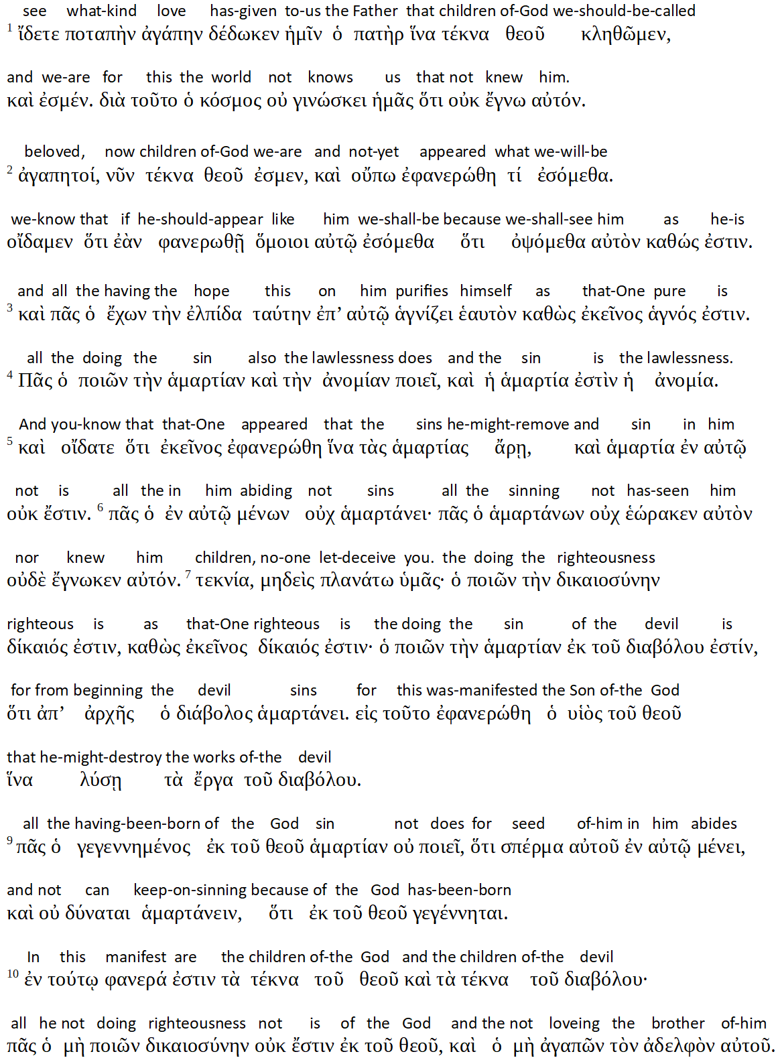

3. Manuscript Variants in 1 John 3:1-10

3:1 From the 4th century, instead of “has given to us,” some manuscripts read, “has given to you” or “gave to us.” In some places, the Greek hémin (“you”) sounded like the Greek humin (“we”), and scribes could easily mishear them, when one was reading the text and another was writing what he heard.
From the 14th century, some manuscripts omit the words, “and so we are.”
From the 4th century, some manuscripts read, “know you,” (humas) instead of “know us” (hémas).
3:2 From the 10th century, some manuscripts insert “and” before “we know.”
3:5 From the 4th century, some manuscripts read, “we know,” instead of “you know.”
From the 4th century, some manuscripts insert “our” before “sins,” as in 1:9; 2:2 and 12.
3:7 From the 4th century, some manuscripts read teknia for “children,” which occurs in 3:1 and 2, instead of paidia, a synonym that appears in 2:14 and 18. In both cases the translation, “children,” remains the same.
3:8 From the 5th century, a few manuscripts start verse 8 with “And.”
3:10 From the 5th century, some manuscripts insert a definite article before “righteousness,” and from the 10th century, two manuscripts have “is not righteous” instead of “not practice righteousness.”
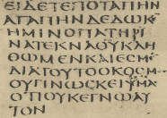 | 1 John 3:1 from Greek Codex Sinaiticus  Sign א  Text Old and New Testaments  Date c. 330–360 CE  Script Greek  Found Mount Sinai 1844  Now at Brit. Libr., Leipzig Univ., St. Catherine's Monastery  Size 38.1 × 34.5 cm (15.0 × 13.6 in)

4. Parallels between 1 John 3:1-10 and the Gospel of John

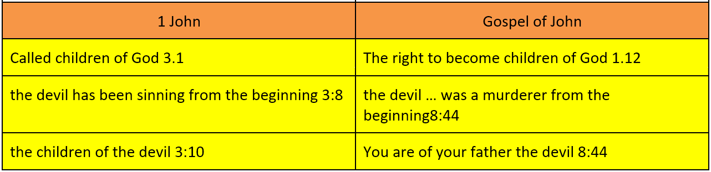

5. Analytical outline for preachers, teachers and groups leaders.

This outline derives from a linguistic discourse analysis rather than from abstract theology or from a need of alliteration.

Part 2: Our Adversaries 2.18 - 3.18

VI. Lawless Sinners 3.1-10

A. The world’s ignorance 3.1-3

1. God calls us his children 3.1

a. And we are

b. The world does not recognize us

2. We shall one day be like Jesus 3.2

a. Already God’s children

b. Although not known

3. We purify ourselves often 3.3

B. Jesus and sinners 3.4-6

1. The practice lawlessness 3.4

2. Jesus came to do away with sins 3.5
a. The righteous stop sinning 3.6
b. Sinners have not known Jesus

C. Seducers and the righteous 3.7-10

1. Their leaders 3.7-8
a. The righteous do what is right 3.7
(1) Jesus is righteous
(2) Jesus came to destroy the devil’s works 3.8
b. Sinners belong with the devil

2. Their identify

a. Children of God 3.9

b. Children of the devil 3.10

6. Important terms and their historical meanings in 1 John 3:1-10
destroy λύω luô
4 to do away with, destroy, bring to an end, … destroy the works of the devil 1J 3:8.
he ἐκεῖνος ekeinos
pertaining to an entity mentioned or understood and viewed as relatively remote in the discourse setting, that person. [1J 2:6 3:3, 5, 7, 16 4:17 = Jesus]
hope ἐλπίς elpis
1 looking forward to something with some reason for confidence respecting fulfillment, hope, … Christian expectation … 1J 3:3
lawlessness ἀνομία anomia
1 state or condition of being disposed to what is lawless, lawlessness, opposite of [righteousness] … 1J 3:4:
sin ἁμαρτία hamartia
1 a departure from either human or divine standards of uprightness … 1J 3:4, 8.
Download from 1john.currah.download a more complete list of terms and definitions from 1 John 3:1-10. Definitions extracted from Bauer, Arndt, Gingrich and Danker, Greek Lexicon (2001).

7. Greek grammar of 1 John 3:1-10. Subject nouns and pronouns
Greek verbs do not require a subject noun or pronoun, for verb endings indicate their subject person and number.
For example, in 1 John 3:2, the Greek says, “when appears,” without a subject, but with a third-person singular verbal ending. In this case, the subject of “appears” is the same as the subject of the preceding “appeared,” namely, “what we will be.”
Likewise, “shall be” and “shall see” have no subject noun or pronoun, but both verbs have a first-person plural verbal ending implying “we” as their subject.
In contrast, in 1 John 3:3, the verb “is” has a subject, the third-person, singular, masculine demonstrative “that one” (eikeinos), referring to Jesus, as in 1 John 2:6, 3:3, 5, 7, 16 and 4:17.
Thus one may translate 1 John 3:2-3, “What we will be has not yet appeared; but we know that when it appears we shall be like him, because we shall see him as he is. And everyone who thus hopes in him purifies himself as Jesus himself is pure.”
Only teach about Greek grammar, if learners are able to understand it and are eager to learn.

8. Teachable points from 1 John 3:1-10
Ask the Holy Spirit to show you teachable ideas and summaries from the passage. For example:
Three Great Contrasts  1. Who we are (children of God) versus what we will be (like him) 3.2  2. Those who practice righteousness (3.4) versus those who practice lawlessness (3.7)  3. Children of God versus children of the devil 3.10  Sinners  1. They know neither Jesus nor us 3:1  2. They make a practice of sinning 3:4  3. They have neither seen Jesus nor known him 3:6  4. They try to deceive Christians 3:7  5. They are of the devil 3:8  6. They are the children of the devil 3:10  7. They are not of God 3:10  8. They do not love their brothers 3:10  Sin is …  1. Not knowing God 3:1  2. Not purifying oneself 3:3  3. Lawlessness 3:4  4. Trying to deceive Christians 3:7  5. Being of the devil 3:8  6. Not being born of God 3:9  7. Being children of the devil 3:10  8. Not practicing righteousness 3:10  9. Not loving one’s brother 3:10  The devil  1. Has been sinning since the beginning 3:8  2. Jesus destroys his works 3:8  3. Sinners are his children 3:1 |  |  | God the Father  1. Has given us his love 3:1  2. He calls us his children 3:1, 10  3. We are born of him 3:9  The Son of God  1. He will appear 3:2  2. We shall see him as he is 3:2  3. He appeared in order to take away sins 3:5  4. In him there is no sin 3:5  5. No one who abides in him keeps on sinning 3:6  6. He is righteous 3:8  7. He appeared was to destroy the works of the devil 3:8  Real Christians  1. God has given us his love 3:1  2. God calls us his children 3:1  3. We are now children of God 3:1, 2  4. We shall be like Jesus 3:2  5. We hope in Jesus 3:3  6. We purify ourselves 3:3  7. We abide in Jesus 3:6  8. We do not keep on sinning 3:6  9. We practice righteousness 3:7  10. We are righteous as he is righteous 3:7  11. We are born of God 3:9  12. God’s seed abides in us 3:9  13. We cannot keep on sinning 3:9  14. By this it is evident we are children of God 3:10
Parentage | Birth | Childhood |  | Family
God | born of God | children of God |  | of God
Devil | (null) | children of the devil |  | of the devil
Instead of reading or talking about all of these points, have learners form tiny groups. Have each group read a few verses of 1 John 3:1-10, looking for the topic. It is not necessary to find or to report all of the items. After a few minutes, ask someone in each tiny group to tell two or three items that the group members found. Thank all for their cooperation.

9. Two historical Christian doctrines.
Righteousness. Jesus practised righteousness, by always obeying God his Father. Christians practice righteousness by obeying Jesus’ commandments. Jesus commanded Christians to believe in God and in him, and to love one another. Righteousness is believing that which is true about Jesus, and showing love towards Christians. Unrighteousness is to deny the truth about Jesus, or not to show love for Christians.
Christians’ sins. Christians practice righteousness, because they are born of God. But Satan tempts Christians to sin, and Christians sometimes commit sins. When they do so, they feel shame or guilt. When Christians confess their sins to God, he forgives them and cleanses them from all unrighteousness. When Christians are being tempted to sin, they should ask God for strength to resist the temptation, and to flee from it.

10. Practical application of 1 John 3:1-10 for Christians
After someone or several have read or recited 1 John 3:1-10 in small gatherings of learners,
pose queries such as these:
- What have you learnt from this passage about God?
- What have you learnt from this passage about Jesus?
- What have you learnt from this passage about sin?
- What have you learnt from this passage about the devil?

Whilst preaching, teaching or leading, recommend ways in which to apply the passage or put it into practice. For example:
- Review seven basic commandments of Jesus.
- Identify antichristian teachers in your city who habitually transgress Jesus’ commandments.
- Invite everyone to confess to God all sins they know that they have committed and not yet confessed, citing 1 John 1:8-9.
- Add to your chart of Future Events the appearing of Jesus and our being made like him.
- Assure those who obey Jesus that they are already God’s children, members of his family.
- Lead troubled individuals to ask Jesus to remove their sins and to destroy the works of the devil.

Conclusion
- Download documents for this lesson at 1john.currah.download.
- Read five times 1 John 3:11-18 before you view the next video lesson.
- Please, leave comments or queries, or write to me at the download site. I shall try to reply to you by email or in a video.

