“Let us teach the New Testament!”

First Epistle of John
Lesson 9, 1 John 4:1-6
1john.currah.download September 2019

Introduction

In this ninth of 15 lessons on the New Testament Book of 1 John, we shall deal with these ten topics:

1. 1 John 4:1-6 in the English Standard Version (2016)
2. 1 John 4:1-6 SBL Greek NT (2010) with English interlinear
3. Greek textual variants in 1 John 4:1-6
4. Parallels between 1 John 4:1-6 and the Gospel of John
5. Analytical outline of 1 John 4:1-6
6. Important vocabulary and historical meanings
7. Greek grammar: Object complement (double accusative)
8. Teachable points from 1 John 4:1-6
9. An historical Christian doctrine: The Christ, the Messuah
10. Practical applications of 1 John 4:1-6 for Christians

1. The English Standard Version (2016) text of 1 John 4:1-6
​¹ Beloved, do not believe every spirit, but test the spirits to see whether they are from God, for many false prophets have gone out into the world.
² By this you know the Spirit of God: every spirit that confesses that Jesus Christ has come in the flesh is from God, ³ and every spirit that does not confess Jesus is not from God. This is the spirit of the antichrist, which you heard was coming and now is in the world already.
⁴ Little children, you are from God and have overcome them, for he who is in you is greater than he who is in the world. ⁵ They are from the world; therefore they speak from the world, and the world listens to them.
⁶ We are from God. Whoever knows God listens to us; whoever is not from God does not listen to us. By this we know the Spirit of truth and the spirit of error.
2. Interlinear Greek-English Text of 1 John 4:1-6
¹ Beloved, not every spirit believe, but test the spirits
¹ Ἀγαπητοί, μὴ παντὶ πνεύματι πιστεύετε, ἀλλὰ δοκιμάζετε τὰ πνεύματα
if from the God they-are, for many false-prophets have-gone-out into the world.
εἰ ἐκ τοῦ θεοῦ ἐστιν, ὅτι πολλοὶ ψευδοπροφῆται ἐξεληλύθασιν εἰς τὸν κόσμον.
² By this you-know the Spirit of-the God: every spirit that confesses Jesus Christ
2 ἐν τούτῳ γινώσκετε τὸ πνεῦμα τοῦ θεοῦ· πᾶν πνεῦμα ὃ ὁμολογεῖ Ἰησοῦν Χριστὸν
in flesh having-come from the God is, ³ and every spirit that not confesses the Jesus
ἐν σαρκὶ ἐληλυθότα ἐκ τοῦ θεοῦ ἐστιν, 3 καὶ πᾶν πνεῦμα ὃ μὴ ὁμολογεῖ τὸν Ἰησοῦν
from the God not is. And this is the-one of-the antichrist, which you-have-heard
ἐκ τοῦ θεοῦ οὐκ ἔστιν· καὶ τοῦτό ἐστιν τὸ τοῦ ἀντιχρίστου, ὃ ἀκηκόατε
that he-is-coming, and now in the world is already. ⁴ You, from the God are, children,
ὅτι ἔρχεται, καὶ νῦν ἐν τῷ κόσμῳ ἐστὶν ἤδη. 4 ὑμεῖς ἐκ τοῦ θεοῦ ἐστε, τεκνία,
and you-have-overcome them, for greater is the-one in you than the-one in the world.
καὶ νενικήκατε αὐτούς, ὅτι μείζων ἐστὶν ὁ ἐν ὑμῖν ἢ ὁ ἐν τῷ κόσμῳ·
⁵ They from the world are; for this from the world they-speak, and the world
5 αὐτοὶ ἐκ τοῦ κόσμου εἰσίν· διὰ τοῦτο ἐκ τοῦ κόσμου λαλοῦσιν καὶ ὁ κόσμος
to-them listens. ⁶ We from the God are. The-one knowing the God listens to-us;
αὐτῶν ἀκούει. 6 ἡμεῖς ἐκ τοῦ θεοῦ ἐσμεν· ὁ γινώσκων τὸν θεὸν ἀκούει ἡμῶν,
who not is from the God not listens to-us.
ὃς οὐκ ἔστιν ἐκ τοῦ θεοῦ οὐκ ἀκούει ἡμῶν.
From this we-know the Spirit of-the truth and the spirit of-the error.
ἐκ τούτου γινώσκομεν τὸ πνεῦμα τῆς ἀληθείας καὶ τὸ πνεῦμα τῆς πλάνης.
3. Manuscript Variants in 1 John 4:1-6

4:2 From the 4th century, a few manuscripts read, “we know the Spirit of God” instead of you know the Spirit of God.”
One 4th century manuscript reads, “to have come” instead “has come.”
4:3 From the 4th century, some manuscripts insert “come in the flesh” after “Jesus;” and from the 9th century, two manuscripts insert “to have come.”
4:6 A 5th century and a 14th century manuscripts omit the clause, “whoever is not from God does not listen to us,” because a copyist’s eye went from the first “us” to the second “us,” a common kind of scribal error.
Download from 1john.currah.download a more complete list of variants.
4. Parallels between 1 John 4:1-6 and the Gospel of John

1 John | Gospel of John
Jesus [is] Christ come in the flesh 4:2 | the Word became flesh and dwelt among us, 1:14  confess Jesus to be Christ 9:22
he who is in you is greater 4:4 | for he dwells with you and will be in you 14.17
He who is in the world 4.4 | The prince of this world 14.30; 16:11
They are of the world, speak or the world, the world listens to them 4.5 | He who is of the earth belongs to the earth and speaks in an earthly way 3:31  if you were of the world, the world would love you as its own 15.19  The world has hated them because they are not of the world, just as I am not of the world 17.14
Whoever knows God listens to us; whoever is not from God does not listen to us 4:6 | Everyone who is of the truth listens to my voice.” 18:37

5. Analytical outline for preachers, teachers and groups leaders.

Part 3: Our Christian Faith 3.19 – 5.5
ΙX. We have the Spirit 4:1-6
A. We can test spirits 4.1-3
1. The spirits of false prophets 4.1
2. The Spirit of God 4.2
a. Those who profess that Jesus is the Christ
b. Those who profess this Jesus 4.3
B. We defeat false prophets 4.4
1. God is greater than spirits
2. They are from the world 4.5
C. We discern spirits 4.6
1. The Spirit of Truth
2. The spirit of error

6. Important terms and their historical meanings in 1 John 4:1-6
Definitions condensed from Bauer, Arndt, Gingrich and Danker, Greek Lexicon (2001).
false prophet ψευδοπροφήτης pseudoprophétés
one who falsely claims to be a prophet of God or who prophesies falsely, false/bogus prophet … 1J 4:1.
prophet προφήτης prophétés
1 a person inspired to proclaim or reveal divine will or purpose.
listen ἀκούω akouô
3 to receive news or information about something, learn about something.
spirit πνεῦμα pneuma
7 an activating spirit that is not from God… Because there are persons activated by such spirits, it is necessary to test the various kinds of spirits 1J 4:1b.
test δοκιμάζω dokimazô
1 to make a critical examination of something, to determine genuineness, put to the test, examine … spirits (of bogus prophets) 1J 4:1.

7. Greek grammar of 1 John 4:1-6. Object complement with “confess”
Both John (John 9:22, 1 John 4:2, 2 John 7) and Paul (Rom. 10.9, 1 Cor. 8.6, 12.3, Phil. 2.11) employ one noun (or pronoun) to define another noun (or pronoun), when both nouns are objects of the same verb of confession. The subject takes the nominative case whereas the object and its complement take the accusative case, forming a double accusative.
Thus, in 1 John 4:2, it would be accurate to translate, “Every spirit that confesses Jesus [to be] Christ come in the flesh is from God” or, “Every spirit that confesses [that] Jesus [is] Christ come in the flesh is from God.”
This verse complements 1 John 2:22 (“Jesus is the Christ”) and 1 John 5:1 (“believes that Jesus is the Christ”). And in 1 John 4:3, “Jesus” has a definite article which points to “Jesus” in verse 2: “confess this Jesus,” that is, the Jesus who is Christ come in the flesh.”
Only teach about Greek grammar, if learners are able to understand it and are eager to learn.

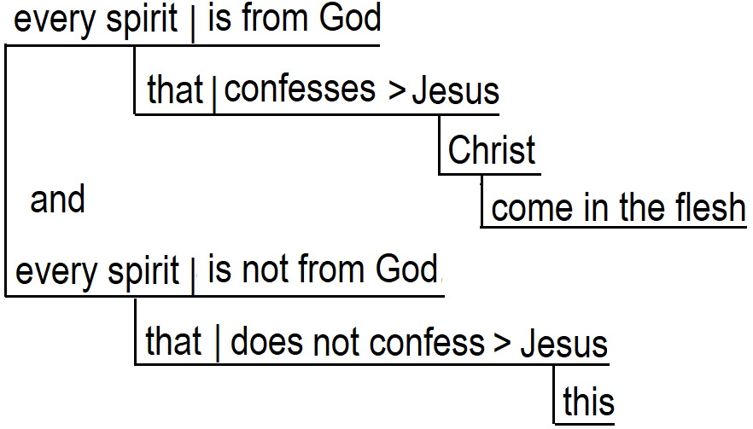
8. Teachable points from 1 John 4:1-6
Ask the Holy Spirit to show you teachable ideas and summaries from the passage. For example:
True Christians  1. Confess Christ come in the flesh 4.2  2. Know the Spirit of God 4.2  3. God is in them 4.4  4. Have defeated the false prophets 4.4  5. Know God 4.6  6. Listen to the Christian apostles 4.6  7. Know the Spirit of Truth 4. | False Christians  1. Believe every spirit 4.1  2. Listen to false prophets 4.1  3. Do not confess Christ come in flesh 4.3  4. Have the Spirit of Antichrist 4.3  5. Are from the world 4.5  6. Do not listen to the Christian apostles 4.6  7. Are not from God 4.
The holy Trinity  God 4.1  Spirit of God 4.2  Christ has come in the flesh 4.2 | An evil trinity  Antichrist 4.3  Spirit of antichrist 4.3  False prophets 4.1

Lying spirits in the world today say:
1. Jesus never lived
2. Jesus was an angel, not a real man
3. Jesus was a teacher but was not the Christ
4. Jesus was a man, and Christ was a spirit
5. Jesus was not crucified
6. Jesus did not die on his cross
7. Jesus did not rise from the dead
8. Jesus is not the Son of God

What other lies about Jesus have you heard from false prophets, from other religions, from non-Christian teachers, from neighbours, from books or from the Internet?

Instead of reading or talking about all of these points, have learners form tiny groups. Have each group read a few verses of 1 John 4:1-6, looking for the topic. It is not necessary to find or to report all of the items. After a few minutes, ask someone in each tiny group to tell two or three items that the group members found. Thank all for their cooperation.
9. An historical Christian doctrine: Jesus is the Christ, the Messiah
The Christ, the Messiah. In ancient times, holy men of God used to anoint new kings by pouring oil on their head. In Hebrew language, the word for anointed is “messiah,” (meshiakh) and in Greek language, the word for anointed is “Christ” (christos).
Jews called their kings the Lord’s messiah. For hundreds of years, Jewish believers often talked about a great, future King whom they called the Messiah. When Jesus came into the world, he let everyone know that he is the Messiah, that is, the Christ.
In the years when John wrote 1 John, philosophers began to teach that the Christ was a spirit whom their gods sent to dwell with the man Jesus, and that Jesus was not the Christ. So 1 John teaches that Jesus is the Christ, and that the Christ came into the world “in the flesh,” that is, as the man Jesus.

10. Practical application of 1 John 4:1-6 for Christians

After someone or several have read or recited 1 John 4:1-6 in small gatherings of learners, pose queries such as these:
- What have you learnt from this passage about God?
- What have you learnt from this passage about Jesus?
- What have you learnt from this passage about false teachers?

Whilst preaching, teaching or leading, recommend ways in which to apply the passage or put it into practice. For example:
- Ask parents to explain to their children this week your church’s teaching about Jesus.
- Have learners tell false teaching they have heard recently about Jesus.
- Affirm other Christian denominations that have right teaching about Jesus.
- Invite learners to collect from their own homes any books, pamphlets, tapes, disks and objects that have false teaching about Jesus, then to bring these together and burn them with fire.

Conclusion
- Download documents for this lesson at 1john.currah.download.
- Read five times 1 John 4:7-13 before you view the next video lesson.
- Please, leave comments or queries, or write to me at the download site. I shall try to reply to you by email or in a video.

