“Let us teach the New Testament!”

First Epistle of John
Lesson 12, 1 John 5:1-5
1john.currah.download September 2019

Introduction

In this twelfth of 15 lessons on the New Testament Book of 1 John, we shall deal with these ten topics:

1. 1 John 5:1-5 in the English Standard Version (2016)
2. 1 John 5:1-5 SBL Greek NT (2010) with English interlinear
3. Greek textual variants in 1 John 5:1-5
4. Parallels between 1 John 5:1-5 and the Gospel of John
5. Analytical outline of 1 John 5:1-5
6. Important vocabulary and historical meanings
7. Greek grammar: Aorist participles with indicative verbs
8. Teachable points from 1 John 5:1-5
9. An historical Christian doctrine: The commandments of God
10. Practical applications of 1 John 5:1-5 for Christians

1. The English Standard Version (2016) text of 1 John 5:1-5
​¹ Everyone who believes that Jesus is the Christ has been born of God, and everyone who loves the Father loves whoever has been born of him.
² By this we know that we love the children of God, when we love God and obey his commandments.
³ For this is the love of God, that we keep his commandments. And his commandments are not burdensome.
⁴ For everyone who has been born of God overcomes the world. And this is the victory that has overcome the world—our faith.
⁵ Who is it that overcomes the world except the one who believes that Jesus is the Son of God?

2. Interlinear Greek-English Text of 1 John 5:1-5
¹ Everyone who believes that Jesus is the Christ of the God has-been-born
¹ Πᾶς ὁ πιστεύων ὅτι Ἰησοῦς ἐστιν ὁ χριστὸς ἐκ τοῦ θεοῦ γεγέννηται,
and everyone who loves the one-having-begot loves also the one-having-been-born of him.
καὶ πᾶς ὁ ἀγαπῶν τὸν γεννήσαντα ἀγαπᾷ καὶ τὸν γεγεννημένον ἐξ αὐτοῦ.

² By this we-know that we-love the children of-the God, whenever the God
² ἐν τούτῳ γινώσκομεν ὅτι ἀγαπῶμεν τὰ τέκνα τοῦ θεοῦ, ὅταν τὸν θεὸν

​ We-love and the commandments his we-do. ³ this for is the love of-the God,
ἀγαπῶμεν καὶ τὰς ἐντολὰς αὐτοῦ ποιῶμεν· ³ αὕτη γάρ ἐστιν ἡ ἀγάπη τοῦ θεοῦ

that the commandments his we-keep. And the commandments his burdensome not are.
ἵνα τὰς ἐντολὰς αὐτοῦ τηρῶμεν, καὶ αἱ ἐντολαὶ αὐτοῦ βαρεῖαι οὐκ εἰσίν,

⁴ For everyone who having-been-born of the God overcomes the world. And this is the victory
⁴ ὅτι πᾶν τὸ γεγεννημένον ἐκ τοῦ θεοῦ νικᾷ τὸν κόσμον. καὶ αὕτη ἐστὶν ἡ νίκη

that having-overcome the world—the faith our. ⁵ Who and is that overcoming the world
ἡ νικήσασα τὸν κόσμον, ἡ πίστις ἡμῶν· ⁵ τίς δέ ἐστιν ὁ νικῶν τὸν κόσμον

if not the believing that Jesus is the Son of-the God?
εἰ μὴ ὁ πιστεύων ὅτι Ἰησοῦς ἐστιν ὁ υἱὸς τοῦ θεοῦ;

3. Manuscript Variants in 1 John 5:1-5
5:1 From the 4th century, most manuscripts insert “also” before “loves whoever.”

One 4th century manuscript reads, “whatever has been born,” as in 5:4, instead of “whoever has been born.”

5:2 One 8th century copyist mistakenly wrote, “obey” in the indicative mood instead of the subjunctive.

From the 4th century, some manuscripts read, “keep” instead of “obey.”

5:5 One 4th century manuscript inserts “And” at the beginning of the verse.
Download from 1john.currah.download a more complete list of variant readings.

4. Parallels between 1 John 5:1-5 and the Gospel of John
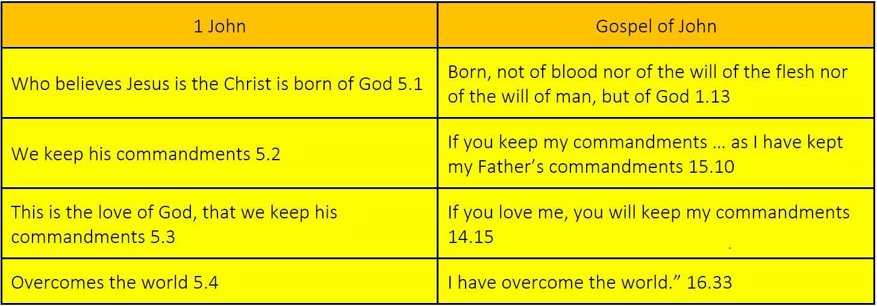

5. Analytical outline for preachers, teachers and groups leaders.

Part 3: Our Christian Faith 3.19 – 5.5
Verses 1-5 present the fifth of five great advantages of Christian faith.
XII. We have the Christ 5.1-5

A. True Christian faith 5.1-2

1. Believe that Jesus is the Christ 5.1
2. Born of God
3. Love God’s children 5.2

a. By loving God
b. By obeying his commandments

B. Love for God 5.3-4a

1. Obey his commandments 5.3
2. Overcome the world 5.4a

C. Overcome the world 5.4b-5

1. By our Christian faith 5.4b
2. Believing that Jesus is the Son of God 5.5

6. Important terms and their historical meanings in 1 John 5:1-5
Definitions condensed from Bauer, Arndt, Gingrich and Danker, Greek Lexicon (2001).
burdensome βαρύς barus
generally ‘heavy’, in our literature in imagery and metaphors pertaining especially to things or persons that are burdensome because of demands or threats.
2 pertaining to being a source of difficulty or trouble because of demands made.
a not difficult to carry out … 1J 5:3.

7. Greek grammar of 1 John 5:1-5. Aorist Participles & Indicative Verbs

Aorist Participles with Indicative Verbs
“In the indicative, the aorist usually indicates past time with reference to the time of speaking (thus, “absolute time”). Aorist participles usually suggest antecedent time to that of the main verb (i.e., past time in a relative sense). There are exceptions to this general principle, of course, … due to intrusions from other linguistic features vying for control… Outside the indicative and participle, time is not a feature of the aorist.” Daniel B. Wallace, Greek Grammar Beyond the Basics, Zondervan, 1996.

πᾶς ὁ ἀγαπῶν τὸν γεννήσαντα ἀγαπᾷ o καὶ τὸν γεγεννημένον ἐξ αὐτοῦ. 1 John 5:1 NA28
“Everyone who loves (present participle) the Father (i.e, the Begetter, present participle) loves (present indicative) whoever has been born (aorist participle) of him.” 1 John 5:1 ESV
Christians who love God also love those whom the Father has already caused to be born again.

αὕτη ἐστὶν ἡ νίκη ἡ νικήσασα τὸν κόσμον, ἡ πίστις ἡμῶν. 1 John 5:4 NA28
“This is (present indicative) the victory that has overcome (aorist participle) the world.” 1 John 5:4 ESV
Our faith has already overcome the evil world system.

8. Teachable points from 1 John 5:1-5
Ask the Holy Spirit to show you teachable points from the passage. For example:
Divine logic of faith and obedience

1. Sole condition to be born again: believe that Jesus is the Christ. 5.1
2. Sole proof that one is born again: love others who are born again 5.1
3. How to know that we love born-again Christians: love and obey God 5.2
4. Sole proof that one loves God: keep his commandments 5.3
5. God’s commandments are not burdensome for those who are born again 5.3-4
6. Sole condition to overcome the world: be born again 5.4
7. Sole proof that one has overcome the world: believe that Jesus is the Son of God 5.5

False beliefs about Jesus:

1. Jesus does not exist (atheists).
2. Jesus is not the Christ (Jews, Gnostics).
3. Jesus is not the Son of God (Moslems).
4. Jesus did not die on a cross (Moslems, JWs).
5. Jesus did not rise back to life (Moslems, JWs, atheists).
6. Jesus is one of many gods (Hindus).
7. Jesus was an angel (JWs, some Adventists).
8. Jesus was one of many prophets (Moslems).
9. Jesus was one of many great teachers (most religions).
10. Jesus has gone to another planet (Mormons).
11. Jesus will never return (Jews, atheists).
12. Jesus cannot save you (atheists, most religions).

Instead of reading or talking about all of these points, have learners form tiny groups. Have each group read a few verses of 1 John 5:1-5, looking for the topic. It is not necessary to find or to report all of the items. After a few minutes, ask someone in each tiny group to tell two or three items that the group members found. Thank all for their cooperation.

9. An historical Christian doctrine: The commandments of God
God’s commandments. God gave a commandment to our first parents, Adam and Eve, “Be fruitful and multiply and fill the earth and subdue it, and have dominion … over every living thing” (Genesis 1:28). But they disobeyed him. To the tribes of Israel, God gave Ten Commandments, besides many laws (Deuteronomy 5:6-12). But they disobeyed him.
When Jesus came into the world, he gave his followers a new commandment, “A new commandment I give to you, that you love one another: just as I have loved you, you also are to love one another…” (John 13:34-35). Before Jesus died and rose back to life, God commanded followers, “This is my beloved Son, with whom I am well pleased; listen to him” (Matthew 17:5).
Jesus said, “If you love me, you will keep my commandments.” (John 14:15). “And his commandments are not burdensome” (1 John 5:3).
10. Practical application of 1 John 5:1-5 for Christians
After someone or several have read or recited 1 John 5:1-5 in small gatherings of learners, pose queries such as these:
- What have you learnt from this passage about God?
- What have you learnt from this passage about Jesus?
- What have you learnt from this passage about being born of God?
- What have you learnt from this passage about love?

Whilst preaching, teaching or leading, recommend ways in which to apply the passage or put it into practice. For example:
- Insist on obeying God and on faith in Jesus as messiah, the Son of God.
- Review again several basic commandments of God that Jesus taught.
- Invite everyone to think about more ways in which to show love one for another, then pray that God himself will visit each one in a fresh way.
- Invite everyone to put their faith in Jesus to be born of God.
- Invite everyone to tell about ways in which the world has recently tempted them to disobey God or to deny that Jesus be the Son of God. Then pray one for another to remain faithful to Jesus by obeying his commandments.
Conclusion
- Download documents for this lesson at 1john.currah.download.
- Read five times 1 John 5:6-13 before you view the next video lesson.
- Please, leave comments or queries, or write to me at the download site. I shall try to reply to you by email or in a video.

