Greek Prepositions
Prepositions generally modify verbs and govern substantives (nouns, participles and articular infinitives). In 1 John 5:14-17 the preposition πρὸς (pros) governs “him” and “death”.
Translation of a preposition depends (a) on its function in a sentence, and (b) on the nature (person, thing, or place) and on the case (genitive, dative or accusative) of the substantive(s) that it governs.
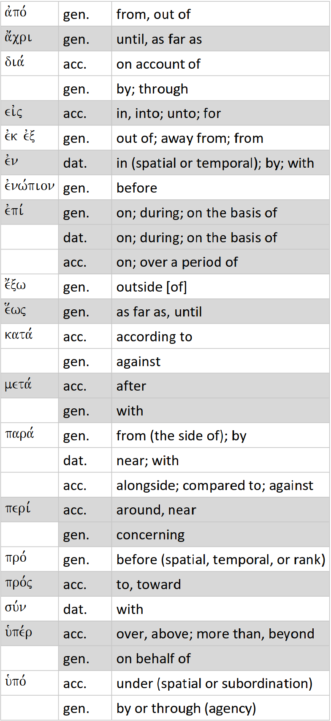
From Todd Scacewater, Exegetical Tools: Greek Primer, page 46. www.exegeticaltools.com

