Greek Papyrus 09 = Oxyrhynchus 402
Found at Oxyrhynchus, Egypt
Size 8 x 5.2 cm, copied 3rd century CE
Published by Bernard Grenfell & Arthur S. Hunt in 1903
1 John 4:11-12
Ο ΘΣ ΤΑΠΡΙΣΕΝ ΗΜΑΣ, ΚΑΙ ΗΜΕΙΣ  ΟΦΕΙΛΟΜΕΝ ΑΛΛΗΛΟΥΣ ΑΓΑΠΑΝ ΘΝ  ΟΥΔΕΙΣ ΠΩΠΟΤΕ ΤΕΘΕΑΤΑΙ.  ΤΟΝΕΙΝ ΕΑΝ ΑΓΑΠΩΜΕΝ ΑΛΛΗ  ΛΟΥΣ, Ο ΘΣ Ε ΗΜΙΝ ΜΕΝΕΙ ΚΑΙ Η Α  ΓΑΠΗ ΑΥΤΟΥ ΤΕΤΕΛΕΙΩΜΕΝΗ | 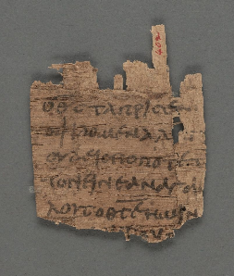 | ὁ θεὸς τάπρισεν ἡμᾶς, καὶ ἡμεῖς  ὀφείλομεν ἀλλήλους ἀγαπᾶν. θεὸν  οὐδεὶς πώποτε τεθέαται.  τονειν ἐὰν ἀγαπῶμεν ἀλλή-  λους, ὁ θεὸς ἐν ἡμῖν μένει καὶ ἡ ἀ  γάπη αὐτοῦ τετελειωμένη ἐστίν
1 John 4:14-17
ΑΠΕΣΤΑΛΚΕΝ ΤΟΝ ΥΝ ΣΩΤΗ  ΡΑ ΤΟΥ ΚΟΣΜΟΥ ΟΣ ΕΑΝ ΟΜΟΛΟ  ΓΗΣΗΙ ΟΤΙ ΙΗΣ ΕΣΤΙΝ Ο ΥΣ ΤΟΥ  ΘΥ, Ο ΘΣ ΕΝ ΑΥΤΩΙ ΜΕΝΕΙ ΚΑΙ  Ο ΘΣ ΕΝ ΑΥΤΩ ΕΣΤΙΝ ΚΑΙ ΗΜΕ_{ΙΣ} ΕΓΝΩΚΑΜΕΝ ΚΑΙ ΠΕΠΙΣΤΕΥΚΑ  ΜΕΝ ΤΗΝ ΑΓΑΠΗΝ ΗΝ ΕΧΙ Ο ΧΘΣ  ΕΝ ΗΜΙΝ Ο ΘΣ ΑΓΑΠΗ ΕΣΤΙΝ, ΚΑ  Ο ΜΕΝΩΝ ΕΝ ΤΗΙ ΑΓΑΠΗΙ ΕΝ ΤΩΙ  ΘΩ ΜΕΝΕΙ ΚΑΙ Ο ΘΣ ΕΝ ΑΥΤΩΙ ΜΕ  ΕΙ ΕΝ ΤΟΥΤΟΩ ΤΕΤΕΛΕΙΩΤΑΙ Η | 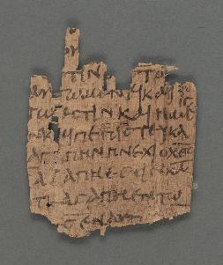 | ἀπέσταλκεν τὸν υἱὸν σωτῆ  ρα τοῦ κόσμου. Ὃς ἐὰν ὁμολογ  ήσῃ ὅτι Ἰησοῦς ἐστιν ὁ υἱὸς τοῦ  θεοῦ, ὁ θεὸς ἐν αὐτῷ μένει καὶ  αὐτὸς ἐν τῷ θεῷ. καὶ ἡμεῖς  ἐγνώκαμεν καὶ πεπιστεύκα  μεν τὴν ἀγάπην ἣν ἔχει ὁ θεὸς  ἐν ἡμῖν. Ὁ θεὸς ἀγάπη ἐστίν, καὶ  ὁ μένων ἐν τῇ ἀγάπῃ ἐν τῷ  θεῷ μένει καὶ ὁ θεὸς ἐν αὐτῷ  μένει. Ἐν τούτῳ τετελείωται ἡ
Black = visible text  Red = missing text  Underscore = original overbar for abbreviations | KEY | Transcription in modern, accented characters with abbreviations expanded.  Italic = mistakes.

