FIRST JOHN 1:1-4
‘Concerning the Word of Life’
07 & 10 March 2024

Who was John?
● A son of Zebedee, a Judean Jew, a fisherman by trade, and of Salome, a relative of Jesus’ mother, Mary (Jn 19:25; Mt 27:56; Mk 15:40).
● One of Jesus’ twelve apostles (see next slide).
● Author of the Gospel of John, in which he records several of Jesus’ theological discourses.
● Late in his life, John became a leader of churches at Ephesus and in Asia Minor.
● Lived to about age 90, dying around the year 100.
Polycarp (69-155 CE), a 2nd-century Christian bishop of Smyrna, who had been a disciple of John, cited 1 John 4:2-3 when he wrote: “Everyone who does not confess that Jesus Christ has come in the flesh is an antichrist.” Πᾶς γὰρ ὃς ἂν μὴ ὁμολογῇ Ἰησοῦν Χριστὸν ἐν σαρκὶ ἐληλυθέναι, ἀντιχριστός ἐστιν. The Epistle of Polycarp to the Philippians 7:1 (Apostolic Fathers I, Loeb Classical Library, Harvard University Press, Cambridge, 1975,
pp. 292-3.)
Date of 1 John: Near the year 100
● The Christians of Asia Minor were in their second and third generations.
● The population had become tolerant of their new religion.
● Their main opposition came not from persecution (Eph. 19.29; Rev. 2.13) …
● but from the appeal of Greek philosophy and the allure of Roman wealth.

Purpose of 1 John
To steer young generations of Christians towards Jesus’ original Good News.
● To gain full joy. 1.4
● To urge them not to sin. 2.1
● To recall Christian truth. 2.12-14, 21
● To warn them about deceivers 2.26
● To assure them of everlasting life 5.13

1st & 2nd century Gnosticism
● All matter is evil; the spirit-realm is good.
● God unknowable; less spirits called Aeons.
● World created by an inferior Demiurge.
● Humans must deal with ignorance, not sin.
● To achieve salvation, folk need knowledge (gnosis, γνῶσις), not redemption.
● There are today new gnostic religions.
Secessionists (separatists)
● Expelled from synagogues, some returned to pre-Christian Judaism (2:19, 22; 4:3).
● Others reverted to idolatry or to the imperial cult (4:1; 3:16; 5:21).
● Gnosticism (God unknowable, aeon spirits, spirit/flesh divide, 1:8).
● Docitists (Christ divine, not human, 4.2).
● Cerinthian (Christ-Spirit onto Jesus, 2:22).
Secessionists today
● New atheism & naive scientism.
● American cults and militant religions.
● Gender confusion & sexual perversion.
● Political left & global governance.
● Apostacy from ignorant evangelicalism.
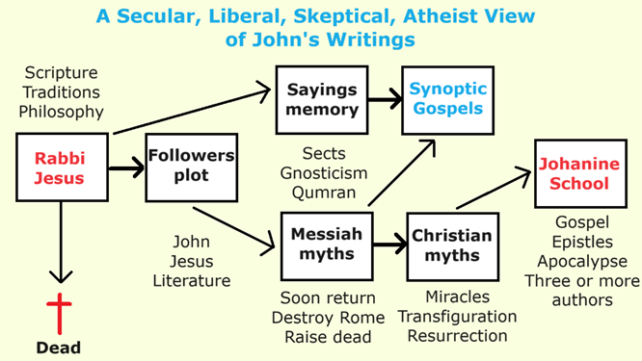

Earliest Greek manuscripts 1 John
Bible versions, including 1 John are translated from ancient Greek manuscripts.
● The earliest Greek manuscript of 1 John (Papyrus 9) dates from the 3rd century.
● Two manuscripts (א and A) date from the 4th and 5th centuries
● B, C and 048 date from the 5th century.
● 23 others from the 7th century and later.
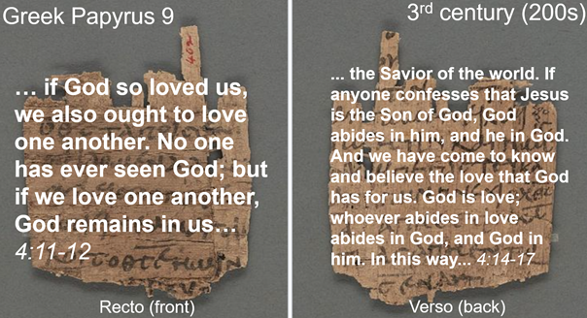
1 John Outline
Part 1: Our Fellowship with God 1.1 – 2.17
I. The Word of Life 1.1-4
II. The Original Message 1.5 – 2.2
III. The New Commandment 2.3-11
IV. The Will of God 1.12-19
Part 2: Our Adversaries 2.18 – 3.18
Part 3: Our Christian Faith 3.19 – 5.5
Part 4: Our Confidence with God 5.6-21

1 John 1:1 (NASB 2020)
¹ What was from the beginning, what we have heard, what we have seen with our eyes, what we have looked at and touched with our hands, concerning the Word of Life—
● Why no greeting?
● What beginning?
● Who are ‘we’?
● Why no ‘whom’?
● Seen and looked at?
● Touched when?
● Word of?
● What kind of life?

Gospel of John chapter 1
¹ In the beginning was the Word, and the Word was with God, and the Word was God.
³ In Him was life…
¹⁴ And the Word became flesh, and dwelt among us, and we saw His glory…
³⁴ “I myself have seen [him], and have testified that this is the Son of God.”
● The Word: Greek Logos. In Scripture and in philosophy, the Logos = God speaking.
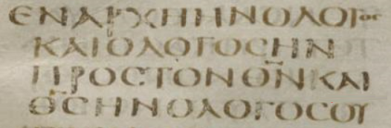
John 1:1. Greek Codex Sinaiticus, 4th century CE

1 John 1:1
● What is the importance of sensual data in matters of faith?
● How can one both believe Jesus and think rationally about science and reality?
● Touched when?
● How was eternal life ‘with (continuous past) the Father’ and ‘revealed (simple past) to us’.

1 John 1:2
² and the life was revealed, and we have seen and testify and proclaim to you the eternal life, which was with the Father and was revealed to us—
● Revealed, how?
● Distinguish “testify” and “proclaim”.
● Eternal life?
● Who and where is “the Father?”

1 John 1:3
³ what we have seen and heard we proclaim to you also, so that you too may have fellowship with us; and indeed our fellowship is with the Father, and with His Son Jesus Christ.
● Fellowship: Greek koinônia: sharing, participation, mutual interests.
● With us: the apostles unique experience.
● With the Father and the Son: How?

1 John 1:4
⁴ These things we write, so that our joy may be made complete.
● Things: What things?
● Write: (Present tense). Where is it, today?
● Joy: Experience gladness. How?
● Complete: What had the apostles not yet done by the end of the first century?
● Our: May manuscripts read “your joy”. ‘Our’ = hémôn, ‘your’ = hymôn.

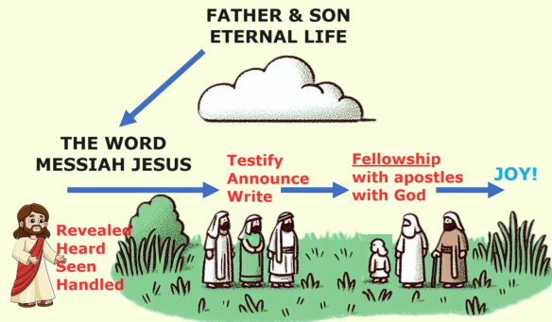
Chronology of the Life  1. Eternal  2. Son  3. With the Father  4. Word  5. From the beginning  6. Jesus Christ  7. Was revealed to his apostles | 8. Apostles heard, seen, handled  9. Their fellowship with Father & Son  10. They testify, announce  11. They write  12. Our fellowship with apostles  13. Their/our joy  14. Joy complete

