FIRST JOHN 2:3-11
‘We keep His commandments’
21 & 24 March 2024
Download from http://1john.currah.download
Discourse structure
Part 1: Our Fellowship with God 1.1 – 2.17
I. The Word of Life 1.1-4
II. The Original Message 1.5 – 2.2
III. The New Commandment 2.3-11
IV. The Will of God 1.12-19 Part 2: Our Adversaries 2.18 – 3.18
Part 3: Our Christian Faith 3.19 – 5.5
Part 4: Our Confidence with God 5.6-21

Keep His commandments. 2:4-5a
³ By this we know that we have come to know Him, if we keep His commandments.
Jesus said, “If you love Me, [then] you will keep My commandments.” John 14:15
“You are My friends, if you do what I command you.” John 15:14
● By this: Effect caise/
● Know him: Know by experience.
● Keep: Obey, live by.
● Commandments: Guidelines for life.
Jesus’ Ten Commandments
1. You believe in God, believe in me, too.
2. Stay in my words.
3. Repent, believe my good news, and receive my Holy Spirit.
4. Follow me.
5. Love God, others, believers & enemies.
6. Pray to God in my name.
7. Remember my death.
8. Give freely to others.
9. Make new followers.
10. Baptize new followers.

Moses’ Ten Commandments
1. Worship no other gods.
2. Do not make idols.
3. Do not sin using my Name.
4. Rest on the Sabbath day (Fri to Sat eve).
5. Honor your father and mother.
6. Do not murder.
7. Do not commit adultery.
8. Do not steal.
9. Do not lie about others.
10. Do not desire other people’s things or spouse.
The love of God. 2:4-5a
⁴ The one who says, “I have come to know Him,” and does not keep His commandments, is a liar, and the truth is not in him; ⁵ but whoever follows His word, in him the love of God has truly been perfected.
Jesus promised, “If you abide in Me, and My words abide in you, [then] ask whatever you wish,
and it will be done for you.” John 15:7.
● Liar: Most evil parades as good.
● Love of God: Love for God.
● Perfected: Fulfilling its purpose.

Authority Good goal Evil intent
Adolph Hitler Rebuild nation Exterminate
Joseph Smith Restore church Polygamy
Prophets True religion Deny Jesus
Narcissist Love you Own desires
Drug traffic Inner peace Addiction
Big Pharma Public heath Profiteer
Government Just rule Confiscate
Antichrist World peace Satanic rule

Taxonomy of evil
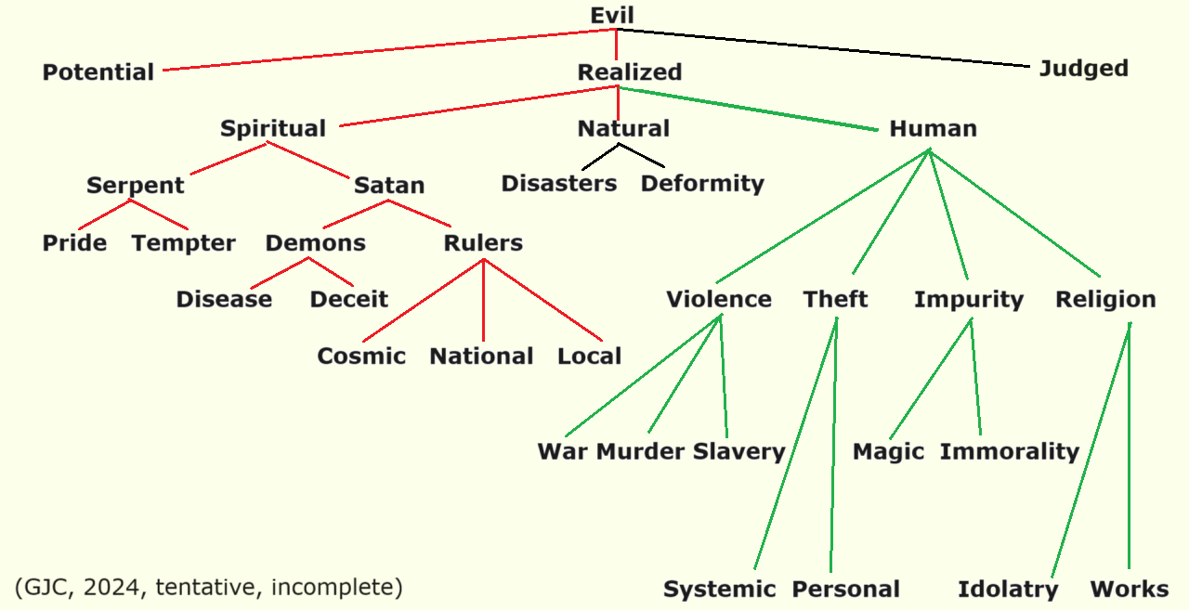
Keep His commandments. 5b-6
By this we know that we are in Him: ⁶ the one who says that he remains in Him ought, himself also, to walk just as He walked.
Jesus warned, “Whoever does not carry his own cross and come after Me cannot be My disciple.”
Luke 14:27
● In Him: United with him.
● Remain: Committed, awaiting glory.
● Own cross: Ready to die, if required.
● Walk: Daily life and behavior.
● Disciple: Obedient follower.
The new commandment. 2:7
⁷ Beloved, I am not writing a new commandment to you, but an old commandment which you have had from the beginning; the old commandment is the word which you have heard.
Jesus Commanded, “I give you a new commandment, that you love one another.” John 13:34

The True Light. 2:8
⁸ On the other hand, I am writing a new commandment to you, which is true in Him and in you, because the darkness is passing away and the true Light is already shining.
“The true light, which enlightens everyone, was coming into the world… To all who received him, who believed in his name, he gave power to become children of God” John 1:9-12.
Remain in the Light. 2:9-10
⁹ The one who says that he is in the Light and yet hates his brother or sister is in the darkness until now. ¹⁰ The one who loves his brother and sister remains in the Light, and there is nothing in him to cause stumbling.
Woe to the world because of things that cause sin! Such things are bound to come, but woe to the one through whom they come!” Matthew 18:7
● Brother: Other Christian believers.
● Hates: Despise, exclude, slander.
● Stumble: Entice to disbelieve, to sin.

Blinding darkness. 2:11
¹¹ But the one who hates his brother or sister is in the darkness and walks in the darkness, and does not know where he is going because the darkness has blinded his eyes.
Jesus warned, “If you walk in the darkness, you do not know where you are going. While you have the light, believe in the light, so that you may become children of light.” John 12:35-36
● Where: Everlasting darkness. Hell.
● Blinded: Deceived, disbelieve, deny truth.

