FIRST JOHN 3:11-18
‘The message which you have heard’
18 & 21 April 2024
Download from http://1john.currah.download
Discourse structure
Part 1: Our Fellowship with God 1.1 – 2.17
Part 2: Our Adversaries 2.18 – 3.18
V. Antichristian teachers 2.18-29
VI. Lawless sinners 3.1-10
VII. Those who Hate Christians 3.11-18
Part 3: Our Christian Faith 3.19 – 5.5
Part 4: Our Confidence with God 5.6-21

Practice righteousness, 3:10
Jesus said, “I am giving you a new commandment, that you love one another; just as I have loved you.”
John 13:34

Reasons others hate & ridicule us
● They blame us for others’ past history.
● Their religions accuse us of evil deeds.
● Our beliefs contradict their beliefs.
● They know that we do not retaliate.
● We openly oppose their evil deeds.
● They fear we may side with their enemies.
● They lust after our children or youth.
● They are motivated by evil spirits.

A. The example of Cain, 3.11-12:
God The example of Cain, 3.11-12a
● Message: Jesus’ & his apostles’ teaching.
● Beginning: Eye & ear-witness accounts.
● Cain: Adam’s & eve’s first child.
● Brother: Abel, a righteous young man.

The example of Cain, 12b
‘Cain said to his brother Abel, “Let's go out to the field.” While they were in the field, Cain attacked his brother Abel and killed him.’ Genesis 4:8

● Reason: Premeditated, purposeful.
● Evil: ‘Pornicious,’ evil in action.
● Righteous: Obeying God’s rules.
Cain ben Adam
● Firstborn son of Adam and Eve.
● Practiced sacrifice without real faith.
● Murdered his righteous brother Abel.
● Complained about his punishment.
● Yahweh protected him from others.
● Went away from Yahweh’s presence.
● Settled in the land of Nod, east of Eden.
● Married and fathered a son, Enoch.
● Founded a city named for his son, Enoch.

B. When they hate us, 3:13-15
The world hates you, 3:13-14
Jesus said, “Blessed are you when people hate you… Love your enemies, do good to those who hate you.” John 17:25

● World: the socio-political system.
● Hate: De-value, regard as inferior.
● Love: Value, treat as worthy.
● Death: No everlasting life, ruled by Satan.

Hatred = murder, 3:15
Jesus explained, “Out of the heart come evil thoughts, murder, adultery, sexual immorality, theft, false witness, slander.” Matthew 15:19
● Murder: To desire or to cause death.
● Eternal life: Joy now, rewards in heaven, bodily resurrection, reign with Christ in his kingdom, become all that God intends.

Everlasting life
● For the righteous, Mt 25:46.
● In the age to come, Lk 18:30.
● Through faith in Jesus, Jn 3:15-16.
● Passing from death into life, Jn 5:24.
● Raised to life on the last day, Jn 6:40, 54.
● Will never perish, Jn 10:28.
● The free gift from God, Ro 6:23.
● Promised by God who never lies, Ti1:2.

The righteous love, 3.16-18
We lay down our lives, 3:16K
Jesus said, “I know the Father; and I lay down my life for the sheep… that I may take it up again.”
John 10:15, 17
To lay down one’s life
(1) Die in order that others may live.
(2) Share goods with others who are in need.
(3) Give time to tell others about Jesus.
(4) Risk being insulted or falsely accused.

The love of God, 3:17

Jesus taught, “Forgive, and you will be forgiven; give, and it will be given to you. ... For with the measure you use it will be measured back to you.” Luke 6:37-38

● Goods: Things that sustain life.
● Need: Endangered health, safety and life.
● Heart: (1) Bowels, (2) emotions.
● Love of God: His love for us, ours for him, or his kind of love for others?
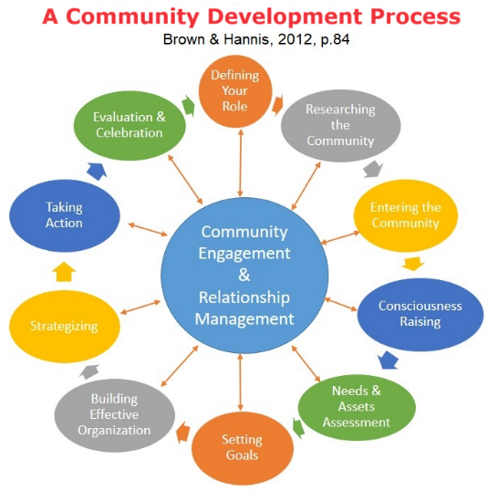
What inputs sustain human life?
● Nutritious food. Agriculture.
● Clean water. Hydrology.
● Secure shelter. Construction.
● Hygiene. Sanitation.
● Community. Security.
● Effective remedies. Health care.
● Life skills. Education.
● Reasons to live and to let live. Faith & hope.
● What more?

The righteous love, 3:18

Paul wrote, “Insist on these things, so that those who have believed in God may be careful to devote themselves to good works. These things are excellent and profitable for people.” Titus 3:8

How could our congregation do more?
(1) Leverage our existing skills.
(2) Take an inventory of members’ skills.
(3) Ask members to donate (up to) one day a month.
(4) Start small and grow.
(5) Do everything ‘in Jesus’ name’.

Assignment

● Read 1 John 3:19–4:6 three times in different versions (www.biblehub.com).
● Visit http://1john.currah.download
● Compile your own insights to share with others next time.

