**Micah  
“Who is like Yah?”**Chapter 1  
11 July 2024

**Forms of divine communication**

DEITY (Eternal consciousness)

Creator

Spiritual

Theophonic

**Incarnation**

Prophetic

Material

Creation

HUMANITY (Temporal-Spatial consciousness)

**Offices of divine communication**

DEITY 🡺 HUMANITY

1 Creator 🡺 Creature

2 Provident 🡺 Provision

3 Prophet 🡺 Message

4 Priest 🡺 Access

5 King 🡺 Rule

6 Judge 🡺 Justice

7 Savior 🡺 Life

**Prophetic status**

1 Inspired (unknown): Local teacher

2 Message (doubted): Travelling preacher

3 Foretelling (noticed): Raving lunatic

4 Fulfillment (affirmed): Prophetic voice

5 Authority (heard): Believed or rejected

6 School (preserved): Words preserved

7 Scripture (final edits): Widely believed

8 Canon (believed): Cited authority

9 Quoted (affirmed): New Testament proofs

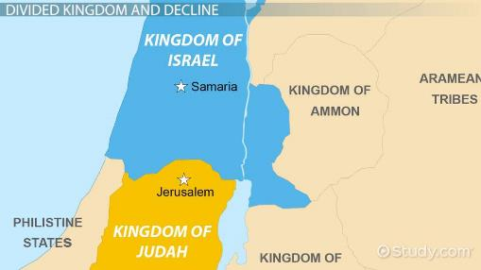

**Micah = “Who (is) like Yah(weh)?”**

**מִיכָה** Mîkah short for **rמִיכָיָה** Mîkayah

מִי = Mî = who

  כ = Ke = like

יָה = Yah = Yahweh (Yah = more ancient)

● Prophesied circa 750–686 BC.

● From Moresheth near Gath in Judah.

● Contemporary of Isaiah and of Hosea.

● Mentioned by Jeremiah (26:18).

**Book of Micah, structure**

Four oracles begin with “Listen!”

1 Judgment is coming (1:1–2:13).

2 Restoration will follow judgment (3:1).

3 The charge against Israel and promise of salvation (6:1).

4 Dishonest business and politics (6:9)

**Micah’s message**

● The main charges against both nations:

**Idolatry**: False beliefs. Disloyalty.

**Injustice**: Evil behavior. Dishonesty.

● The fulfilled prediction of Samaria City’s fall (1:6) served to support the predicted fall of Jerusalem City (7:8-9).

● The book is written in Hebrew poetry, rich in rhyming ideas.

**Assyria**

● A Mesopotamian empire from the 14th century BC to the 7th century BC.

● In the Neo-Assyrian period (911–609 BC), it had the most powerful army.

● It fell to a coalition of Babylonians and Medes in the late 7th century BC.

**Assyria in Israel and Judah**

● Tiglath- Pileser III (r. 745 to 727 BC) invaded Aram (Syria), Philistia, Israel and Judah in 734-32 BC.

● Samaria City fell to the Assyrians in 722/721 BC (Mic. 1:6).

● Jerusalem revolted against Assyria in 701 BC, and Sennacherib’s army was destroyed in 686 (Isa. 37:36-37).

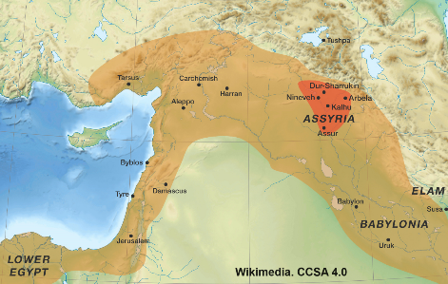

**Babylon**

**Old Babylonia**: 19th – 16th centuries BC.

King Hammurabi (r. 1792 – 1750 BC).

**Neo-Babylonia**: 7th – 6th centuries BC.

Nabopolassar (625-605).

**Nebuchadnezzar (605-562).**

**Persian Period**: 6th – 4th centuries BC.

Cyrus (539-530).

Darius I (522-486).

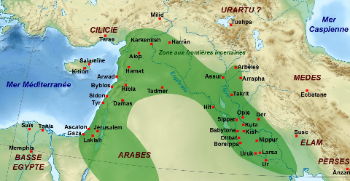

**Micah 1:1** (Samaria, Israel and Jerusalem, Judah)

● Jotham: r. 759-744

● Ahaz: r. 743-728

● Hezekiah: r. 727-699

58km = 36 miles apart

Samaria, est. pop. under 50,000, elev. 300 ft.

Jerusalem, est. pop. Under 30,000, elev. 2577 ft.

**Micah 1:2** (First oracle)

● All: Or both (Israelites and Judahites).

● Earth: Or land (formally Canaan).

● Adonai: Lit. ‘My Lords’. Israel’s God.

**Micah 1:3-4** (High places)

● In the Baal Cycle, an Ugaritic text dating back to around 1500–1300 BC, Baʿal’s abode   
is on the Syrian Mount Zaphon (Sapanu) which means ‘north’.

● “Mount Zion, in the far north [zaphon], the city of the great King.” Psa. 48:2b

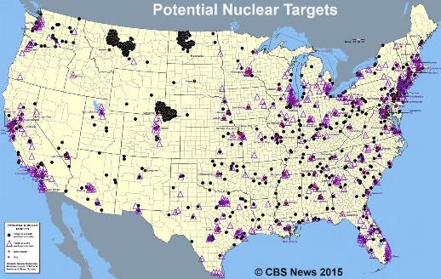

**Micah 1:5-6** (Trangressions)

● High place: pagan worship site.

● Fulfilled: Assyrian invasion 722/721 BC.

**Micah 1:7** (Idolatry in Samaria)

● From the fee of a prostitute

● To the fee of a prostitute

**Micah 1:8-9** (Jerusalem next)

**Assyria in Judah (2 Kings 18)**

701: Sennacherib captures Jerusalem and collects tribute from Hezekiah.

690: Sennacherib sacks cities and towns in Judah. Exiles 200,000 Judeans.

688: A major setback for Sennacherib in Judah. See 2 Kings 19:35

681: Sennacherib’s sons assassinate him in his god’s temple. 19:37

**Micah 1:10-12** (Cities of Judah)

● How can an enemy invasion be said to come down from Yahweh?

● How could the USA ever be invaded?

**Micah 1:13-16** (Same transgression as in Israel)

**Assyrian captivity (exiles)**

732: Galilee and Naphtali are deported to Assyria.

731: Tiglath-Pileser captures Damascus and kills King Rezin of Syria.

724: Shalmaneser V of Assyria seizes Hoshea and lays siege to Samaria.

722: Samaria falls to the Assyrians. “The ten ‘lost tribes of Israel.”

**Babylonian captivity (exiles)**

605: Nebuchadnezzar invades Judah.

605: The first wave of deportation of Judeans to Babylon.

597: The Babylonians capture Jerusalem and King Jehoiachin. 2nd deportation.

586: Babylonians sack Jerusalem and destroy the Temple. 3rd deportation.

Till 582: Additional deportations.