**The Book of Micah**

**“Who is like Yah?”**

Chapter 2

**Pre-Exilic Minor Prophets**

In **Israel** (Samaria), northern kingdom

Amos c. 50 yrs. Foretold restoration.

Hosea c. 38 yrs. Foretold faithfulness.

In **Judah** (Jerusalem), southern kingdom

Micah c. 36 yrs. Foretold prosperity.

Zephania c. 49 yrs. Foretold restoration.

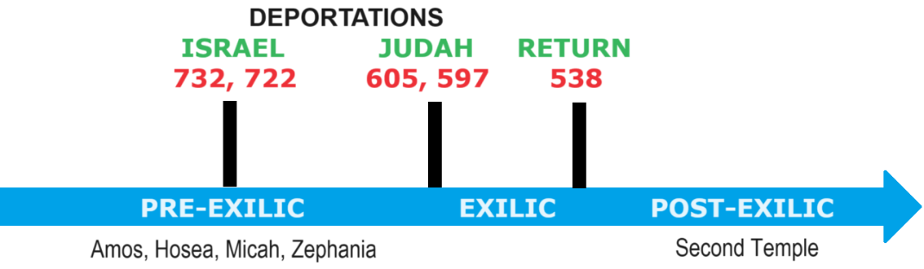

**Social sins in Israel and Judah**

● Land (farm) and home seizures (2)

● Violated inheritance laws (2)

● Haughty attitude (3)

● Suppress prophetic speech (6)

● Seize men’s clothing (8)

● Deprive women and children (9)

● Wind and lies (11)

● Promoted alcoholism (11)

**Poetic parallelism: ideas rhyme**

● Numerical: tell a number, then raise it.

‘six things he hates, yea seven he detests’.

● Synonymous: restate same idea.

‘Give ear to my lament; hear my complaint’.

● Antithetic: state a contrast.

‘The wicked lie; the righteous tell the truth’.

● Progressive: build on first line.

‘Like a tree, planted by a water stream’

**Micah 2:1** (Lexham English Bible 2012)

● Power: *El*, a name of God, implies legal ways in which to obtain wealth at others’ loss.

**Divine judgment**

● God discriminates right and wrong.

● By the criteria of his revealed laws.

● Pronouncing verdicts of weal or woe.

● God searches men’s motives.

● God weighs their actions.

● God avenges wrong.

● God rewards good.

● God forgives the repentant.

**Micah 2:2**

● Inheritance: Protected by divine law, debt must be cancelled every seven years, and property must be returned to owners or heirs every 50 years.

**Confiscation of property**

● Royalty: Royal (divine) privilege.

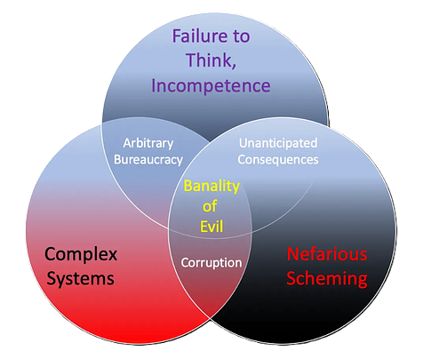● Communism: State ownership.

● Socialism: Government administration.

● Republic: Eminent domain.

● Democracy: Investors’ rights.

● Globalism: Official prerogative.

● Collapse: Gang violence.

**Banal evil in American society**

● Pervasive traffic in narcotics.

● Health-destroying food products.

● Debt slavery by excessive usury.

● Pornography and perversion.

● Homosexuality and transgenderism.

● Abortion, warfare and weapons.

● Financialized land and rental properties.

● Lawfare and excessive imprisonment.

**Micah 2:3**

● Family: Sinning Israelites/Judeans.

● Necks: Bound together with ropes.

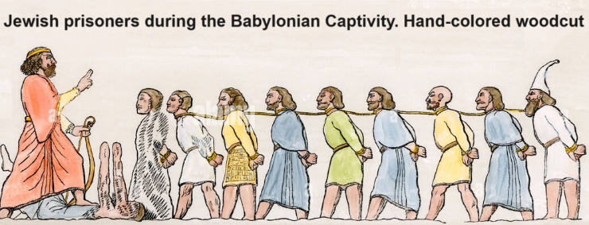

**Individuals & groups in Micah 2**

|  |  |
| --- | --- |
| ● Yahweh 3, 7, 13  ● King 13  ● Micah 8  ● Wicked 1, 2  ● Preacher 11  ● People, family, Jacob 3, 4, 7, 14 | ● Assembly 5, 12  ● Men 2, 8  ● Women 9  ● Children 9  ● Apostate 4  ● Remnant 12 |

**Micah 2:4**

● Field: Land, orchards, and herds.

● Apostate: One who serves other gods.

**Nebuchadnezzar II**

● Reigned Aug. 605 – Oct. 562 BC.

● Neo-Babylonian Empire.

● Sieged Jerusalem during 587-586 BC.

● Destroyed the Jerusalem temple.

**15 levels of authority**

|  |  |
| --- | --- |
| Occult  1. Yahweh: eternal purposes  2. King Messiah: end-time Ruler  3. Holy angels: do God’s will  4. The devil: ‘the god of this world’  5. Spiritual rulers & powers: ideas  6. Elite cabals and networks: agendas  7. Global financiers: confiscate wealth | Overt  8. Imperial powers: dictate to nations  9. Military forces: impose authority  10. Parliaments: legislate  11. Elected officials: execute  12. Bureaucracies: enforce policies  13. Courts: prosecute offenders  14. Police: capture suspects  15. Media: propaganda and censure |

**Micah 2:5-6**

● Lot: Set property lines by casting lots.

● Assembly: Greek OT has ekklesia = NT “church”. Here = Israel/Judah.

**Yahweh’s assembly**

● Eden: Yahweh, Spirits and Humans.

● Israel: Hebrew tribes in their land.

● Church: Messiah in believers’ midst (local, regional, worldwide, universal).

● Kingdom: Messiah ruling on earth.

● Eden: God, Messiah and the redeemed in the new heavens and new earth.

**Micah 2:7-13**

● Not: Rhetorical query expecting ‘yes’.

● Strip off: robbing fellow citizens.

● Returning from war: “with no thought about war” (ESV).

● Resting: Israel no longer a safe place to live and rear a family.

● Uncleanness: idolatry with immorality.

● Drink: Alcohol kills neurons, destroys families, crashes cars, hastens death.

● Tumult: future shouts of thanksgiving and rejoicing.

● Gate: Ishtar Gate, Babylon.

● King: Yahweh. The Davidic dynasty was not restored and will not be until Messiah rules.