**The Book of Micah**

**“Who is like Yah?”**

Chapter 3

**Micah 3:1-2a**

● Justice:

**False prophets named in the bible**

**Balaam** (Numbers 22-24): A prophet hired by Balak, king of Moab, to curse the Israelites. Instead, Balaam prophesied blessings upon them, despite his initial intentions.

**Zedekiah**, son of Chenaanah (1 Kings 22:11): A prophet who falsely prophesied the defeat of King Jehoshaphat and the destruction of Jerusalem.

**Hananiah** (Jeremiah 28): A false prophet who claimed that God would soon restore the Babylonian exile and allow the Jews to return to Jerusalem. Jeremiah, a true prophet, refuted Hananiah’s claims.

**Bar-Jesus** (Acts 13:6-12): A Jewish false prophet who opposed the spread of Christianity in Paphos. He was blinded by God as punishment for his deceit.

**Job’s friends** (Bildad, Eliphaz, and Zophar, Job 4-27): While not explicitly called false prophets, their words were misguided and unhelpful to Job, leading to a false understanding of God’s justice.

(1) Love good and hate evil.

(2) No favor to the rich or to the poor.

(3) Tempered with mercy.

**Political abuses in Micah 3**

● Hate the good and love the evil (2).

● Exploit (devour) people’s wealth (3).

● Pervert their actions (4).

● Revolt against biblical teaching (8).

● Hate justice, misuse law (9).

● Commit murder and other crimes (10).

● Judges who take bribes (11).

**Micah 3:2b-3**

● Metaphor? Or cannibalism in a seige?

**How to ‘eat’ others’ wealth**

● Direct & hidden taxes, fees, charges.

● Borrow fiat money, indebt the people.

● Bribes, kickbacks, favors, donations.

● Lending at excessive usuary rates.

● Exploitive housing, health & heat costs.

● Insider trading and selling ‘short’.

● Market manipulation (gold certificates).

**Micah 3:3-4**

● Time: Coming invasion and exile.

● Evil: Desire for power, privilege, money, revenge, respect, repression.

**When God will not answer prayer**

● Leaders who exploit their people.

● To spend it on our ‘lusts’.

● When he provided it, and we wasted it.

● Ask him to kill lost folk.

● Ask him to give life to Christ deniers.

● Ask for healing while self-poisoning.

● Pray in the name of a false god/dess.

**Micah 3:5**

● Pagan prophets were required to bless kings and approve their plans.

**Prophetic abuses in Micah 3**

● Mislead the people (5).

● Announce peace for a price (5).

● Announce war if not paid (5).

● Foretell the future for a salary (11).

● Leverage theological beliefs (11).

● Deny God’s immanent judgment (11).

**Micah 3:6-7**

● Vision: Foreseeing events.

● Secrets: Revealing hidden events.

● Prophet: Hears and repeats messages.

● Seer: Describes visions.

● Diviner: Interprets omens and signs.

**Pagan divination**

● Subjective guesses while peering into a cup of wine, or viewing viscera.

● Consult witches who call on spirits or ghosts of the dead.

● Receive thoughts while worshiping gods or making blood sacrifices.

● Drug-induced hallucinations.

**Micah 3:8**

● Micah may not have been a member of the prophets’ guild.

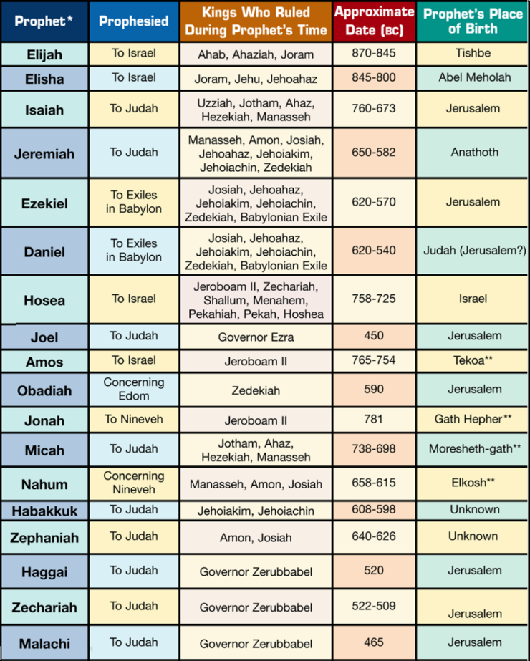**True OT prophets (Deut. 18)**

● Designated spokesmen of God.

● Receive messages from God.

● Meet criteria:

1) An Israelite.

2) Speaks in Yahweh’s name.

3) Conforms to earlier revelations.

4) Foretells the near future.

5) May perform a miraculous sign.

**How to prophesy, 1 Cor. 14:26-40**

● All may prophesy (31)

● Follow NT guidelines (37).

● Listen for a ‘revelation’ (30).

● Keep control of yourself (32-33).

● Await your turn (29-30).

● Build up and encourage (4, 26, 31).

● Let others evaluate (29).

**Micah 3:9-12**

● The prophets spoke to government.

● Power may not corrupt, but money certainly does.

● Plow: Overturn weeds to plant useful crops.

● High place: A pagan worship site.

|  |  |
| --- | --- |
| **Jerusalem was captured 22 times, including:**  586 BC Babylonians, Nebuchadnezzar II.  198 BC Seleucid Greeks, Antiochus III.  63 BC Romans, Pompei.  70 AD Romans, Titus.  1917 AD British, Edmund Allenby.  1967 AD Zionists, Moshe Dayan  2024 AD? Iranians? Pezeshkian? | **Temples in Jerusalem, completed**  1 The wilderness tabernacle. 13th cent BC  2 Solomon’s ‘first’ temple. c. 960 BC  3 Zerubbabel’s temple. 515 BC  4 Herod’s ‘second’ temple. AD 63  5 Jesus’ physical body. c. 2 BC – AD 33  6 Ezekiel’s millennial temple. AD 2030?  7 God himself in a new Jerusalem. 3033? |

**Paid or voluntary clergy**

|  |  |
| --- | --- |
| **Arguments for a paid clergy**  ● Allow them to serve full-time.  ● Reward for work done well.  ● Maintain performance standards.  ● Can be hired and fired.  ● Motivate the gifted into ministry.  ● Provide for their own retirement.  ● Honor God with members’ income. | **Arguments for a volunteer clergy**  ● Appoint the most gifted to office.  ● Appoint the highly motivated.  ● Share authority and opportunity.  ● They learn dependence on God.  ● This keeps new churches affordable.  ● Devote more to evangelism & mission.  ● Eliminate clergy-class privileges. |

**Historical development of paid clergy**

|  |  |
| --- | --- |
| **Early church (1st to 4th centuries)**  ● Fixed salaries for clergy did not exist.  ● Clergy sustained themselves.  ● Clergy often supported poor believers.  ● Itinerate preachers depended on gifts.  ● Clergy were recognized by their gifts, maturity      and generosity. | **Medieval church (5th to 15th cents)**  ● Emperor decreed duties & incomes.  ● State made land grants with tithes.  ● Bishops received land and privileges.  ● Church and state mutually supportive.  ● Clergy appointments were subject to approval     by both church and state. |
| **Post-reformation (16th onwards)**  ● Protestants rejected church hierarchies.  ● Coined ‘the priesthood of all believers’.  ● The clergy funded by gifts & offerings.  ● Coined the concept of a ‘living wage’.  ● Temporary use of gentry-owned land.  ● Clergy adopt a theological system. | **Modern (18th century to the present)**  ● Formal systems for paying clergy.  ● Standard salaries.  ● Paid by denominational funds.  ● Amounts vary by region & tradition.  ● Other benefits (housing & health).  ● Evangelicals paid by congregations. |
| **Recent (mid-20th century to the present)**  ● Rapid multiplication practices.  ● Volunteer evangelists & ‘shepherds’.  ● Believers give to meet urgent needs.  ● Movements are led by visionary clergy.  ● Sponsors subsidize trainers & coaches.  ● Reproductive leaders supported by    ‘upstream’  contributions. |  |