**The Book of Micah**

**“Who is like Yah?”**

Chapter 5

**Micah 5, Chiastic structure**

I. Jerusalem under siege. 5

II. A future Davidic ruler. 2-5a

III. Repulse & rule over Assyria. 5b-6

IV. A future, victorious remnant. 7-9

V. Coming loss with cleansing. 10-15

**Micah 5:1, Jerusalem under siege**

● Foretelling Babylonian attack.

● Contempt and impotence. Assyrian & Babylonian akitu festival.

**Babylonian captivity (BCE)**

605 Jehoiakim, tribute to Nebuchadnezzar II, Daniel.

597 Jehoiachin deposed, 1st major deportation.

594 Zedekiah’s anti-Babylonian conspiracy.

587 Siege and fall of Jerusalem. Temple destroyed.

583 Governor Gedaliah assassinated, flee to Egypt.

538 Decree of Cyrus allowed Jews to return.

515 Foundation of the Second Temple laid.

**Micah 5:2-5a, A future Davidic ruler**

● Rule: Contrast ‘ruler’ in verse 1.

● Origin: Assyrian kings claimed to be descended from or enthroned by gods.

● She: Isa. 7:14. Ahaz (r. 732-716).

● Return: Hezekiah’s revival (r. 716-687).

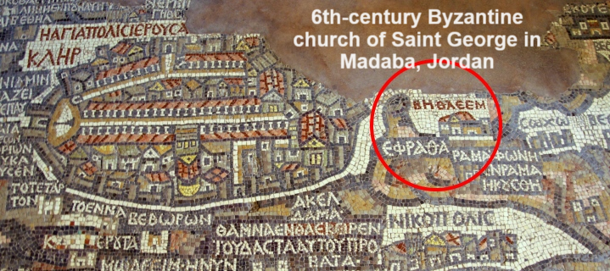

**King David (BCE)**

1035 David born in Bethlehem, Ephrata, Judah.

1025 Samuel anoints David as the future king.

1004 David captures Jerusalem from Jebusites.

993 David is anointed king of Judah at Hebron.

988 David moves to Jerusalem.

±970 Yahweh promises David a lineage forever.

963 David charges to build the Jerusalem temple.

953 David dies after 40-year reign.

**Micah 5:5b-6, Repulse & rule over Assyria**

● Assyrians: Territory occupied by Seleucid Greeks from 3rd century BC.

● Rulers: The Maccabees. 1 Mac 4:18-24.

● Nimrod: Went to Assyria, built Nineveh.

**Maccabean revolt, Book of 1 Macc (BCE)**

331 Alexander defeats Persian emperor Darius II.

312 Seleucus I Nicator founds a Greek empire across Mesopotamia, including Babylonia and Assyria.

167 Hellenizing Seleucid king Antiochus IV desecrates Jerusalem temple.

165 Judean Maccabees defeat Seleucid army.

164 Rededicate temple, restore Jewish worship.

160 Independent Jewish state, Hasmonean dynasty.

141 Parthian Mithridates I ends Seleucid empire.

**Micah 5:7-9, A future, victorious remnant**

● Remnant: Returnees from Babylonia.

● Peoples: Samaritans (mixed), Syrians (Greek), Romans (pagan).

● Hand: Messianic rule, Luke 1:71; 3:17.

● Cut off: Defeated, banished, killed or converted.

**Micah 5:10-15, Coming loss, followed by cleansing**

● That day: Deportation to Babylon.

● (1) Cut off: Loss of material defenses.

● (2) Cut off: Loss of spiritual defenses.

● Sacred: Religious ‘aids to worship’.

● Obey: Submit to Assyrian or Babylonian rule.

**Micah’s predictions** (chapter 5)

● Babylonian siege of Jerusalem.

● Judah’s & others’ Babylonian captivity.

● Return to Judah.

● Assyrian (Seleucid) invasion.

● Maccabean revolt & Hasmoneans.

● Messianic ruler from David’s lineage.

● Messiah’s rules over Judah’s enemies.

**Importance of Micah 5**

● Micah meets the qualification of a true prophet:   
    (1) his predictions come true, and (2) he speaks for Yahweh alone.

● Micah’ fulfilled predictions increase our expectation that his remaining ones will also be fulfilled.

● The biblical prophets deserve our study and our trust.