**MICAH 6**

THIRD DISCOURSE

**YAHWEH’S CASE AGAINST ISRAEL**

Yahweh’s covenantal lawsuit against those guilty of breaking His laws (e.g., Isa 3:13; Jer 2:9; Hos 4:1).

**1 Hear what the LORD says: Arise, plead your case before the mountains,  
and let the hills hear your voice.**

Case = riv = quarrel. Mountains and hills = Major and minor political powers? Where gods dwell. Micah 4:1

Deuteronomy 12:2 “You shall utterly destroy all the places where the nations whom you shall dispossess serve their gods, on the high mountains and on the hills.”

**2 Hear, you mountains, the indictment of the LORD,  
and you enduring foundations of the earth,**

Foundations = permanence and stability… shaken. Related to the gods Psalm 82:5.

Court case of covenant (contract) violation. Deut. 4:25-26,“If you act corruptly by making an idol in the form of anything, thus doing what is evil in the sight of the LORD your God and provoking him to anger, I call heaven and earth to witness against you today that you will soon utterly perish from the land. In pagan covenants, the gods were called as witnesses, sometimes creation.

**for the LORD has an indictment against his people,  
and he will contend with Israel.**

They remain his people.

**YAHWEH’S KINDNESS TO ISRAEL**

**3 “O my people, what have I done to you?   
How have I wearied you? Answer me!**

Some leave the faith when bored with meaningless blather, religious ritual, or nothing worth defending.

**4 For I brought you up from the land of Egypt   
and redeemed you from the house of slavery,  
and I sent before you Moses, Aaron, and Miriam.**

Moses = Prophetic leader; Aaron = prophetic priest; Miriam = prophetic musician.

**5 O my people, remember what Balak king of Moab devised,  
and what Balaam the son of Beor answered him,  
and what happened from Shittim to Gilgal,   
that you may know the righteous acts of the LORD.”**

Num 22:6 “Come now, curse this people for me, since they are stronger than I; perhaps I shall be able to defeat them and drive them from the land, for I know that whomever you bless is blessed, and whomever you curse is cursed.”

24:13 'Though Balak were to give me his house full of silver and gold, I could not do anything contrary to the command of the LORD, either good or bad, of my own accord. What the LORD speaks, that I will speak'

In 1967, a Dutch archaeological expedition, led by H. J. Franken, discovered some inscribed pieces of plaster at a site in Jordan known as Deir ’Allah. Apparently written in Aramaic, the fragments date to about 850 B.C., and they mention Balaam son of Beor, the same figure described as a “seer” in Numbers 22–24 … It can be established that (1) Balaam was a seer, (2) he received a divine message during the night, and (3) his message was not what his neighbors expected to hear.

**Shittim** (Num 33:49 Joshua’s spies and for the Israelites’ entrance into Canaan (Josh 2:1; 3:1… **Gilgal** was the place where the Israelites miraculously crossed the Jordan and established a base camp from which to begin the conquest.

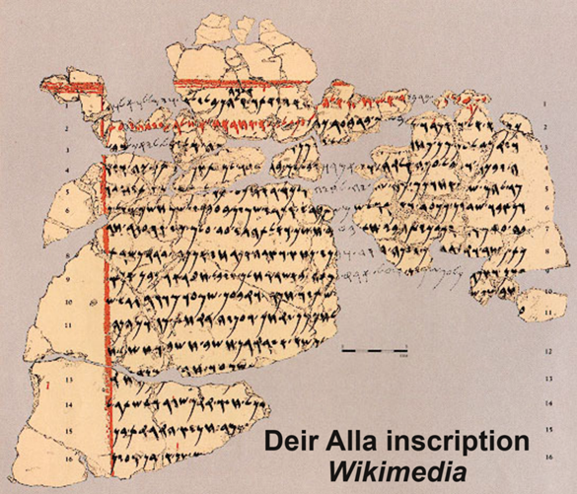

**PROPER WORSHIP OF YAHWEH**

**Query**

**6 “With what shall I come before the LORD,  
and bow myself before God on high?**

**Shall I come before him with burnt offerings,   
with calves a year old?**

Year old=valuable, invested food & care, but no return yet. Thus sacrifice = loss.

1 Sam 15:22 “Surely, to obey is better than sacrifice.”

**7 Will the LORD be pleased with thousands of rams,   
with ten thousands of rivers of oil?**

**Shall I give my firstborn for my transgression,   
the fruit of my body for the sin of my soul?”**

“Texts from Phoenician and Punic colonies, like Carthage in North Africa, describe the ritual of child sacrifice as a means of insuring continued fertility.”

One notable piece of epigraphical evidence for child sacrifice in ancient Phoenicia comes from the stelae found at tophet sites. These stelae often contain inscriptions dedicated to the gods, such as Baal Hammon and Tanit. An example of such an inscription reads: “To the lady Tanit, face of Baal, and to the lord Baal Hammon, that which was vowed (by) PN son of PN, because he heard his voice and blessed him.” These inscriptions typically accompany urns containing the cremated remains of children, indicating that the sacrifices were made in fulfillment of vows to the gods.

American analogues: Convenience and anger abortions. Satanists infanticide rites. Child mutilation.

YHWH claimed all 1st-born for himself, requiring Israelites to redeem them. Exo 13:1-2

**Reply**

**8 He has told you, O man, what is good;   
and what does the LORD require of you**

**but to do justice, and to love kindness,  
and to walk humbly with your God?**

**Justice** = legal protection; love [**loyalty**] = keep promises.

**Chesed**. covenant obligation. David asks Jonathan to show chesed to him because they made a covenant together (1 Sam 20:8); later, David later shows chesed to Jonathan’s son Mephibosheth (2 Sam 9:7).

God’s chesed is an essential part of His character. A characteristic God desires in His people.

2 Chron. 5:13. Ezra 3:11; כִּ֣י טֹ֔וב כִּֽי־לְעוֹלָ֥ם חַסְדֹּ֖ו Ki tôv Ki le’ôlam khesedô. “For (he is) good! For his-loyalty (endures) forever!” «Kee baax. Kee gore ba fàww ci Israayil.» The NT analogue to chesed = pistis, faithfulness, loyal trust.

**Humbly.** Hapax legomenon. tsenan = strengthen; construct; fortify; keep safe. Hiphil: to be caused to be… Proposals: reasonable, careful, cautious; attentive, deliberate, reasonable. “likely indicates carefulness or thoughtfulness.

**YAHWEH’S ACCUSATION AGAINST INDIVIDUALS**

**9 The voice of the LORD cries to the city—  
and it is sound wisdom to fear your name:**

Amos and Hosea spoke to Samaria, Micah about Samaria.

Honor who he is.

Micah prophesied 750-686. Samaria fell in 722/21. Jerusalem fell 686.

**“Hear of the rod and of him who appointed it!**

**10 Can I forget any longer the treasures of wickedness in the house of the wicked,  
and the scant measure that is accursed?**

**11 Shall I acquit the man with wicked scales and with a bag of deceitful weights?**

In times of war or siege, profiteers raised prices on survival goods.

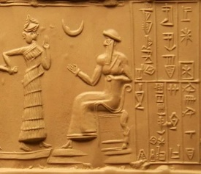Law code of the Ur III king Ur-Nammu (c. 2112 BC – 2094 BC). "If a man uses false weights, he shall pay a fine of 15 shekels of silver."

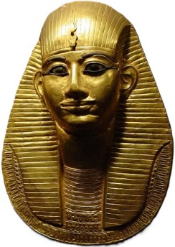Egyptian Instruction of Amenemope (1001–992 BC or 993–984 BC). “Do not move the scales nor alter the weights, nor diminish the fractions of the measure.”

**YAHWEH’S ACCUSATION AGAINST THE RICH**

**12 Your rich men are full of violence; your inhabitants speak lies,  
and their tongue is deceitful in their mouth.**

**13 Therefore I strike you with a grievous blow,  
making you desolate because of your sins.**

**14 You shall eat, but not be satisfied,  
and there shall be hunger within you;**

**you shall put away, but not preserve,  
and what you preserve I will give to the sword.**

**15 You shall sow, but not reap;   
you shall tread olives, but not anoint yourselves with oil;   
you shall tread grapes, but not drink wine.**

A “futility” curse = threatening lack of success in a course of action.

**16 For you have kept the statutes of Omri, and all the works of the house of Ahab; and you have walked in their counsels,   
that I may make you a desolation, and your inhabitants a hissing;   
so you shall bear the scorn of my people.”**

Omri (885– 874 BC) and Ahab (874–853 BC) also serve as labels for monarchs guilty of idolatry.Omri… the Mesha Stele and the Black Obelisk of Shalmaneser III also mention his name. Wikipedia

The existence of Ahab is historically supported outside the Bible. Shalmaneser III of Assyria documented in 853 BC that he defeated an alliance of a dozen kings in the Battle of Qarqar; one of these was Ahab. He is also mentioned on the inscriptions of the Mesha Stele. *Wikipedia*