**MICAH 7 NOTES**

**Micah 7 chiastic structure**

A Food insecurity 1

B Personal insecurity 2

C A failed state 3-4

D Social disintegration 5-6

🡺 Personal spirituality 7

d Anticipated change 8-10

c Promised renewal 11-13

b Future peace 14-17

a Future worship 18-20

**Micah 7:1. Food insecurity.**

|  |  |
| --- | --- |
|  |  |
| *https://www.lavia.org/english/Archivo/GezerEN.html* | |

“The gathering of summer fruit was the last harvest of the year, taking place in late August and September.   
This would be the second crop of figs (the first ripening in June), and this fruit would be dried for consumption through the winter months (see Is 16:9; Jer 48:32). Once it had been harvested and the gleaners had taken all that remained, no further fruit could be expected for many months” (*IVPbbc*).

● What are you doing to prepare for a year of food shortages?

**Micah 7:2. Personal insecurity.**

Fowling and fishing were the common man’s form of hunting since they required only nets and traps.

● What do you believe about personal and family security?

● What are you doing now about it?

**Micah 7:3-4. A failed state.**

● What four evils mark a failed state ?

● What are some current failed states?

● Watchmen? Punishment? Confusion is at hand?

**Micah 7:5-6. Social disintegration.**

What information must folk keep secret during times of social breakdown, or of governmental tyranny?

● Fungible assets?

● Food stores and gardens?

● Mutual-help networks?

● Libraries of books and media?

● Self-defense tools?

**Micah 7:7. Personal spirituality.**

● Isolate three actions.

● Describe each action with activities.

● What does ‘salvation’ mean in context?

**Micah 7:8-10. Anticipation of change.**

● Enemy: grammatically feminine noun.

● Three points for a lesson or sermon.

● Describe darkness and light.

● What will happen to our enemies?

**He pleads my cause**

1. I pledged my loyalty (faith) to Jesus.

2. I want to live right, pleasing him.

3. I often desire/lust to please myself.

4. I sometimes succumb to temptation.

5. I then feel guilt/shame, embarrassment.

6. Others are indignant at me.

7. I finally confess my sin to God.

8. I make restitution or admit wrong.

9. Jesus pleads my cause by his blood.

10. God forgives me and restores my joy.

11. I resolve never to do that again.

12. I return to the work that he gives me.

**Micah 7:11-13. Promised reconstruction.**

● Walls: Decreed by Persian king Artaxerxes I in 445 BC

● Boundary: Returnees repopulate Judah.

● Assyria: Absorbed by Persia in 539.

**Micah 7:14-17. Future peace.**

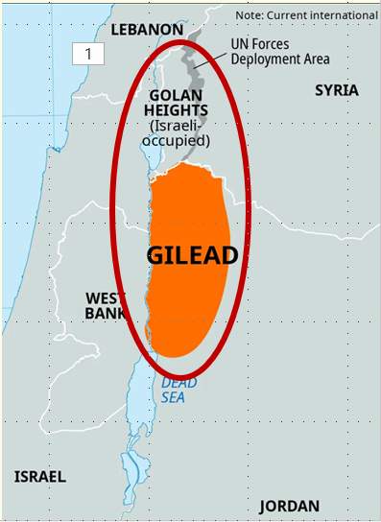

**Jesus:** “this gospel of the kingdom will be proclaimed throughout the whole world as a testimony to all nations, and then the end will come” (Mt 24.14).

**Micah 7:18-20. Future worship.**

● Remnant: Survivors and their children.

● Delights: Many human actions please God, one thing gives him joy…

● Love: *ḥesed* = covenant loyalty.

● Sworn: Yahweh’s permanent covenant.