**Epistle of Paul to Titus**

Introduction and Chapter 1

See [www.powellhurstmen.website](http://www.powellhurstmen.website) to view short videos and to read summary documents on Titus.

**History of Crete Island**

Century BC

5 Pirate city-states

4 War between city-states

3 Hellenization by Madedon & Rhodes

2 Rise of Ierapetra

1 Roman wars and annexation

Century AD

1 Christian mission

**Paul’s mission to Crete**

**Eusebius** (3rd cent. AD): “Second imprisonment … wrote second epistle to Timothy…”  *Ecclesiastical History*, 2:22:2

**Hypothesis**: Following his first imprisonment in Rome, Paul went to Spain and to Crete, between AD 62 and 66, with Titus as his coworker.



**Titus**

Accompanied Paul to Jerusalem (Gal. 2:1-3). Paul sent him to Corinth (2 Cor. 7:13, 8:23, 2 Tim. 4.10), later to Dalmatia.

● A ‘Greek, he resisted circumcision when under pressure from Judaizers.

● A ‘brother’, ‘child’, partner, coworker, and of a ‘same spirit’ to Paul.

● Marked by ‘joy’ and ‘earnest care’.

**Is this epistle pseudepigrapha?**

Do differences between Paul’s general epistles and the pastorals imply forgery?

● Existing pseudepigrapha do not include ‘apostolic’ epistles.

● The early churches recognized the pastorals as authentic.

● They are personal and more technical.

● They may be written by amanuensis.

**Titus: Christian ministry in an undisciplined society**

Chapter 1. CHRISTIAN MINISTRY.

1. Ministry message, 1:1-4

2. Ministry task, 1:5

3. Ministry qualifications, 1:6-9

4. Ministry challenge, 1:10-16

Chapter 2. CHRISTIAN PRESENCE.

Chapter 3. CHRISTIAN IDENTITY.

**Titus 1:1 (NIV), Our message**

**1** Paul, a servant of God and an apostle of Jesus Christ to further the faith of God’s elect and their knowledge of the truth that leads to godliness —

● Servant: Love servant, Deut 15:16-17.

● Apostle: Envoy sent with authority.

● Elect: Chosen to receive life.

● Godliness: Deep respect for deity.

**Titus 1:2, Our message**

**2** in the hope of eternal life, which God, who does not lie, promised before the beginning of time, …

● Hope: Promise 🡺 expectation.

● Eternal: ‘Of the (coming) age’

● Promised: Where in the Hebrew Bible?

● Before: Lit., ‘before eternal ages’.

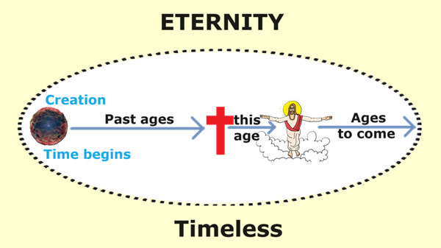

**Titus 1:3**

**3** and which now at his appointed season he has brought to light through the preaching entrusted   
to me by the command of God our Savior, …

● Season: Lit., ‘own times’. (Whose?)

● Preaching: Public declaration (sermon?)

● Entrust: Assumes loyal faith (*pistis*).

● Command: Fake apostles self-appoint.

**Titus 1:4**

**4** To Titus, my true son in our common faith: Grace and peace from God the Father and Christ Jesus   
our Savior.

● True son: Commonly-used title for aa teacher’s disciples.

● Common: Shared (koinos).

● Grace: Kindness that empowers.

● Peace: Harmonious relations.

**Titus 1:5, Our task = to empower others**

**5** The reason I left you in Crete was that you might put in order what was left unfinished and appoint elders in every town, as I directed you.

● Order: To straighten, to correct.

● Appoint: ‘Put’ into a position or task. Neither hire nor elect.

● Elder: ‘Older’. Official.

● Town: No central authority (yet).

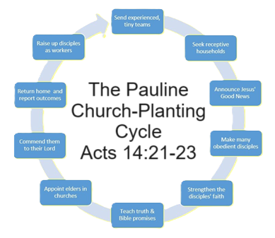

1 Announce Gospel in several places.

2 Make disciples (quickly).

3 Return to each place repeatedly.

4 Strengthen the disciples’ faith. [🡸 The work had halted here. Typical in congregations.]

5 Appoint elders.

6 Pray to commit them to the Lord.

7 Go do the same elsewhere.

**Titus 1:6, domestic qualifications**

**6** An elder must be blameless, faithful to his wife, a man whose children believe and are not open to the charge of being wild and disobedient.

● Blameless: Perfect? Then what?

● Faithful: ‘Man of one woman’.

● Whose: ‘Having children who...’

● Charge: Accused, accusable.

**Titus 1:7, ethical qualifications**

**7** Since an overseer manages God’s household, he must be blameless — not overbearing, not quick-tempered, not given to drunkenness, not violent, not pursuing dishonest gain.

● Overseer: *Episkopos*, ‘overseer’.

● Manages: *Oikonomon*, ‘steward’.

● Drunken: Folk normally drank 2 parts water to 1 part wine at normal fermentation.

**Titus 1:8, personal qualifications**

**8** Rather, he must be hospitable, one who loves what is good, who is self-controlled, upright,   
holy and disciplined.

● Hospitable: Care for the needy.

● Self-controlled: Wise minded. (ideas)

● Upright: Law abiding. (limits)

● Holy: God fearing. (faith)

● Disciplined: Inner strength. (appetites)

**Titus 1:9, doctrinal qualifications**

**9** He must hold firmly to the trustworthy message as it has been taught, so that he can encourage others by sound doctrine and refute those who oppose it.

● Taught: Noun: content from Jesus.

● Encourage: ‘Invite’ folk to embrace reality.

● Sound: Correct, free from error.

● Doctrine: As transmitted by Jesus’ apostles.

**Titus 1:10-11, protect house-churches**

**10** For there are many rebellious people, full of meaningless talk and deception, especially those of the circumcision group. **11** They must be silenced, because they are disrupting whole households [house-churches] by teaching things they ought not to teach—and that for the sake of dishonest gain.

**Titus 1:12, Epimenides**

**12** One of Crete’s own prophets has said it: “Cretans are always liars, evil brutes, lazy gluttons.”

**Epimenides** (7th or 6th century BCE) in his work titled Cretica, quoted in Callimachus’ *Hymn to Zeus*.   
The Cretan lie was to teach that Zeus was mortal.

**Titus 1:13-14 Rebuke them**

**13** This saying is true. Therefore rebuke them sharply, so that they will be sound in the faith **14** and will pay no attention to Jewish myths or to the merely human commands of those who reject the truth.

● Hellenistic Jews were prolific writers, expanding on biblical accounts. The Book of Enoch is even quoted in the NT.

**Titus 1:15, the pure**

**15** To the pure, all things are pure, but to those who are corrupted and do not believe, nothing is pure. In fact, both their minds and consciences are corrupted.

● Pure: Baptized, forgiven believers.

● Corrupted: Non-believers who pretend to abide by rules.

**Titus 1:16, those who are unfit for doing good**

**16** They claim to know God, but by their actions they deny him.   
They are detestable, disobedient and unfit for doing anything good.

● Detestable: Justify the wicked. Pro. 17:15

● Disobedient: To Jesus’ commands.

● Unfit: *adokimos*. Failed the test.