**PAUL’S EPISTLE TO TITUS**

CHAPTER 3

12 September 2024

**Titus: Ministry in an undisciplined society**

Chapter 1. CHRISTIAN MINISTRY.

Chapter 2. CHRISTIAN PRESENCE.

Chapter 3. CHRISTIAN IDENTITY.

I. Submissive and gentle. 1-2

II. Repentant and converted. 3-5

III. Holy Spirit and hope. 6-7

IV. Faith and good works. 8

V. Unity and leadership. 9-10

**Titus: Submissive to rulers**

**1** Remind them to be submissive to rulers and authorities, to be obedient, to be ready for every good work, **2** to speak evil of no one, to avoid quarrelling, to be gentle, and to show perfect courtesy towards all people. *ESV*

● Submissive: Voluntary, as in 2:5, 9.

● All people: Including whom?

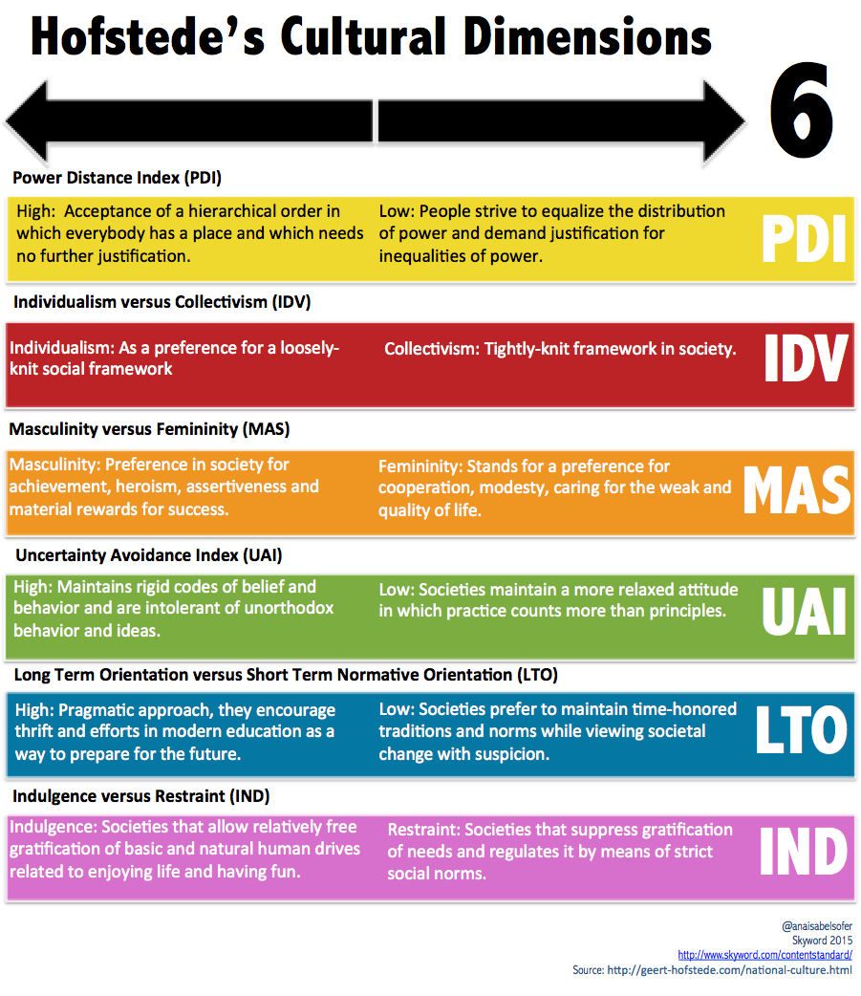

**Biblical submission**

● God is the ultimate authority and ruler.

● God operates through hierarchies.

● God steers legitimate authorities.

● God condemns abusive authorities.

● God is able to distract authorities.

● Christians pray to God for authorities.

● Only submit to legitimate authority.

● Flee from abusive, unjust authorities.

**Cultural ‘dimensions’** (Hofstede)

● Power distance: inequality.

● Individualism – collectivism.

● Uncertainty avoidance.

● masculinity – femininity.

**Leadership ‘styles’**

● Autocratic: Command and control.

● Passive: Trust others to perform.

● Participative: Listen to others first.

● Bureaucratic: All adhere to rules.

**Titus: Our past**

**3** For we ourselves were once foolish, disobedient, led astray, slaves to various passions and pleasures, passing our days in malice and envy, hated by others and hating one another.

● Query: So what? Why mention this?

● Query: What are some common addictions which Jesus breaks?

**Titus: He saved us**

**4** But when the goodness and loving kindness of God our Savior appeared, **5a** he saved us,   
not because of works done by us in righteousness, but according to his own mercy, …

● Query: Goodness? Loving kindness? (hendiadys)

● Query: Who is our Savior?

**Titus: Saved**

We have been saved: results, Eph 2:8.

We were saved: a past event, Rom 8:24.

We are saved: present state, 1Cor 15:2.

We are being saved: continuing, 1Cor 1:18.

We will be saved: yet to come, Rom 5:9.

● Query: Saved from what?

● Query: Saved unto what?

● Query: Saved for what?

**Titus: Regeneration**

**5b** by the washing of regeneration and renewal of the Holy Spirit, **6** whom he poured out on us richly through Jesus Christ our Savior, …

● Query: What washing regenerates and renews? Acts 22:16 with 1 Peter 3:21.

● Query: Who is our Savior?

**Titus: Justification**

**7** so that being justified by his grace we might become heirs according to the hope of eternal life.

● Justified: Declared righteous.

● Grace: Sovereign love.

● Heirs: Unearned gift.

● Hope: Lively expectation.

● Eternal: Endless perpetuity.

**Titus: Good works**

**8** The saying is trustworthy, and I want you to insist on these things, so that those who have believed in God may be careful to devote themselves to good works. These things are excellent and profitable for people.

● Query: What are ‘good works’.

● Query: How do faith and works relate?

**Titus: Foolish controversies**

**9** But avoid foolish controversies, genealogies, dissensions, and quarrels about the law,   
for they are unprofitable and worthless.

● Foolish: What does this mean?

● Avoid: Continuous, middle voice verb.

● Law: *nomikos* = ‘legal’, ‘lawyer’.

**Titus: Warped and sinful**

**10** As for a person who stirs up division, after warning him once and then twice, have nothing more to do with him, **11** knowing that such a person is warped and sinful; he is self-condemned.

● Division: *hairetikos* = schismatic.

● Condemned: Disqualified for eldership.

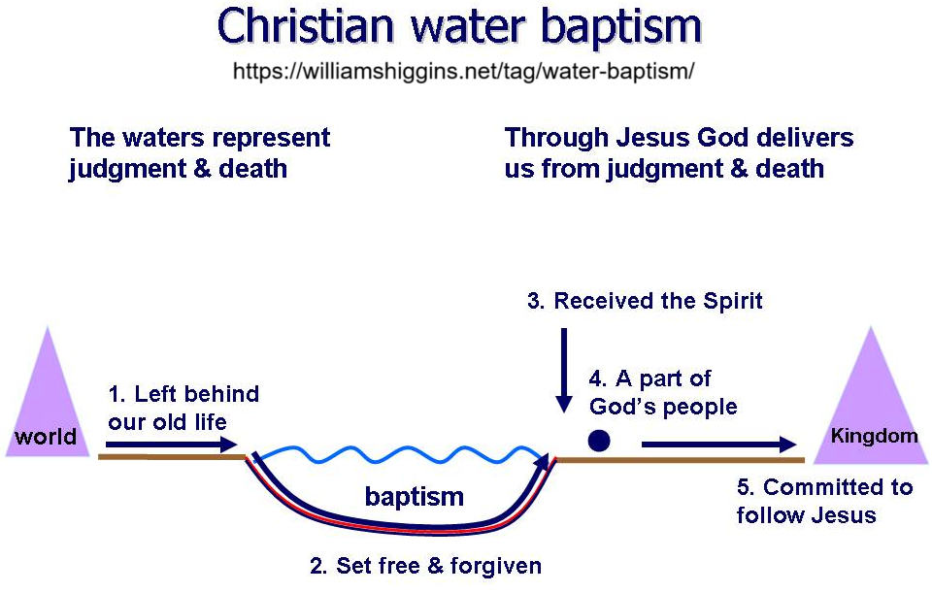**Major (incomplete) views on baptism**

● Catholic: Regenerates by removing   
    original sin.

● Lutheran: Regenerates by forgiving   
    sin and granting faith.

● Baptist: Symbolic act by believers.

● Reformed: Confers grace and seals.

● Orthodox: Symbolic death and  
    resurrection: enter the Kingdom.

**Galen’s current view of baptism**

● Symbolic (reenactment): Jesus’ death   
   and resurrection.

● Conscious: For those who repent.

● Effective: Unites with Christ (much as a wedding effects real marriage.)

● Prayer: Requests a clear conscience.

● Entrance: Membership in the church.

● Testimony: Before God, angels, and humans, though not always in public.

**Titus: Zenas and Apollos**

**12** When I send Artemas or Tychicus to you, do your best to come to me at Nicopolis, for I have decided to spend the winter there. **13** Do your best to speed Zenas the lawyer and Apollos on their way; see that they lack nothing.

● Lawyer: Romans law? Or Torah law?

● Apollos: What was his ministry work?

**Titus: More good works**

**14** And let our people learn to devote themselves to good works, so as to help cases of urgent need, and not be unfruitful. **15** All who are with me send greetings to you. Greet those who love us in the faith. Grace be with you all.