A TRACKING TOOL FOR NEW CHURCH PLANTS
Three-day workshop held at
Kolhapur, Maharashtra
October 28-30, 2013

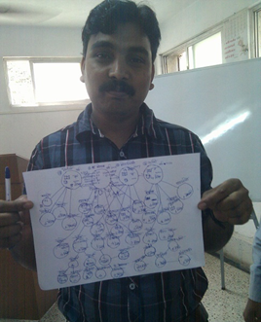

Sponsored by
e3 Partners

Animated by
Galen Currah
galen@currah.us

Corrected September 5, 2014
Pastor Gireesh Nedungadi invited about 18 church planters from his ministry network. These met for two full days, employing highly-interactive bible-discovery methods, discussions and simulations. They were joined a third day by about 12 representatives of pastor coalitions from different districts of the state.
MOSES’ MENTORSHIP & TRACKING
Participants enacted the story of Jethro and Moses, charting out the relations between Moses, the 70 elders, and the chiefs of 1000, 100, 50 and ten households. This structure allowed important issues to be reported up their supervisory line, and timely answers to come back down the line, informing their entire nation.
JESUS’ MENTORSHIP & TRACKING
Small groups conducted a discovery bible study on the mentorship methods of Jesus from Mt 9:35-10:13; Mark 6:7-12 & 30, Luke 9:1-6 & 10; Luke 10:1-9 & 17. The groups reported several observations, including these:
* Jesus appointing and empowering workers.
* These were to praying for more labourers (“the resources come from the harvest”).
* Jesus planned with them their methods, where to go, what to do, what to say.
* Jesus listening to reports & stories from workers, related to their agreed plans.
The participants practiced, in pairs, parts of a seven-step coaching method, done in any order:
- Pray for wisdom to take next steps.
- Listen to reports, stories, and opportunities. (Fill in a tracking form.)
- Agree on a plan for each worker’s next steps.
- Assign bible readings and practical guidelines related to their agreed plan.
- Review previous assignments, listening to workers tell what they learned.
- Provide instructions and practice together any new skills.
- Intercede for their work, for their churches and their new labourers.
THE APOSTLES’ MENTORSHIP & TRACKING
Small groups held a discovery bible study, to find ways in which the apostles would track and report the outcomes of their ministries, from:
- Acts 2.41-42; 6.1; 12.14; 2 Cor 10.15-16
- Acts 2.47; 6.7; 13.48-49; Matt 28:29-20
- Acts 1.8; 5.14; 9.31; 19.20
- Acts 11.24; 16.5; Rom 16.8-10; Rev 5.9
Participants noted how the apostles reported on: baptisms, disciples added, increasing or multiplying, the same for churches, reaching which social classes, cities and regions, and approximate dates. This bible study, several noted later, convinced them that tracking was a biblical and helpful part of a church-planting ministry.
Small groups held a discovery bible study from Acts 2 on ways in which the primitive church expressed their obedience to commandments of Jesus, of which some 21 are reported in practice in these verses. Participants noted several commandments related to three phases of a church plant:
- Acts 2:38-41 on evangelism steps
- Acts 2:42-43 on disciple-making
- Acts 2:44-47 on basic church life
- Acts 2:47. These verses can provide a kind of check list on elements of a church plant.
PAUL’ MENTORSHIP & TRACKING
After reviewing the three generations of Paul’s mentorship from 2 Timothy 2:1-2, participants enacted the story of the Epistle to the Colossians, identifying places (Ephesus, Colossae, Laodicea and Hierapolis) and laborers’ names of (Paul, Timothy, Epaphras, Archippus, Nympha and others). They noted how timely reporting up the coaching line led to timely instruction coming down the line in the form of this epistle, which went to several workers and congregations.

TOWARDS A CHURCH-PLANT TRACKING TOOL
The participants; evening assignment was to diagram generational relations between their churches and cell with trainers and apprentice shepherds. See on the following pages the model that emerged during this workshop. It borrows heavily from existing tools of forgotten origins.
Next day, each one presented a map that s/he had drawn, showing generations of churches and house groups s/he had planted, along with activities that each gathering practiced, numerical statistics on attenders, baptisms, children and losses, and any current shepherds. Photos were taken each one with his map.
From those maps, each one constructed a table into which they transported the same data in a form suitable for entry into a computer spreadsheet or a database. Next, they projected, on their maps, communities to be penetrated and churches yet to be started.

OTHER SUBJECTS OF INTEREST
Participants noted how to indicate gatherings that have dissolved or defected, as well as shepherds that have quit or defected. There was some discussion on how to deal with wolves who buy away shepherds and churches.
Participants reviewed twelve practices that normally lead to church reproduction. Some diagrams and observations on how churches reproduce most rapidly by starting tiny groups that double quickly in size, as opposed to big groups and congregations that double more slowly because of losses.
In reply to queries, we reviewed the origin of five basic pastoral duties that can lead to five fears regarding church reproduction: doctrine, unity, control, finances and persecution. The one solution to the first four of these remains the same: mentorship chains that ensure timely reporting and help.
There was also a friendly discussion of how e3 Partners operates and of its information needs as an active sponsor of these expanding ministry coalitions.
Pastor Nedungadi led a final session in which attenders agreed they should implement tracking of their ministry outcomes. Following this workshop, Nedungadi wrote to say that he and some of the participants have meet to refine this model tracking tool and to design others that meet their recognized informational needs.

CHURCH AND CELL REPORT MAP
When you meet with church planters or with shepherds of new churches, help them draw a simple map of their churches and cells, along with those churches’ activities.
Have them draw circles on paper. Each circle represents a church or a cell. Connect the circles with lines, showing mother churches with their daughter and grand-daughter churches. For example:
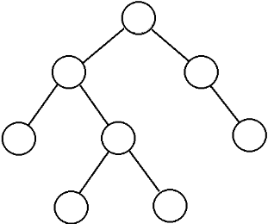

Above each circle, write the name of the place where the church or cell meets, and write the year in which the church or cell began to meet. Beneath each circle, draw symbols that show the kinds of activities that a church or cell has begun to practice. These symbols may look like these:
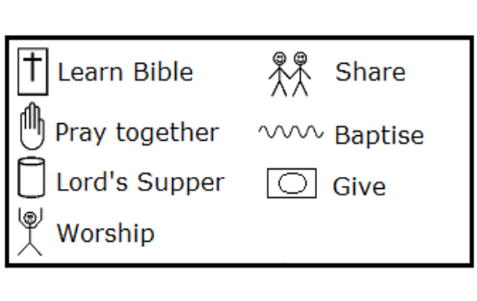
If a shepherd has been appointed in a church or cell, then draw a stick-man beside the circle, and write the shepherd’s name near the stick-man. For example:
Inside each circle, write numbers that show how many persons are in the church or cell.
A = Number of adult attenders
B = Number of baptised believers
C = Number of children and youth
D – Number of those who have died or departed from the church or cell
Beside each circle, write how many generations from the mother church or cell: 1, 2, 3 and so forth.
A complete church or cell drawing might look like this:
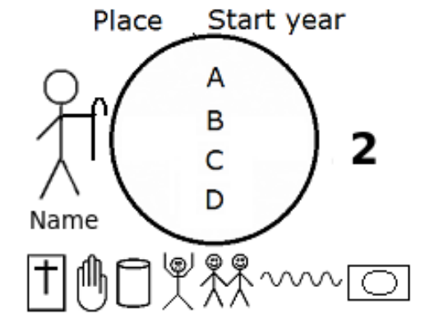
Afterwards, transfer all this information to a report form like the one on the following page.
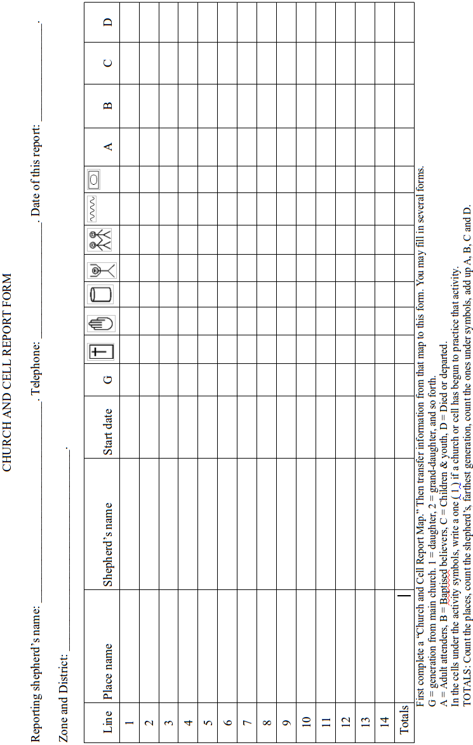
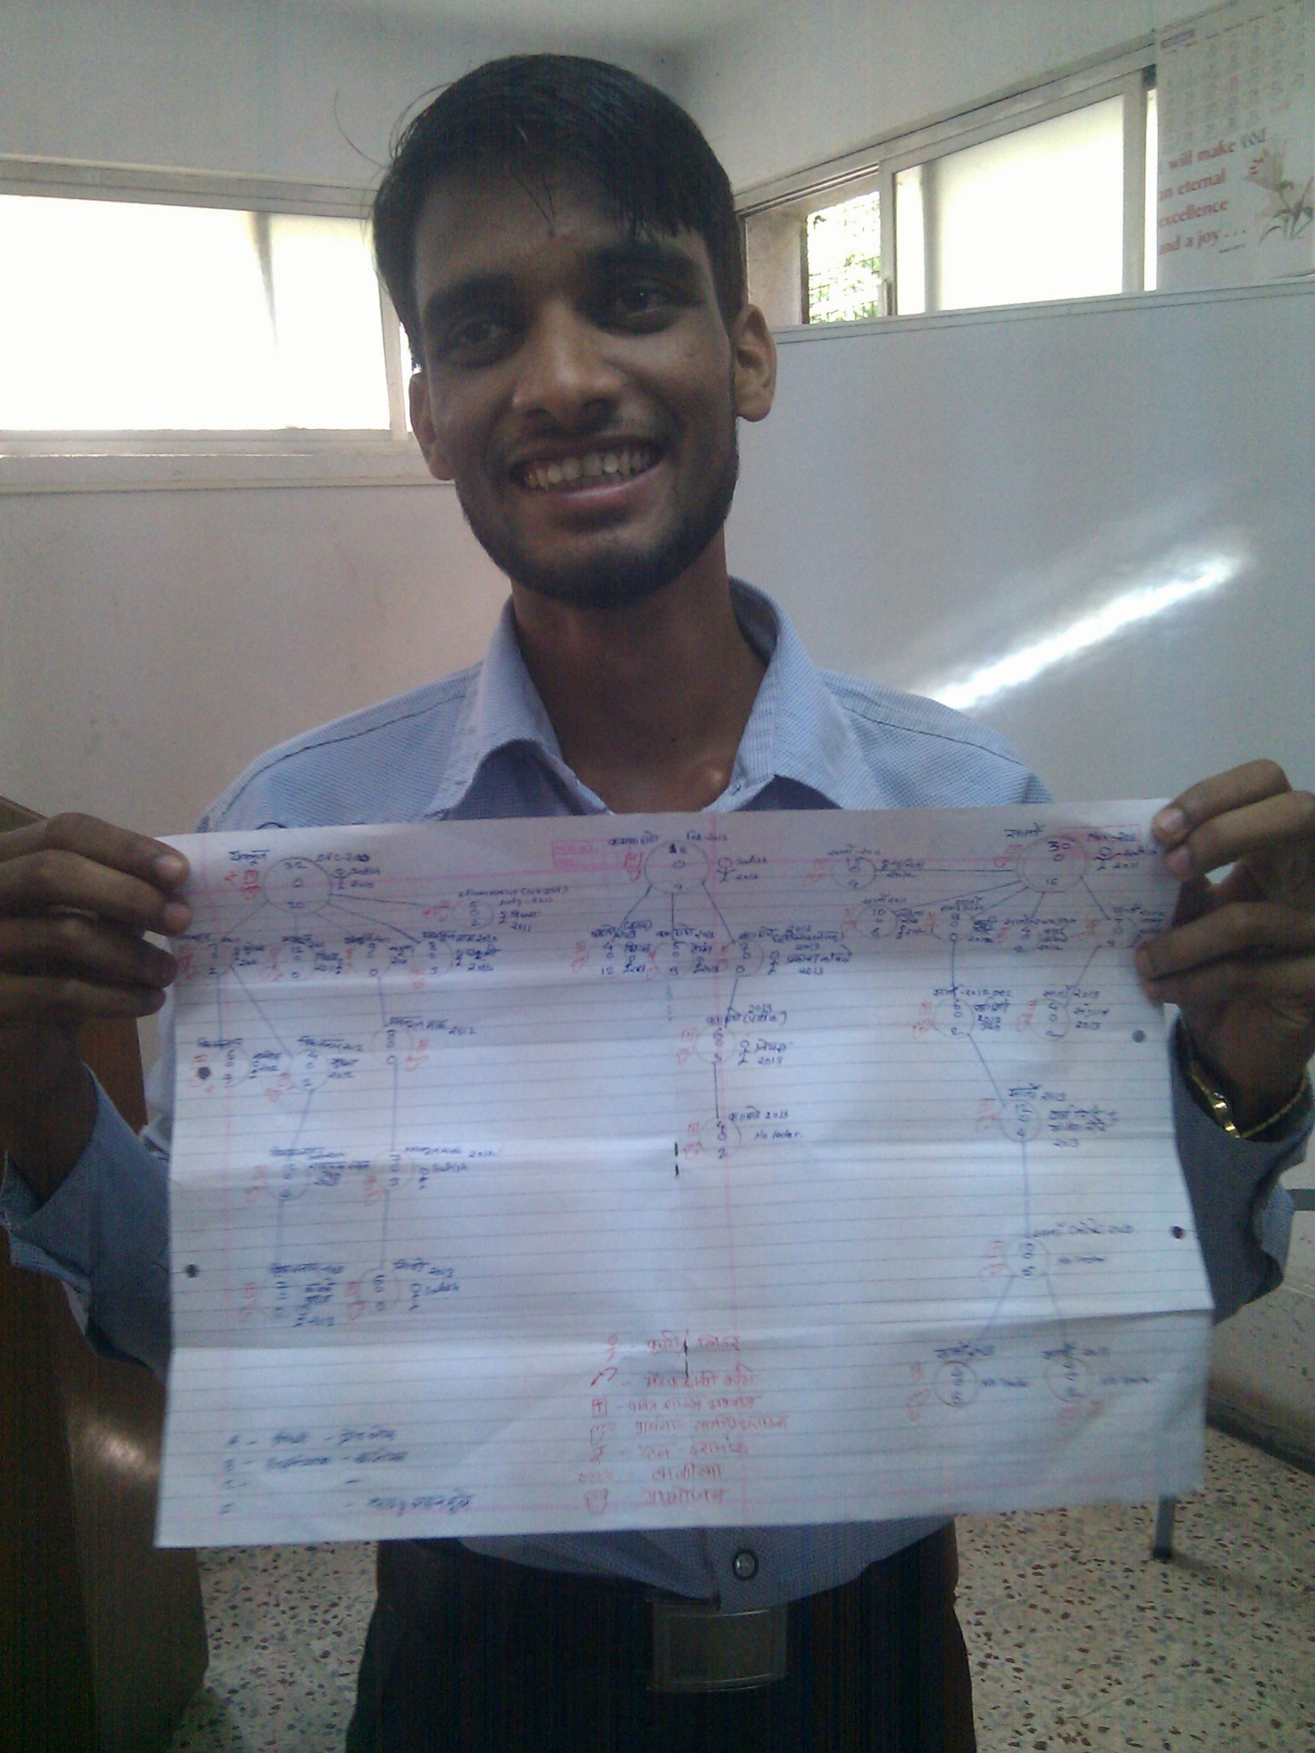
A five-generation church-planting map from a district in Maharashtra State, India
October 29, 2013

