A MODEL WORKSHOP ON
TEN PRACTICES THAT FACILITATE REPRODUCTIVE DISCIPLE-MAKING
Patrick O’Connor and Galen Curah, 15 August 2016
OBJECTIVE
Participants lay plans to model reproducible methods in every facet of making disciples.
OUTCOME
Local workers implement methods that reproduce new believers, disciples, cells and leaders.
KEY TEXTS
Discipleship: Matthew 28:18-20. Acts 2:37-47. Acts 14:21-23. Acts 18:23.
Training: Mark 6:7-13, 30-31; Acts 20:18-21, 31-32; Acts 19:31; 2 Timothy 2:1-2.
DEFINITIONS
Disciples: those who practice together regular, loving obedience to Jesus’ commandments.
Disciple-making: teaching others to obey Jesus’ commandments through biblical practices.
Training: making disciples of those who make disciples of others
CONTEXT
The making of loving, obedient disciples remains a basic, ceaseless requirement for birth, growth and reproduction of Christian cells, churches, missions and movements.
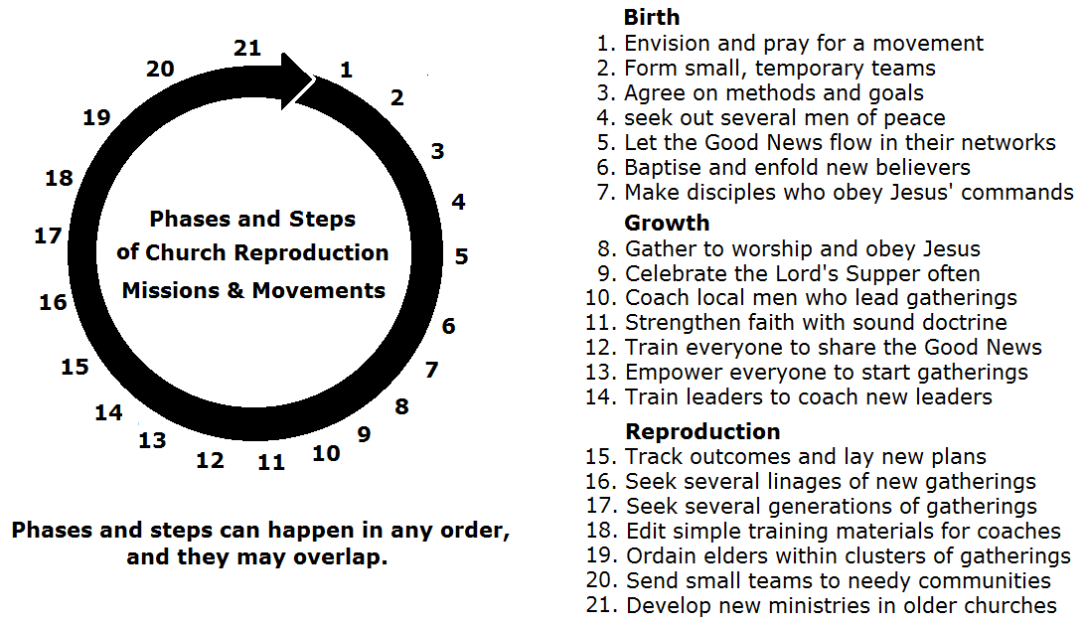
PRESENTERS
Patrick O’Connor, a former church-planting missionary to Honduras, remains an active, international trainer-consultant, currently serving with e3 Partners. patrick.oconnor@e3partners.org
Galen Currah, a former church-planting missionary to Senegal and pastoral training specialist, edits training materials. galencurrah@peopleofyes.com
PREPARATION
Arrange for seating that allows participants to form small groups easily.
Make enough copies of this handout, that each participant may receive on at the start.
If you will celebrate the Lord’s Supper together, then arrange for an edible and a cup of beverage for each small group.
INTRODUCTION
Explain that this workshop provides a model that participants may choose to present to their co-workers at another time and place. Participants may not need a workshop like this one, but others may.
Each of the ten modules deal with step 7 in the diagram on the cover page, and may take about 30 minutes.
Explain the purpose of each of the sections in the ten modules:
Current conviction. These presuppositions have been observed across many missionary endeavors.
Dramatic sketch. These amusing dramas may last only a minute or two.
Bible example. Some way in which the convictions seem to have been practiced by Jesus or apostles.
Real-life example. Presenters and participants alike can share briefly about their experience.
Group discussion. Small groups reply to a query from their reading of Scripture.
Practical application. This can be a silent few minutes for reflection, planning and writing.
Optional exercise. Time permitting.
Proof texts. Bible verses suitable for teaching or further discussion.
METHOD
Interaction remains expected and invited. Though questions are welcome, controversial subjects may be evaded.
Whilst the presenters have their own theology, missionary methods, and opinions on most topics, they expect participants to draw upon Scripture and each other’s experience.
Small groups will discuss a query or a topic for up to seven minutes, then give a report. A presenter will warn when one minute remains. Reports will tell only one idea, until several groups have given their report. If there are many groups, then not all will always report.
CONCLUSION
It is our prayer that every participant will receive from the Lord Jesus least one insight, idea, skill or affirmation useful to the Holy Spirit in bring many new disciples into the Father’s house.

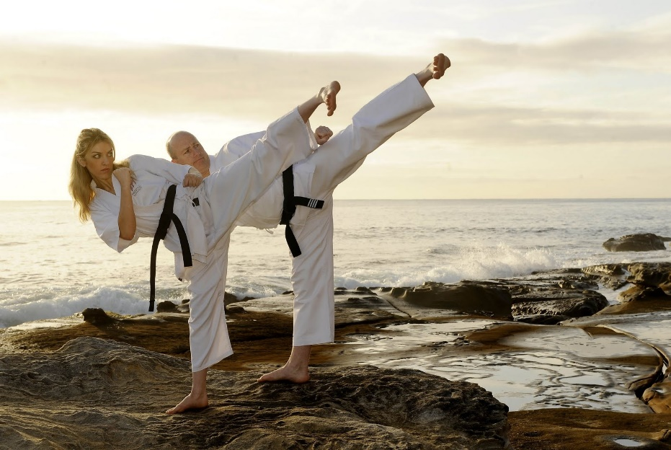
- MODEL
Current conviction
- Demonstrate every activity in ways that others can imitate immediately in their work with others.
- Keep every activity so simple and imitable, that anyone can do the same with others.
Dramatic sketch. Patrick reports to Galen. He has been preaching at the believers to win others, but they do nothing. Galen and Patrick practice telling a story with gestures or with pictures. Patrick plans to teach some men on how to tell stories. [Do so with the participants: tell, listen, discuss.]
Bible example. Mark 1:35-39. Jesus modelled prayer and ministry for his intimate disciples.
Real-life example. Galen held model home group meetings with Mamadou, who then went and did the same with others, resulting in a new cell group starting almost every week in a Moslem city.
Group discussion. What were some other ways in which Jesus and his apostles modelled methods for their co-workers? [Have a few groups report. A few others, next time.]
Practical application. Describe ways in which you will seek to model methods that others can imitate immediately. [Have a few individuals report. A few others, next time.]
Optional exercise. Participants lead each other in telling a very short bible story, than posing a simple query, such as, “What could you do in order to put this text into practice, this week?”.
Proof texts
I have given you an example, that you also should do just as I have done to you. Truly, truly, I say to you, a servant is not greater than his master, nor is a messenger greater than the one who sent him. If you know these things, blessed are you if you do them John 13:15-17
You … have followed my teaching, my conduct, my aim in life, my faith, my patience, my love, my steadfastness, my persecutions and sufferings that happened to me 2 Timothy 3:10-11
Shepherd the flock of God that is among you … being examples to the flock. 1 Peter 5:2-3
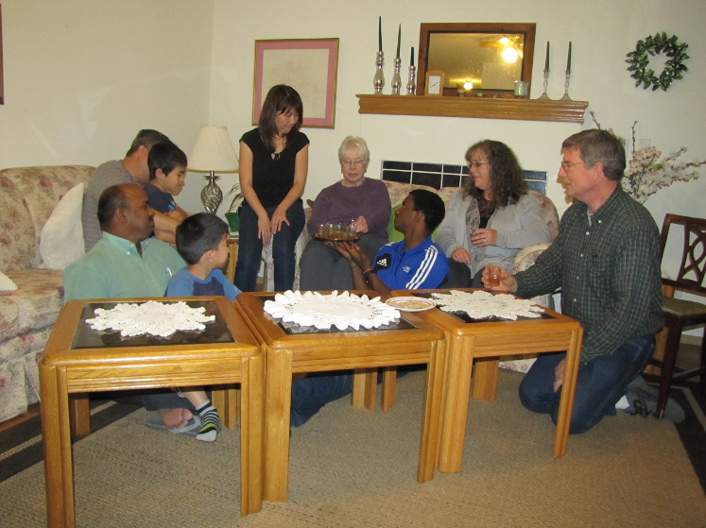
- OBEY
Current conviction
- Teach all seekers and believes to obey Jesus’ general commandments above all else.
- Require of others to do nothing more than what Jesus has commanded.
Dramatic sketch. Patrick reports to Galen that the new believers resist adopting modern clothing, and that they have to go to market Sunday mornings. Galen teaches Patrick to sort all ideas and practices by three-levels of biblical authority in churches. [Commandments, practices and traditions.]
Bible example. Matthew 28:18-20. Jesus supreme commandment. The first church in Jerusalem obeying 21 of Jesus’ commands.
Real-life example. Patrick painted a poster in every new gathering site, listing out seven basic commandments of Jesus that everyone reviewed often. [He often would illustrate love for God, for spouse and for others.]
Group discussion. What commandments of Jesus did the first church at Jerusalem begin obeying?
[Evangelism, Acts 2:26-41. Discipleship, Acts 2:42-43. Body life, Acts 2:44-47.]
Practical application. Which of the basic commandments of Jesus need attention in each of our current cells and churches? How will we teach them to obey these in ways that others can imitate?
Optional exercise. Celebrate the Lord’s table in small groups, following a simple model, employing only elements available on site.
Proof texts
If you love me, you will keep my commandments. … You are my friends if you do what I command you. John 14:15; 15:14
This is why I wrote, that I might test you and know whether you are obedient in everything. 2 Corinthians 2:9
This is the love of God, that we keep his commandments. And his commandments are not burdensome. 1 John 5:3

- GATHER
Current conviction
- Gather seekers and disciples only to praise Jesus and to obey his commands.
- Keep all gatherings interactive, so that each one’s spiritual gifts may manifest.
Dramatic sketch. Patrick reports that a JW introduced false doctrine in a home group. Should he forbid holding home groups, and only hold services with a liturgy? Galen explains that we cannot avoid false doctrine, so we coach leaders to help discipleship cells discover truth from the Bible.
Bible example. Acts 2:42. From the start of the Christian movement, new churches encouraged four activities: (1) apostles, stories about Jesus, (2) sharing amongst themselves, (3) the Lord’s supper in their homes, and (4) praying one for another’s urgent needs.
Real-life example. Galen describes his first experience with an underground house church, during the Communist days in Ethiopia.
Group discussion. Describe the activities of an early Christian gathering from 1 Corinthians 14:24-31. [Act out a sketch in which a guest falls under conviction, while the believers prophesy.]
Practical application. Plan a home gathering in which everyone is welcome to share. What will be some interactive worship activities? Which commandments of Jesus will they obey together?
Optional activity. Participants form groups in which they (a) report on ways they have experienced God in the past week; (b) pray for each others urgent needs; (c) urge each other to remain faithful.
Proof texts
“Return to your home, and declare how much God has done for you.” Luke 8:39
Day by day, attending the temple together and breaking bread in their homes… Acts 2:46
Greet also the church in their house. Romans 16:5
If anyone comes to you and does not bring this teaching, do not receive him into your house or give him any greeting 2 John 1:10
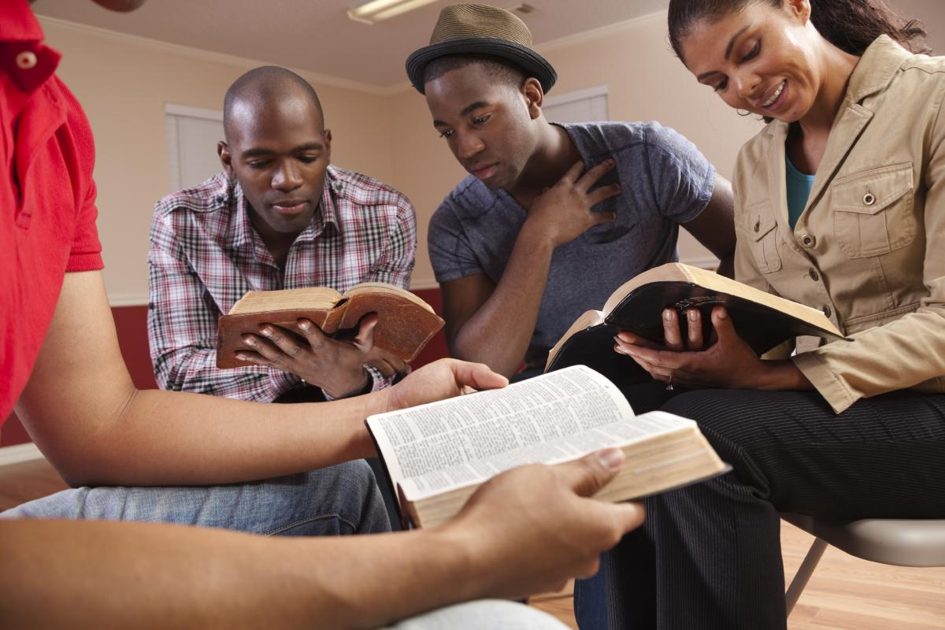
- TEACH
Current conviction
- Teach truth first from Bible stories that learners will be able to share with others, in turn.
- Teach through dialogue, so that we learn needs, and everyone learns from each other.
Dramatic sketch. Patrick reports that some local folk have never read the Bible, and they do not know what his theological words mean. Many seekers have deep problems, yet they do not see themselves as sinners. Galen recommends recounting a number of chronological bible stories for seekers and new believers, depending upon the Holy Spirit to convict each one of his spiritual needs.
Bible example. Matthew 19:3-5. In his teaching, Jesus often referenced Bible stories on Creation, Satan, Noah, Moses, Elijah and others, illustrating spiritual ideas from agriculture and daily life.
Real-life example. The “Ee-taw” video recounts how an entire Mok village was converted through several days of chronological bible stories. Ministries that reproduce disciples and multiply churches employ “discovery bible study” in evangelism and in Christian worship.
Group discussion. What are some current learning needs in your ministry? What Bible stories speak to those needs? [Recommend “Shepherd’s Storybook” (http://storybook.paul-timothy.net).]
Practical application. Lay a plan to introducing Bible stories, Bible sketches or Bible pictures into your teaching. [http://www.justobeyjesus.com/#!bible-stories/c4td]
Optional activity. Have a volunteer ask others to read a bible story, then retell it in their own words as other help him, and pose a few open-ended queries about the story.
Proof texts
A disciple is not above his teacher, but everyone when he is fully trained will be like his teacher.
Luke 6:40
They devoted themselves to the apostles' teaching and the fellowship, to the breaking of bread and the prayers Acts 2:42
Him we proclaim, warning everyone and teaching everyone with all wisdom, that we may present everyone mature in Christ. Colossians 1:28
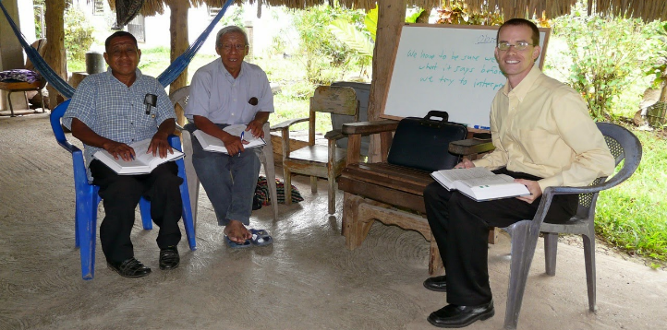
- COACH
Current conviction
- Empower the willing to make disciples of others, in ways that we have modelled.
- Coach willing workers who prove able to coach others to do the same, in turn.
Dramatic sketch. Patrick complains that none of the believers meets qualifications for leadership. Galen explains the difference between maturity and gifting. He asks, “Whom could you coach as they serve as ‘provision shepherds’?” They review together elements of a coaching session. [Pray for wisdom, listen to reports, lay plans for immediate implementation, assign bible reading and a study booklet, review earlier assignments, practice new skills, intercede for others.]
Bible example. Mark 6:7-13, 30-31. Jesus planned with his disciples, trusted them to make mistakes, and listened attentively to their reports, afterwards. The apostle John wrote to three levels of maturity: children, youth and parents. The apostles would appoint elders based on their demonstrated maturity and ministry ability.
Real-life example. Patrick relates how he appointed provisional shepherds in every new church, or authorised workers to do so. Many of these shepherds were eventually ordained as pastors. [www.peopleofyes.com www.paul-timothy.net]
Group discussion. What are the main obstacles or failures that prevent men from assuming leadership in their community? Which of those relate to maturity? Which to obedience to Christ?
Practical application. Identify an individual in every place or family whom you could appoint as a provisional leader. Lay a plan to approach each one and offer to coach him as he provides shepherding care to his family or to a cell group.
Optional activity. Participants form pairs, one coaching the other following a coaching process giving one minute to each step. After seven minutes, they change roles and follow the same process.
Proof texts
Every great matter they shall bring to you, but any small matter they shall decide themselves.
Exodus 18:22
“Every scribe who has been trained … brings out of his treasure what is new and what is old.”
Matthew 13:52
When Priscilla and Aquila heard [Apollos], they took him aside and explained to him the way of God more accurately. … He greatly helped those who through grace had believed, Acts 18:26-27
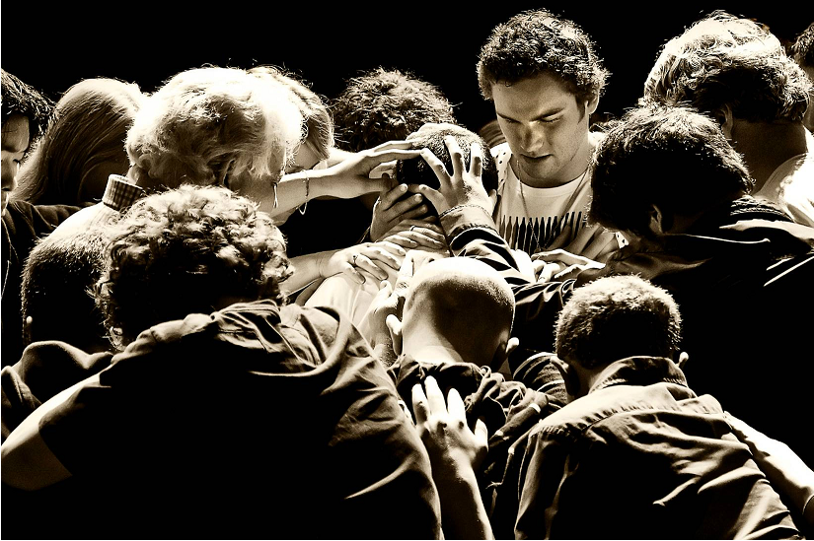
- LOVE
Current conviction
- Maintain inter-personal relations with disciples who do the same with others.
- Make disciples mainly in small groups that practice together all that they learn together.
Dramatic sketch. Patrick moans, “I have preached on Jesus’ commands but no one obeys them. I have also tried one-on-one discipleship, but it degenerates into abstract theology, and little action.” Galen explains how the apostles obeyed Jesus’ command to make disciples, by starting clusters of many little churches in homes, where believers they obeyed Jesus together.
Bible example. 2 Timothy 1:2. Paul related to Timothy as a “dear son.” Timothy was no mere student, servant or trainee. Treat new leaders with affection, and they will remain loyal to you.
Real-life example. Patrick describes several men with whom he spent a lot of time, sharing life and worship. Galen describes the breaking of bad habits by a small group’s love and prayer.
Group discussion. Describe Paul’s training methods and content from Acts 20:4-6, 31-35.
Practical application. How could I better spend my time with a few men whom I can prepare to work with their own family, friends and cell groups?
Optional activity. Form small groups of three or four. Spend two minutes only listening to one talk about his current needs and struggles. Then have one other pray for him. Repeat until each one who is willing to do so, has shared, or until you run out of time.
Proof texts
A new commandment I give to you, that you love one another: just as I have loved you, you also are to love one another. John 13:34
Love one another with brotherly affection. Outdo one another in showing honor. Romans 12:10
Let us consider how to stir up one another to love and good works, not neglecting to meet together, as is the habit of some, but encouraging one another. Hebrews 10:24-25
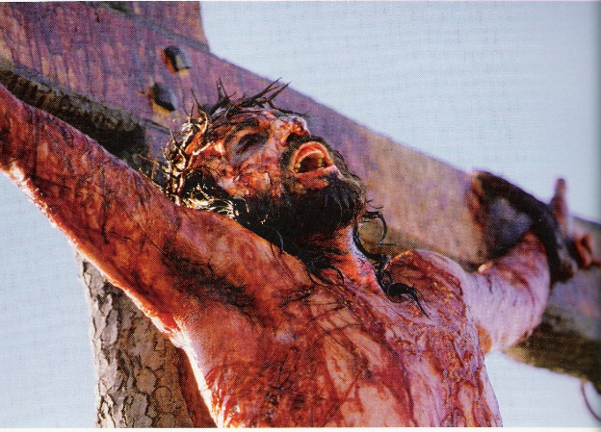
- EVANGELISE
Current conviction
- Let the Good News flow mainly through existing families and friendships.
- Let everyone tell the Good News to others in ways that fit their culture and personality.
Dramatic sketch. Patrick laments, “I have taught the Roman Road and Anselm’s theory of the atonement, till I am blue in my face, yet no one shares these precious truths with others.” Galen asks, “Well, what was the original, apostolic Good News?”
Bible example. Luke 24:44-48. Jesus commanded the Good News in The apostles followed this pattern in their sermons as recorded in the Book of Acts.
Real-life example. Patrick relates how the good news flowed within families and villages of Honduras. Galen tells how he learned to tell the Good News story in Wolof language.
Group discussion. What are the main points of the Good News, according to Jesus, to the Book of Acts, and Paul? Which of these points are missing from typical, Western, gospel witness? [Acts 2:21-24, 38. 5:29-33. 10:38-42. 13:27-31. 17:1-3. 17:29-31. 26:18-23. 1 Cor. 15:3-5]
Practical application. Plan to teach those stories in a way that local folk can tell them to others, agreeing with them about whom they will tell those stories in their own way.
Optional activity. Participants form pairs, in which each one takes a turn telling the Good News story in the space of one minute, along with an invitation.
Proof texts
“Thus it is written, that the Christ should suffer and on the third day rise from the dead, and that repentance and forgiveness of sins should be proclaimed in his name to all nations
Luke 24:46-47
Christ died for our sins in accordance with the Scriptures, that he was buried, that he was raised on the third day in accordance with the Scriptures, and that he appeared to Cephas, then to the twelve. 1 Corinthians 15:3-5
in your hearts honor Christ the Lord as holy, always being prepared to make a defense to anyone who asks you for a reason for the hope that is in you; yet do it with gentleness and respect
1 Peter 3:15
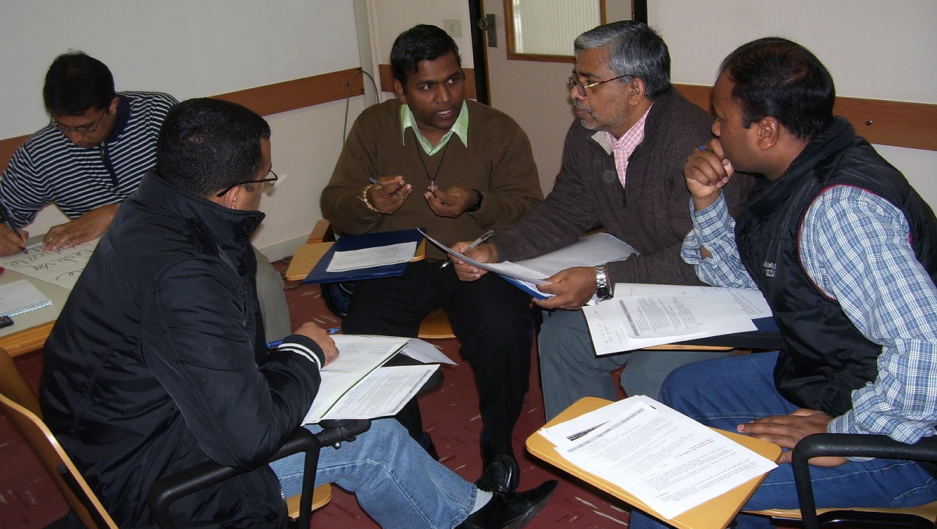
- REPORT
Current conviction
- Have every disciple report on how he obeyed Jesus, in the past week, and on what happened.
- Have every disciple tell how he will obey Jesus, this week, and will help others to do the same.
Dramatic sketch. Patrick reports that several communities have asked for a missionary, but he does not have enough time or energy to help them. He wants Galen to help. Galen asks him to think of some folk whom Patrick could coach and send to each place.
Bible example. Colossians 1:1, 7. Epaphras learned the Good News in Ephesus, then took it home to Colossae, from whence local folk carried it to Laodicea and Hierapolis. [Act out this story.]
Real-life example. Recount the phenomenal success of T4T in China, where continual training with accountability has seen the Good News reach 100s of 1000s. [Explain the three thirds.]
Group discussion. Report to each other on ways in which they have obeyed Jesus in the past month, and what was the outcome. Let each one tell a way in which he will obey some command of Jesus in the coming week.
Practical application. Lay a plan to training every believer in evangelism, in disciple making or in cell leadership, with regular accountability to report on outcomes.
Optional activity. Participants form pairs in which each one reports on (a) his major activities, and on (b) advances and losses over the past year.
Proof texts
The apostles returned to Jesus and told him all that they had done and taught. Mark 6:30
Sopater the Berean, son of Pyrrhus, accompanied him; and of the Thessalonians, Aristarchus and Secundus; and Gaius of Derbe, and Timothy; and the Asians, Tychicus and Trophimus. Acts 20:4
So that you also may know how I am and what I am doing, Tychicus the beloved brother and faithful minister in the Lord will tell you everything. Ephesians 6:21
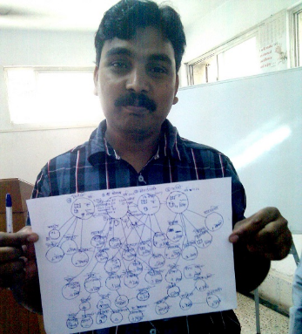
- TRACK
Current conviction
- Allow every disciple to start making disciples of others, as soon as God allows.
- Keep track of disciples’ disciples to their third generation, coaching them in how to coach others.
Dramatic sketch. Patrick reports, “I give my disciples assignments, but I have no idea of what they do about it. When I ask about their progress, they always say something vague?” Galen shares with Patrick how to draw a linage chart showing generations of mother-to-daughter churches, and of father-to-son leaders. [Illustrate. Recommend www.wordwatchers.link]
Bible example. Acts 6:7. The Book of Acts describes many facts about the spread of the Good News: who, where, how, when, with whom, to whom, and outcomes for baptisms, new disciples and cell group multiplication.
Real-life example. Patrick describes the training chains that he established with new leaders in new churches in the mountains of Honduras.
Group discussion. Everyone sketches a linage chart of their work, and shares it with the other members of his discussion group. Time allowing, project where you expect new growth to happen.
Practical application. Everyone draws a map of his ministry region, noting existing work and neglected places. He then indicates by name a believer who could potentially go to each place. He then plans to recruit that person.
Optional activity. Draw a linage map of who is making disciples and of whom. Expand this map to show mother-to-daughter church lines, father-to-son coaching lines. Show your map to someone and recount how reproduction happened.
Proof texts
Jesus went throughout all the cities and villages, teaching in their synagogues and proclaiming the gospel of the kingdom and healing every disease and every affliction. Matthew 9:35
The disciples were increasing in number… The word of God continued to increase, and the number of the disciples multiplied greatly in Jerusalem, and a great many of the priests became obedient to the faith. Acts 6:1-7
From Jerusalem and all the way around to Illyricum I have fulfilled the ministry of the gospel of Christ Romans 15:19

- REPRODUCE
Current conviction
- Let new discipleship cells spring up anywhere, before holding big meetings.
- Appoint as cell leaders only those individuals who have made disciples of others.
Dramatic sketch. Patrick reports that a number of new cell groups have started in the homes of seekers and of new believers. Now some old believers want to be put in charge of those groups and are already talking about how to spend tithes and offerings. Galen advises to let each one lead his own group and to raise up his own leaders of new groups. Together, they map where disciples could carry the gospel, and they lay a plan to share that vision with them.
Bible example. Acts 14:21-23. In the “Pauline Cycle” the apostles appointed elders within a few weeks of starting several new churches. Remember: the steps of the Cycle can occur in any order.
Real-life example. Galen recounts how Ibrahim started new churches in 30 villages, till he no longer had time to tend to his cattle and fields, until he appointed local leaders. Patrick tells how new campus cell groups keep out old Christians who bring traditions that hinder rapid reproduction.
Group discussion. There are two types of churches, elephantine churches and rabbitine churches. Note what are some strengths and weaknesses of each kind? What is the potential of each kind to make disciples of a vast, neglected population?
Practical application. Each participant lays a plan to launch many little discipleship cells within a bigger church. As a second track, they identify the newest believers, laying a plan to mobilise these and to coach them as they start new cells with their unsaved family and friends.
Optional activity. Review seven facets of a coaching session. Demonstrate integrating linage mapping with receiving reports during a coaching session. Lastly, lay maps before the Throne of Heaven and intercede for more disciples, more workers, more discipleship cells…
Proof texts
I am the vine; you are the branches. Whoever abides in me and I in him, he it is that bears much fruit, for apart from me you can do nothing. John 15:5
[Paul] …took the disciples with him, reasoning daily in the hall of Tyrannus. This continued for two years, so that all the residents of Asia heard the word of the Lord, both Jews and Greeks. Acts 19:9-10
I left you in Crete, so that you might put what remained into order, and appoint elders in every town as I directed you Titus 1:5

