Stay on Track with the
Good Shepherd
Monitoring outcomes of disciple-making movements

October 2013

About this manual
This book serves as an introductory guide to those who plan to make many disciple by training and empowering others

How to employ this book
Employ this book in a ‘workshop’ to stimulate discussion amongst co-workers, and to find sample tracking tools.
Do not adopt these sample tracking tools. Rather look at them to get some ideas. Create your own tracking tools. The best tracking tools are those what supply you with information that you need.

What is tracking
Tracking is to keep records of what happened as a result of ministry work. Share those records with those who pray with you and help you plan your work.

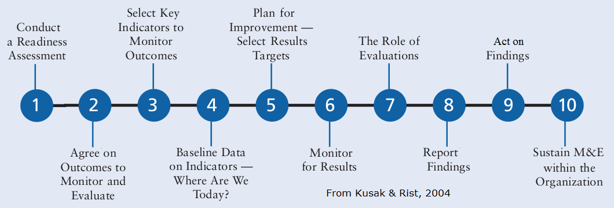
Who track
Those who make disciples, also keep records and fill in forms on paper. If they cannot write, then they must tell someone who can fill in the forms for them.

Five tracks to follow
In this manual, we shall follow five tracks that lead to making disciples of entire ethnies and whole regions:
- Lambs (new believers)
- Sheep (new disciples)
- Flocks (new gatherings)
- Shepherds (new leaders)
- Fields (new communities)

What are outcomes
Outcomes are all that happens in others, because of your ministry work. Your ministry work causes outcomes. It is the Holy Spirit that makes both happen. He gives you spiritual power to do ministry, and he works in others to give them faith and to help them obey Jesus.

What is monitoring
Tracking and monitoring go together. Those who track keep records and make reports. Those who monitor read those reports, pray for wisdom, and make new plans. Tracking with monitoring would prove worthless, and monitoring without tracking would not prove possible.

Who monitor
God gives you men and women who pray for you, who train you, and who help you plan. You track the outcomes of your work and you report to them. As soon as you begin training others, you will monitor their work, and they will track outcomes and report to you.

What are indicators
When you count visible persons, objects and events, these indicate (show or prove) that invisible or immeasurable things have happened. These things indicate that (1) inputs have been applied, (2) activities have been conducted, or (3) outcomes have happened. Thus, indicators must be:
- Measurable – they can be accessed (seen or heard) and quantified (counted or measured).
- Verifiable – others can measure the same things and get similar results.
- Economical – it does not take too much time or money to access these indicators.
- Informative – the measures reveal, describe or prove inputs, activities and outcomes.

Fill in tracking forms
If you mentor or coach others, train others or supervise others, then one of your tasks is to show them how track the outcomes of their work. You must keep them supplied with tracking forms that they fill in. If they are illiterate, then you may have to help them fill in their forms. Collect tracking forms regularly, at least once a month.

Make use of tracking forms
Look over each tracking form with the worker who filled it in. Thank him for his faithful work. Ask questions about what he said and did in his ministry work, to learn what worked well and what did not. (Mark 6:30)
Make plans with each worker to help him take his next steps. Pray with him that God will give his flocks increase.
Take information from each one’s tracking form, and compile it into your own tracking forms. Then submit your tracking form to your mentor or supervisor.

Who are sponsors
Sponsors are those who understand what God wants to do in your state and district. Sponsors monitor ministry outcomes. Sponsors plan with ministry leaders what they will do next. Some sponsors find money to pay for training workshops and for training materials. Sponsors do not pay salaries and they do not pay rewards for your work.

Critical path
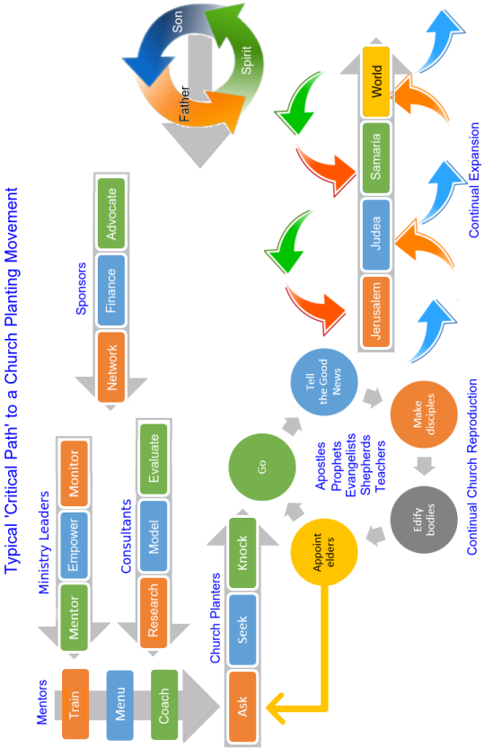

Pray with Faith, Plan by Faith

Vision
Every community in our country has in it those who worship the One True God with faith in Jesus the Messiah.

Covenant
Agree with your co-workers, in prayer, that you will let believers, disciples, gatherings and new workers multiply as fast as the Lord will allow.

Mission
To establish, in every ‘unreached’ community of our region, gatherings of local believers who worship the One True God with faith in Jesus the Messiah.

Goals
- To win one million folk who repent towards the One True God and who obey Jesus the Messiah.
- To bring those million folk together in ten thousand flocks that obey Jesus’ commandments.
- To appoint ten thousand shepherds who lead those flocks and care for their members.
- To empower 100 trainers who mentor shepherds to reproduce their flocks and themselves.

Convictions
- Sustained prayer by leaders raises up willing workers.
- Practical training motivates one-in-five folk to take action.
- Continual training leads to continual action.
- Multiplying trainers leads to more training and more action.
- The original Good News wins others to faith in Jesus.
- Discovery bible study increases obedience to Scripture.
- Obeying Jesus’ commandments makes believers faithful disciples.
- The empowering of disciples to start gatherings leads to the multiplication of churches.
- The Mentoring of shepherds leads to mature churches.
- The multiplying of churches leads to self-sufficient giving.
- The tracking of outcomes leads to better planning.

Plans
- Set measurable objectives
- Decide whom to train
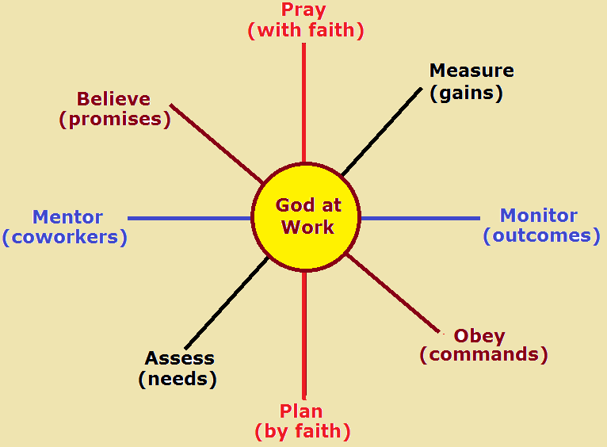
- Decide who will go where
- Decide what they will do and say
- Provide required resources
- Decide how to monitor workers
- Decide how to track outcomes

Budget
In rapidly-growing disciple-making movements, most workers are self-supported volunteers. (Matthew 10:9-10) Leaders do not allow outsiders to control them with money. However, outsiders can help with expensive items, such as Bibles, evangelistic literature, training materials, travel to provide mentoring, and holding training seminars.

Outcome indicators
- New believers Numbers of baptism less number of apostates
- New disciples Numbers of obeying seven commandments
- New churches Numbers of gatherings that practice five activities
- New shepherds Numbers enrolled in mentorship program
- New mentors Numbers of shepherds empowering others
- New trainers Frequency of training workshops
- New fields Numbers of places reported
- New communities Demographic statistics

Monitor and evaluate
- Monthly, collect reports, compile data, analyze results
- Annually, compare results with goals

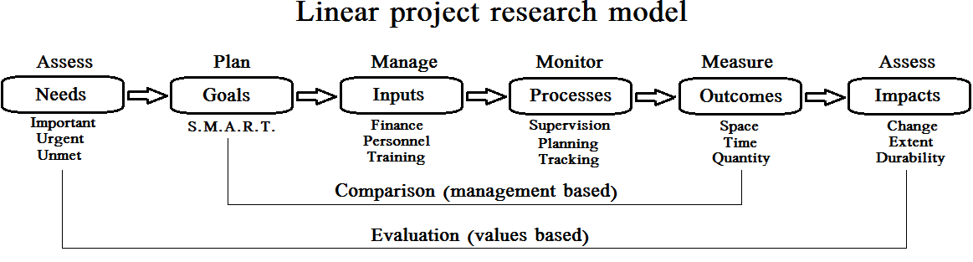

Discussion topics

In what ways did the apostles track outcomes?
Have workshop participants form little discussion groups or three or four. Assign each group one or more of these Scripture passages. Instruct them to read each passage and to answer together his query: “In what ways did the apostles track ministry outcomes?” After seven minutes, have someone in each group tell one thing that the group agreed upon. Agree with all good answer. After all groups have reported, then each one may tell other things that they agreed upon.
(a) Matt. 16:18-19; 24:14; 28:18-20 (b) Luke 9:1-6; Luke 24:47
(c) Acts 2:40-47; Acts 6:1, 7 (d) Acts 11:15-18; 19-24; Acts 12:24
(f) Acts 13:48-49; Acts 15:6-8 (g) Acts 8:14-17; Acts 15:12-14;
(e) Acts 19:20; Romans 15:20-21 (f) 2 Cor. 9:10-15; Rev. 5:9-10

Discuss: How could tracking help to answer these queries?
- Which communities have come receptive to the Good News?
- Which believers have yet to learn to tell the Good News?
- Which believers have yet to become obedient disciples?
- Which groups of believers have yet to become a real church?
- Where shall we send outreach teams?
- What new skills do our workers need to learn?
- Which workers should we make trainers of other workers?
- What do shepherds and pastors need to learn, so they can lead their churches?
- How can we justify our request for ministry funds?
- What can we honestly report to our sponsors?

Module 1
Stay on track with new lambs:
Monitoring evangelism outcomes

How did the apostles track new believers?
(a) Luke 24:44-49 (b) Acts 2;41 2:47 (c) Acts 5:14 11:24

Keep the Good News flowing within a community
- Know and teach the original Good News. Luke 24:44-49
- Train all believers to tell the Good News with power. Luke 10:1-9
- Plan with them whom they will tell, when and where.
- Have them report back, and rejoice with them. Luke 10:17
- Empower them to baptize new believers.
- Coach them to make disciples of new believers.
- Train them to become trainers.
- Keep track of receptive communities.

How will you keep track of new believers?
- Form a task group and plan together to track new believers.
- Who will report to whom?
- Who will train them to do so?
- What facts must they report?
- In what form will they record these facts?
- Draft up Sample report form.
- How often will they report these facts?
- How will you classify those facts? (Place? Age? Ethnicity? Language? Literacy?)
- Write down your plan and pray for each other to implement this plan.

Sample evangelism training for all believers.
- See appendix E: Evangelism Training

Sample evangelism tracking tools

E1 Evangelism tracking tool for evangelists
E2 Evangelism tracking tool for shepherds
E3 Evangelism tracking tool for trainers
M3 Evangelism tracking map
E4 Evangelism tracking tool for supervisors
E5 Evangelism tracking tool for sponsors

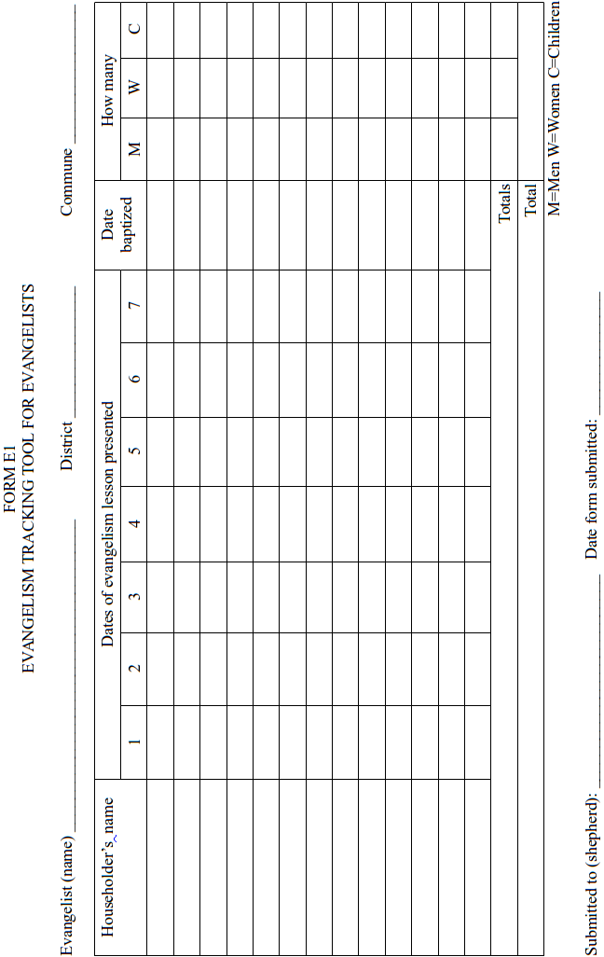
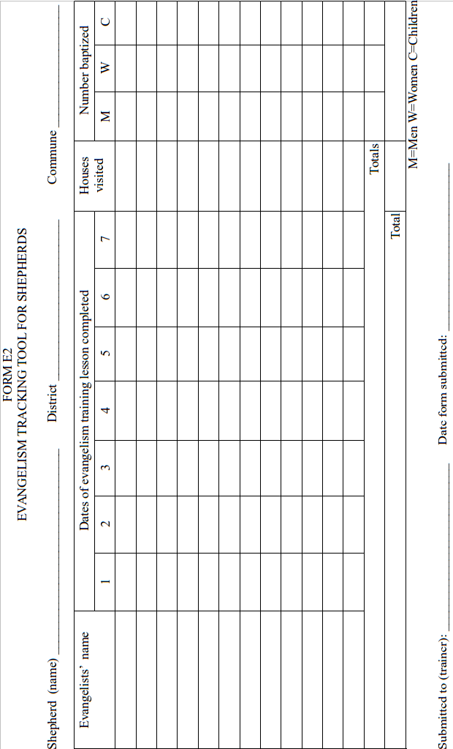
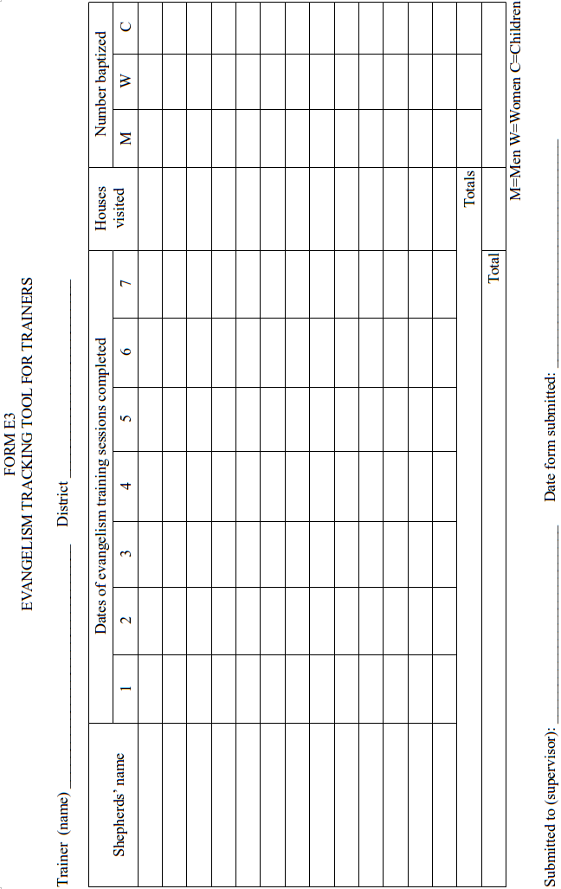
MAP E3
EVANGELISM TRACKING MAP FOR SHEPHERDS & TRAINERS

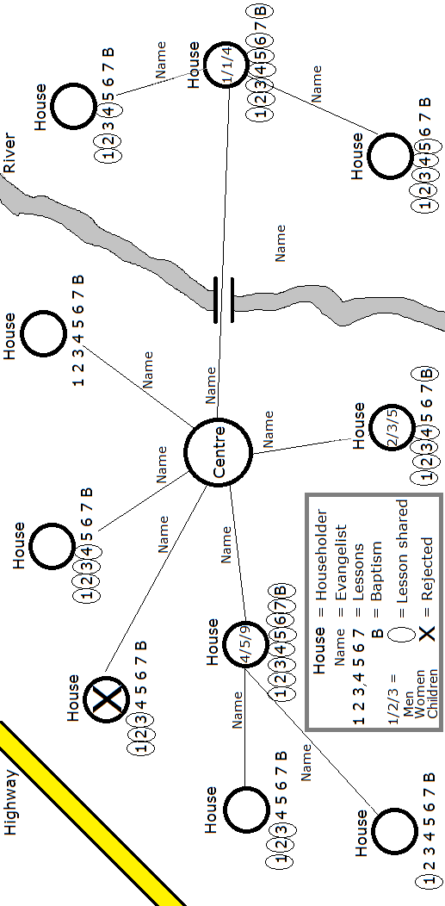
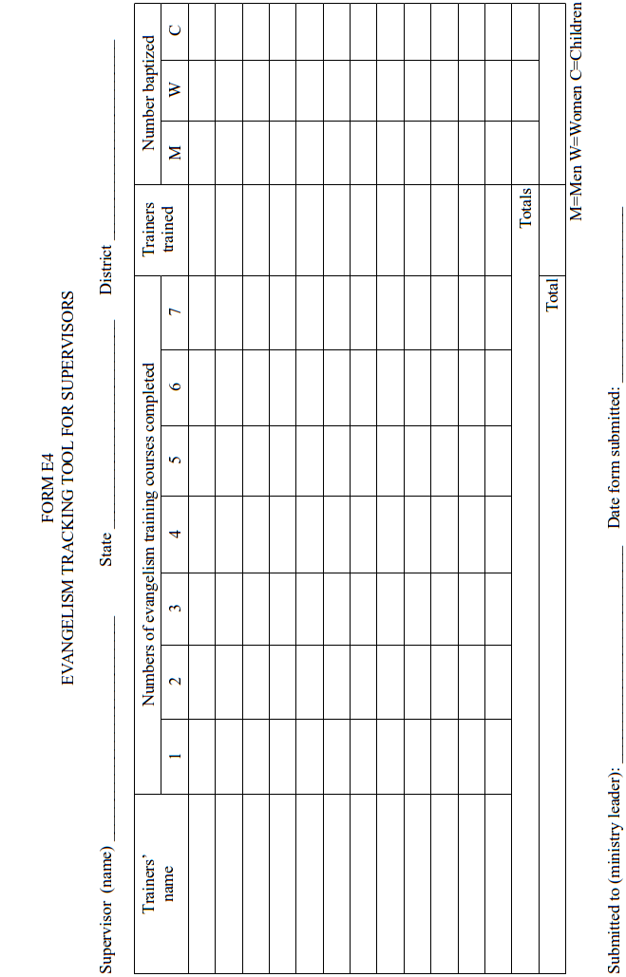
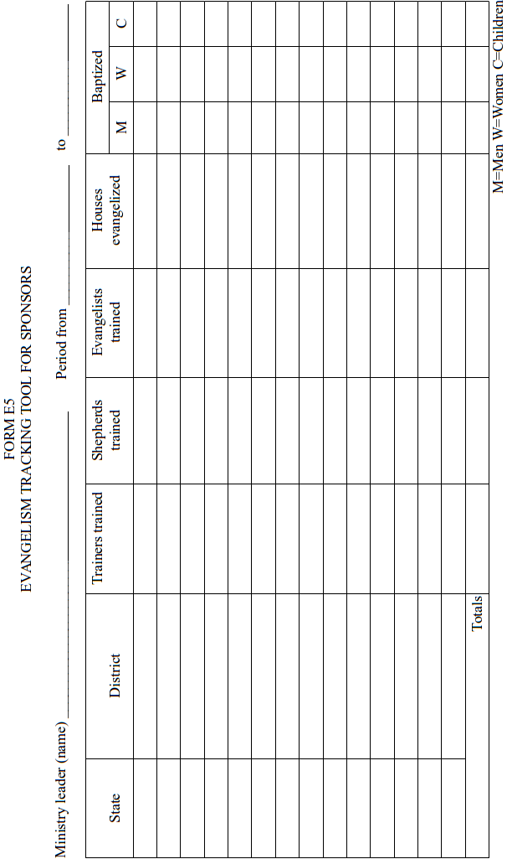

Module 2
Stay on track with new sheep:
Monitor discipleship outcomes

How did the apostles track new sheep?
(a) Matt. 28:19-20 (b) Acts 6:1 6:7

Keep making lovingly-obedient disciples?
- Lead a bible discovery lesson on basic commandments of Jesus.
- Teach a set of basic commandments of Jesus to all new disciples.
- Help new disciples memorize basic commandments of Jesus.
- Practice with new disciples obedience to each of those commandments.
- Empower new disciples to obey Jesus commandments anytime, anywhere.
- Have disciples report to each other on their obedience.

How will you keep track of new disciples?
- Form a task group and plan together to track new disciples.
- Who will report to whom?
- What facts must they report?
- In what form will they record these facts?
- Who will train them to do so?
- Draft up Sample report form.
- How often will they report these facts?
- How will you classify those facts? (Place? Age? Ethnicity? Language? Literacy?)
- Write down your plan and pray for each other to implement this plan.

Sample discipleship training for soul-winners.
- See Appendix D: Discipleship Training

Sample discipleship tracking tools.
D1 Discipleship tracking tool for evangelists
D2 Discipleship tracking tool for shepherds
D3 Discipleship tracking tool for trainers
D4 Discipleship tracking tool for supervisors
D5 Discipleship tracking tool for sponsors

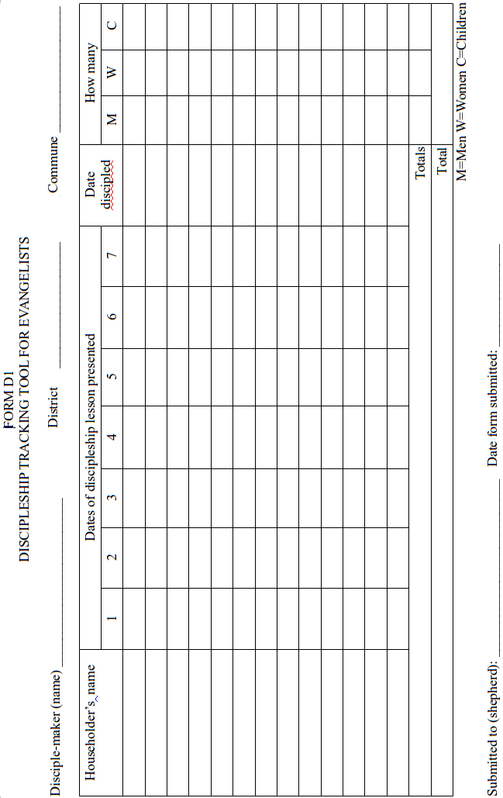
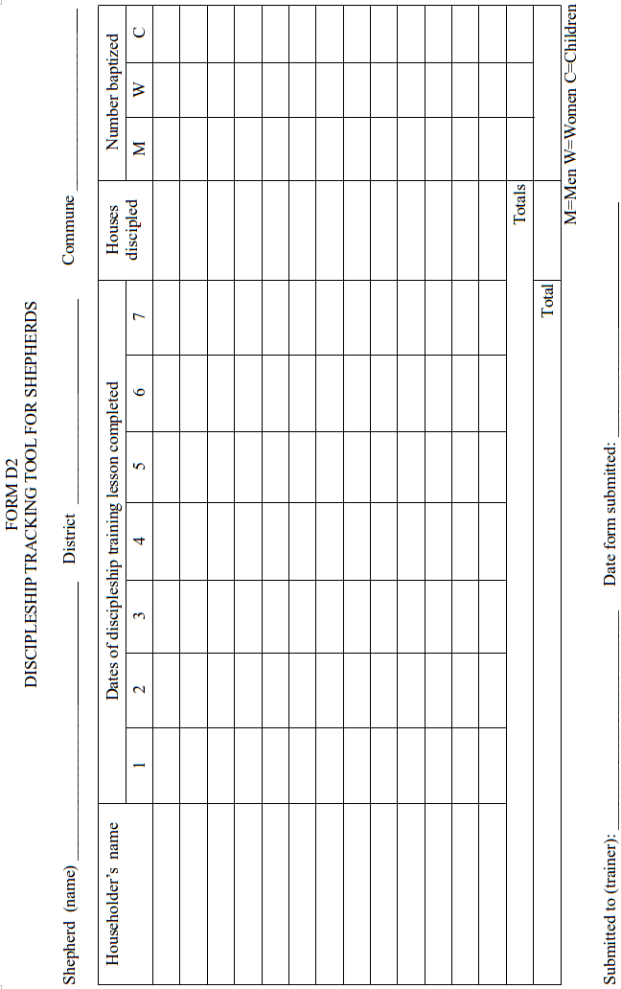
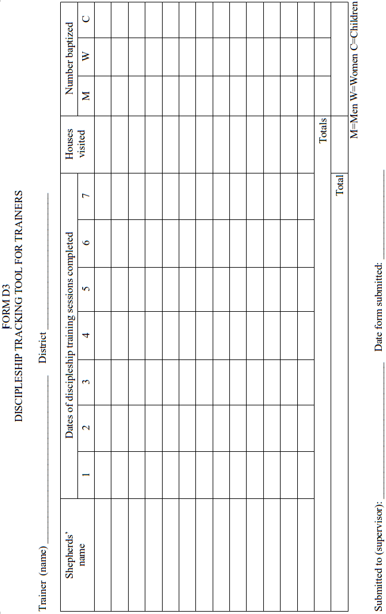
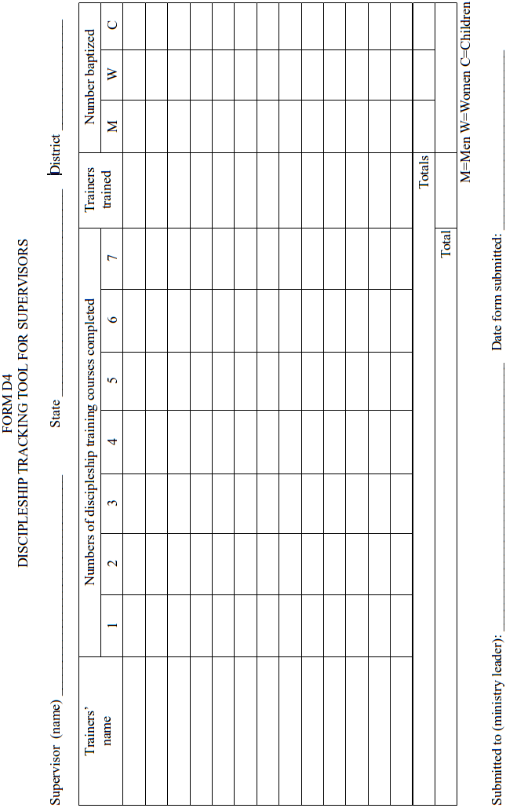
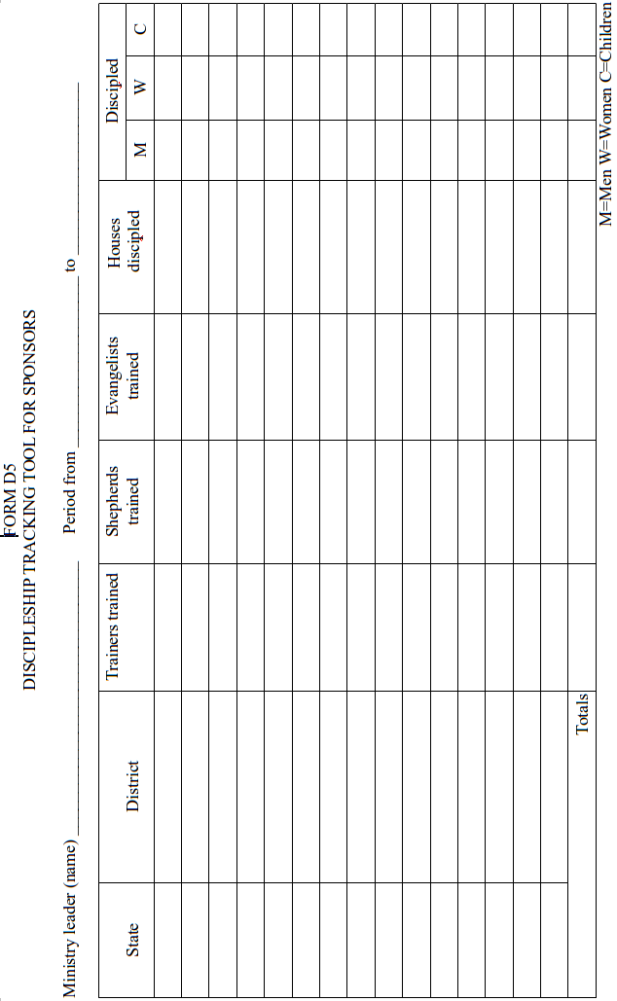

Module 3
Stay on track with new flocks:
Monitor church planting outcomes

How did the apostles track new gatherings?
(a) Acts 9:31 16:5

Keep reproducing new gatherings?
- Train every shepherd in a method for starting new gatherings
- Have shepherds teach every new cell and church its biblical duties.
- Have shepherds empower every new gathering to start daughter gatherings.
- Mentor shepherds in planning for new gatherings.
- Empower shepherds to appoint and train shepherds of new gatherings.

How will you keep track of new gatherings?
- Form a task group and plan together to launch new gatherings.
- Who will report to whom?
- What facts must they report?
- In what form will they record these facts?
- Who will train them to do so?
- Draft up Sample report form.
- How often will they report these facts?
- How will you classify those facts? (Place? Age? Ethnicity? Language? Literacy?)
- Write down your plan and pray for each other to implement this plan.

Sample church-plant training for disciple-makers.
- See Appendix C: Church Planter Training

Sample church-plant tracking tools.
C1 Church-plant tracking tool for evangelists
C2 Church-plant tracking tool for shepherds
C3 Church-plant tracking tool for trainers
C4 Church-plant tracking tool for supervisors
C5 Church-plant tracking tool for sponsors
C6 Church status Form
C7 Church generational chart
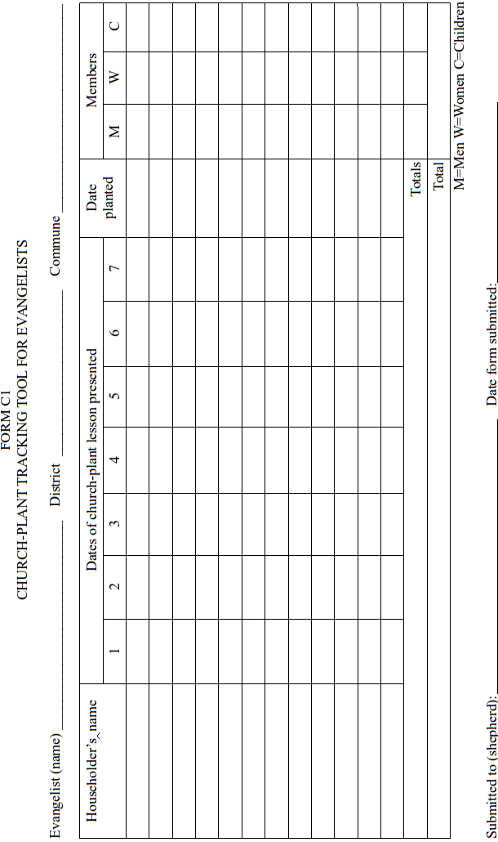
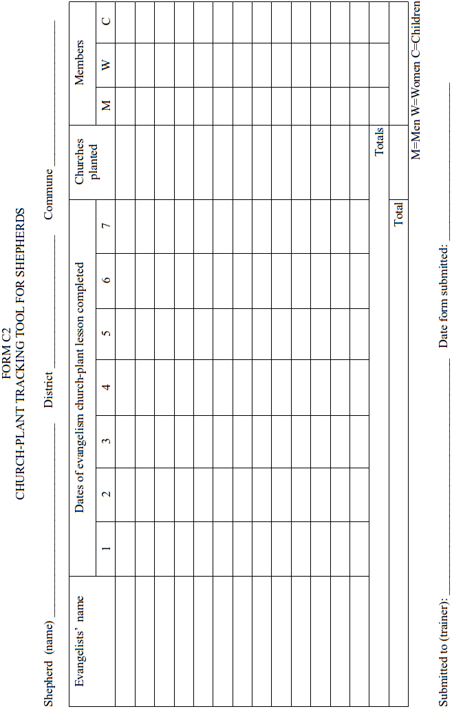
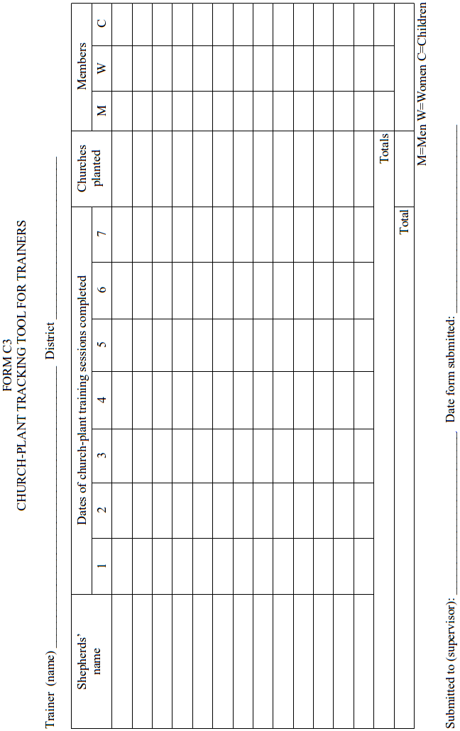
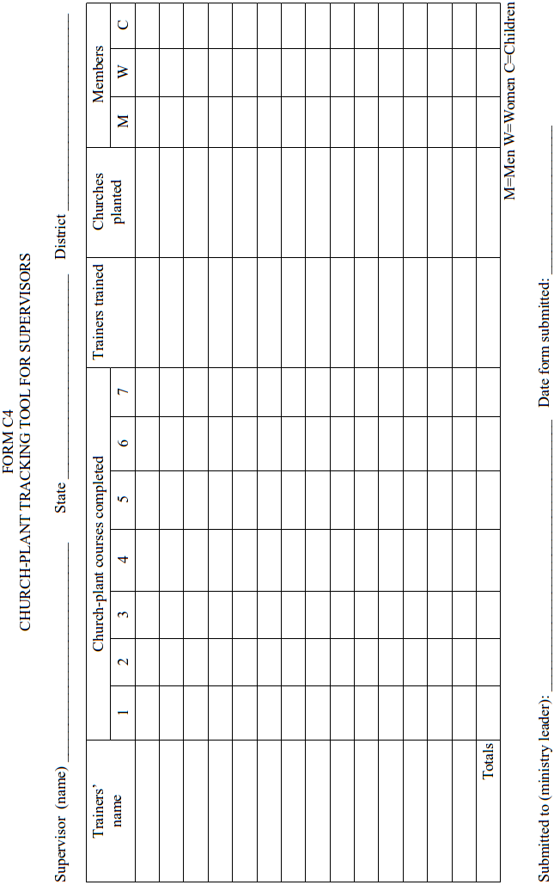
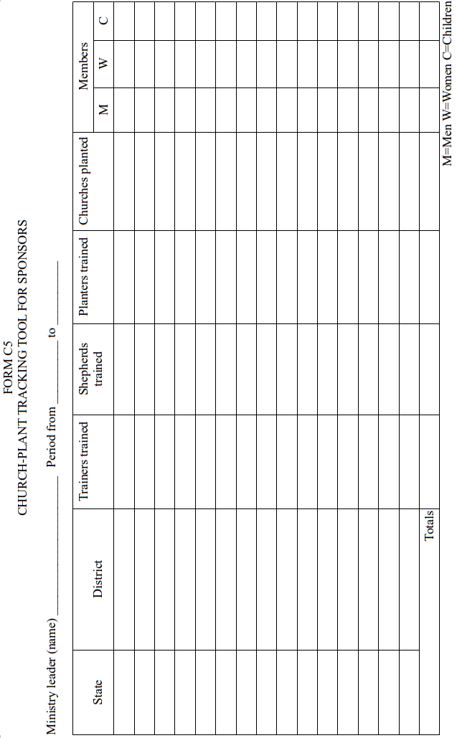

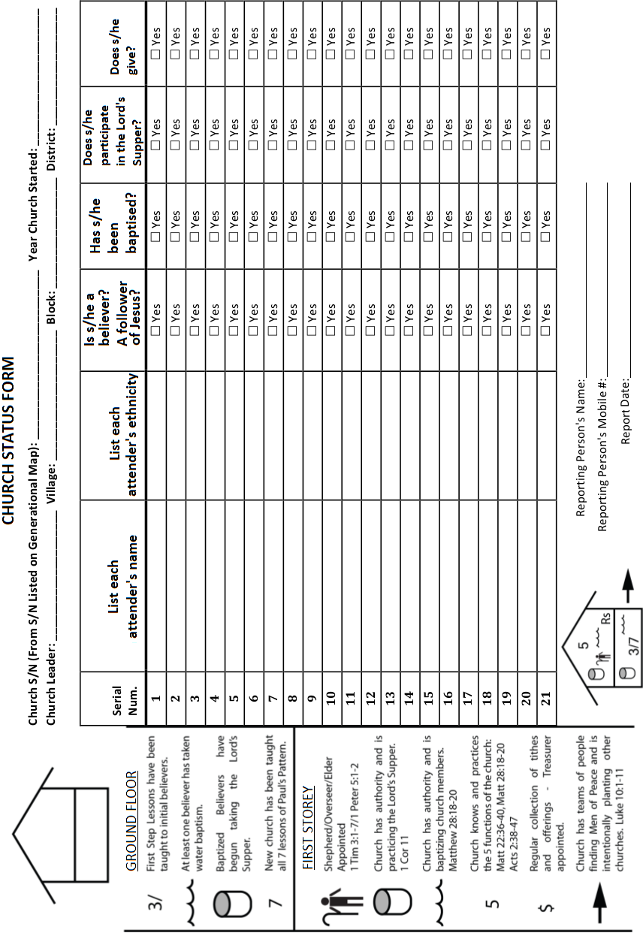
C6 Church Status Form

C7 Generational chart
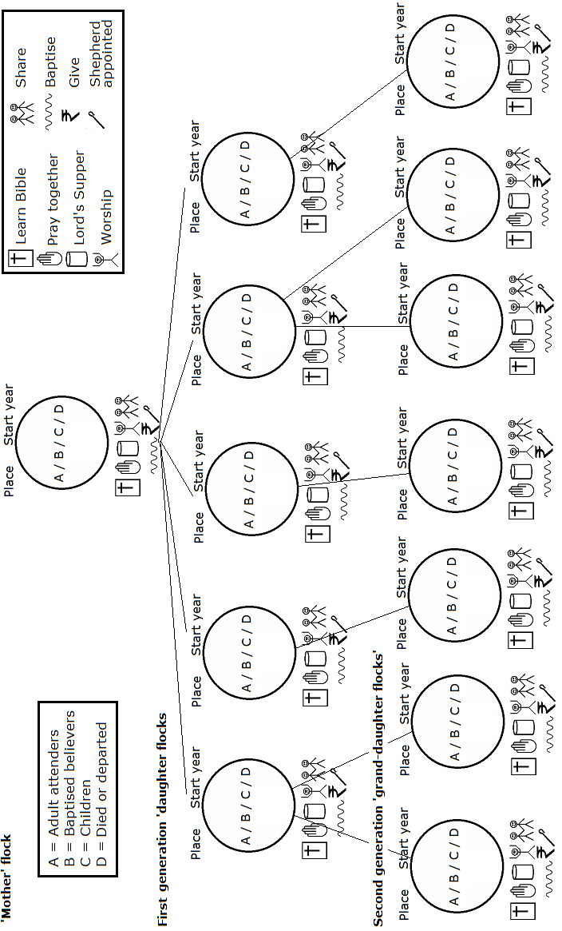

Module 4
Stay on track with new shepherds:
Monitor shepherd training outcomes

How did the apostles track new shepherds?
(a) Titus 1:5 (b) 2 Tim. 2:1-2 (c) Col 4:15-17

Keep reproducing new shepherds?
- Empower new workers to do all that you do. Luke 9 10
- Listen to them and plan with them. Mark 6:30
- Obtain or build a set of shepherd training materials. Acts 20:20
- Keep training for several months. Acts 19:10
- Set up training ‘chains.’ 2 Tim. 2:1-2
- Hold strategy conferences. Acts 20:4

How will you keep track of new shepherds?
- Form a task group and plan together to mentor workers.
- Who will mentor whom?
- Who will report to whom?
- What facts must they report?
- In what form will they record these facts?
- Who will train them to do so?
- Draft up Sample report form.
- How often will they report these facts?
- How will you classify those facts? (Place? Age? Ethnicity? Language? Literacy?)
- Write down your plan and pray for each other to implement this plan.

Sample mentorship training for church planters
- See Appendix D: Shepherd Develop Training

Sample mentorship tracking tools
M1 Mentorship tracking for mentors
M2 Mentorship tracking for trainers
M3 Mentorship tracking for supervisors
M4 Mentorship tracking for sponsors
M5 2 Timothy 2:2 training ‘chains’
M6 Geographical maps
M7 Kinship chart

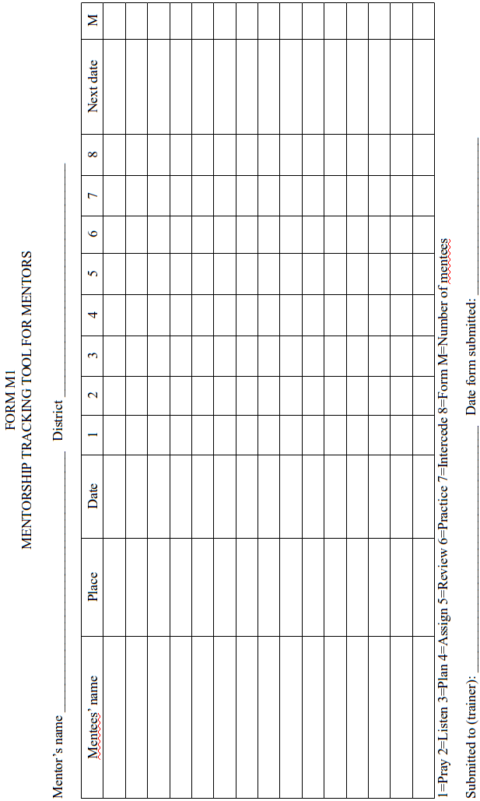
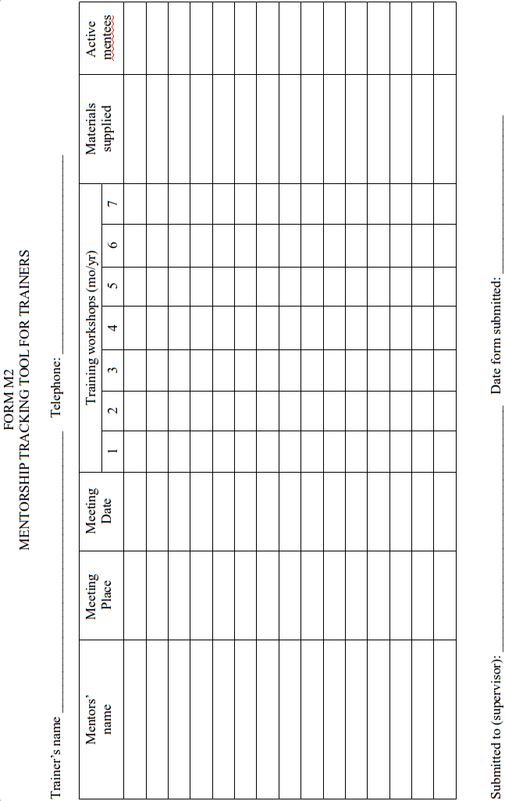
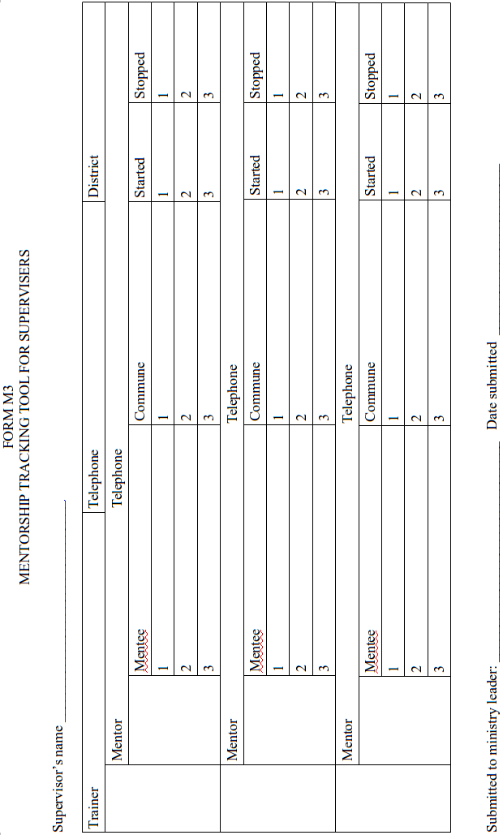
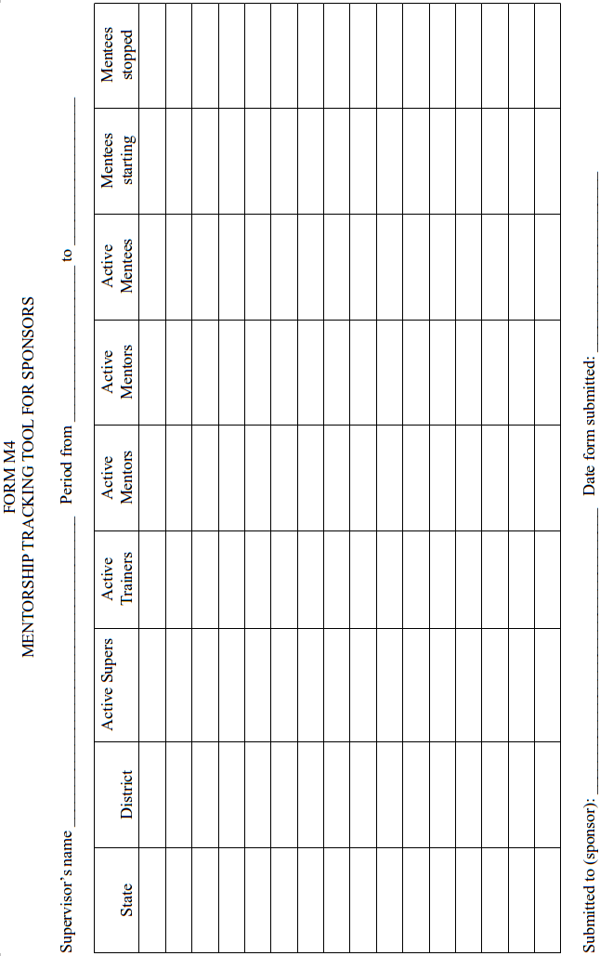
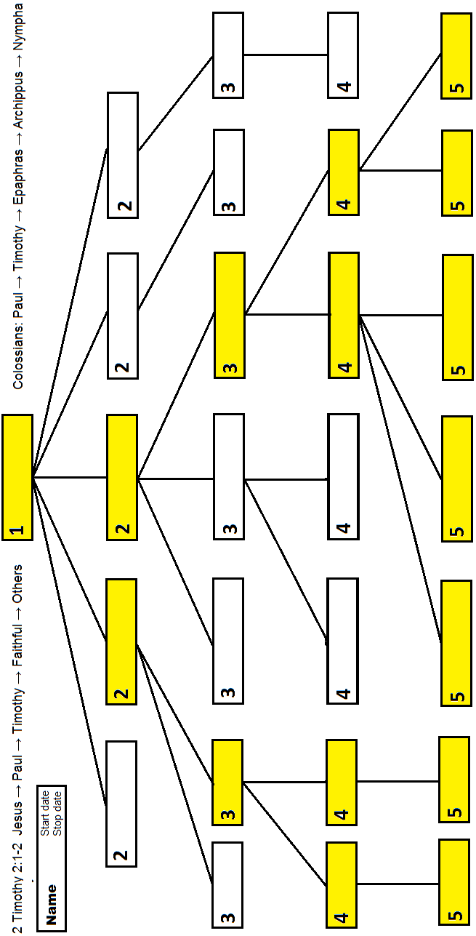

M6 Geographical Map
Shepherds draw a map, indicating the location of their main church and all other gatherings that have been planted under his ministry. They indicate the location of all new churches and gatherings, along with the year each one started. If any no longer exist, then they indicate the year in which each one dissolved. Even if a church or gathering has defected to another denomination, still show it on this map. Write on every map, the date, the map-maker’s name, shepherd’s name, and other information that you need to know. When the map is complete, the shepherds takes its photo.
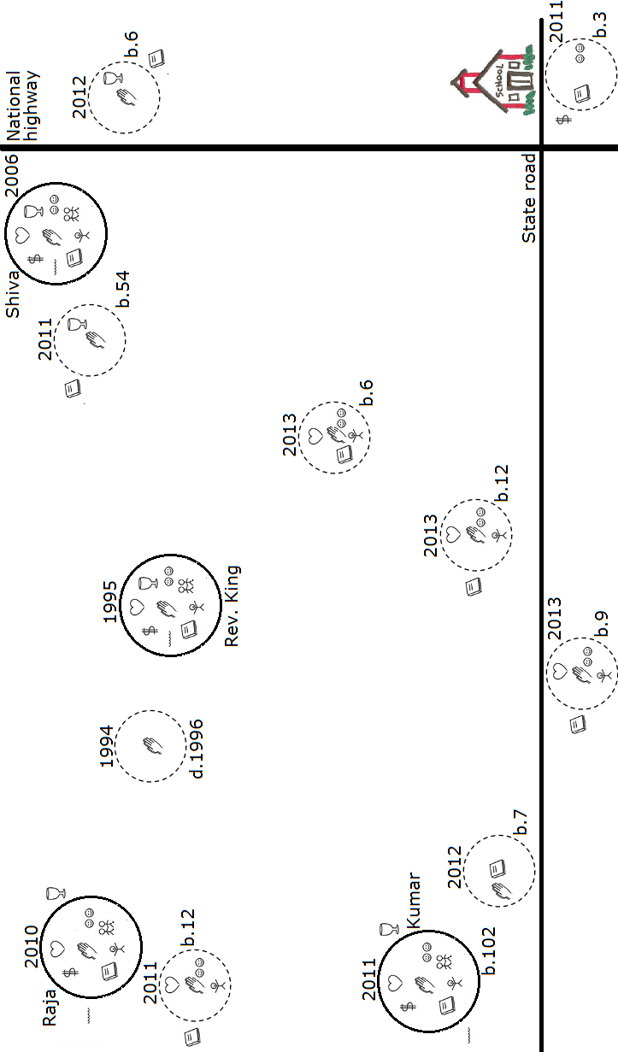

M7 Kinship chart
Show churches and gatherings in a chart that draws lines from each ‘mother’ church to its ‘daughter’ churches and gatherings. Indicate location, starting date, ending date, leader’s name, baptisms and typical attendance. Afterwards, employ the ‘church circles’ symbols to indicate the current health of new church and new fellowship. Write on every map, the date, surveyor’s name, pastor’s name, church and denominational name, and state, district and commune. When the chart is complete, both the worker and the pastor take a photograph of it.

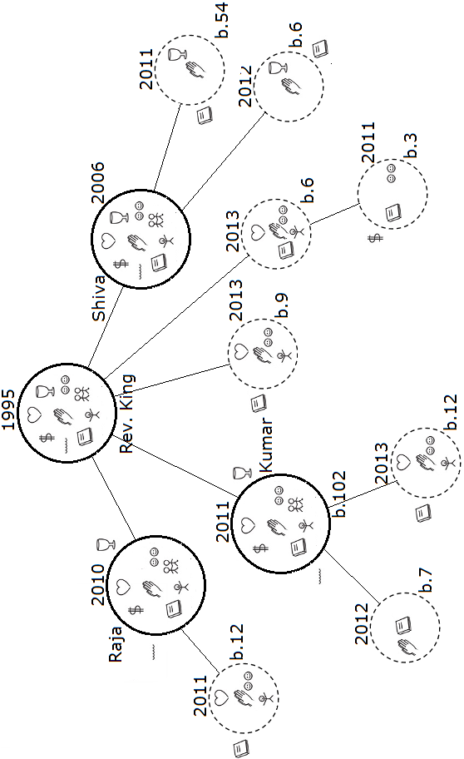

Module 5
Stay on track with new fields:
Monitor expansion outcomes

How did the apostles track new fields?
(a) Acts 1:8 2:5 6:7 (b) Acts 8:1 8:4 8:25 8:27 (c) Acts 9:31 10:1 11:18
(d) Acts 13:4 13:48-49 19: 10 19:20 20:4 (e) Rom. 15:19 2 Cor. 10:16

Keep penetrating new fields?
- Obtain or draw maps showing neglected communities.
- Collect demographic and spiritual facts about them.
- Send these facts to churches and ministries, requesting prayer.
- Present these facts in churches and conferences.
- Pray to the Lord of the harvest for workers.
- Coordinate with other ministries to penetrate new communities.
- Train, commission, send and mentor workers.

How will you keep track new fields?
- Form a task group and plan together to penetrate new communities.
- Who will send whom?
- Who will report to whom?
- What facts must they report?
- In what form will they record these facts?
- Who will train them to do so?
- Draft up Sample report form.
- How often will they report these facts?
- How will you classify those facts? (Place? Age? Ethnicity? Language? Literacy?)
- Write down your plan and pray for each other to implement this plan.

Sample field training for church planters.
- See Appendix E: Expansion Training

Sample field tracking tools.
X1 Ex[ansion tracking tool for eaders
X2 Ex[ansion tracking tool for supervisors
X3 Ex[ansion tracking tool for sponsors


