Powellhurst Men
Hebrews 2:5–3:2
Discussion Queries
Logic: Having shown that God’s Son is greater than all angels, the text now explains why he became a human being.
Read 2:5-8a
1) How will things change in the 'world to come'?
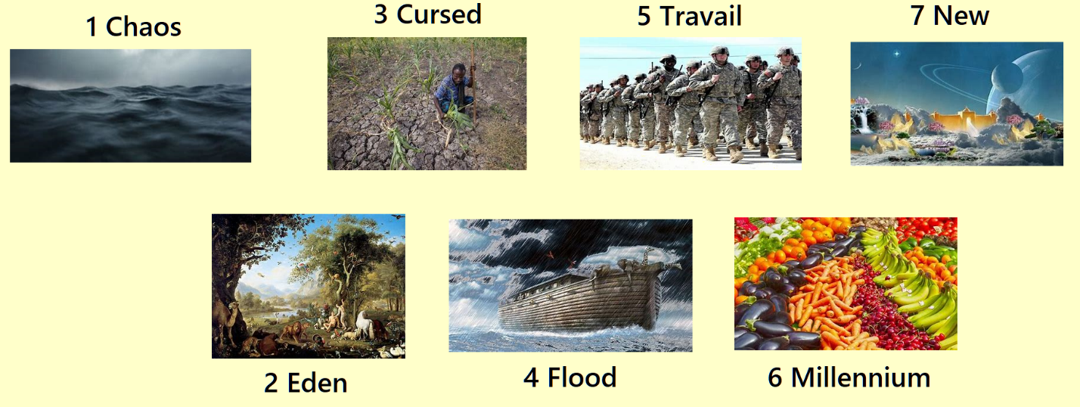
Read 2:8b-9
2) How have things changed since Jesus came?
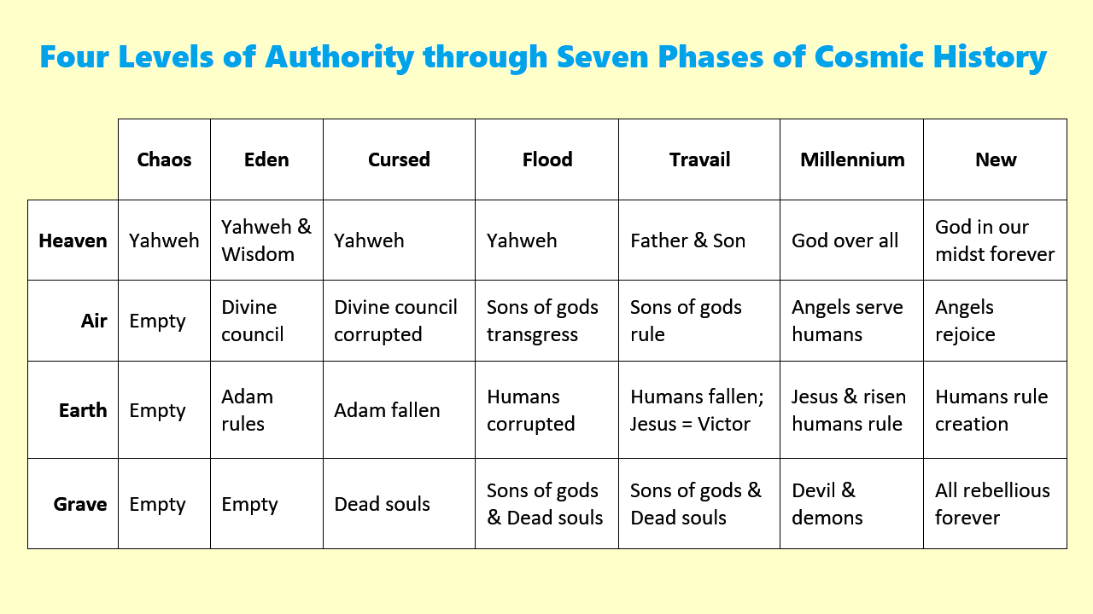
Download from hebrews.currah.download

Read 2:10-13,
3) What did Jesus accomplish at his first coming?
4) What benefits does Jesus bring to human beings?
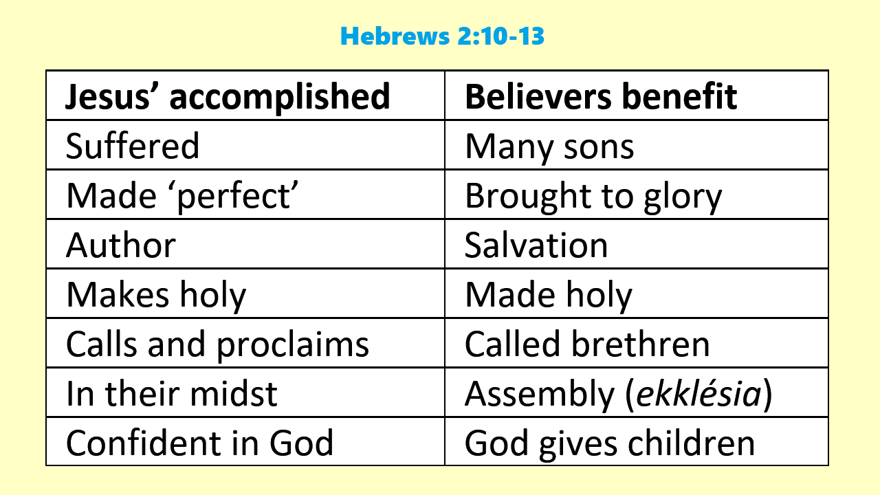

Read 2:14-16
5) In what ways has Jesus solved the problem of death?
6) In 2:15, does 'fear of death' mean
(a) humans were afraid to die?
(b) they were under threat of eternal death?
7) The devil's 'power of death', does this mean:
(a) the devil goes about killing humans?
(b) he rules over the dead in the underworld?
(c) he demands that God damn sinners?

Read 2:17-18
8) What work has Jesus completed on our behalf?
9) What work does Jesus perform on our behalf?
10) How would this matter to us, if authorities demanded that we renounce allegiance to Jesus?

Read 3:1-2
11) In what ways were Moses and Jesus faithful apostles?
12) In what ways were Moses and Jesus faithful high-priests?
See Lesson 3 on Hebrews 3:3–19

