**REPENTANCE**

**Biblical Theology**

20 & 23 June 2024

**Biblical theology**

1. Read Scripture.  
2. Identify recurring themes.

3. Assemble passages dealing with a theme.

4. Analyze and compare those passages.

5. Summarize their content.

6. Formulate a tentative doctrine.

7. Ask others to assess that doctrine.

8. Teach that doctrine humbly.

**Repentance, definition (BDAG)**

Noun

● *Metanoia*: *meta* = ‘change’ + *noia* = ‘mind’

● Meaning: ‘turning about, conversion’

Verb

● *Metanoeō*: *meta* = ‘change’ + *noeō* = ‘think’

● Meaning: “1 change one’s mind, 2 feel remorse, repent, be converted” (BDAG)

|  |  |
| --- | --- |
| **First Testament repentance**  ● In captivity (1 Kings 8:47)  ● Any man (Psa. 7:11-12)  ● The Ninevites (Jonah 3:4-10; Luke 11:32  ● Jerusalemites (Jer. 5:3; 8:4-5; 15:7; 26:3)  ● Israelite idolators (Eze. 14:5-7; )  ● Israelite transgressors (Eze. 18:30-32; 33:11)  ● Israel (Isa. 9:13) | **First Testament examples**  ● Job (Job 42:6)  ● Rahab (Josh. 2:11)  ● Jonah (Jon. 2:7)  ● Ninevites (Jon. 3:8; Luke 11:32)  ● David (Psa. 51)  ● Ruth (Ruth 1:14-15)  ● Naaman (2 Kings 5:17) |

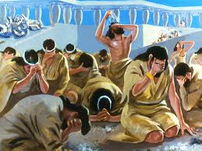**New Testament examples**

● Zacchaeus (Luke 19:8)

● Jews at Pentecost (Acts 2:36-38)

● Judeans with John (Matt. 3:1-2)

● Galileans (Matt. 4:17)

● Saul/Paul (Acts 9:17-18)

● Thief (Luke 23:41-43)

● Pagans (1 Thess. 1:9-10)

**Assembled passages**

Jews repent (Acts 2:36-40)

Gentiles repent (2 Thess. 1:7-10)

John’s ministry (Mark 1:4; Matt. 3:8; Luke3:10-14)

Jesus’ ministry (Mark 1:15; Luke 5:32; Matt. 11:20; Luke 13:3-5; 15:7, 10; 24:47)

The apostles’ ministry (Acts 2:38; 11:18; 17:30; 19:4; 20:21; 26:19-20)

New Testament epistles (Rom. 2:4; 2 Cor. 7:10; 2 Pet3:9)

Repent from what? (2 Cor. 12:21; Heb. 6:1, 6; Rev. 2:5; 12:21; 3:17-19; 9:20-21)

Repent unto what (Matt. 3:8; Luke 3:8; Mark 1:15; Acts 2:38; 11:18; 19”4; 26:20; 2 Cor 7:10; Acts 26:20; Rev. 2:5; 16:9; 1 Thess.1:6-10)

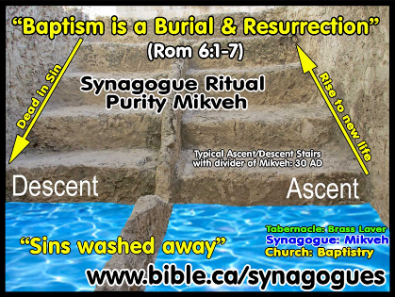**Repentance & faith for salvation**

1. We leave our former beliefs and sins.

2. We put our trust in the Lord Jesus Christ.

3. God forgives us everything we ever did.

4. We get baptized and join a church.

5. God gives to us his indwelling Holy Spirit.

6. We learn to please God by how we live.

7. When we mess up, we repent and return.

**Repentance & faith in evangelism**

1. In Bible studies, ask readers what they have learned about sin.

2. Explain how God will forgive those who regret and abandon their sins & gods.

3. Recount how Jesus died and rose to life to save forever those who trust in him.

4. Offer God’s Spirit and everlasting life.

5. Invite them to quit their big sins, to trust in Jesus, and to be baptized.

