SIX CYCLES OF THE APOCALYPSE
Galen Currah, October 2021

Most Bible scholars, believers and skeptics alike, recognize that the New Testament Book of Revelation has a structured consisting of several sections or cycles, and that these cycles overlap in their portrayal of cosmic history. Some have noted that the book conforms to the classic Greek tragedy, a popular form of theatre in the Roman empire. See https://en.wikipedia.org/wiki/Greek_tragedy

Commentators observe that each of the cycles begins with (1) a vision of events or beings in heaven, leads into (2) events and beings on earth, and ends with (3) praise or prayers to the God of heaven. Whilst commentators differ slightly as to the end of one cycle and start of another, I suggest the following outline of six episodes, organized around the repeated reference to ‘a time, times and a half time’.

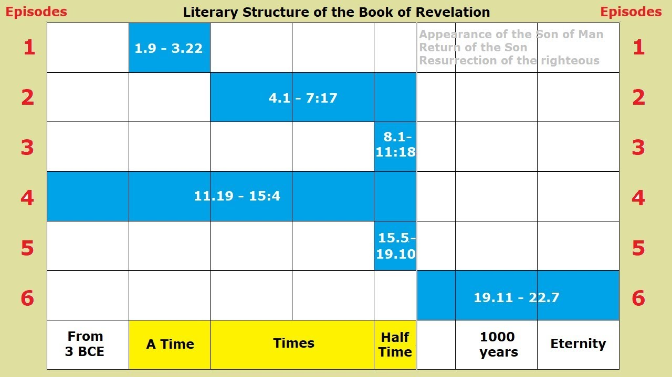
From https://youtu.be/Hj-oY4cd9I8

Opening 1:1-8. God → Revelation → Jesus → Angel → John → Readers → Hearers.
● Episode 1 1:9–3:22. Jesus and seven churches. Loyalty to Jesus and future rewards.
● Episode 2 4:1–7:17. A sealed scroll from heaven. The Lamb, Israel and Gentiles nations.
● Episode 3 8:1–11:18. Seven trumpet judgements. Two end-times witnesses.
● Episode 4 11:19–15:4. Overview of cosmic history from 3 BCE till the fall of ‘Babylon’.
● Episode 5 15:5–19:10. Seven plagues of God’s wrath against cosmic Babylon.
● Episode 6 19:11–22:7a. The victorious return of Jesus, his reign, and the new heaven and earth.
Closing 22:7b-24. John → Prophecy. Jesus → Angel → Churches → Hearers

Popular prophesy preachers often start with a contrived calendar of the end-times events, then try to make Revelation follow that calendar, forcing the details fit their scheme.

The Lord willing, our Powellhurst men’s Bible study of November 4th will deal with Revelation 11:19–13:10, observing how it affirms the teaching of Jesus and of Paul that we encountered over the past two months of studies, including instruction for believers who must endure end-of-days troubles, awaiting Jesus’ appearance and return.

