Brief Introduction to
Acts 1:1-11

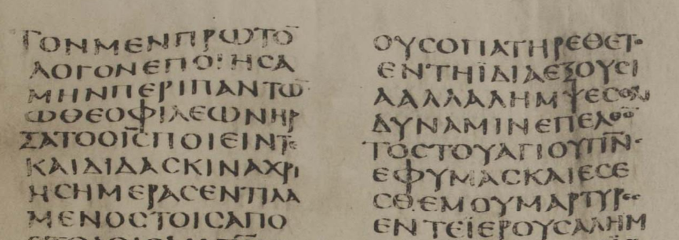
Acts 1:1, Codex Sinaiticus, fourth century CE

In these 11 verses, Luke presents the major themes of the entire book, providing an outline of its contents, which match the spread of Christianity between 33 and 62 CE.

¹ In the first book, O Theophilus, I have dealt with all that Jesus began to do and teach, ² until the day when he was taken up, after he had given commands through the Holy Spirit to the apostles whom he had chosen.
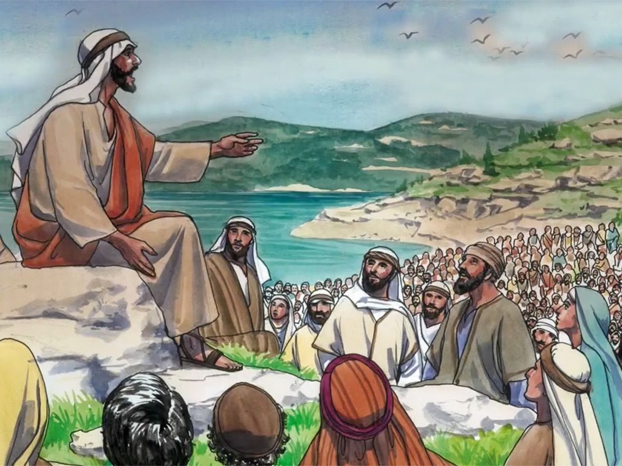

NOTES

Ancient writers used to dedicate their books to a patron who supported them.

In verses 1 and 2, Luke connects this book with his Gospel, introducing seven themes that he will amplify or explain in the following verses, much as a bud grows and expands into a flower. These include:

1. Luke’s role as historian (Gospel of Luke)
2. Jesus’ historical deeds (Suffering & death)
3. Jesus’ teaching (Kingdom of God)
4. Jesus’ chosen apostles (eleven still alive)
5. Jesus’ last commands (to wait, to witness)
6. Jesus’ soon ascension (risen & taken up)
7. Jesus and the Holy Spirit (promised coming)
DISCUSS

(A) What was Luke’s previous book (logos)?
● The Gospel of Luke.

(B) Who was Theophilus?
Two interpretations:
● Luke’s patron who supported his writing project.
● Any reader who loves God or is loved by God, the meaning of the name Theophilus.

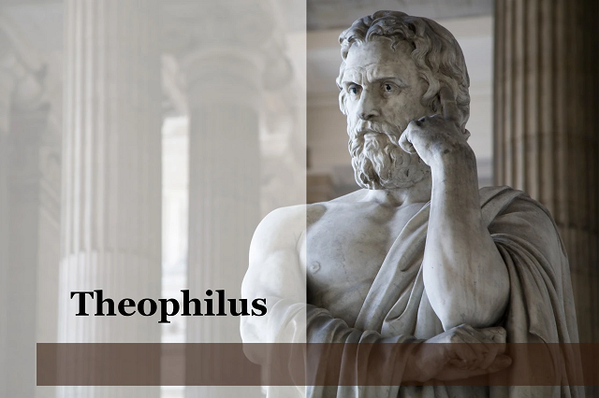

(C) What period is included between “began to do” and “until he was taken up”?
Two interpretations:
● What Jesus began on earth he continues to do from heaven.
● The period between Jesus’ birth and his resurrection.

(D) What commands did Jesus give?
See verses 4 and 8.
● Remain in Jerusalem.
● Wait for the Father to send the Holy Spirit.

(E) What did Jesus do “through the Holy Spirit”?
Two interpretations:
● Jesus gave commands through the Spirit. (But Luke’s Gospel says nothing about this idea.)
● If this phrase looks forwards to verses 5 & 8, then it may mean “about the Holy Spirit”.not “through” but “about the Spirit”.

³ He presented himself alive to them after his suffering by many proofs, appearing to them during forty days and speaking about the kingdom of God.

NOTES

The Kingdom of God has many meanings in the Bible, but for many ancient Jews, it meant that God would one-day make Israel to rule over all nations. (Jesus never denied this meaning.)

DISCUSS

(F) What was Jesus’ “suffering”?
● Arrest, beating, scourging, crucifixion...

(G) What were Jesus’ “many proofs”?
● Appearing, speaking, showing his wounds, eating, repeatedly during 40 days.

(H) What did Jesus say about “the Kingdom of God”?
See verses 6 and 7.
● Jesus has inaugurated the Kingdom of God,
● but the Father has delayed its fulfillment.

⁴ And while staying with them he ordered them not to depart from Jerusalem, but to wait for the promise of the Father, which, he said, “you heard from me; ⁵ for John baptized with water, but you will be baptized with the Holy Spirit not many days from now.”

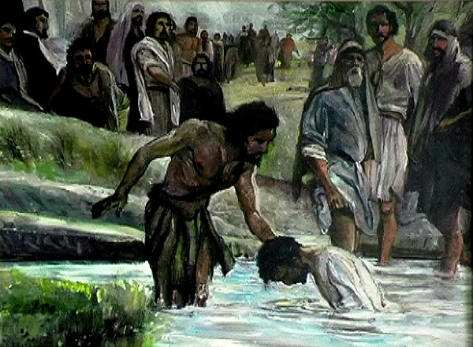

NOTES

Matthew 3:11 “I baptize you with water for repentance, but He who is coming after me is mightier than I...; He will baptize you with the Holy Spirit and fire.”

John 7:37 “If anyone thirsts, let him come to me and drink. ... This he said about the Spirit.”

“Baptism in the Holy Spirit” happens four times in The Acts: (1) with Jews, (2) with Samaritans, (3) with Gentiles and lastly (4) with disciples of John the Baptist.

Thus, in 1 Corinthians 12:13, Paul will write, “In one Spirit we were all baptized into one body—Jews or Greeks, slaves or free—and all were made to drink of one Spirit.”

DISCUSS

(I) What was so important about Jerusalem?

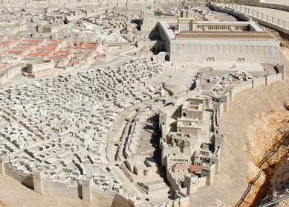

● Jerusalem was whither the Holy Spirit would descend ten days later.
● Jerusalem was where Jews and Gentile converts would be gathering by their 1000s, including those from the lost northern tribes of Israel.
● Jerusalem was, one day, to become the capital city of Messiah’s coming kingdom, whence his glory was to go out to the nations.
● Jerusalem = Mount Zion = Har-Moghed = “the far north” = City of the Great King.

(Ja) What did the title“Holy Spirit” mean to Jews before Pentecost?
● See Isaiah 63:10-11: “They grieved his Holy
Spirit” he who put in the midst of them his Holy Spirit”.

(Jb) What does it mean to “be baptized in the Holy Spirit”?
● See verse 8: “when the Holy Spirit has come upon you”.

⁶ So when they had come together, they asked him, “Lord, will you at this time restore the kingdom to Israel?” ⁷ He said to them, “It is not for you to know times or seasons that the Father has fixed by his own authority.

NOTES

“Come together” = possibly “enjoying a meal together” (literally, ‘taking salt together’).

“The Kingdom” = now that Messiah was come, they expected him to make Israel great again.

DISCUSS

(K) How does Christian hope build upon Jewish eschatology?
● Most Christians affirm Israel’s future hope.
● Most Christians affirm that Israel’s future has begun with Jesus’ coming, death, resurrection and ascension as reigning King.
● Most Christians affirm that final fulfillment awaits Jesus’ return.
● Most Christians affirm that all Gentile communities must receive Jesus’ good news before Jesus return and fulfill his reign on earth.

(L) What are some of the “times or seasons” about which we have learned from other Scriptures?

Some or all of the following:
● Israel invaded and made desolated (65-72 CE).
● “The days [season] are evil”.
● “Stand in the evil day”.
● The rebellion and rule of an Antichrist.
● 42 months of troubles and endurance.
● Jesus’ coming in clouds as conqueror.
● The Day of the Lord.
● A 1000-year reign.
● The everlasting new heaven and new earth.

⁸ But you will receive power when the Holy Spirit has come upon you, and you will be my witnesses in Jerusalem and in all Judea and Samaria, and to the end of the earth.”

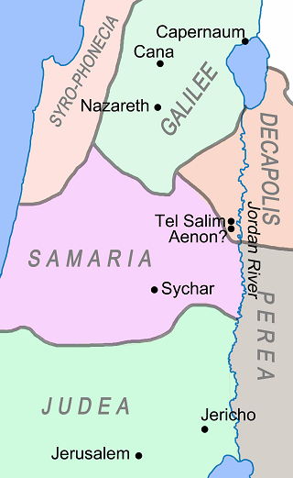

NOTES

Luke structures the entire Book of Acts by this pattern. See video at powellhurstmen.website on the “Structure of the Book of Acts”.

Some called Rome “the end of the earth”, others Tarshish or Spain where Paul would later seek to go.

DISCUSS

(M) What would power from the Holy Spirit enable Jesus’ apostles to do?
● Bear witness to what they had heard Jesus say, and had seen him do.
● Undertake mission to ethnic communities in other regions.

(N) What does power from the Holy Spirit enable Christians to do, today?

⁹ And when he had said these things, as they were looking on, he was lifted up, and a cloud took him out of their sight. ¹⁰ And while they were gazing into heaven as he went, behold, two men stood by them in white robes, ¹¹ and said, “Men of Galilee, why do you stand looking into heaven? This Jesus, who was taken up from you into heaven, will come in the same way as you saw him go into heaven.”

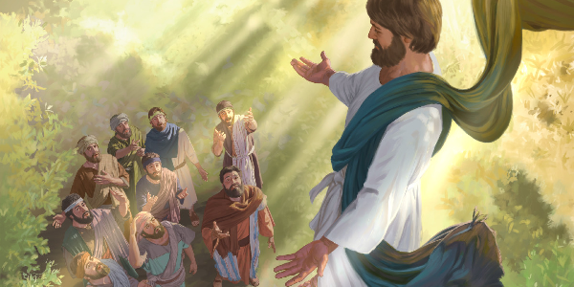

NOTES

In these verses, “heaven” could have two referents: (1) the visible sky and (2) the invisible abode of God.

Angels from the invisible heaven often appear in the Bible as men. (Nowhere in the Bible do angels have wings. Only throne guardians.)

DISCUSS

(O) What was that cloud?
Interpretations:
● An atmospheric cloud.
● A crowd of heavenly beings.
● A cloud of glory from God.

(P) Why did God choose to remove Jesus from earth in such a silly, visible manner?

Suggestions
● So that his apostles would know that he really still exists, is alive, and is in his glorified body.
● So that all Christians would know what to look for upon Jesus’ return and appearance in the clouds.
● So that Bible readers may know that Jesus is the Son of Man described in Daniel 7:13-14.

So, then, what do we take away from today’s study?
Facts to know:
Truths to believe:
Examples to follow:
Orders to obey:
Questions to answer:

