BAPTISM OF GENTILES IN THE HOLY SPIRIT
Acts 10 & 11 (NRSVue)

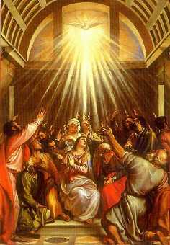

Contextual Outline
I. Jesus promises power for witness to the nations. 1:1-11
II. The apostles witness in Jerusalem and Judea. 1:12–6:7
III. Believers witness in Judea and Samaria. 6:8–9:31
IV. The apostles witness to gentiles. 9:32–14:28
V. The Lord affirms the conversion of gentiles. 15:1-16:5
VI. Paul preaches the gospel to the Greeks. 16:6–19:20
VII. Paul preaches the gospel to the Romans. 21:15–28:31

[Text between square brackets reflects variant readings from ancient manuscripts of the fifth century or earlier. + = mss add, – = mss omit, ~ = mss replace.]
Background Scriptures

John the Baptist: “I have baptized you with water, but he will baptize you with the Holy Spirit.” Mark 1:8

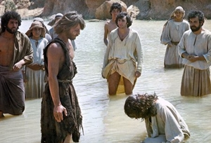
Messiah Jesus: “Let anyone who is thirsty come to me, and ... drink.” … Now he said this about the Spirit, which believers in him were to receive. John 7:37-39

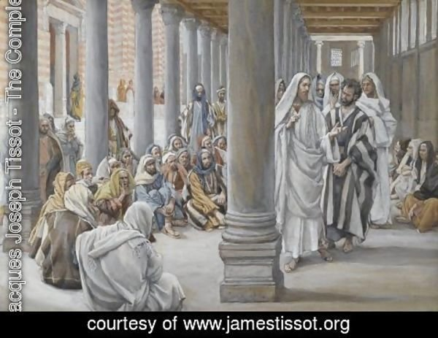
Apostle Paul: “In the one Spirit we were all baptized into one body—Jews or Greeks, slaves or free—and we were all made to drink of one Spirit.” 1 Corinthians 12:13
Theological Definitions

Baptism in/of/with the Holy Spirit: God has poured out his Spirit upon the major ethnic communities. Since then, every baptized Christian believer within those communities receives this Spirit.

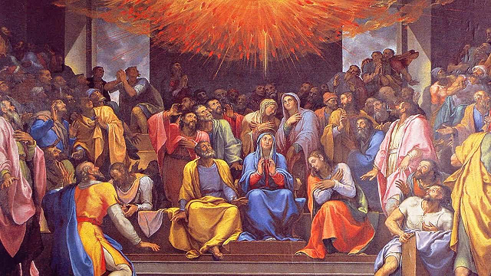

Filling with the Holy Spirit: God enables Christians, through his Spirit, to obey Jesus’ commandments, and to speak on his behalf.
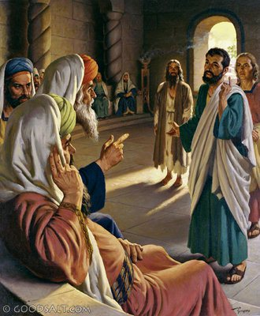
ACTS 10
NRSVue 2022, the most recent Bible version in English

1. The Lord sends a vision to a ‘man of peace’

¹ In Caesarea there was a man named Cornelius, a centurion of the Italian Cohort, as it was called. ² He was a devout man who feared God with all his household; he gave alms generously to the people and prayed constantly to God.
³ One afternoon at about three o’clock he had a vision in which he clearly saw an angel of God coming in and saying to him, “Cornelius.” ⁴ He stared at him in terror and said, “What is it, Lord?” He answered, “Your prayers and your alms have ascended as a memorial before God. ⁵Now send men to Joppa for a [certain] Simon who is called Peter; ⁶ he is lodging with Simon, a tanner, whose house is by the seaside.”

⁷ When the angel who spoke to him had left, he called two of his slaves and a devout soldier from the ranks of those who served him, and after telling them everything he sent them to Joppa.

Cornelius: A gentile believer in Israel’s God. May not have converted to Judaism or attended synagogue.

Discuss: Does God approve of the good works of those not yet born again (regenerate)? See 10:35. Compare Romans 2:14; contrast Romans 8:7-8.

2. The Lord prepares a Christian worker

⁹ About noon [~3 pm] the next day, as they [~these] were on their journey and approaching the city, Peter went up on the roof to pray. ¹⁰ He became hungry and wanted something to eat, and while it was being prepared he fell into a trance. ¹¹ He saw the heaven opened and something like a large sheet coming down, being lowered to the ¹² In it were ground by its four corners. all kinds of four-footed creatures and reptiles and birds of the air.

Trance (ἔκστασις, ekstasia): Used in Septuagint of Adam (Gen. 2:21) and of Abraham (Gen. 15:12), for Hebrew תַּרְדֵּמָה tardémah “deep sleep”.

¹³ Then he heard a voice saying, “Get up, [–Peter]; kill and eat.” ¹⁴ But Peter said, “By no means, Lord, for I have never eaten anything that is profane or unclean.” ¹⁵ The voice said to him again, a second time, “What God has made clean, you must not call profane.” ¹⁶ This happened three times, and the thing was suddenly taken up to heaven.

Discuss: What is it that God has made clean?

3. The Lord arranges for them to meet

¹⁷ Now while Peter was greatly puzzled about what to make of the vision that he had seen, suddenly the men sent by Cornelius appeared. They were asking for Simon’s house and were standing by the gate. ¹⁸ They [~he] called out to ask whether Simon, who was called Peter, was staying there.
¹⁹ While Peter was still thinking about the vision, the Spirit said [–to him], “Look, three men are searching for you. ²⁰ Now get up, go down, and go with them without hesitation, for I have sent them.” ²¹ So Peter went down to the men and said, “l am the one you are looking for; what is the reason for your coming?”

²² They answered, “Cornelius, a centurion, a righteous and God-fearing man who is well spoken of by the whole Jewish people, was directed by a holy angel to send for you to come to his house and to ²³ hear what you have to say. Peter invited them in and gave them lodging.

Man of peace: Luke 10:6. Righteous, well spoken of, hospitable. May come to you. Look for such folk!

4. The man of peace gathers other folk

The next day he got up and went with them, and some of the brothers and sisters from Joppa accompanied him: ²⁴ The following day they [~he] came to Caesarea. Cornelius was expecting them and had called together his relatives and close friends. ²⁵ On Peter’s arrival, Cornelius met him and, falling at his feet, worshipped him.

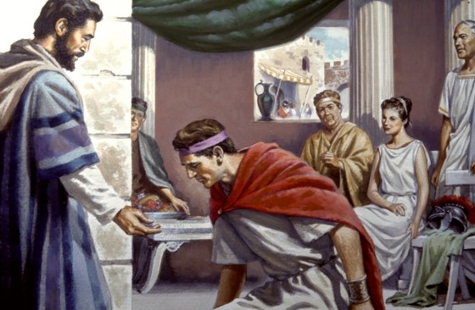

Man of peace: He gathers family and friends in his own home to hear about Jesus.

²⁶ But Peter made him get up, saying, “Stand ²⁷ And as he up; I am only a mortal. talked with him, he went in and found that many had assembled, ²⁸ and he said to them, “You yourselves know that it is improper for a Jew to associate with or to visit an outsider [man], but God has shown me that I should not call anyone profane or unclean. ²⁹ So when I was sent for, I came without objection. Now may I ask why you sent for me?”

Humility: We must accept invitations to come share in uncomfortable circumstances.

5. The Christian worker listens carefully

³⁰ Cornelius replied, “Four days ago at this very hour, at three [–o’clock], I was praying in my house when suddenly a man in dazzling clothes stood before me. ³¹ He said, ‘Cornelius, your prayer has been heard, and your alms have been remembered before God. ³² Send therefore to Joppa and ask for Simon, who is called Peter; he is staying in the home of Simon, a tanner, by the sea.’ [+who,] When he comes, will speak with you. ³³ Therefore I sent for you immediately, and you have been kind enough to come. So now all of us are here in the presence of God to listen to all that the Lord has commanded you to say.”

Man of peace: Invites you to explain the Good News. Do not forget to do so. If s/he refuses Christ, then he will be lost, despite his good works.

6. The worker relates the Good News about Jesus

³⁴ Then Peter began to speak to them [~Peter replied]: “l truly understand that God shows no partiality, ³⁵ but in every people anyone who fears him and practices righteousness is acceptable to him.

Partiality: Preference for Jews over gentiles, Whites over Blacks, rightists over leftists, rich over poor, westerners over easterners.

Acceptable: Luke 4:24 ‘accepted’ (by men). Elsewhere of persons or practices approved by God.

³⁶ [+For] You know the message [+which] he sent to the people of Israel, preaching peace by Jesus Christ—he is Lord of all. ³⁷ That message spread throughout Judea, beginning in Galilee after the baptism that John announced: ³⁸ how God anointed Jesus of Nazareth with the Holy Spirit and with power; how he went about doing good and healing all who were oppressed by the devil, for God was with him.
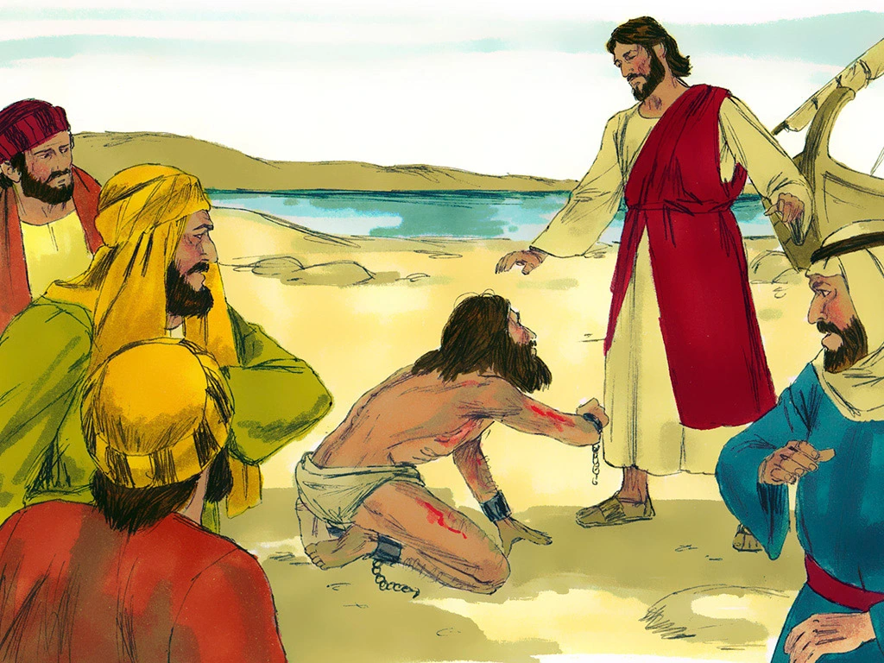

Peace: Between Jews and gentiles.
Lord of all: All ethnicities.
John: Better known than Jesus. Baptized Jews.
Nazareth: Customary designation used with common names.

Peter’s doctrine about Jesus’ life
1. Jesus is Messiah
2. Jesus brought peace
3. He is Lord of all
4. God anointed him with his Holy Spirit (anoint = χρίω, chriō ► Χριστός, christos = Christ)
5. Jesus did good by healing the oppressed (Greek hendiadys = 2 words/phrases for one idea)
6. He was stronger than the devil
7. God was with him.

³⁹ We are witnesses to all that he did both in Judea and in Jerusalem. They put him to death by hanging him on a tree, ⁴⁰ but God raised him [–on] the third day and allowed him to appear: ⁴¹ not to all the people but to us who were chosen by God [–as witnesses and] who ate and drank with [–him] after he rose from the dead.

Peter’s doctrine about Jesus’ resurrection
1. We (apostles) are (eye)witnesses to all that Jesus did.
2. They crucified Jesus (public execution).
3. God raised him (back to life) from amongst the dead.
4. He appeared to witnesses who knew him.

⁴² He commanded [~instructed] us to preach to the people and to testify that he [~this] is the one ordained by God as judge of the living and the dead. ⁴³ All the prophets testify about him that everyone who believes in him receives forgiveness of sins through his name.”

Peter’s doctrine about Jesus’ authority
1. We must testify by preaching (Greek hendiadys).
2. God has made Jesus judge over the quick & the dead.
3. The prophets testify about him.
4. God forgives the sins of those who believe in Jesus.
5. This comes through Jesus’ Name.

7. Folk believe, receive the Spirit and get baptized

⁴⁴ While Peter was still speaking, the Holy Spirit fell upon all who heard the word. ⁴⁵ The circumcised believers who had come with Peter were astounded that the gift of the Holy Spirit had been poured out even on the gentiles: ⁴⁶ for they heard them speaking in tongues and extolling God. Then Peter said, ⁴⁷ “Can anyone withhold the water for baptizing these people who have received the Holy Spirit just as we have?” ⁴⁸ So he [~they] ordered them to [~that they] be baptized in the name of Jesus Christ. Then they invited him to stay for several days.

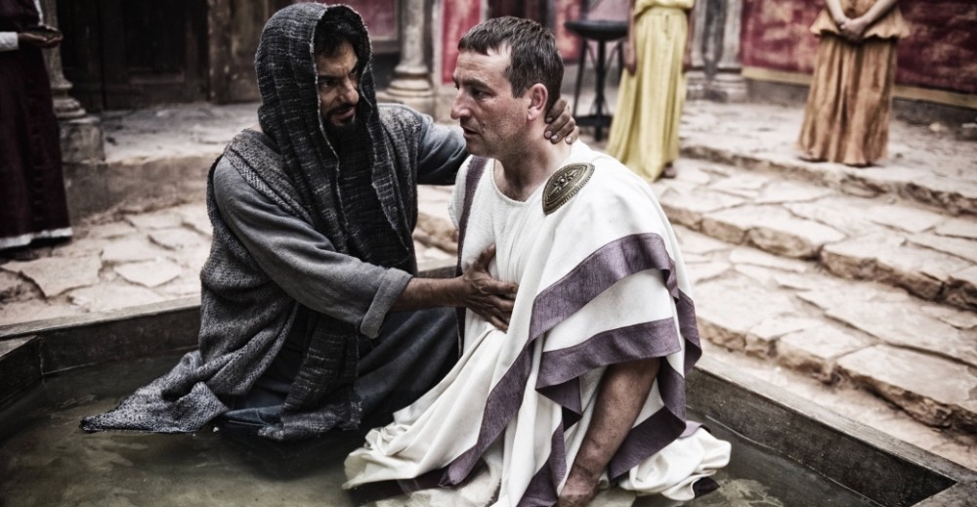

Fell: The Spirit came from above, suddenly
Speaking: Literally ‘his words’ (rhéma)
Heard (44): ‘are listening’ present tense, attentively
Word: the message (logos), content of words.
Circumcised: Jewish believers who know Aramaic
Poured out: An act of God, not their own emotions
Heard (46): ‘were hearing’
Speaking: extolling God in other languages (Greek hendiadys: probably Aramaic).
In the Name: goes with ‘ordered’? or with ‘be baptized’?

ACTS 11

8. The Christian worker explains his reasons

¹ Now the apostles and the brothers and sisters who were in Judea heard that the gentiles had also accepted the word of God. ² So when Peter went up to Jerusalem, the circumcised believers criticized him: ³ saying, "Why did you [singular/plural] go to uncircumcised men and eat with them?"

⁴ Then Peter began to explain it to them, step by step, saying, ⁵ I was in the city of Joppa praying, and in a trance I saw a vision. There was something like a large sheet coming down from heaven being lowered by its four corners, and it came close to me. ⁶ As I looked at it closely I saw four-footed animals, beasts of prey, reptiles, and birds of the air. ⁷ also heard a voice saying to me, ‘Get up, Peter; kill and eat.’ ⁸ But I replied, ‘By no means, Lord, for nothing profane or unclean has ever entered my mouth.’ ⁹ But a second time the voice answered from heaven, ‘What God has made clean, you must not call profane.’ ¹⁰ This happened three times; then everything was pulled up again to heaven.

9. The Christian worker explains his actions

¹¹ At that very moment three men, sent to me from Caesarea, arrived at the house where we were [~I was]. ¹² The Spirit told me to go with them and not to make a distinction between them and us. These six brothers also accompanied me, and we entered the man’s house: ¹³ He told us how he had seen the [~an] angel standing in his house and saying, ‘Send to Joppa and bring Simon, who is called Peter; ¹⁴ he will give you a message by which you and your entire household will be saved.’
Entire household: Can families be converted at the same time? Compare Acts 16:31, “Believe in the Lord Jesus, and you will be saved, you and your household.”
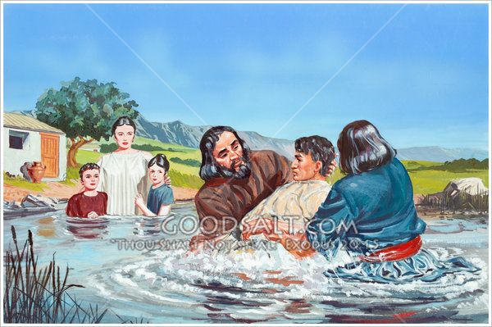

¹⁵ And as I began to speak, the Holy Spirit fell upon them just as it had upon us at the beginning: ¹⁶ And I remembered the word of the Lord, how he had said, ‘John baptized with water, but you will be baptized with the Holy Spirit.’ ¹⁷ If then God gave them the same gift that he gave us when we believed in the Lord Jesus Christ, who was I that I could hinder God?”

As upon us: Baptism of the Spirit for Jews (Acts 2).
The beginning (arché): “repentance and remission of sins should be preached in his name among all nations, beginning (archō) at Jerusalem Luke 24:47
Word of the Lord: Acts 1:5
To them ... to us: Jews and gentiles alike.

10. Christian leaders learn new theology

¹⁸When they heard this, they were silenced. And they praised [~began praising] God, saying, “Then God has given even to the gentiles the repentance that leads to life.”

Repentance: To stop disobeying God by putting faith in the Lord Jesus Christ.

Life: Everlasting life, including (a) a new life starting now, (b) rise from death at the resurrection when Jesus returns, and (c) living forever in Jesus’ coming Kingdom.

BAPTISM IN THE HOLY SPIRIT

The data (facts)

- God has kept his promise to pour out his Spirit upon “all flesh” (all ethnicities). See 1 Corinthians 12:13
- These included Jews (chapter 2), Samaritans (8), gentiles (10), and the disciples of John the Baptist (19).
- This happened to large gatherings.
- This happened to those who came to faith in Jesus when they heard the Good News.
- This happened in the presence of Jesus’ apostles.
- The “tongues” that they spoke were real languages, which those present understood as praise to God.
- There are no reports of this happening again, in the New Testament or in church history.
- Missionaries report similar, spontaneous events where they preach the Good News for the first time.

Implications and applications

- Baptism in the Holy Spirit was for the first Christians.
- Ever since, all who repent and come to faith in Jesus Christ receive the same Holy Spirit.
- Speaking “in tongues” is not a necessary sign of receiving the Holy Spirit.
- We may promise to unbelievers that they will receive the Holy Spirit when they put their faith in Jesus.
- We may trust the Holy Spirit (1) to convince pre-believers, (2) to regenerate new believers, and (3) to dwell with all believers.
- If you speak in tongues, then thank God, but do not shame Christians who have different gifts from God.
- Beware of those who preach “baptism in the Holy Spirit” as a way to recruit you into their church.
- Christians may be “filled with the Holy Spirit” whenever they need power to obey Jesus.

Acts 5:32, “We are witness to these things, and so is the Holy Spirit whom God has given [or ‘gives’, timeless aorist tense] to those who obey him.”

Ephesians 5:18, “Be filled [iternative present tense] with the Spirit, as you sing.”

