A Brief Introduction to
Acts 12:24-25; 13:1-4; 14:20-23, 27
with Dr Galen Currah
Progress outline of Acts
I. Jesus promises power for witness to the nations 1:1-11
II. The apostles witness in Jerusalem and Judea 1:12–6:7
III. Believers witness in Judea and Samaria 6:8–9:31
IV. The apostles witness to Gentiles 9:32–14:28
V. Jerusalem affirms the conversion of Gentiles 15:1-16:5
VI. Paul preaches the gospel to the Greeks 16:6–19:20
VII. Paul preaches the gospel to the Romans 21:15–28:31

Summary statements in Acts
“The Lord added to their number day by day those who were being saved” (2:47).
“So the word of God spread. The number of disciples in Jerusalem increased rapidly” (6:7).
“Then the church throughout Judea, Galilee and Samaria ... grew in numbers, living in the fear of the Lord” (9:31).
“The word of God continued to increase and spread” (12:24).

How Paul and Barnabas Planted Many Churches
in Ten Parts

1. Barnabas and Saul Move to a Less Reached City (12:24)
Ὁ δὲ λόγος τοῦ θεοῦ ηὔξανεν καὶ ἐπληθύνετο.
The, next, Word of God was increasing and was-being-multiplied.
²⁴ Thus, adherents to God’s [~the Lord’s] Message were increasing in number by multiplying.

adherents: metonymy = use of the name of one object or concept (Word of God) for that of another to which it is related (those who believed God’s message).
increasing and multiplying: hendiadys = two verbs used of a single action.
Increase = numerical; multiply = reproduction

2. Barnabas and Saul Prove Faithful Workers (12:25)
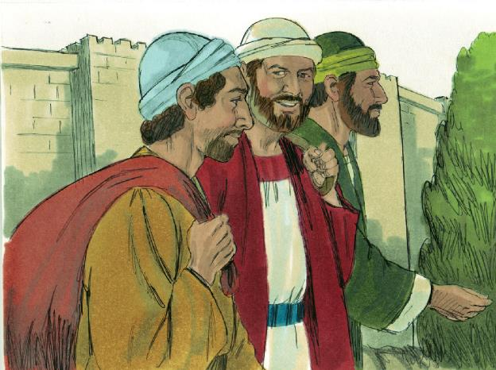
Images (c) Sweet Publications. Used with permission.
Βαρναβᾶς δὲ καὶ Σαῦλος ὑπέστρεψαν εἰς Ἰερουσαλὴμ πληρώσαντες τὴν διακονίαν, συμπαραλαβόντες Ἰωάννην τὸν ἐπικληθέντα Μᾶρκον.
Barnabas, and, and Saul returned unto Jerusalem having-fulfilled the ministry, taking-along-with John the-one-being-called Mark.
²⁵ So, Barnabas and Saul returned to Antioch [+from Jerusalem], Syria, having accomplished their mission [–to Jerusalem], bringing along with them John [~who was called upon] Mark.
Acts 11:30, “...send relief to the believers living in Judea; this they did, sending [apostellō, send as apostles] it to the elders by Barnabas and Saul.
to Jerusalem. Does it go with “returned” or with “mission”? Some translators replace the preposition “to” with “from”.
NOTE. From this point onwards, the Book of Acts shifts attention from Peter, Jerusalem and Judaism, to Paul and his mission to Gentiles.

3. Barnabas and Saul Learn to Make Disciples (13:1)
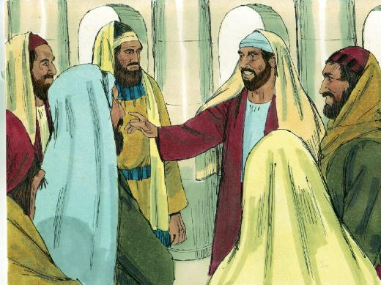
Ἦσαν δὲ ἐν Ἀντιοχείᾳ κατὰ τὴν οὖσαν ἐκκλησίαν προφῆται καὶ διδάσκαλοι ὅ τε Βαρναβᾶς καὶ Συμεὼν ὁ καλούμενος Νίγερ καὶ Λούκιος ὁ Κυρηναῖος, Μαναήν τε Ἡρῴδου τοῦ τετραάρχου σύντροφος καὶ Σαῦλος.
Were, and, in Antioch per the being assembly prophets and teachers, which included on-one-hand Barnabas, and Simeon the-one-being-called the African, and Lucius the Cyrenian, on-another-hand Manaen (of Herod the tetrarch reared-with), and Saul.
¹ Now, there were within Church at Antioch, prophets: Barnabas, Simeon called Nigerian, and Lucius the Cyrenian, and teachers: Manaen, who was reared with Herod the tetrarch, and Saul.
Church. All previous mentions of ‘church’ refer to the many house gatherings in Jerusalem, which were all Jewish. Here in 13:11, Luke refers to house gatherings in Antioch that included many Gentiles.
Prophets. Speak messages from the Holy Spirit. 1 Cor. 14:29-30
Teachers. Instruct disciples in obedience to Jesus’ commandments. Matt. 28:19 (Only here in the Acts.)
prophets … and teachers … Greek te … te divides the list of names into two groups.
Barnabas. Jew. From Judea.
Simeon. Gentile. From Africa.
Lucius. Gentile. From North Africa.
Manaen. Jew. From Galilee.
Herod Antipas. Governed Galilee, 4 BCE to 39 CE.
Saul. Jew. From Tarsus.
4. Barnabas and Saul Are Appointed Missionaries (13:2)

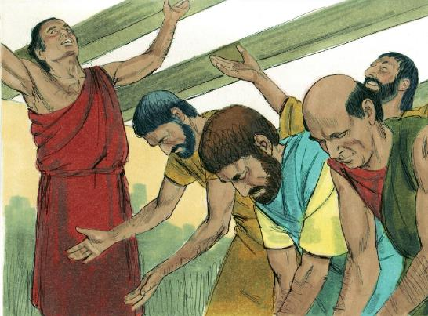

Λειτουργούντων δὲ αὐτῶν τῷ κυρίῳ καὶ νηστευόντων εἶπεν τὸ πνεῦμα τὸ ἅγιον· ἀφορίσατε δή μοι τὸν Βαρναβᾶν καὶ Σαῦλον εἰς τὸ ἔργον ὃ προσκέκλημαι αὐτούς.
Serving, and, they the Lord and fasting, said the Spirt the Holy One, ordain-apart now to-me the Barnabas and Saul for the work which I-have-summoned-to them.
² Well, whilst they were serving the Lord by fasting, the Holy Spirit said to them, ‘Separate now Barnabas and Saul for the work to which I have called them!’
Serving. Usually used of religious work.
By fasting. Greek Hendiadys. No time for meals.
Now. The Greek particle dé after a command makes it urgent.
Separate. A formal designation for particular work.
Called. A formal summons.

5. The Church Releases Barnabas and Saul (13:3)
τότε νηστεύσαντες καὶ προσευξάμενοι καὶ ἐπιθέντες τὰς χεῖρας αὐτοῖς ἀπέλυσαν.
Then, having-fasted and prayed, and having laid the hands upon them, they-released them.
³ Then, having prayed with fasting, they laid their hands on them and sent them off.
Fasting. Refraining from usual activities, in order to focus on ministry, on prayer or on hearing from the Lord.
6. They Leave for a Neglected ‘Field’ (13:4)

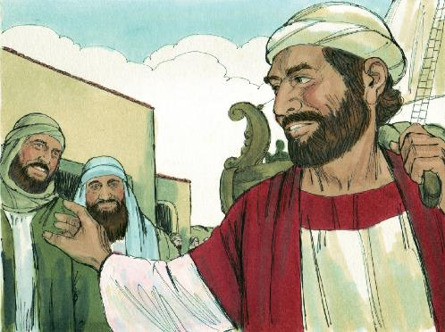
Αὐτοὶ μὲν οὖν ἐκπεμφθέντες ὑπὸ τοῦ ἁγίου πνεύματος κατῆλθον εἰς Σελεύκειαν, ἐκεῖθέν τε ἀπέπλευσαν εἰς Κύπρον…
These, therefore, having-been-sent-out first by the Holy Spirit, came-down-to Seleucia, secondly from-thence sailed-off for Cyprus.
⁴ So, after the Holy Spirit had sent them out, and they had come to [~from] Seleucia, Barnabas and Saul themselves sailed from there to Cyprus.
Greek men … te = both … and …
Sent. The church releases; the Holy Spirit sends; the missionaries book passage.
Themselves = emphatic Greek pronoun.
Cyprus. Nearest reachable, non-contiguous land, without going through Paul’s home city, Tarsus.
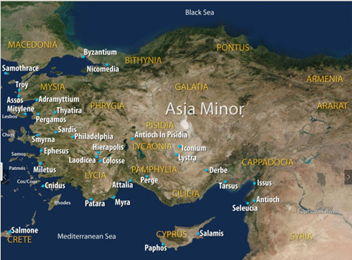

7. They Start Several, Simultaneous Works (14:20b)
Καὶ τῇ ἐπαύριον ἐξῆλθεν σὺν τῷ Βαρναβᾷ εἰς Δέρβην.
And the marrow, he-went-out with the Barnabas unto Derbe.
^{20b} And the next day, Paul left with Barnabas for Derbe.

Lystra … Derbe. Towns in the district of Lycaonia, in the Roman province of Galatia, in south-central Asia Minor, connected by a major route, about 100 kms or 60 miles apart.
Mission stratagem. While you start one church, start several others also.

8. They Communicate Christian Truth (14:21-22)
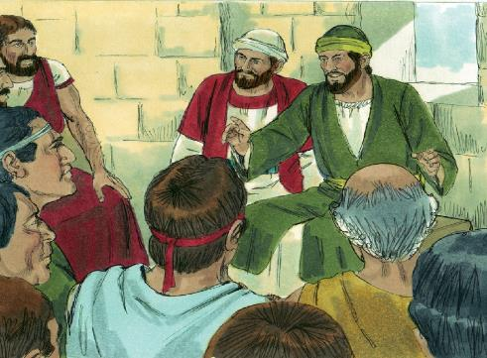
εὐαγγελισάμενοί τε τὴν πόλιν ἐκείνην καὶ μαθητεύσαντες ἱκανοὺς ὑπέστρεψαν εἰς τὴν Λύστραν καὶ εἰς Ἰκόνιον καὶ εἰς Ἀντιόχειαν ἐπιστηρίζοντες τὰς ψυχὰς τῶν μαθητῶν, παρακαλοῦντες ἐμμένειν τῇ πίστει καὶ ὅτι διὰ πολλῶν θλίψεων δεῖ ἡμᾶς εἰσελθεῖν εἰς τὴν βασιλείαν τοῦ θεοῦ.
Having-evangelized, and, the city that-one and having-discipled many, they-returned unto the Lystra and unto Iconium, and unto Antioch, strengthen the souls of-the disciples, exhorting to remain-in the faith and that through many troubles must we enter into the kingdom of-the God.
²¹ When they had both evangelized [~were evangelizing] that city and made many disciples, Paul and Barnabas returned to Lystra, Iconium, and Pisidian Antioch, ²² where they began strengthening the disciples’ souls, by urging them to remain faithful to Jesus, explaining that we must enter the Kingdom of God by passing through many difficult experiences.
Evangelize. Explain the Good News about Jesus to willing hearers, then baptize new believers.
Make disciples. Teach seekers and believers how to obey Jesus’ commandments, straight away.
Return. Divide time between different new churches.
Strengthen souls. Teach biblical doctrines, including the present and future Kingdom of God.
Urging. Counsel: apply acquired wisdom.
Faithful. Jesus is Lord, crucified, risen, interceding and coming again. No other gods. No fear of men. No other doctrine.

9. They Appoint Competent Leaders (14:23)

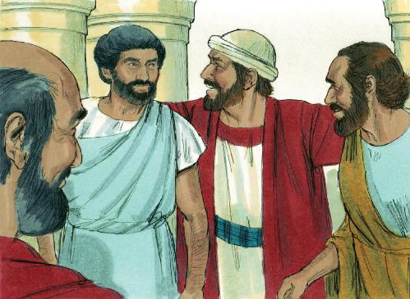

χειροτονήσαντες δὲ αὐτοῖς κατʼ ἐκκλησίαν πρεσβυτέρους, προσευξάμενοι μετὰ νηστειῶν παρέθεντο αὐτοὺς τῷ κυρίῳ εἰς ὃν πεπιστεύκεισαν.
Having hand-picked, and, to-them per church, elders, having prayed with fastings, they put-beside them to-the Lord unto whom they had believed.
²³ Thus, after they had appointed elders in every church, having prayed and fasted for them, they entrusted them to the Lord Jesus in whom they had come to believe.

Appoint. Of offical actions. Recognize character. Observe gifts. Test obedience. Watch for fruit. No voting.
Didaché 15:1 (late 1st century CE), “Appoint for yourselves bishops and deacons who are worthy of the Lord: men who are meek and not lovers of money, and who are honest and proven. For they also perform the service of the prophets and teachers.”
Elders. Socially respectable. Emotionally mature. Spiritually ready. Plurality of elders.
Church. Gatherings of disciples, led by elders, obeying Jesus’ commandments together.
Every. Greek preposition kata with singular noun = distributive plural meaning.
Entrust. Neither long-term authority, nor long-term dependence.
Believed. Pluperfect tense: early believers who had believed and have remained faithful.

10. They Report Back to Antioch (14:27)

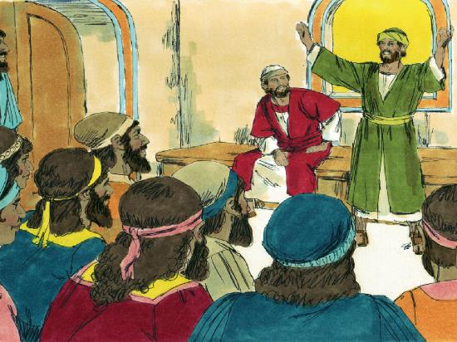

παραγενόμενοι δὲ καὶ συναγαγόντες τὴν ἐκκλησίαν ἀνήγγελλον ὅσα ἐποίησεν ὁ θεὸς μετʼ αὐτῶν καὶ ὅτι ἤνοιξεν τοῖς ἔθνεσιν θύραν πίστεως.
Having arrived, and, also having-gathered-together the church, they-announced how-much the God did with them and that he opened to-the gentiles door of-faith.
²⁷ Thus, arrived back, they gathered the church members, and reported on the great things that God had done, saying, ‘God opened the door of faith to the gentiles.’
Having arrived and having gathered. Translated here as “arrived back, they gathered”.
Gathered. Barnabas and Saul were still elders.
Saying. Greek hoti often introduces direct discourse (quotation).
Door of faith. How to interpret this metaphor?

Group work

Form groups of two or three, one of whom takes notes. Take four minutes to do the following:
1. Read together Acts 14:20b through 23 and 27.
2. Identify all the actions steps that the apostles followed.
3. Put these intoan order that makes sense to your group.
4. Report back to everyone present the steps that you identified, whilst someone takes notes.
5. Each group will report on points that previous reports did not mention.
Discuss ways in which you could follow the same steps to start churches, cell groups or home gatherings.
Pray and ask the Lord to make it happen.

