Brief Introduction to Acts 15
New Revised Standard Version Updated Bible: With Deuterocanonical and
Apocryphal Books of the Old Testament. Copyright © 2022 by
National Council of Churches, USA
[Text between brackets = variant manuscript readings from the 5th century CE or earlier]
The Jerusalem Council: Must gentiles become Jews to be saved?
¹ Then certain individuals came down from Judea and were teaching the brothers, “Unless you are circumcised according to the custom of Moses, you cannot be saved.”
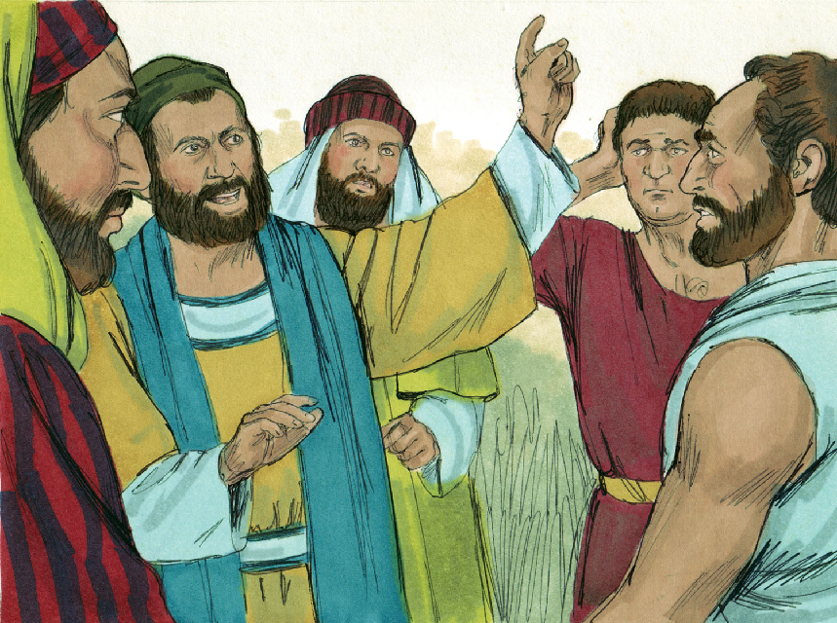
Images Copyright (c) Sweep Publishers. Used by permission.
Query: How do false doctrines enter churches?
Query: What are some current, non-biblical, salvation requirements taught by some churches?
Some say, “You cannot be saved unless you …”
1. Go forwards in a public meeting
2. Say the “sinners’ prayer”
3. Stop sinning
4. Keep the Ten Commandments
5. Be baptized
6. Be baptized by our clergy
7. Be baptized by immersion
8. Speak in tongues
9. Believe in certain doctrines
10. Reject certain other doctrines
²And [~therefore] after Paul and Barnabas had no small dissension and debate with them, Paul and Barnabas and some of the others were appointed to go up to Jerusalem to discuss this question with the apostles and the elders.
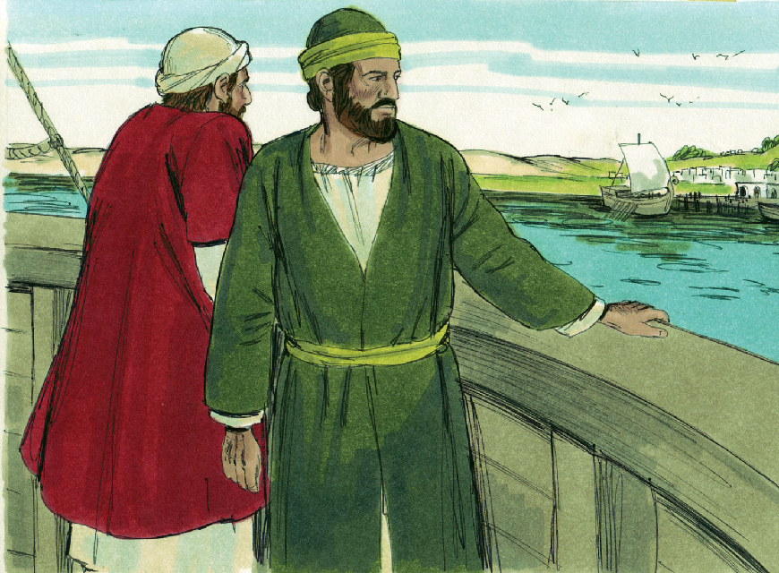
Query: What is the first step to counter false teaching in churches? What is the next step, if the first fails?
Greek: the apostles and elders = viewed as a single class.
Query: Why was Paul’s apostolic authority not decisive in this situation?

³ So they were sent on their way by the church, and as they passed through [–both] Phoenicia and Samaria, they reported the conversion of the gentiles and brought great joy to all the brothers and sisters.
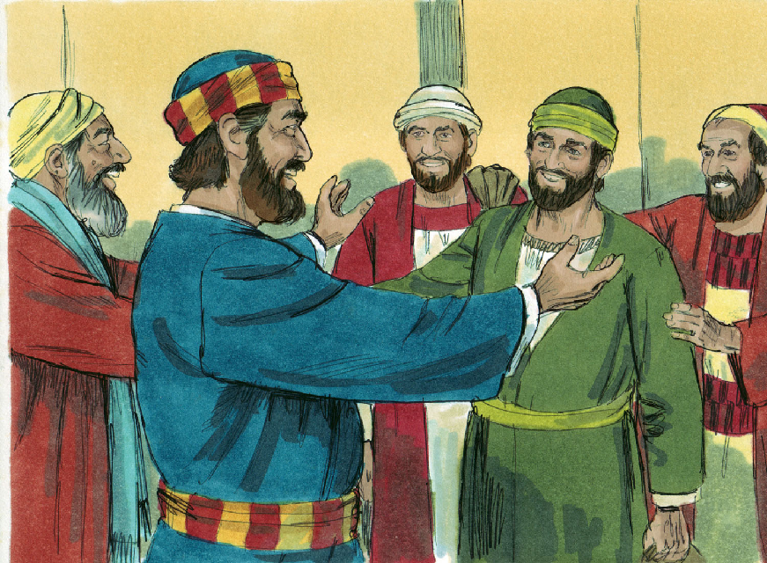
Query: Why take time to report about Gentile conversion in both Phoenicia and Samaria?
Query: Why would Jewish Christians, who knew the Tanach, rejoice over Gentiles becoming Christians?
⁴ When they came to Jerusalem, they were welcomed by the church and the apostles and the elders, and they reported all that God had done with them.
Greek: Three entities: the church, the apostles, and the elders?
Query: How are these distinct? How do they relate, each one to the others? (kai … kai … kai …) Or: the church, including the apostles and the elders.
⁵ But some believers who belonged to the sect of the Pharisees stood up and said, “It is necessary for them to be circumcised and ordered to keep the law of Moses.”
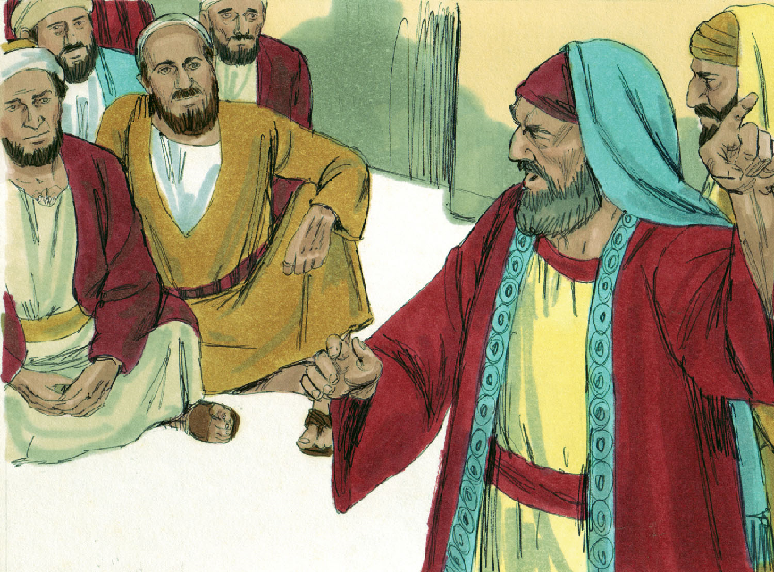

Pharisees: Theologically, morally, and politically conservative. Who resembles them, today?
Greek: Three continuous, present tense verbs.
Query: What was their logic? Is such logic used by anyone, these days?
Query: What would be the effect of their ideas, if applied in cross-cultural missionary work?

⁶ [~Both] The apostles and the elders met together to consider this matter. ⁷ After there had been much debate, Peter stood up and said to them, “My brothers, you know that in the early days God made a choice among you, that I should be the one through whom the gentiles would hear the message of the good news and become believers.
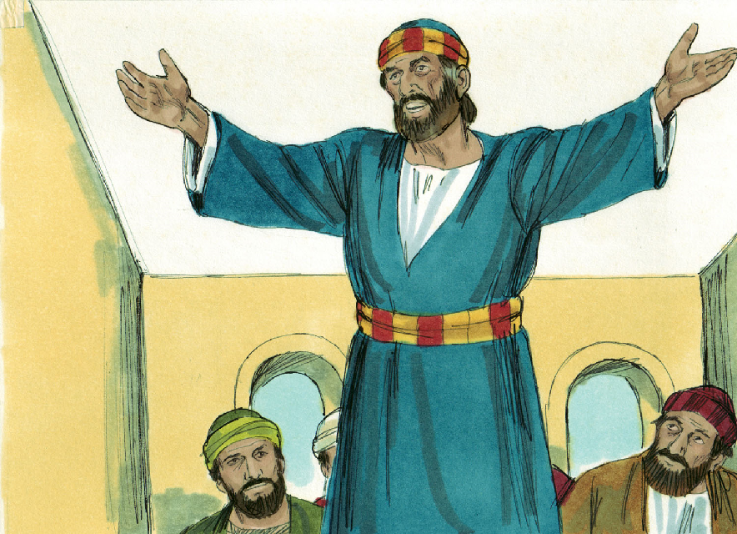

Query: Why did the apostles not simply dictate a correct teaching? (See John 16:13)
Query: Why include mere elders in discussion with apostles?
‘God chose me’. Jesus (Matt. 16:18; Luke 24:46-47) and the Holy Spirit (Acts 10:19-20).
Query: According to Peter, what did gentiles have to do, to become Christians?

⁸ And God, who knows the human heart, testified [–to them] by giving them the Holy Spirit, just as he did to us, ⁹ and in cleansing their hearts by faith he has made no distinction between them and us.
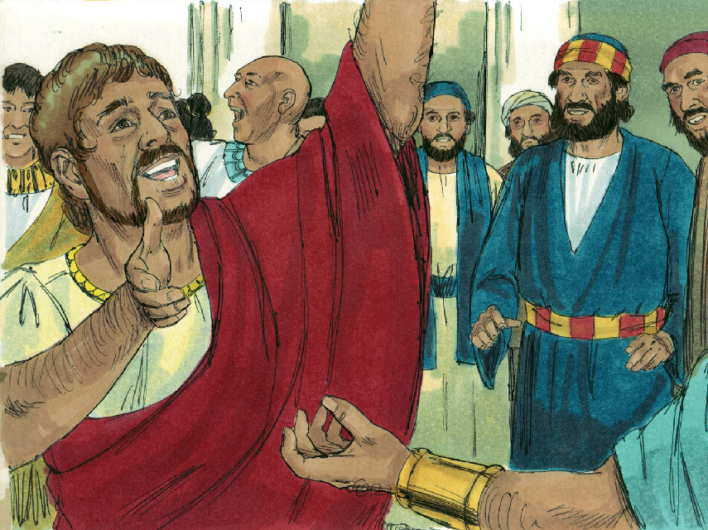
Acts 10:44-45
Query: What does God do for all who put their faith in Jesus?
● testifies to them by giving to them his Holy Spirit
● cleanses their heart by their faith
● for Jews and for gentiles without distinction
Query: What is an implication of this truth for evangelism and for missionary work, today?

¹⁰ Now, therefore, why are you putting God to the test by placing on the neck of the disciples a yoke that neither our ancestors nor we have been able to bear? ¹¹ On the contrary, we believe that we will be saved through the grace of the Lord Jesus [+Christ], just as they will.”
Test: Provoke God by opposing first-covenant legal requirements, to new-covenant divine grace.
Yoke: A common metaphor used of a master’s instruction given to his disciples to obey.
Greek: “By grace ... we believe to be saved’.
The tenses of salvation: (were …, have been …, are …, are being …, will be … saved).
Query: Saved from what? Saved unto what?
Grace: Love that gives freely to willing receivers. Jesus secured our salvation by his own death and resurrection, on behalf of Jews and gentiles alike.

¹² The whole assembly kept silence and listened to Barnabas and Paul as they told of all the signs and wonders that God had done through them among the gentiles.
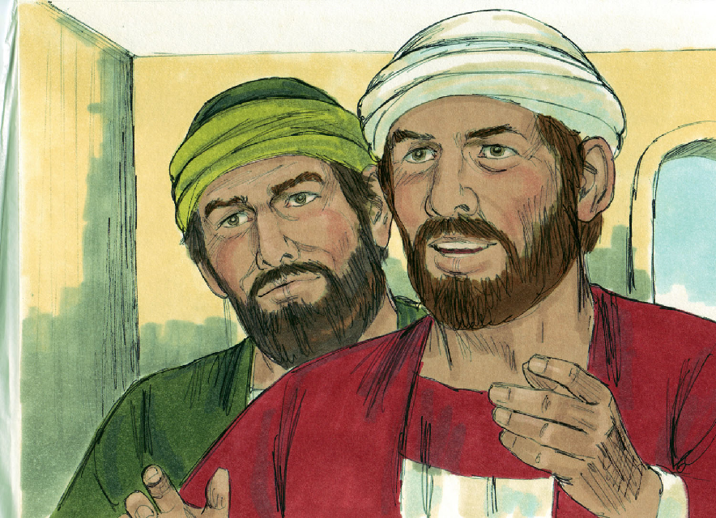
Greek: Hendiadys, ‘wonderful signs’.
Query: Why did they talk about wonderful signs?

¹³ After they finished speaking, James replied, “My brothers, listen to me. ¹⁴ Simeon has related how God first looked favorably on the gentiles, to take from among them a people for his name. ¹⁵ This agrees with the words of the prophets, as it is written, …
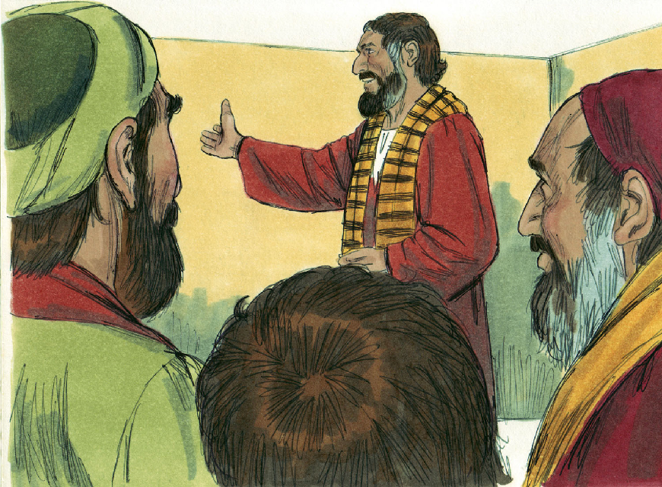

Query: Who was James? (Acts 12:1; Jam. 1:1).
Query: Who was Simeon?
A people for his name: One new ethnicity. ‘For his name’ = as his own, as Israel had been.
Query: Agrees with which prophets’ words? (‘It is written’ = First Covenant Scripture.)

Amos 9:11-12
¹⁶ ‘After this I will return [~returning],
and I will rebuild the dwelling of David,
which has fallen;
from its ruins I will rebuild it,
and I will set it up,
¹⁷ so that all other peoples may seek the Lord—
even all the gentiles over whom my name has been called.
Thus says the Lord, …
Isaiah 45:21
[~the one] who has been making these things ¹⁸ known from long ago.’
James finds patterns in the Tanach that he interprets in support of the gospel.
I will return. See Amos 9:9 “I will shake the house of Israel among all the nations.” Interpreted as the 12 tribes present at Pentecost.
Dwelling of David. skh = thicket > branches > hut > tent > dwelling > house. Interpreted as dynasty.
I will rebuild … set up. Interpreted as resurrection of Jesus.
Other peoples. Hebrew: ‘the remnant of Edom’, which had been subjected to King David. Hebrew ’dôm (Edom) ≈ ’dm (adam, humanity) ➔ Greek: ‘the rest of human beings [anthropoi],’ interpreted by James as conversion of Gentiles.
Isaiah 45:22 “Be saved, all the ends of the earth!” ≈ “You will be my witnesses … to the ends of the earth” (Jesus, Acts 1:8)

¹⁹ “Therefore I have reached the decision that we should not trouble those gentiles who are turning to God, ²⁰ but we should write to them to abstain only
[–from] things polluted by idols and from sexual immorality and from whatever has been strangled and from blood. ²¹ For in every city, for generations past, Moses has had those who proclaim him, for he has been read aloud every Sabbath in the synagogues.”
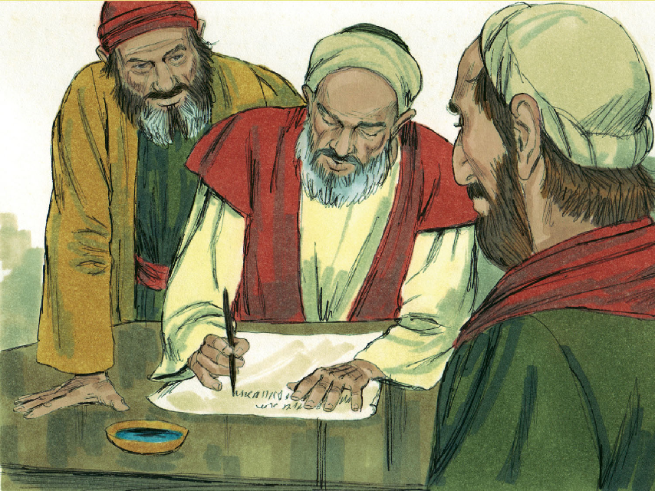
Decision. Literally, “I judge.”
Query: An opinion? A suggestion? Expressing the consensus of the apostles and elders?
A revelation from the Holy Spirit?
Trouble. Literally “overly-trouble” beyond the following. 2 Maccabees 11:31, “full permission for the Jews to enjoy their own food and laws, just as formerly, and none of them shall be molested in any way for what may have been done in ignorance.”
Abstain. Greek middle-voice verb = voluntarily, not a new law for Christians.
Moses. The Pentateuch specifically, the Tanach generally.

Common pagan worship practices
Offensive to God
Polluted. Meals eaten in the presence of idols (See Leviticus 17:8-9).
Immorality. Temple prostitution (See Leviticus 18:26).
Offensive to Jews
Strangled. Ritual sacrifice (See Leviticus 17:8-13). Compare 1 Thessalonians 1:9; 1 Peter 4:3.
Blood. Ritual drinking of blood, or eating of blood sausages (See Leviticus 17:10-12).

Conclusion
Query: What are some truths that we have learned from Acts 15:1-21.
● Jews and Gentiles alike are saved by grace through their faith.
● Jews and Gentiles alike have received God’s Holy Spirit.
● Gentiles do not have to become Jews, to be saved.
● Gentiles ought to avoid pagan practices that offend God and Jews.
● In doctrinal disputes, let everyone tell their view, and then let recognized leaders
render their decision.
● Prophetic Scriptures and the apostles’ teaching remain our basic test of truth
statements.

