Acts 2:1-21

Book of Acts Structure

I. Jesus promises power for witness to the nations
II. The apostles witness in Jerusalem & Judea
A. The church in Jerusalem is planted 1:12–2:47
1. The Lord chooses a twelfth apostle 1:12-30
2. Jews are baptized in the Holy Spirit 2:1-13
a. The Father gives his promised Holy Spirit 1-4
b. The Father Regathers Judah & Israel 5-13
3. Peter preaches the gospel to Israelites 2:14-36
a. Joel’s prophecy fulfilled 14-21
b. Nathan’s prophecy fulfilled 22-28
c. David’s prophecy fulfilled 29-36
4. The apostles plant churches in Jerusalem 2:37-47
B. The church in Jerusalem expands 3:1–6:7
III. Believers witness in Judea & Samaria
IV. The apostles witness to Gentiles
V. The Jerusalem church affirms the conversion of Gentiles
VI. Paul preaches the gospel to the Greeks
VII. Paul preaches the gospel to the Romans

II.A.2. Jews are baptized in the Holy Spirit 2:1-13

a. The Father gives his promised Holy Spirit 1-4

¹ Now when the day of Pentecost had come, they were all together in one place. ² Suddenly a sound like a violent wind blowing came from heaven and filled the entire house where they were sitting. ³ And tongues spreading out like a fire appeared to them and came to rest [~and sat] on each one of them. ⁴ All of them were filled with the Holy Spirit, and they began to speak in other languages as the Spirit enabled them.

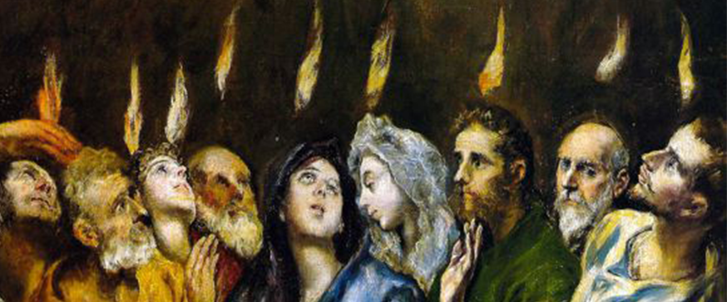

QUERY: What was the significance of the Feast of Pentecost?

Suggestions:
● It was the next big event after Passover and Jesus’ crucifixion and resurrection, when many Jews were gathered in Jerusalem.
● All major events concerning Messiah Jesus occur on biblical holidays.

QUERY: Where were they all together?

Suggestions:
● In the upper room where they were staying, and God brought crowds to hear them.
● In one of many gathering spaces at the Jerusalem temple where crowds were already present.

QUERY: What was significant about “wind” and “fire”?

Note: Ezekiel 1:4, “wind … fire” preceded the flying, wheeled throne of Yahweh, “the glory of the LORD” (28).

● Yahweh returns to the temple, settling on ‘living stones’ who are the temple of God.
● Flying thrones on wheels for gods are known from antiquity.

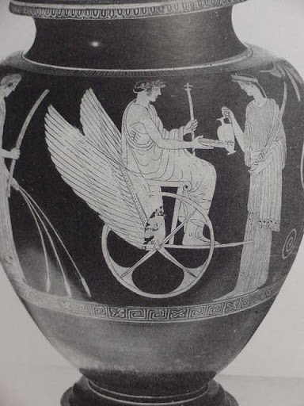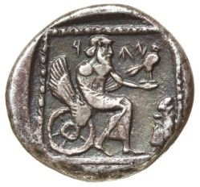
Greek vase 5th century BCE — 6th century BCE ¼ shekel coin

QUERY: In what sense have the end-times begun, preceding Jesus’ second coming?

● Messiah has come, bringing redemption and salvation for both Jews and Gentiles.
● Yahweh has returned to Jerusalem and taken up residence in the midst of his people.
● Jews from both Judah and Israel are present, will believe in Jesus and receive the Spirit that Joel, Jeremiah and Ezekiel foresaw.

b. The Father Regathers Judah & Israel 5-13

⁵ Now there were devout Jews from every nation under heaven residing in Jerusalem.
⁶ When this sound occurred, a crowd gathered and was in confusion, because each one heard* them speaking in his own language [~speaking in tongues].

*Literally, “was hearing”.

QUERIES: Heard whom speaking?

● The apostles who were Galileans (2:7-8), rustic country bumpkins.

Was this a miracle of speaking? Or of hearing?

● Verse 8: ‘Hearing in our languages’ = ‘in which we were born’ (dative of sphere?).
● Verse 11: “We hear them (object genitive of ‘hear’) speaking in (+adverbial dative) our own languages the (object accusative) great things of God.”

⁷ Completely baffled, they [+all] said, “Aren’t all these who are speaking [+one to another] Galileans? ⁸ And how is it that each one of us hears them in our own native language?
⁹ Parthians, Medes, Elamites, and residents of Mesopotamia, Judea and Cappadocia, Pontus and the province of Asia, ¹⁰ Phrygia and Pamphylia, Egypt and the parts of Libya near Cyrene, and visitors from Rome, ¹¹ both Jews and proselytes, Cretans and Arabs—we hear them speaking in our own languages about the great deeds God has done!”
¹² All were astounded and greatly confused, saying to one another, “What does this mean?” ¹³ But others jeered at the speakers, saying, “They [~these] are drunk on new wine!”

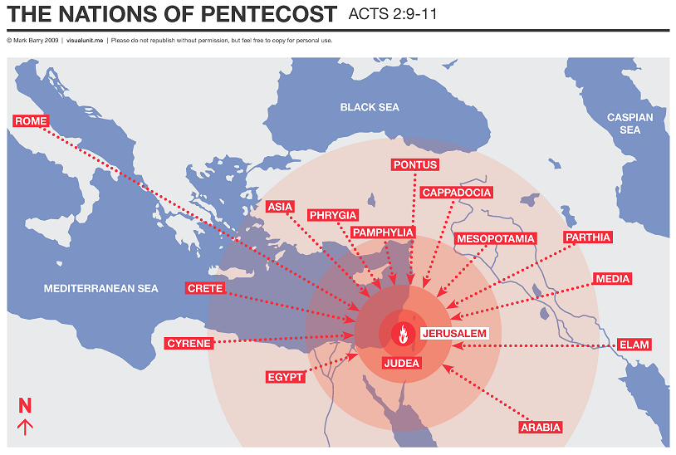

QUERY: Why this emphasis on ethnicity and on language?

● Genesis 11:9 Yahweh scattered them and their languages multiplied.
● Deuteronomy 32:8 (LXX & DSS). God abandoned the Gentiles to lesser gods.
● Isaiah 2:2. All the nations would one day return to Yahweh.
● Jeremiah 5:19. Yahweh scattered Israel among foreign nations.
● Matthew 28:19. Make disciples of every ethnicity.
● Revelation 7:9 Every nation, tribe, people, tongue worship the Lamb of God.

II.A.3. Peter preaches the gospel to Israelites 2:14-36

a. Joel’s prophecy fulfilled 14-21

¹⁴ But Peter [+then] stood up with the eleven [~ten apostles], raised his voice, and addressed them: “You men of Judea and all you who live in Jerusalem, know this and listen carefully to what I say. ¹⁵ In spite of what you think, these men are not drunk, for it is only [–nine o’clock] in the morning.

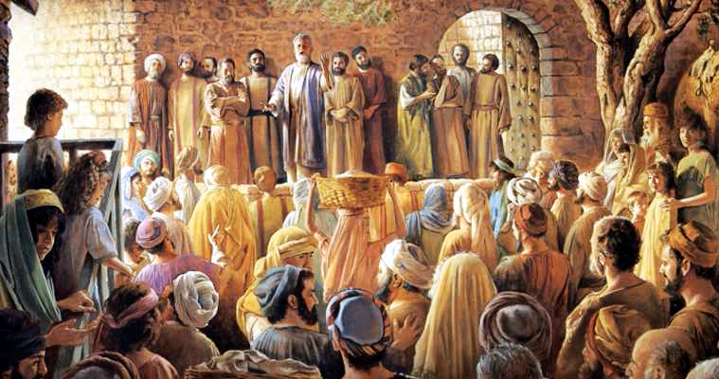

QUERY: Whence came Peter’s courage, his recall and his eloquence?
● Acts 2:4. He had minutes earlier been filled with the Holy Spirit. See Galatians 5:18,
● Acts 2:17. “They will prophecy” (Joel 2:28).

NOTE: The content of biblical speaking in tongues was prophecy. Acts 10:45; 19:6, “they spoke with tongues and prophesied.” (Greek hendiadys, “a complex idea is expressed by two words connected by a copulative conjunction”, dictionary.com)

¹⁶ But this is what was spoken about through the prophet Joel:
¹⁷ ‘And’ in the last [~those] days ‘it will be,’ God says, ‘that I will pour out my Spirit on all people, and your sons and your [~their] daughters will prophesy, and your young men will see visions, and your old men will dream dreams.
¹⁸ Even on my servants, both men and women, I will pour out my Spirit’ [–in those days], [–and they will prophesy].
¹⁹ ‘And I will perform wonders in the sky above and miraculous signs on the earth below, blood and fire and clouds of smoke.
²⁰ The sun will be changed to darkness and the moon to blood before [+which] the great [–and glorious] day of the Lord comes.
²¹ And then everyone who calls on the name of the Lord will be saved.’

QUERY: How did Peter dare to insert words into Joel’s prophecy?
● His hearers knew that Joel has prophesied about the last days, and Peter joins the dots.
● The languages that the crowd had heard were a form of prophecy.
● Peter was going to announce that (1) the promised salvation has come, and (2) the Day of the Lord remains imminent.

QUERY: What about the other ‘wonders’ that Joel had predicted?
● Matthew 27:45 “darkness over all the land”
● Matthew 27:54 “the earth quaked, and the rocks were split”
● Acts 2:2 “a sound from heaven”

QUERY: So, then, what shall we do?

● Acts 2:4. Be filled with the Holy Spirit every day (Gal. 5:18, iterative present tense verb).
● Acts 2:17. Seek to prophesy (1 Cor. 14:1, 24).
● Acts 2:18. Follow our vision (Acts 10:3, 17).
● Acts 2:21. Call upon the name of the Lord to be saved (Rom. 10:9).

Next study

b. Nathan’s prophecy fulfilled 22-28

c. David’s prophecy fulfilled 29-36

