INTRODUCTION TO ACTS 4:23-31; 5:12-16

ACTS 4:23-31

Book context

I. Jesus promises power for witness to the nations 1:1-11
II. The apostles witness in Jerusalem & Judea 1:12–6:7
A. The church in Jerusalem is planted 1:12–2:47
B. The church in Jerusalem expands 3:1–8:3
1. By the apostles’ witness 3:1-4:22
a. Before the people 3:1-26
b. Before the authorities 4:1-22
c. Before the Lord 4:23-31; 5:12-16
d. Before the church 4:32-5:11
e. Before the high priest 5:17-42
2. By the believer’s word 6:1–8:3

Preceding context

After the Lord had healed a lame man in public, Jesus’ apostles, Peter and John, were teaching folk inside the Jerusalem temple complex. The temple police arrested them, and brought them before the Jewish Sanhedrin, or council. These officials ordered them to stop teaching about “the Name of Jesus,” threatened them, had them beaten, and then released them.

²³ When they had been released, they went to their own companions and reported everything that the chief priests and the elders had said to them. ²⁴ And when they heard this, they raised their voices to God with one mind and said, “Lord, it is You who made the heaven and the earth and the sea, and everything that is in them, ²⁵ who by the Holy Spirit, through the mouth of our father David Your servant, said,

‘Why were the nations insolent,
And the peoples plotting in vain?
²⁶ ‘The kings of the earth took their stand,
And the rulers were gathered together
Against the Lord and against His Christ.’

Immediate Outline

The apostles react to official abuse 4:23
1. They report to the others
2. They pray to God 4:24
a. In agreement
b. Citing Scripture
1) Acknowledge the Creator
2) Believe inspired Scripture 4:25
3) Quote content
4) Infer application
a) Mention enemies 4:26
b) Exalt Jesus 4:26-28
Anti-christian scoffers accuse Peter (or Luke) of misinterpreting Psalm 2, asserting that nations = peoples = Gentiles, because they occur in poetic parallel.

Why were the nations insolent,
And the peoples plotting in vain?

However, although the word for ‘nation’ (goy) usually refers to Gentiles, the word for ‘people’ (am) often refers to Israel in the Hebrew Bible. Thus, Peter quite legitimately makes the following contrasts:

Pagans Israelites
nations (goyim) peoples (amim) 25
Pilate Herod 27
Gentiles (Romans) peoples of Israel 27

²⁷ For truly in this city there were gathered together against Your holy servant Jesus, whom You anointed, both Herod and Pontius Pilate, along with the Gentiles and the peoples of Israel, ²⁸ to do whatever Your hand and [Your] purpose predestined to occur.

Literal Greek: “Were gathered, upon truth, in this city, against thy holy servant Jesus, whom thou christened, both Herod and Pontius Pilate, with Gentiles and peoples, Israel, to do that which thy hand and thy will foreordained to happen.”

Two translations
Reformed: “Gentiles and peoples gathered to do that which you foreordained.”
Alternative: “Thy servant Jesus whom you christened to do that which you foreordained.”

Logically

● Did leaders gather to do the ordained will of God? (God ordains evil?)
● Or did God anoint Jesus to do his ordained will? (God ordains redemption!)

Contextually

● The phrase ‘your hand’ in verse 28 is repeated in verse 30 referring to miracles of healing done through Jesus’ name.
● In Greek, the verb ‘gathered’ is farther removed than ‘anointed Jesus’ from ‘to do your will’.

Diagrammatically
Greek
English
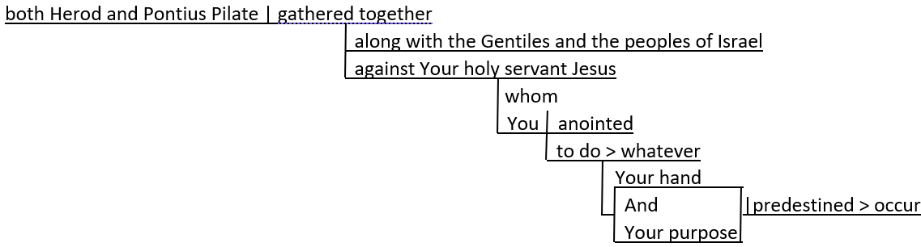

Biblically

“The Spirit of the Lord is upon Me, because he anointed Me to bring good news to the poor” (Luke 4:18 = Isaiah 61:1).

²⁹ And now, Lord, look at their threats, and grant it to Your bond-servants to speak Your word with all confidence, ³⁰ while You extend Your hand to heal, and signs and wonders take place through the name of Your holy servant Jesus.”

Immediate outline (continued)

c) Request boldness 4:29
d) Expect miracles 4:30

³¹ And when they had prayed, the place where they had gathered together was shaken, and they were all filled with the Holy Spirit and began to speak the word of God with boldness.

Immediate outline (continued)

3. God answers 4:31
a. Earth tremor
b. Filled with the Spirit
c. Begin again to speak the Word

ACTS 5:12-16

12 At the hands of the apostles many signs and wonders were taking place among the people; and they were all together in Solomon’s portico. 13 But none of the rest dared to associate with them; however, the people held them in high esteem.

Immediate outline (continued)

d. Miracles happen 5:12
e. Unity maintained

4. Folk respond

a. Esteem from all 5:13

Signs of a true apostle

“The signs of a true apostle were performed among you with utmost patience, with signs and wonders and mighty works.” (Paul)
2 Corinthians 12:12

“Now He called the twelve together and gave them power and authority over all the demons, and the power to heal diseases. And He sent them out to proclaim the kingdom of God and to perform healing.” (Peter) Luke 9:1-2

“Confess your sins to one another and pray for one another, that you may be healed. The prayer of a righteous person has great power as it is working.” (All Christians) James 5:16

¹⁴ And increasingly believers in the Lord, large numbers of men and women, were being added to their number, ¹⁵ to such an extent that they even carried the sick out into the streets and laid them on cots and pallets, so that when Peter came by at least his shadow might fall on any of them. ¹⁶ The people from the cities in the vicinity of Jerusalem were coming together as well, bringing people who were sick or tormented with unclean spirits, and they were all being healed.

Immediate outline (continued)

b. Many new believers 5:14
c. Jerusalem’s needy folk healed 5:15
d. Other towns’ needy folk healed 5:16

