ACTS 7:51-60
STEPHEN’S DISCOURSE

BACKGROUND

Stephen, when accused by false witnesses, before the Jerusalem Sanhedrin, of “speaking against” the temple and against the Mosaic Law (6:13), replies by recounting accurately highlights of Israelite history.

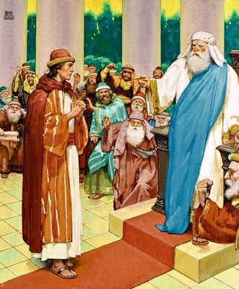
Image © Classic Bible Arts Goodsalt.com

Stephen’s Thesis: Despite the many ways in which the YHWH, the God of Israel, had blessed the Israelites, they often rebelled against him, disobeying his laws and instructions, worshiping other gods. Stephen cites five instances:

1. The Israelites rejected Moses when he first offered to deliver them from Egyptian oppression. 7:23-27
2. Some 40 years later, when Moses was leading the Israelites towards a promised land, they “were unwilling to be obedient to him; on the contrary they rejected him and turned back to Egypt in their hearts.” 7:39
3. They went so far as to make idols for themselves, while Moses was away receiving the Law from the LORD at Mount Horeb 7:40-41

4. The prophet Amos accused the Israelite Northern tribes of worshiping Babylonian and Syrian minor gods related to the planet Saturn. 7:43

5. Israelites persecuted and murdered many of their own prophets sent to them from God. 7:52
AMOS 5:26

26 You shall take up Sikkuth your king, and Kiyyun your star-god—your images that you made for yourselves… (NASB)
26 וּנְשָׂאתֶ֗ם אֵ֚ת סִכּ֣וּת מַלְכְּכֶ֔ם וְאֵ֖ת כִּיּ֣וּן צַלְמֵיכֶ֑ם כּוֹכַב֙ אֱלֹ֣הֵיכֶ֔ם אֲשֶׁ֥ר עֲשִׂיתֶ֖ם לָכֶֽם׃ (Masoretic Hebrew)
26 καὶ ἀνελάβετε τὴν σκηνὴν τοῦ Μολοχ καὶ τὸ ἄστρον τοῦ θεοῦ ὑμῶν Ραιφαν, τοὺς τύπους αὐτῶν, οὓς ἐποιήσατε ἑαυτοῖς. (Greek Septuagint)

ACTS 7:43

43 You took up the tent of Moloch and the star of your god Rephan, the images that you made to worship… (NASB)
43 καὶ ἀνελάβετε τὴν σκηνὴν τοῦ Μόλοχ καὶ τὸ ἄστρον τοῦ θεοῦ [ὑμῶν] Ῥαιφάν, τοὺς τύπους οὓς ἐποιήσατε προσκυνεῖν αὐτοῖς... (Greek New Testament)

mlk מַלְכְּ : (a) king; (2) a god named King; (3) Moloch.

skkth סִכּוּת : (a) Succoth, tents; (b) “Saturn; Assyrian … epithet for Ninib-Ninurta” (HALOT).

kynn כִּיּוּן ‎: “a name of Saturn, Syrian kēwān, Arabic kaiwān: Saturn” (HALOT).

● “The Masoretic vocalization of both names is that for idols” (DDD).
● “In Mesopotamia. Saturn is the only star not related to one of the major deities” (DDD).

STEPHEN’S COUNTER-ACCUSATION

⁵¹ “You men who are stiff-necked and uncircumcised in [your] heart and ears are always resisting the Holy Spirit; you are doing just as your fathers did. (NASB)

NOTES
1. stiff-necked = obstinate, Exodus 33:3
2. uncircumcised ≈ like Gentiles
3. ears → covered their ears, v. 57, Jer. 6:10
4. Holy Spirit ← Isa. 63:9-14, Angel of his Presence,
an everlasting Name, the Spirit of YHWH.

DISCUSS
● Why did Steven mention the Holy Spirit?
● How does this help explain the "unforgivable sin"? Matt. 12:31-32

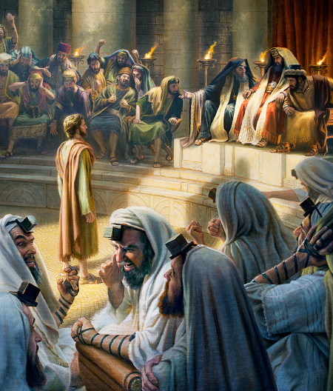
https://www.jw.org/en/library/books/bearing-thorough-witness/persecution/stephen/

NOTES
1. The Righteous One ← Isa. 53:11; Acts 2:27
2. Rhetorical question ≈ declarative statement
3. Ordained = ordered, commanded
4. Ordained by (eis) angels ≈ Gal. 3:19 (dia)

DISCUSS
● Which point of the Law had they not kept? See 7:27
● Betrayed to whom?
● Who killed the Righteous One?

THE ILLEGAL EXECUTION OF STEPHEN
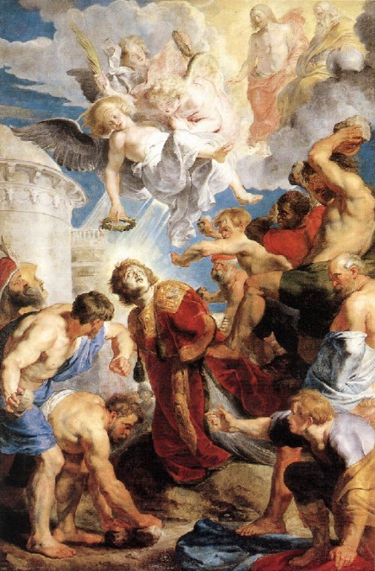
http://hermandaddesancristobalburguillos.blogspot.com/2010/
12/el-evangelio-de-hoy-fiesta-de-la.html
⁵⁴ Now when they heard this, they were infuriated, and they began gnashing their teeth at him. ⁵⁵ But he, being full of the Holy Spirit, looked intently into heaven and saw the glory of God, and Jesus standing at the right hand of God; ⁵⁶ and he said, “Behold, I see the heavens opened and the Son of Man standing at the right hand of God.”

NOTES
1. Gnash teeth. A cultural signal.
2. Full of ≈ marked by, motivated by Acts 6:5, 8
3. Heaven opened, Heb. 10:12-20
4. The Son of Man (Jesus), Dan. 7:13-14; Luke 22:69
5. Psalm 110:1 said 'my Lord' would 'sit' beside God

SON OF MAN

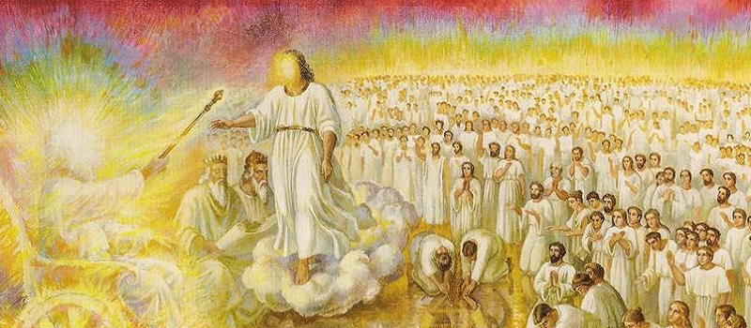
https://www.jesusfollower.ca/archives/17523

“Behold, with the clouds of heaven one like a son of man was coming… And to Him was given dominion, honor, and a kingdom.” Daniel 7:13-14

RIGHT HAND

“Your right hand, Lord, is majestic [δοξάζω] in power.” Exodus 15:6
“From now on the Son of Man will be seated at the right hand of the power of God.” Luke 22:69

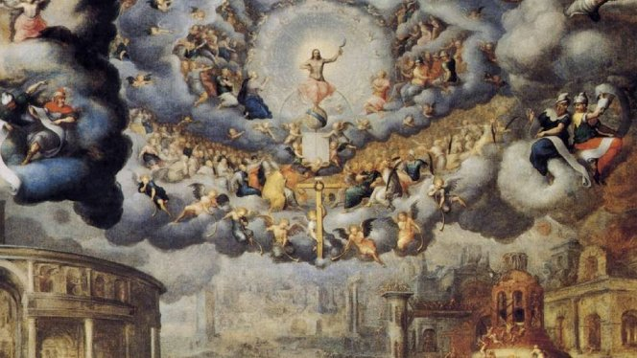
https://twitter.com/bishopbarron/status/1064103512383135744
“You shall see the Son of Man sitting at the right hand of power, and coming with the clouds of heaven.”
Mark 14:61-62

“[Stephen] saw the glory of God, and Jesus standing at the right hand of God.” Acts 7:55

“Behold, I see the heavens opened and the Son of Man standing at the right hand of God.” Acts 7:56

THE BLESSED

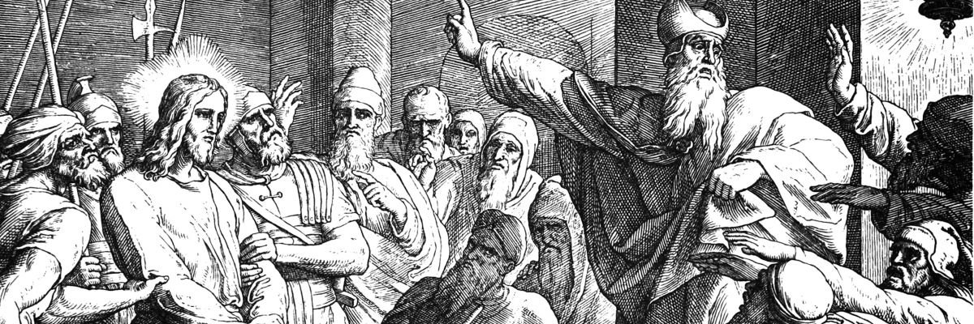
https://www.catholic.com/magazine/online-edition/the-timing-of-jesus-trial

“King Solomon will be blessed [eulogew], and the throne of David will be established before the Lord forever.” 1 Kings 2:45

The high priest was questioning [Jesus], “Are You the Christ, the Son of the Blessed One [eulogew]?” And Jesus said, “I am.” Mark 14:61-62

POWER

“Lord … you rule over all, and in Your hand is power [dynamis] and might; and it lies in Your hand to make great and to strengthen everyone.
1 Chronicles 29:11-12

“You shall see the Son of Man sitting at the right hand of power [dynamis], and coming with the clouds of heaven.” Mark 14:61-62

DISCUSS
● Who can be "full of the Holy Spirit"?
● What does it mean "to be full"?
● Who else in Steven's defense saw the glory of God?
● What will we see at the moment of death?
● 'Standing'. Was Jesus welcoming Steven, interceding on his behalf, or judging the mob
(Isa. 3:13)?

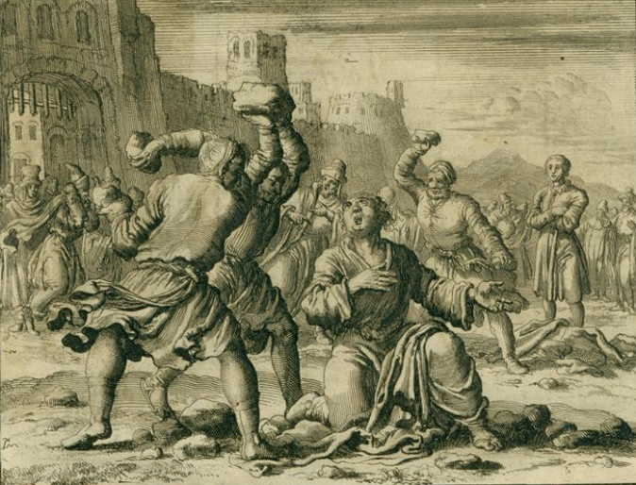
Stoning of Stephen, AD 34, 1685 - Jan Luyken - WikiArt.org

⁵⁷ But they shouted with loud voices, and covered their ears and rushed at him with one mind. ⁵⁸ When they had driven him out of the city, they began stoning him; and the witnesses laid aside their [own] cloaks at the feet of a young man named Saul.

NOTES
1. 'One mind', Acts 1:14, 46; 4:24.
2. 'The witnesses', Deut. 17:6-7; John 8:7

DISCUSS
● Whom else had they killed 'outside of the city'?
● What law was the mob keeping?
● What law was the mob breaking?
● Who was the young man named Saul? Acts 22:20

⁵⁹ They went on stoning Stephen as he called on the Lord and said, “Lord Jesus, receive my spirit!” ⁶⁰ Then he fell on his knees and cried out with a loud voice, “Lord, do not hold this sin against them!” Having said this, he fell asleep.

NOTES
1. 'Receive my spirit', Luke 23:46. Imperatives.
2. First time anyone's said, 'Lord Jesus'.
3. Jesus: 'forgive them', Luke 23:34 variant mss reading papyrus P75, third century & Codex Vaticanus, 5th. Did early scribes want to make Jesus to be as spiritual as Stephen? Or did Stephen learn this prayer from Jesus' example?

DISCUSS
● When is it alright to command God to do something?
● What is it that falls asleep at the moment of death?
● Did God ever answer Stephen's prayer that God forgive his murderers?
● What sin is so horrible, that God will not forgive it?

