**THE CONVERSION OF SAUL OF TARSUS  
 FROM ACTS 9:1-9; 22:3-21; 26:12-20 (NRSV)**

[text between brackets = variant reading  
from the 5th century or earlier]

Key to biblical text colours: Luke — Paul — Jesus —Ananias

**1. Saul’s historical persona and religious identity**

22 3 “I am a Jew, born in Tarsus in Cilicia, but brought up in this city, educated at the feet of Gamaliel according to the strict manner of the law of our fathers, being zealous for God as all of you are this day.”

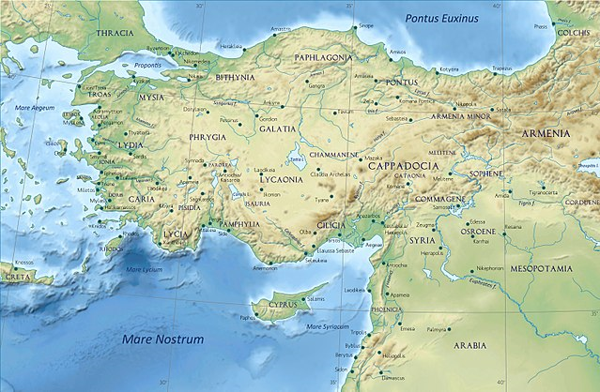  
Creative Commons BY-SA 4.0

* ‘I am a Jew’ (*‘ani yehudi*).   
  A common confession to this day.
* This city = Jerusalem.
* Gamaliel I= grandson of Hillel, a Pharisee, a member of the Jerusalem Sanhedrin. He defended the apostles (Acts 5:34).
* Law of our fathers: the oral law transmitted by   
  rabbis aside from the Hebrew Scriptures.

**2. Saul’s religious zeal and persecution of Christians**

9 1 But Saul, still breathing threats and murder against the disciples of the Lord, went to the high priest 2 and asked him for letters to the synagogues at Damascus, so that if he found any [belonging] to the Way, men or women, he might bring them bound to Jerusalem.

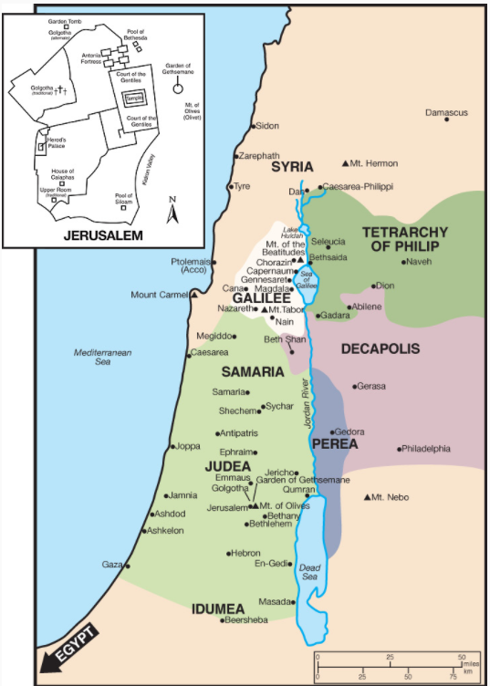

*Olivetree Bible Maps: Then and now*, NT 1-70 CE, (c) 2008 RW Research, Inc.

* ‘threats and murder’ (hendiadys) = ‘murderous threats’.
* ‘letters’ = some sort of extradition authority. Compare 1 Maccabees 15:21, “if any scoundrels have fled to you from their country, hand them over to the high priest Simon, so that he may punish them.”
* ‘The Way’ = Early Jewish designation for this sect. Would soon become ‘gathering’, disciples, Christians.

**3. Saul’s authority to pursue Christians at Damascus**

22 4 “I persecuted this Way to the death, binding and delivering to prison both men and women, 5 as the high priest and the whole council of elders can bear me witness. From them I received letters to the brothers, and I journeyed toward Damascus to take those also who were there and bring them in bonds to Jerusalem to be punished. 26 12 In this connection I journeyed to Damascus with the authority and commission of the chief priests.”

* Levels of authority: imperial, provincial, regional, royal, religious. Provincial governors invested religious councils with authority over their adherents.
* Brothers = Jewish leaders of synagogues.
* Damascus = provincial capital of Syria that included Judea (Israel).

**4. Jesus appears to Saul in great light**

9 3 Now as he went on his way, he approached Damascus, and suddenly a light from heaven flashed around him. 22 6 “As I was on my way and drew near to Damascus, about noon, 26 19 O king, I saw on the way a light from heaven, brighter than the sun, that shone around me and those who journeyed with me.”

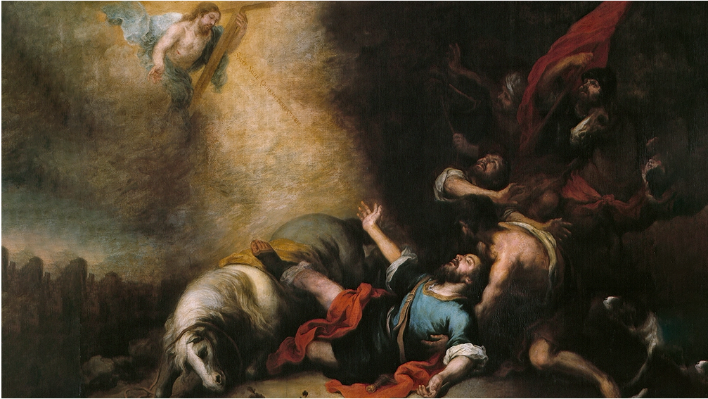  
Murillo | Public Domain via Wikipedia

* ‘O king’ = Bring attention to the following.
* ‘the way’ = the road, not the Christians.

**5. Jesus speaks to Saul, commissioning him**

9 7 And falling to the ground he heard a voice. 22 9“And I fell to the ground and heard a voice saying to me, 9 14 ‘Saul, Saul, why are you persecuting me?’ 26 8 And I answered, “’Who are you, Lord?’

* ‘Saul, Saul’ = repeated name as in Genesis 22:1 and in 1 Samuel 3:4, indicates a divine call.
* ‘lord’ = Title of respect for superiors.

22 8 And he said to me, 9 5 ‘I am Jesus [of Nazareth], whom you are persecuting. 26 16 But rise and stand upon your feet, for I have appeared to you for this purpose, to appoint you as a servant and witness to the things in which you have seen [me] and to those in which I will appear to you, 17 delivering you from your people and from the Gentiles—to whom I am sending you 18 to open their eyes, so that they may turn from darkness to light and from the power of Satan to God, that they may receive forgiveness of sins and a place among those who are sanctified by faith in me.

* ‘servant and witness’ (hendiadys) = servant who bears witness.
* 'deliver from (*ek*) = *out of*, not keep *from* arrest, beatings, prison, mobs, shipwrecks, snake bites…
* Qualifications of a true apostle of Jesus Christ: (a) Saw the risen Messiah physically.   
  (b) Was personally appointed by Jesus.  
  (c) Received visible, audible revelations from Christ.
* Seven elements of Christian conversion:   
  (1) eyes opened,   
  (2) turn from deceit to truth,   
  (3) turn from Satan to God,   
  (4) receive forgiveness of sins,   
  (5) receive a place,   
  (6) made holy,   
  (7) have faith in Jesus.

**6. Jesus orders Saul to enter Damascus,   
and to await instructions**

9 7 The men who were traveling with him stood speechless, hearing the voice but seeing no one. 22 9“Now those who were with me saw the light but did not understand the voice of the one who was speaking to me. 10 And I said, ‘What shall I do, Lord?’ And the Lord said to me, ‘Rise, and go into Damascus, and there you will be told all that is appointed for you to do.’

* ‘to hear’ *akouō* + genitive ‘of’ = hear with understanding; + accusative (direct object) = hear a sound.
* When does the Lord refuse to reply to the query, ‘What shall I do, Lord?’

**7. Saul waits and fasts for three days**

9 8 Saul rose from the ground, and although his eyes were opened, he saw nothing [~no one]. So they led him by the hand and brought him into Damascus. 22 11 “[I stood up] And since I could not see because of the brightness of that light, I was led by the hand by those who were with me, and came into Damascus.” 9 9 And for three days he was without sight, and neither ate nor drank.

* Contrast 2 Corinthians 4.6, “God … is the One who has shone in our hearts.”
* Does fasting ensure that one will receive a revelation from Jesus, or of Jesus?

**8. Jesus appears to Ananias, ordering him   
to go heal Saul**

9 10 Now there was a disciple at Damascus named Ananias, 22 12 a devout man according to the law, well spoken of by all the Jews who lived there. 9 11 The Lord said to him [in a vision], “Ananias.” And he said, “Here I am, Lord.” And the Lord said to him, “Rise and go to the street called Straight, and at the house of Judas look for a man of Tarsus named Saul, for behold, he is praying, 12 and he has seen in a vision a man named Ananias come in and lay his hand[s] on him so that he might regain his sight.”

* Disciple = one who learns teaching and who obeys instructions from a teacher. In this case, a pracCticing Jew who is also a follower of Jesus.
* Lord = Jesus who is instructing a disciple of his.

**9. Ananias objects, then relents and   
goes to find Saul**

22 13 But Ananias answered, “Lord, I have heard from many about this man, how much evil he has done to your saints at Jerusalem. 14 And here he has authority from the chief priests to bind all who call on your name.” 15 But the Lord said to him, “Go, for he is a chosen instrument of mine to carry my name before [the] Gentiles and kings and the children of Israel. 16For I will show him how much he must suffer for the sake of my name.” 17 So Ananias departed and entered the house.

* ‘saints’ = holy ones, that is, those belonging to Jesus.
* ‘who call on your name’ = whether Lord, Jesus, or Lord Jesus, in any language of our choice.
* Gentiles = literally ‘all (kinds of) people’
* Verse 15, ‘for’ (hoti) = cause; verse 16 ‘for’ (gar) = reason. Cultural logic?
* ‘the house’ = ‘the’ refers to a previously-mentioned house, where Saul was staying.

**10. Ananias prays for Saul to regain is sight**

22 13 “Ananias came to me, and standing by me said to me, ‘Brother Saul, receive your sight.’” 9 17 And laying his hands on him he said, “Brother Saul, the Lord Jesus who appeared to you on the road by which you came has sent me so that you may regain your sight and be filled with the Holy Spirit.” 18 And immediately something like [~as if] scales fell from his eyes, and he regained his sight. 22 13 “And at that very hour I received my sight and saw him.”

* ‘receive your sight’ (anablepō) = (1) look up; (2) see again.
* ‘filled with the Holy Spirit’. The Jews were already ‘baptized in the Spirit’, yet at each one’s baptism that one would be filled with the Spirit.

**11. Ananias confirms Saul’s call and baptizes him**

22 14 “And Ananias said, ‘The God of our fathers appointed you to know his will, to see the Righteous One and to hear a voice from his mouth; 15 for you will be a witness for him to everyone of what you have seen and heard. 16 And now why do you wait? Rise and be baptized and wash away your sins, calling on his name.’” 9 18 Then he rose and was baptized; 19 and taking food, he was strengthened [~regained strength].

* ‘God of our fathers’ = continuity with the first covenant. One does not change his ethnicity.
* ‘the Righteous One’ = “the Just One, of whom you now have become the betrayers and murderers” (7:52).
* ‘be baptized’ = an opportunity to call on the Lord’s name, and to be assured of forgiveness of sins, besides to be received into a local body of Christ.

**12. Jesus warns Saul to leave Jerusalem**

22 17 “When I had returned to Jerusalem and was praying in the temple, I fell into a trance [to see] and 18saw him saying to me, ‘Make haste and get out of Jerusalem quickly, because they will not accept your testimony about me.’ 19 And I said, ‘Lord, they themselves know that in one synagogue after another I imprisoned and beat those who believed in you. 20 And when the blood of Stephen your witness was being shed, I myself was standing by and approving and watching over the garments of those who killed him.’

* Saul’s second vision of Jesus.
* ‘I fell’ = literally, ‘it happened to me … to become in ecstasy (*ekstasis*)’, not ‘slain in the Spirit’, but conscious of another reality.
* To identify culturally with a community can get us in trouble, even if we are filled with the Spirit.

**13. Jesus commissions Saul apostle to Gentiles**

22 21 And he said to me, ‘Go, for I will send you far away to the Gentiles.’”

* ‘I will send’ (apostellō) 🡺 apostle (apostolé).
* Gentiles (no definite article): non-Jews.

**14. Saul has been obedient to his heavenly vision**

26 19 “Therefore, O King Agrippa, I was not disobedient to the heavenly vision, 20 but declared first to those in Damascus, then in Jerusalem and throughout all the region of Judea, and also to the Gentiles, that they should repent and turn to God, performing deeds in keeping with their repentance.”

* Jews have to repent by calling on the Name of the Lord Jesus, for they already know the True God.
* Gentiles have to repent by turning to the God of Israel, calling on the Name of the same Lord Jesus.
* Both must learn to obey the commandments of the Lord Jesus.