Brief Introduction to the
Book of Acts
of the Apostles of Jesus Christ

Dr. Galen Currah, November 2021

What kind of book is The Acts?

The Acts was written in Greek as a history of the early Christian movement during the three decades from 33 CE to 62 CE, in the historiographical style of Greek historians, describing selected events and personalities, with reference to contemporary political leaders. (Longenecker. Witherington)

The Acts describes events that occurred during the reigns of four Roman Emperors:
Tiberius 14-37
Caligula 37-41
Claudius 41-54
Nero 54-68
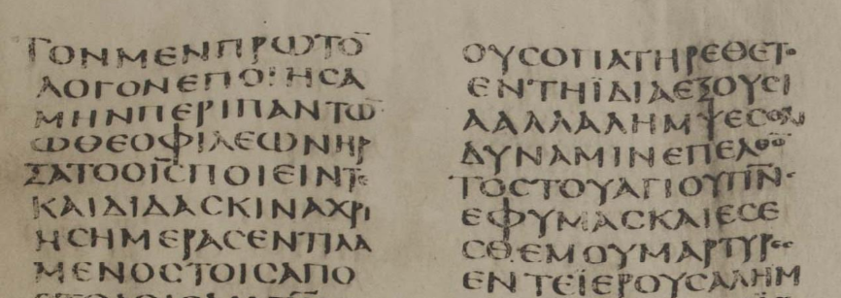
Acts 1, Codex Sinaiticus, fourth century CE

The Acts is the second of two volumes dedicated to a Christian named Theophilus who may have sponsored the author’s writing. The first volume was the Gospel attributed to Luke. Both Books are included in the canon of Scriptures called The New Testament.

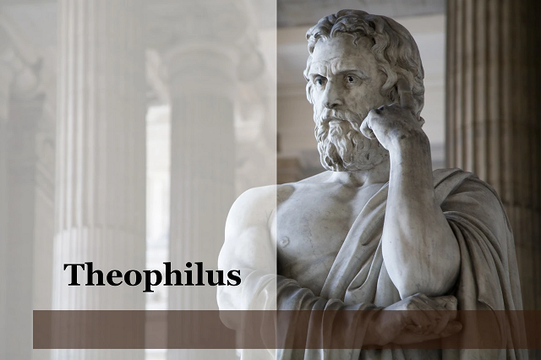

Who wrote The Acts?

All ancient writers who mention the book attribute it to a Greek-speaking Christian named Luke, a short form of Lucanus, Lucianus, Lucius, or Lucillus.

Luke is named in The Anti-Marcionite Prologue to the Gospel of Luke (written between 150 and 180 CE) which contains the oldest reference to the Book of Acts.

Iraneus, Bishop of Lugdunum in Gaul (now Lyon, France), who lived from c. 130 till c. 202 CE, asserted in c. 180 CE, that four Gospels, Matthew, Mark, Luke, and John, were canonical scripture.

Luke served as companion and collaborator of the Apostle Paul, who names him in his epistles to the Colossians: “Luke the beloved physician greets you” (4:14), to Timothy: “Luke alone is with me” (2:4:11) and to Philemon: “Luke, my fellow worker” (1:24).

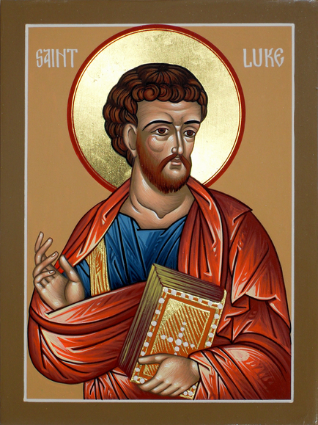

In Colossians 4:14, Luke is identified as being a physician, that is, “one who undertakes the cure of physical ailments” (BDAG). Thus, Luke cited in his Gospel the well-known dictum of Jesus, “Those who are well have no need of a physician, but those who are sick” (Luke 5:31).

Whether Luke was a Jew or a Gentile, he was conversant with Judaism and with the Tanakh (Old Testament), able to relate Christian teaching to Jewish history, eschatology and sensitivities.

For whom did Luke write The Acts?

Luke’s primary readers would have been Jewish and Gentile Christians in the churches established by the Apostle Paul. His Gospel and The Acts were widely copied, soon becoming Scripture of all the early churches, being approved by all the early church councils.

Secondary readers include Jews who had questions about how Christianity could be a fulfillment of their eschatology, that is, beliefs about the future of Israel, of the messianic kingdom, and of Gentile salvation.

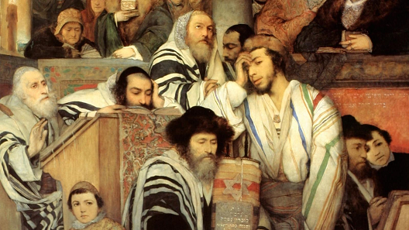
"Jews Praying in the Synagogue on Yom Kippur" by Maurycy Gottlieb, 1878.
(Wikimedia Commons)

Tertiary readers include pagan Gentiles who were concerned about the legality of Christianity, since none of the Roman officials, during those three decades, opposed Christian doctrines or practices.

Greco-Roman pagan sacrifice

What were Luke’s sources for The Acts?

Luke’s prologue to his first book, that is, his Gospel, probably applies as well to this second book, The Acts:

Inasmuch as many have undertaken to compile a narrative of the things that have been accomplished among us, just as those who from the beginning were eyewitnesses and ministers of the word have delivered them to us, it seemed good to me also, having followed all things closely for some time past, to write an orderly account for you, most excellent Theophilus, that you may have certainty concerning the things you have been taught (Luke 1:1-4).

From 2 Timothy 4:11, it appears that Luke collaborated with Paul, with Timothy and with Mark, consulting collected documents. Luke had ample opportunity to learn from Paul during their travels to various cities, participating in Paul’s missionary work. Thus, in parts of The Acts, Luke employs the pronoun “we” (16:10-40; 20:5–21:18; 27:1–28:16).

During Paul’s detention at Caesarea on the Judean coast, between 57 and 60 CE, Luke must have consulted with Christian leaders, and have interviewed eyewitnesses to the events in Jerusalem and Judea.

During Paul’s incarceration at Rome, between 60 and 62 CE, Luke doubtless interviewed Christians familiar with the early missions of Peter and of Paul, or read their written accounts.

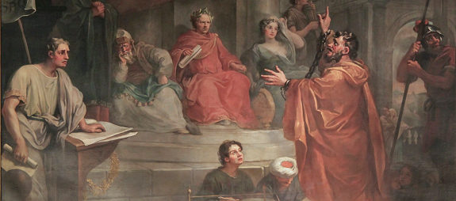
Paul making his defense before Felix Agrippa, about 58 CE

When and where did Luke write The Acts?

After gathering anecdotes, interviews, testimonials and written accounts over several years, Luke may have composed the final form of his Gospel and of The Acts in Rome where Paul was in confinement for “two whole years” (Acts 28:30-31; 60-62 CE).

Why did Luke write The Acts?

If Luke’s express purpose for his Gospel and for The Acts was “to write an orderly account … that you may have certainty concerning the things you have been taught,” then there are several apparent themes in The Acts that suggest several other purposes, as well.
● To recount the history of early Christian expansion
● To relate Jesus’ promises to his apostles’ accomplishments
● To compare Jewish eschatology to fulfillment in Christianity
● To describe the miraculous work of the Holy Spirit
● To provide models for church life and for missionary work
● To preserve early apostolic messages and methods
● To prove Paul’s apostleship in comparison with Peter’s
● To demonstrate that Gentiles are co-heirs of salvation with Jews
● To defend Gentile Christianity from Jewish legalists
● To advocate for Christianity as a legal faith under Roman law

Can we rely upon ancient copies of The Acts?

All ancient books that were copied repeatedly across several centuries were subject to scribal errors and to editing. The art of textual criticism consists of several rules and methods for ascertaining the probable original wording of a text.

Current published editions of The Acts in Ancient Greek are based upon manuscripts dated to the third, fourth and fifth centuries CE. All of existing manuscripts of The Acts tell the same story, in spite of mistakes and improvements made by ancient copyists. In our study of The Acts, we shall mention some of these when they help or hinder interpretation.

What will we learn from The Acts?
The Holy Spirit will teach us fresh insight and applications that we cannot always foresee. Some of the lessons that many others have learned from The Acts include the following:
1. The qualifications of genuine apostles of the Lord Jesus.
2. The power of the original, apostolic gospel message.
3. Ways in which to obey Jesus’ commandment to make disciples.
4. Apostolic models of how to start and grow new churches.
5. Missionary strategies and tactics that win communities to faith.
6. How prayer appropriates the love, grace and power of God.
7. How congregations can hear from the Holy Spirit.
8. Practices that help churches to reproduce and to multiply.
9. How spiritual gifts operate in church and in mission.
10. Ways in which to survive and to thrive under persecution.
11. What the baptism in the Holy Spirit really was.
12. Ways in which Jesus’ apostles interpreted the Old Testament.
13. How Jews remain Jewish whilst believing in Jesus.
14. How Gentiles become Christians without becoming Jewish.
15. Roles of church leaders and prerogatives of church members.
16. The background to Paul’s epistles.
And much more...

