Colossians 4.2-18
Legacy Standard Bible 2022
Fifth century or earlier manuscript variants: [inserted] [~replaced] [–omitted]
Learning objectives
● Participants will form or join a prayer band.
● Participants will ask God for opportunities.
● Participants will learn to reply to outsiders.
Working Outline of Colossians 4.2-18
I. Co-workers and I greet you. 1.1-2
II. Co-workers and I write to strengthen you. 1.3–4.6
A. We thank and pray to God for you. 1.3-12
B. Christ ranks above all others. 1.13–3.17
C. Therefore, behave as Christians. 3.18 – 4.6
1. In Christian households. 3.18 – 4.1
2. Praying and speaking wisely. 4.2-6
a. Devoted to prayer. 2-4
b. Answering outsiders. 5-6
III. Co-workers and I share with you. 4.7-18

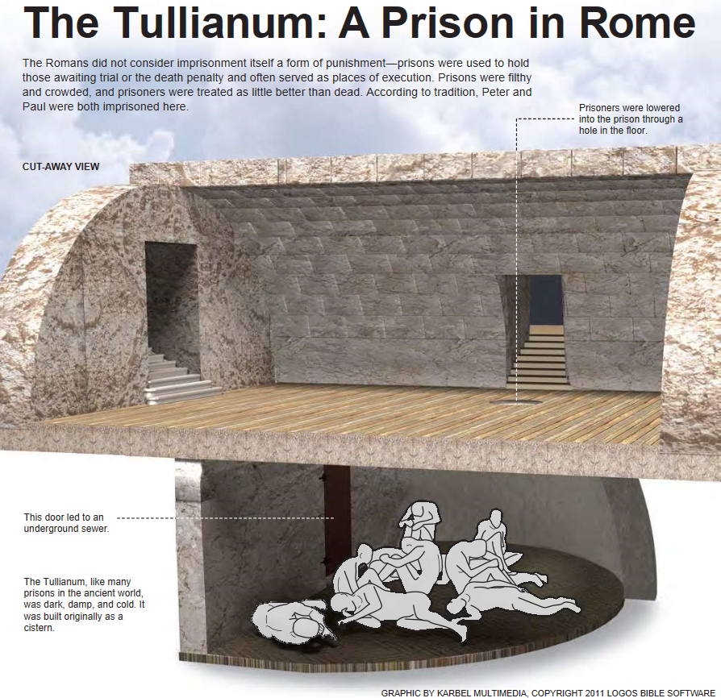 | 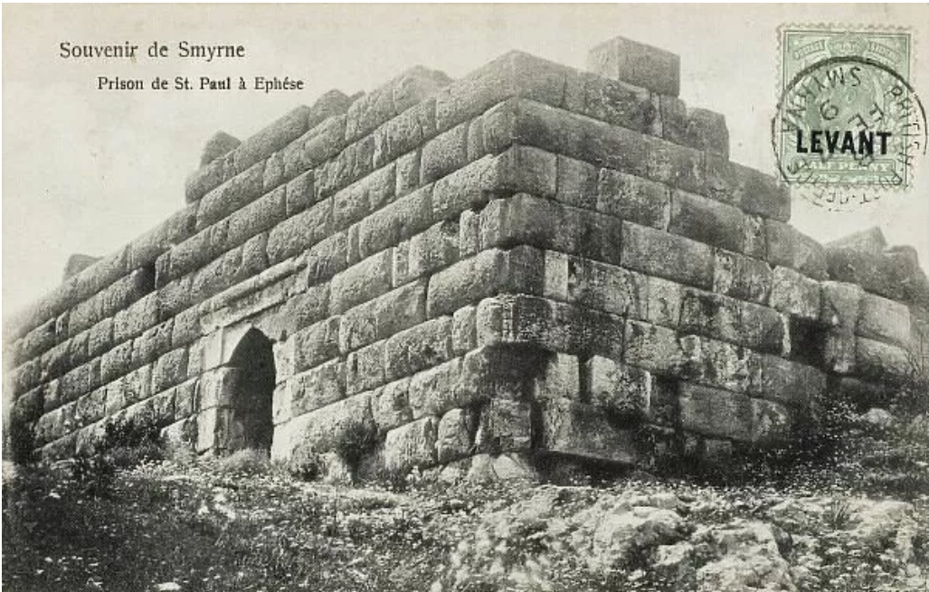  A prison in Ephesus

² Devote [~Devoting] yourselves to prayer, being watchful in it with thanksgiving; ...

Devote: 1 remain nearby. 2. persist in something. How can we persist, if we lack discipline?
Prayer: What makes prayer boring? Joyful? What can we expect from prayer?
Watchful: Looking for what? Why do we not pray in church?
Thanksgiving: Before or after an answer comes?

³ praying at the same time for us as well, that God will open up to us a door for the word, so that we may speak the mystery of Christ [~God] [with boldness], for which [~whom] I have also been bound, ⁴ that I may make it manifest in the way I ought to speak.

Door: Opportunity? Or mouth?
Bound: What got Paul arrested? Or was he obligated by Jesus?
Ought: same verb as bound.
How can we obtain rewards from others’ ministry work?

Suggestions for group prayer

● Invite the Holy Spirit to help you pray.
● “Enter His gates with thanksgiving and His courts with praise... Bless His name.”
● Cite any pertinent promise that you recall.
● “Let your requests be made known to God.”
(He already knows the details and ramifications.)
● Keep your public prayers brief.
● Keep a record of requests and of answers, and report on these.
● Expect God to answer, for he hates formal religion.

⁵ Walk in wisdom toward outsiders, redeeming the time. ⁶ Let your words always be with grace, seasoned with salt, so that you will know how you should answer each person.

In wisdom: Here is how to do so…
Words: Same word as in verse 3.
Grace: “1. quality that invites favorable reaction …
5. response to generosity, thanks.” BDAG
To know how: When we are ‘prayed up’, and our manner remains gracious, then the Lord gives wisdom on the spot.
¹² Epaphras, who is one of your number, a slave of Christ Jesus, sends you his greetings, always striving for you in his prayers, that you may stand complete and fully assured in [~filled with] all the will of God.

Strive: struggle with an opponent.
That: The Colossians’ current need while being enticed to worship through angel intermediaries.
Complete: Needing nothing more than their faith in Jesus.
Assured: Trust in the gospel from and about Jesus.

Epaphras (‘lovely’)

With Paul at Ephesus. Also in jail?
‘Epaphras, my fellow prisoner [synaiḥmalôtos, fellow spearman] in Christ Jesus’. Philemon 1:23

He had brought the gospel to Colossae.
‘You learned it from Epaphras’. Col. 1:7

Spontaneous expansion: Unhindered by tradition, rules, or rationalism, most Christians invite others to Jesus.

Historical reconstruction
1. Epaphras had gone from Colossae to Ephesus, where he heard the gospel.
2. After receiving instruction, he returned to Colossae where he told the gospel
to others.
3. The local Jews urged the new Christians to worship via angelic mediators.
4. Epaphras returned to Ephesus, where he and Timothy visited Paul who was still in jail.
5. There Paul and Timothy composed this epistle, which ephasus carried back to
Collossae and shared with Christians in Heiropolis and Laodocea.
6. Paul composed the Epistle to the Ephesians, which also circulated amongst the
churches, including Colossae.
7. This is an instance of 2 Tim 2:1-2. ‘The things which you have heard from me [Paul] ...,
[Timothy] entrust these to faithful men [Epaphras] who will be able to teach others
also [Colossians].

