Ephesians 6:10-20
New English Translation Bible 2019
Fifth century or earlier manuscript variants: [inserted] [~replaced] [–omitted]
Working Outline of the Epistle to the Ephesians
I. Greeting 1:1-2 E Ephesus
II. Praise 1.3-14 P Praise
III. Prayer 1:15-23 H Hope
IV. Teaching 2:1 – 3:21 E Edification
V. Exhortation 4:1-32 S Spiritual life
VI. Warning 5:1-21 I Instruction
VII. Counsel 5:22 – 6:9 A Attitudes
VIII. Spiritual warfare 6:10-20 N Negotiation
IX. Closing 6:21-23 S Salutation
Learning objectives
● Participants will understand that Jesus Christ prepares believers for spiritual warfare.
● Participants view personal, social and political opposition as caused by unseen spiritual beings.
● Participants will learn to pray in ways that exalt the Lord Jesus over the unseen spiritual realm.
Structure of Ephesians 4:1-16
A. Be strengthened in the Lord 10
B. Clothe yourselves with God's armour 11
Purpose: to stand against the devil
Reason: we struggle against spiritual forces 12
C. Take up the full armour 13
Result: able to stand your ground
D. Stand firm 14
Actions 14-16
E. Put on salvation and the Spirit 17
F. Praying for all the saints 18
G. Praying for me 19
Result 1: right words to speak
Result 2: to speak boldly 20
A. Be strengthened in the Lord
10 Finally, be strengthened in the Lord and in the strength of his power.
Query: How does one get strengthened with the
Lord's power?
Replies: 'Ask, and you will receive', Luke 21:36;
Hear, believe, obey, speak the Word of God, Rev 3:8.
Query: Cite some biblical examples.
Replies: Sampson, Jud 16:28; David, 1 Sam 30:7; Jesus, Luke 24:33. Paul, 1 Tim 1:12; Christians, Heb 13:9

B. Clothe yourselves with God's armour

11 Clothe yourselves with the full armor of God, so that you will be able to stand against the schemes of the devil.

Query: How does one do that?
Scheme: methodeia = 'method ...scheming, craftiness ... Eph 4:14'. BDAG
Query: What are some of the devil's schemes?
Replies: See next paragraph.

Who is the devil?

Tempter: he rationalizes our disobedience, debauchery.
Denier: he removes truth from human minds.
Murderer: he kills humans whom he rules in sheol/hades.
Liar: he whispers false ideas into human minds.
Flatterer: he inspires arrogance in the incompetent.
Trapper: he brings social disgrace to church leaders.
Ruler: he exercises power over the dead.
Sinner: he rebel against Yahweh since the beginning.
Hater: he sows discord amongst Christians.
Deceiver: he moves national leaders to conspire.

We struggle against spiritual forces
12 For our [~your] struggle is not against flesh and blood, but against the [methods] [–rulers, against the powers], against the world rulers of this darkness, against the spiritual forces of evil [–in the heavens].

Query: In what ways must we struggle?
Query: Who are those spirit dudes?
Query: How did they get into the heavens?
Query: What harm can they do to us?

‘Spiritual forces of evil’

Devil: diabolos = The archenemy of Yahweh who slanders him, 'the principal transcendent evil being'. BDAG
Rulers: arché = 'an authority figure who initiates activity or process'. BDAG
Powers: exousia = '5 bearer of ruling authority'. BDAG
World rulers: kosmokratōr = 'world-ruler ... spirit beings, who have parts of the cosmos under their control'. BDAG
Spiritual forces: pneumatikos = '(evil) spirits'. BDAG
Evil: ponéria = 'the wickedness that ruins the life of people ... evil-mindedness'. BDAG

C. Take up the full armour

13 For this reason, take up the full armor of God so that you may be able to stand your ground on the evil day, and having done everything, to stand.

Query: How does one do that?
Query: What is 'the evil day'?
Query: Will we really be able to stand during the end times?
Jesus: "Stay alert at all times, praying that you may have strength ... to stand before the Son of Man." Luke 21:36

Psalm 82 (quoted by Jesus)

1 God has taken his place in the divine council;
in the midst of the gods he holds judgment:
2 “How long will you judge unjustly
and show partiality to the wicked?”
6 I say, “You are gods,
children of the Most High, all of you;
7 nevertheless, you shall die
like mortals and fall like any prince.”

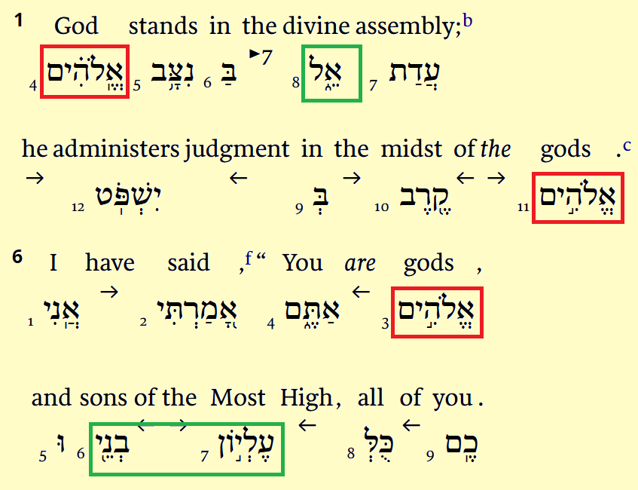

D. Stand firm

14 Stand firm therefore, by fastening the belt of truth around your waist, by putting on the breastplate of righteousness, 15 by fitting your feet with the preparation that comes from the good news of peace ...
Query: How does one do that?
Truth: How does one learn truth?
Righteousness: How does one become righteous?
Good News: What good news?
Peace: Peace with whom?

16 and in all of this, by taking up the shield of faith with which you can extinguish all the flaming arrows of the evil one.

E. Put on salvation and the Spirit

17 And take the helmet of salvation and the sword of the Spirit (which is the word of God).

Evil one: ponéros = ‘being morally or socially worthless ... evil-intentioned person ... the devil’.
Shield: Believe the Word.
Sword: Speak the Word.

F. Praying for all the saints

18 With every prayer and petition, pray at all times in the Spirit, and to this end be alert, with all perseverance and petitions for all the saints.
Hendiadys: Rephrase ‘prayer and petition’. ‘prayerful petition’? ‘Petitionary prayer’?
Query: At all what times?
Ambiguity: ‘pray in the Spirit’ or ‘pray in your spirit’?
Query: How does one pray in the Spirit?

G. Praying for me

19 Pray for me also, that I may be given the right words when I begin to speak —that I may confidently make known the mystery [-of the gospel], 20 for which I am an ambassador in chains. Pray that I may be able to speak [this] boldly as I ought to speak.
‘Praying at all times’
Query: Suggest some things to ask God to do for those who speak the gospel, teach the Bible, train Christians, represent the church to government, counsel those in need. For whom else?

Three prayer times

Personal prayers: Say anything we wish. Vent our emotions. Listen carefully. Watch for results. — We are not disciplined enough, cannot think of things to say; we
get distracted, bored or doubtful.
Small group prayers: Share urgent needs and burdens. Get immediate prayer. Report back results — Make requests without rehearsing details that God already knows.
Big group prayers: Big requests, petitions or groups, communities, nations. Praise songs & scripture reading. — Do not expose personal issues.

