Ephesians 2.11-22
New English Translation Bible 2019
Fifth century or earlier manuscript variants: [inserted] [~replaced] [–omitted]

Working Outline of the Epistle to the Ephesians
I. Greeting 1:1-2 E Ephesus
II. Praise 1.3-14 P Praise
III. Prayer 1:15-23 H Hope
IV. Teaching 2:1 – 3:21 E Edification
V. Exhortation 4:1-32 S Spiritual life
VI. Warning 5:1-21 I Instruction
VII. Counsel 5:22 – 6:9 A Attitudes
VIII. Spiritual warfare 6:10-20 N Negotiation
IX. Closing 6:21-23 S Salutation

Structure of Ephesians 2.11-22
Imperative: Remember: 11
You were Gentiles without God 12
Affirmation: But now you are near 13
Explanation 1: For he is our peace 14
Having made the two races one 14-15a
Purposes: To make one new humanity 15b
And to reconcile both by his cross 16
Explanation 2: And he announced peace 17
Cause: We both access the Father in one Spirit 18
Result: Therefore you are fellow citizens, God’s family 19
Details: Built upon the apostles & prophets 20
Growing in the Lord 21
Being united in the Spirit 22

Acts 21:28
28 “Men of Israel, help! This is the man who teaches everyone everywhere against our people, our law, and this sanctuary! Furthermore he has brought Greeks into the inner courts of the temple and made this holy place ritually unclean!”
Ephesians: Paul may have penned this epistle from prison in Caesarea, following his arrest in Jerusalem, charged with desecration of the temple.

Imperative (since God has livened us 2:5)
11 Therefore [~because of this] remember that formerly you, the Gentiles in the flesh—who are called “uncircumcision” by the so-called “circumcision” that is performed on the body by human hands—
Query: Why say, ‘in the flesh’?
They were no longer Gentiles in Christ! See 2:15.
Query: Why say, ‘performed ... by human hands’? See Leviticus 26:1 LXX.
There is a ‘circumcision of the heart’! See Rom. 2:29.

Remember
12 that you were at that time without the Messiah, alienated from the citizenship of Israel and strangers to the covenants of [the] promise, having no hope and without God in the world.
Query: What are five advantages of being born a Jew? (From this text.)
Atheist: atheos, 1 without God, 2 atheist. Polytheists and Christians accused each other of atheism. ‘The charge was especially volatile, since the security of the state depended on proper relationships with the gods.’ BDAG

Eight covenants providing a promise
Noahic: Never again a worldwide flood.
Abrahamic: A posterity, a land, and Gentile blessing.
Mosaic: National prosperity and security.
Sinaitic: Personal and family prosperity.
Davidic: Everlasting kingship descended from David.
Isaiahic: A national redeemer and a prophetic spirit.
Everlasting: Peace, multiplication, knowing Yahweh.
New: Forgiveness of sins, Israel and Judah reunited, and the gift of God’s Spirit

Affirmation
13 But now in Christ Jesus you who used to be far away have been brought near by the blood of [Jesus] Christ.
Query: Which Gentiles are now nearer than before? All of them? Or only Christian Gentiles?
Query: Just near? Or all the way?
Query: Why say ‘bythe blood of Christ’ and not just ‘by Christ’?
Query: How does this allude to the First Covenant sacrificial system?
Explanation 1: He is our peace
14 For he is our peace, the one who made both groups into one and who destroyed the middle wall of partition, the hostility, 15 when he nullified in his flesh the law of commandments [–in decrees].
Query: What kind of peace? What does it look like?
Query: Both what groups? Into one what?
Query: Nullified how? It is no longer applicable to the forgiven!
Query: How does ‘flesh’ relate to ‘blood’ in verse 13?
Josephus, Wars of the Jews, Book 5
193 When you go through these [FIRST] cloisters, unto the second [COURT OF THE] temple, there was a partition made of stone all round, whose height was three cubits: its construction was very elegant; 194 upon it stood pillars, at equal distances from one another, declaring the law of purity, some in Greek, and some in Roman letters, that "no foreigner should go within that sanctuary; " for that second [COURT OF THE] temple was called "the Sanctuary."
The Dividing Wall
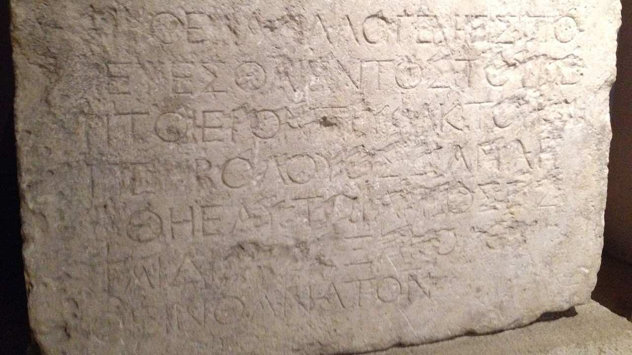 | ΜΗΘΕΝΑΑΛΛΟΓΕΝΗΕΙΣΠΟ  ΡΕΥΕΣΘΑΙΕΝΤΟΣΤΟΥΠΕ  ΡΙΤΟΙΕΡΟΝΤΡΥΦΑΚΤΟΥΚΑΙ  ΠΕΡΙΒΟΛΟΥΟΣΔΑΝΛΗ  ΦΘΗΕΑΥΤΩΙΑΙΤΙΟΣΕΣ  ΤΑΙΔΙΑΤΟΕΞΑΚΟΛΟΥ  ΘΕΙΝΘΑΝΑΤΟΝ | No stranger is to enter  within the balustrade round  the temple and  enclosure. Whoever is caught  will be himself responsible  for his ensuing  death.
Discovered 1871. en.wikipedia.org/wiki/Temple_Warning_inscription — Wikimedia Commons

First Testament views on Gentiles
1 Kings 8:41-43. “Foreigners, who do not belong to your people Israel ... will come and direct their prayers toward this temple. Then listen from your heavenly dwelling place and answer all the prayers of the foreigners. Then all the nations of the earth will acknowledge your reputation, obey you as your people Israel do...
Isaiah 56:6-7. As for foreigners who become followers of the LORD and serve him, who love the name of the LORD and want to be his servants ... I will make them happy in the temple where people pray to me... for my temple will be known as a temple where all nations may pray.”
Purposes
He did this to create in himself [~him] one new [~common] man out of two, thus making peace, 16 and to reconcile them both in one body to God through the cross, by which the hostility has been killed.
New = kainos; common = koinos.
Query: What body? Or Whose body?
Query: What does it mean to ‘kill the hostility’? Why not say, ‘remove the hostility’?
Explanation 2: He announced peace
17 And he came and preached peace to you who were far off and peace to those who were near, 18 so that through him we both have access in one Spirit to the Father.
Query: When and where did Jesus preach peace to those who were far off? To those who were near? (See below)
Query: What does it mean to access the Father “in one Spirit”? Why say ‘Spirit’ and not ‘Messiah’?

Jesus preached peace to those near!
John 14:27 ‘Peace I leave with you; my peace I give to you. Not as the world gives do I give to you. Let not your hearts be troubled, neither let them be afraid.’ ESV
John 20:21 ‘Peace be with you. As the Father has sent me, even so I am sending you.’ ESV

Did Jesus preach peace to those far?
LXX: ‘Peace upon peace to those that are far and to those that are near’ NETS. Eph. 2:17 Isa. 57:19.
MT: ‘Peace, peace, to the far and the near’ NRSVue. Includes Gentiles (Isa. 56:6-7).
Grammar: Greek ‘dative’ noun case without presupposition may mean ‘to’ or ‘for’ in a given context.

Result
19 So then you are no longer foreigners and non-citizens, but you are fellow citizens with the saints and members of God’s household, 20 because you have been built on the foundation of the apostles and prophets, with Christ Jesus himself as the cornerstone.
Metaphors: Citizens, household, foundation, cornerstone. What is their common meaning?
Query: What ‘saints’ are these?
Grammar: The apostles and prophets. First Testament or New Testament prophets? (See below)

Cornerstone or capstone?
“The only place ἀκρογωνιαῖος [cornerstone] is used in the LXX is Isa[iah] 28:16, and there it clearly refers to a cornerstone that is part of a foundation.” NET2
The apostles and prophets
“Because the prophets appear after the mention of the apostles and because they are linked together in 3:5 as recipients of revelation about the church, they are to be regarded not as Old Testament prophets, but as New Testament prophets.” NET2

NET2 = New English Translation, 2nd Edition. See www.netbible.org
Details
21 In him [–the] whole building, being joined together, grows into a holy temple in the Lord, 22 in whom you also are being built together into a dwelling place of God [~Christ] in the Spirit.
Metaphors: Building, joined, temple, dwelling place. What is their meaning?
Query: Explain ‘in the Lord’ and ‘in the Spirit’. The living God both builds a temple and dwells within it.

Towards a New Humanity (hostility)
1. Gentiles in the flesh
2. Citizens of Israel
3. Covenants of promise
4. Circumcision
5. Hope and God in the world
6. Law of decrees
7. Hostility!
Towards a New Humanity (reconciliation)
8. Messiah came in flesh
9. Blood of the cross
10. Law of decrees nullified
11. Partition destroyed
12. Hostility killed
13. New humanity in him
14. Reconciled to God
Towards a New Humanity (peace)
15. Two groups become one
16. Peace announced
17. Access to the Father
18. In one Spirit
19. Fellow citizens
20. God’s household
21. A holy temple
Share
What is one truth, insight, belief or action that you learned from Ephesians 2:11-22, this week?
For next time
Let us read a chapter of Ephesians each day in versions that you trust. Let us study Ephesians 3:1-21, preparing comments and queries for discussion.

