GUIDE TO EPHESIANS 1:15-23
POWELLHURST MEN’S BIBLE STUDY
THURSDAY 18 AND SATURDAY 20 AUGUST 2022
New English Translation Bible 2019
Fifth century or earlier manuscript variants: [inserted] [~replaced] [–omitted]
Working Outline of the Epistle to the Ephesians
I. Greeting 1:1-2 E Ephesus
II. Praise 1.3-14 P Praise
III. Prayer 1:15-23 H Hope
IV. Teaching 2:1 – 3:21 E Edification
V. Exhortation 4:1-32 S Spiritual life
VI. Warning 5:1-21 I Instruction
VII. Counsel 5:22 – 6:9 A Attitudes
VIII. Spiritual warfare 6:10-20 N Negotiation
IX. Closing 6:21-23 S Salutation
Structure of Ephesians 1:15-23
15 Cause: Chosen (3-14), faith and love
16 Activity: thanks and prayers
17 Purpose: wisdom and revelation
18-19 Reason: perceive inheritance & power
20 Proof: Christ raised and seated
21 Result 1: Christ is exalted, now and in age to come
22 Result 2: Christ is Head of his community (church)
23 Result 3: Christ is the Fullness
Cause and purpose of thanks when praying
15 For this reason, because I have heard of your faith in the Lord Jesus and [–your love] for all the saints, 16 I do not cease to give thanks for you when I remember you in my prayers.
Query: What reason? Faith: (1) believe truth, (2) remain loyal.
[–your love]: Scribes’ eye skipped from one “the” to another “the”.
17 I pray that the God of our Lord Jesus Christ, the glorious Father, will give you spiritual wisdom and revelation in your growing knowledge of him, 18 — since the eyes of [–your] heart have been enlightened — ...
Which God: Zeus? The True God who sent Jesus!
Father of glory: Glorious? Or who gives glory?
Spirit of: Holy Spirit? Our own spirit? Attitude?
Query: What is wisdom? (sophia)
Query: What is revelation? (apokalypsis)
Query: What is knowledge? (epignôsis)
Query: When were/are we enlightened? (photizô)
Eyes of the heart — spiritual wisdom
● ‘Open my eyes’, Psa 119.18; ‘his eyes’, 2 Kings 6:17
● ‘They shall establish eternal truth guided by the instruction of His holy spirit’. 1QS 4.3-4 Manual of Discipline
● ‘May He enlighten your mind with wisdom for living, ... with the knowledge of eternal things’. 1QS 2:3
● ‘My soul recovered the spirit of understanding, and I began to speak words in the presence of ... Yahweh.’ 4 Ezra 5:22 [After 70 CE]
Reasons for thanks when praying
… so that you can know what is the hope of his calling, what is the wealth of his glorious inheritance in the saints, 19 and what is the incomparable greatness of his power toward us who believe, as displayed in the exercise of his immense strength.
Know: (oida, sight, factual knowledge)
Query: Whose is “his” (four times)?
Query: To what hope does he call human beings ?
Query: Who inherit(s)?
Query: What are saints?
Believe: Present tense = to keep on believing.
Biblical rhetorical style
● ‘By the greatness of his might, and because he is strong in power not one is missing’. Is 40:26
● Micah 3:8 ‘I am filled with power, with the spirit of the LORD, and with justice and might’.
● Zechariah 4:6 ‘Not by might, nor by power, but by my spirit’.
● ‘I will make them know my power and my might, and they shall know that my name is the LORD’.
● ‘power … energy … might … strength.’ Eph 1:19
Proof for our hope
20 This power he [has] exercised in Christ when he raised him from the dead and seated him at his right hand in the heavenly realms …
Result #1
21 far above every rule and authority and power and dominion and every name that is named, not only in this age but also in the one to come.
Realms: Ancients divided the heavens into three or seven levels, each inhabited by different spirit beings.
Spirits: Ancients believed that national affairs were dictated by spiritual beings, gods or daemons.
Names: Pagans sought to exorcise evil spirits by invoking powerful names of gods and spirits.
Collaborating texts
● Deut 32:8 (LXX & DSS) ‘Most High apportioned the nations ... according to the number of the gods’.
● Psa. 110.1 ‘Sit at my right hand...’
● 1Q33 (=1QM) 15.14 ‘The God of Israel is about to raise His hand in His wondrous [streng]th [against] all the spirits of … the gods’.
● 1 Enoch 16:10 ‘He will summon all the host of heaven ... the angels of power and all the ngels of the principalities’.
Cultural background
Pagans: Believed the world was run by fate. Mystery cults offered power to free initiates from fate. ‘Men ... even if they do not want to, they will be compelled in any case to follow what is destined.” (Hippolytus, Refutation of all heresies, 3rd cent. BCE)
Jews: Believed that only Israel was free from spirit rulers. ‘Over all hath He placed spirits in authority to lead them astray from Him. But over Israel He did not appoint any angel or spirit, for He alone is their ruler’. Jubilees 15:32
Christians: believe that Jesus now has ‘all authority in heaven and on earth’ Matthew 28:17
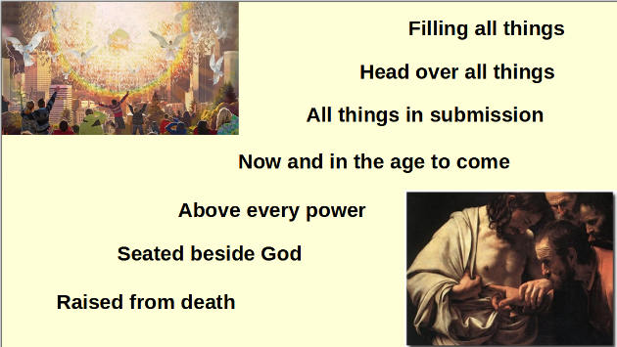

Result #2
22 And God put all things under Christ’s feet, and gave him to the church as head over all things.
Result #3
23 Now the church is his body, the fullness of him who fills all in all.
Psa. 8.6 ‘You have given them dominion ... you have put all things under their feet’.
Query: Has Christ ceded his headship over the church to a human hierarchy? To a board of elected elders?
Fullness: Does this describe the church who are full of Christ? Or Christ, who is God’s fullness? Col 1:19 2:9
In philosophy: fullness = ‘the sum of the qualities that constitute something’.
In Gnosticism: the angelic aeons.

