Brief Introduction to the Epistle to the Galatians

Author: Saul of Tarsus, a.k.a. the Apostle Paul
Date: Circa year 49 CE
Recipients: Newly-founded, mostly-Gentile churches in the South of the Roman province
of Galatia
Occasion: Paul wrote Galatians to counter a teaching that requires Gentiles to follow Moses’ Law.

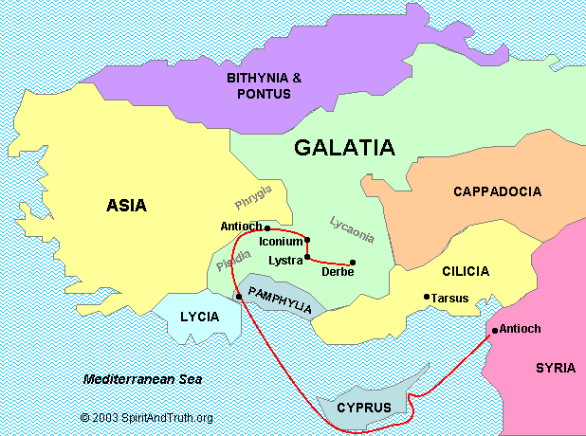
Source: SpiritAndTruth.org

Inferred Chronology
Year CE
33 Jesus appears to Saul near Damascus (Syria). Ac 9:4-5
Saul travels to Arabia, returns to Damascus. Ga 1:17
He returns to Jerusalem, is sent to Tarsus. Ac 9:26, 30
36 After three years, Saul visits Peter for 15 days. Ga 1:18
Jews and Gentiles are converted in Antioch. Ac 11:1921
Barnabas travels to Antioch and ministers. Ac 11:22-24
Barnabas bring Saul to Antioch (Syria). Ac 11:25-26
Barnabas and Saul carry aide to Jerusalem. Ac 11:29-30
They return to Antioch, bringing John Mark. Ac 12:24-25
47 After 14 years, Saul, Barnabas and Titus go to Jerusalem because of a revelation. Ga 2:1-2
Titus, a Hellenist Jew, refuses circumcision. Ga 2:3
Apostles James, Peter and John affirm Paul’s apostleship to the Gentiles. Ga 2:7-9
Peter & James lead a delegation to Antioch. Ga 2:11-12
Their hypocrisy misleads Barnabas. Ga 2:13
Saul reproaches Peter before the others. Ga 2:14
48 Church elders commission Barnabas and Saul. Ac 13:1-3
They plant churches, return to Antioch. Ac 13 & 14
Men from Judea teach Gentiles that they must be circumcised to be saved. Ac 15:11.
Paul and Barnabas debate with these teachers. Ac 15:2
49 Paul writes & sends his Epistle to the Galatians. Ga 1:1-2
Paul and Barnabas lead a delegation through Phoenicia and Samaria to Jerusalem about the issue. Ac 15:3-29
They deliver the council’s letter to Antioch. Ac 15:30

Argument of Galatians
Adapted from Donald Guthrie, NT Introduction (1963)
I. Paul asserts that
1. He received his apostleship from Jesus Christ. 1:1
2. Christ gave himself for our sins to set us free. 1:2-5
“The Lord Jesus Christ … gave himself for our sins to set us free from the present evil age.”

II. Paul rebukes those who pervert the Good News. 1:6-10
“If anyone proclaims to you a gospel contrary to what you received,
let that one be accursed!”

III. Paul relates that:
1. He received his teaching directly from God. 1:11-12
2. Although he formerly was zealous for Jewish traditions, he now preaches the Good News amongst Gentiles. 1:13-17
3. After two meetings with the Jerusalem apostles, they affirmed his apostleship. 1:18–2:10
4. He once exercised his authority by rebuking another apostle. 2:11-14
5. The real issue is a choice between faith in Christ and following the Law. 2:15-21
“We have come to believe in Christ Jesus, so that we might be justified by faith
in Christ, and not by doing the works of the law, because no one will be justified
by the works of the law.

IV. Paul argues that:
1. The Galatians had received the Holy Spirit by faith, not by keeping the Law. 3:1-5
2. Abraham received God’s blessing by faith, not by keeping Law. 3:6-9
3. The law imposed a curse on human beings, which Christ removed by becoming a curse on our behalf. 3:10-14
“Christ redeemed us from the curse of the law by becoming a curse for us …
in order that in Christ Jesus the blessing of Abraham might come to the Gentiles,
so that we might receive the promise of the Spirit through faith.”
4. The covenant promise that God made with Abraham, before the Law came, remains valid. 3:15-18
5. The main purpose of the Law was to prepare the way for Christ who fulfills the promise.
3:19-29
6. Faith in Christ redeems us from the Law, by making us free sons of God. 4:1-7

V. Paul makes a personal appeal
1. They were formerly slaves to elemental spirits, so they should not return to being slaves.
4:8-11
2. They formerly had such goodwill towards him, but false teachers have turned them away from him. 4:12-20
3. As friends, he and they belong to a heavenly Jerusalem, being promised children like Isaac. 4:21-31
4. Freedom excludes circumcision and legalism. 5:1-6
“In Christ Jesus neither circumcision nor uncircumcision counts for anything;
the only thing that counts is faith working through love.”

VI. Paul expounds on freedom in Christ
1. Those who oppose freedom stand condemned. 5:7-12
2. Freedom leads not to license but to mutual love. 5:13-15
3. The Spirit frees us from the works of the flesh, guides us, and bears his fruit in us. 5:16-26.
“The fruit of the Spirit is love, joy, peace, patience, kindness, generosity, faithfulness, gentleness, and self-control.”

4. The spiritual seek to restore those who succumb to temptation. 6:1-5
5. The spiritual work for the good of all, reaping eternal life. 6:6-10

VII. Paul exposes basic motives
1. False teachers want to boast about religion, avoiding persecution from the cross of Christ. 6:11-13
2. Paul boasts about the cross of Christ, being a new creation. 6:14-18

“May I never boast of anything except the cross of our Lord Jesus Christ.”

