Introduction to 1 Thessalonians
Author: Saul of Tarsus, a.k.a. the Apostle Paul
Date: 50 CE, when Gallio was proconsul of Achaia. One of the earliest, surviving Christian documents. Thus, it remains one of the earliest Christian documents surviving.
Greek manuscripts: Papyri 30 (3ed century), 46 (c 200 CE), 65 (3ed century); uncials Sinaiticus
(4th century), Alexandrinus (5th century), Vaticanus (5th century), and a score of others.
Authenticity: Nearly all scholars and historians attribute 1 Thessalonians to Paul.
Marcion, a Christian Gnostic (died c. 160 CE) listed 1 Thessalonians in his canon of authentic scriptures. https://en.wikipedia.org/wiki/Marcion_of_Sinope
The Muratorian Canon, from about 170 CE, lists 1 Thessalonians amongst books believed to be written by apostles of Jesus. https://en.wikipedia.org/wiki/Muratorian_fragment
Drafted as early as c 170 CE, preserved in a 7th cent Latin mss translated from Greek, listing known books believed to be written by apostles of Jesus. Heb no included.
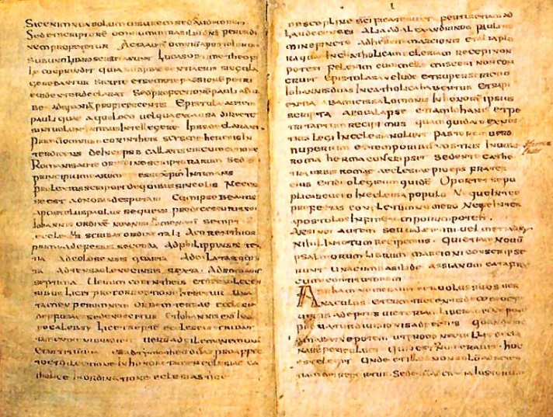 Photo in Public Domain.
Wikimedia Foundation: "faithful reproductions of two-dimensional public domain works of art are public domain"
Recipients: First-century CE Christian believers in Thessalonica, Macedonia.
Thessalonica: The largest city and capital of Macedonia Province. A self-governing, Roman ‘free city’.
Backdrop: Acts 16:16-40 recounts how Paul and his co-workers had been illegally arrested, beaten, jailed and asked to leave Philippi. There Was Not Time to Give Much Instruction to the New Converts, So It Is Not Surprising That Questions Arose As to the Meaning of Some Aspects of
the Christian Faith and of the Conduct Demanded of Believers. HIBD
Acts 17:1-9 recounts how they arrived in Thessalonica, spent three weeks (or Sabbaths) proving from the Jewish Scriptures that Jesus is the Messiah.
After jealous synagogue leaders fomented a riot, Paul fled to Athens, before rejoining his
co-workers in Corinth, where this letter may have been written (1 Thess 3:6; Acts 18:5).
Purpose: Because Paul’s team had to leave the city so soon, they had not had enough time to teach the new believers well. Thus, they wrote this letter to address their needs and questions such as:
● Affirm their conversion by their active faith, love and hope (1:2).
● Strengthen their faith in spite of continuing persecution (2:14).
● Warn against pagan sexual standards (4:4-8).
● Urge them to remain productive citizens who supply theirs and others’ needs
(4:11-12).
● Explain what will become of believers who die before Jesus return (4:13-18).
● Instruct them in basic Christian spirituality (5:12-22).

Teaching outline:
Greeting (1.1)
1. Recalling the believers’ faith hope and love (1.2-10)
2. Reviewing the apostles’ gentle ministry (2.1-16)
3. Assuring of the apostles’ continued care (2.17 – 3.13)
4. Living in a way that pleases God (4.1-12)
5. Awaiting the Lord’s coming (4:13 – 5:11)
6. Maintaining an active spiritual life (5.12-22)
7. Blessing fellow believers (5.23-27)
Greeting (5.28)

Bible Project: https://youtu.be/No7Nq6IX23c

