How a conventional teacher views a student.

How an obedience-oriented trainer views those co-workers receiving training as part of a church body.

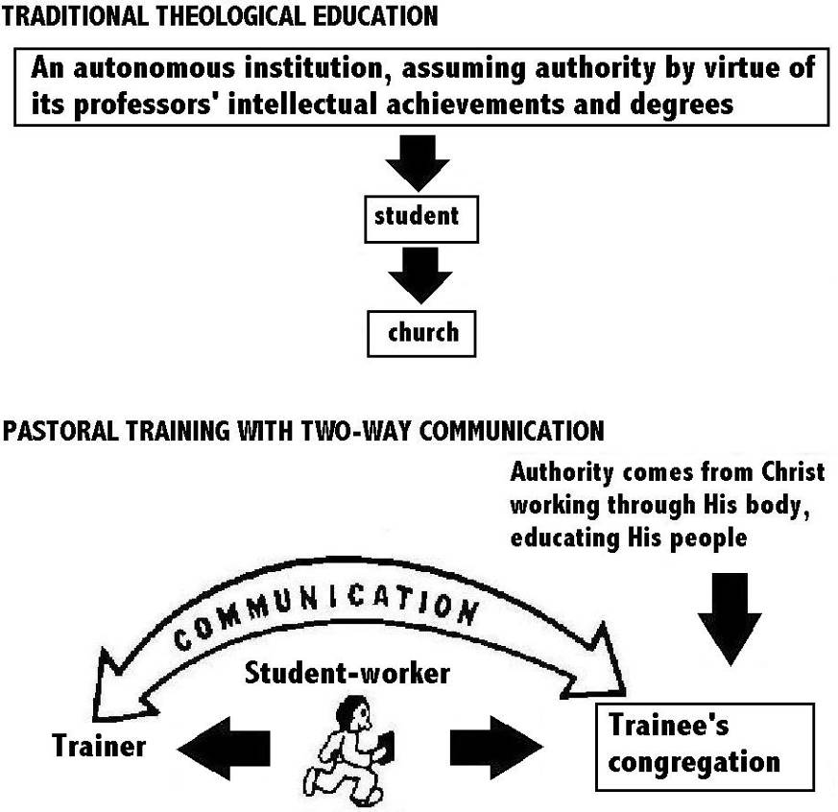
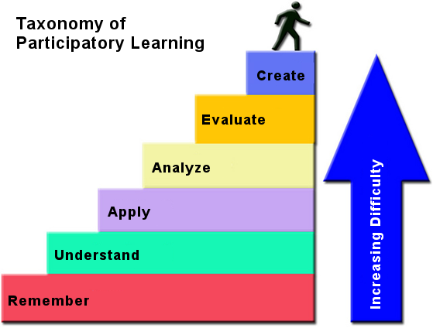

Only if the disciples can remember a concept, can they understand it.
Only if the disciples can understand a concept, can they apply it.
Only if the disciples can apply a concept, can they analyze it.
Only if the disciples can analyze a concept, can they evaluate it.
Only if the disciples can remember, understand, apply, analyze and evaluate a concept, can they create.
Remember:
Recalling Information.
When the disciples can remember, they also are able to recognize, list, tell, discuss, describe, locate, find, etc.
The following are the starting point for some sample ‘remembering’ questions:
- What happened after ...?
- How many/much ...?
- Who was it that ... ?
- Can you name the ... ?
- Describe what happened at...?
- Who spoke to . . .?
- Can you tell why . . .?
- What does this mean . . .?
- Find the meaning of . . .?
- What is . . .?
- Which is true or false . . .?
Understand:
Explaining ideas or concepts.
When the disciples can understand, they also are able to explain simply, interpret, summarize, discuss, draw conclusions, retell, predict, illustrate, etc.
The following are the starting point for some sample ‘understanding’ questions:
- Can you tell or write in your own words...?
- Can you write a brief outline ... ?
- What do you think might happen next ... ?
- Who do you think ... ?
- What was the main idea ... ?
- Who was the key character…?
- Can you distinguish between ... and ...?
- What differences exist between ... and ...?
- Can you provide an example to explain what you mean ... ?
- Can you provide a definition for ... ?
Biblical examples of ‘Remember’ and ‘Understand’:
Exodus 3: 10-16; 1 Chronicles 28:11-19; Daniel 1: 17 & verse 20; Matthew 16:5-12; Matthew 13:18-19; Mark 11:20-26; Luke 17:32-33; Luke 24:5-8; Luke 24: 44-45; John 12:12-16; John 15:20; Acts 8:29-31; Acts 11:15-17; Acts 11:15-17; 2 Corinthians 9:6-7; 2 Timothy 2:3-13; 2 Peter 3:1-2.
Apply:
Using information in another familiar situation.
When the disciples can apply, they also are able to implement (carry out), use, complete, explain, solve, construct, classify, etc.
The following are the starting point for some sample ‘applying’ questions:
- Do you know another instance where ... ?
- Could this have happened in ... ?
- Can you group by characteristics, such as ... ?
- What factors would you change if ... ?
- Can you apply the method used in the story to your own life ... ?
- What questions would you ask of ... ?
- From the teaching, can you propose a set of steps to get started with ... ?
- Under what circumstances, would this information be useful ... ?
Biblical examples of ‘Apply’:
- Positive examples:
Genesis 6: 9-22; Genesis 24: 12-17; Mark 6: 7-13; John 4: 1-42; Acts 10: 17-48; Acts 18: 9-11; Acts 18: 24-28 & 19: 1-7; Acts 26: 15-20
- Negative Examples:
Jeremiah 8: 4-9; Jeremiah 42: 1-4 & 42:19-43:7; Ezekiel chapter 34; Mark 9: 14-29
Analyze:
Breaking information into smaller parts, to identify the components, so as to understand their relationships and unique characteristics.
When the disciples can analyze, they also are able to compare, contrast, organize, explain, check (examine), monitor, identify, distinguish, find, attribute, summarize, investigate, classify, arrange, question, etc.
The following are the starting point for some sample ‘analyzing’ questions:
- Which events could have happened ...?
- If ... happened, what might the results have been?
- How was this similar to ... ?
- What was the underlying theme of ... ?
- What do you see as other possible outcomes?
- Why did ... changes occur?
- Can you compare your ... with that presented in ... ?
- Can you explain what must have happened when ... ?
- How is . . . similar to . . .?
- What are some of the problems of ... ?
- Can you distinguish between ... and ...?
- What were some of the motives behind ... ?
- What was the turning point in the story?
- What was the problem with . . .?
Biblical examples of ‘Analyze’:
Job 28: 12-28; Book of Ecclesiastes; Isaiah 40: 12-31; Mathew 16: 13-17; Mathew 13: 1-57; Mathew 11: 16-24; Mathew 18: 21-35; Mathew 19: 3-11; Mathew 20: 1-16; Mathew 22: 1-14; Acts 17:11; Hebrews 7: 1-28
Evaluate:
Make an informed decision, justify a decision or support a course (plan) of action. Requires the understanding of values.
When disciples can evaluate, they also can decide, choose, recommend, prove (justify), prioritize, verify, put forward constructive and benevolent criticism, experiment, conclude (judge), infer, test, oversee (supervise), etc.
The following are the starting point for some sample ‘evaluating’ questions:
- Is there a better solution to ...?
- Determine (Judge) the value of. .. ?
- Can you explain and defend your position about ... ?
- Do you think ... is a good or a bad thing?
- How would you have handled ... ?
- What changes to ... would you recommend?
- Are you a ... kind of person?
- How would you feel if ... ?
- How effective are ... ?
- What do you think about ... ?
Biblical examples of ‘Evaluate’:
Genesis 13:5-9 & verses 14-17; Genesis 18: 16-33; Daniel 1: 1-16; John 20: 24-28; Acts 6: 1-7; Acts 15: 4-32; 1 Corinthians 2: 10-16; Philippians 3: 1-17
Create:
Generate new ideas, ministries or ways of viewing things that are usually (but not always) produced in the combining of existing knowledge and ideas.
When disciples can create, they also are able to design, plan, imagine, construct, perform creative work, form, compose, produce, solve, invent, formulate, etc.
The following are the starting point for some sample ‘creating’ questions:
- Can you organize … ?
- Can you coordinate … ?
- Can you design a ... ?
- Can you write (compose) a song about ...?
- Can you propose a possible solution to ... ?
- If you had access to unlimited resources how would you deal with ... ? Do you have any specific ideas?
- Can you devise a way to deal with ... ?
- What do you think it would matter if ...?
- What do you think would happen if ...?
- How many different ways can ... ?
- Can you create new and practical uses for ... ?
- Can you write some Bible studies to help disciples with…?
- Can you develop a plan and proposal which would ... ?
Biblical examples of ‘Evaluate’:
Genesis 47: 13-26; Exodus 18:1-27 (Numbers 11: 16-17); Exodus 32: 1-33; 2 Chronicles 3: 1 – 5: 1; Esther 3: 1 - 5: 8; Book of Nehemiah; Daniel 5: 10-16; Acts 15: 1-31; Romans 15: 14-20; 1 Corinthians 9: 19-23; 1 Corinthians 14: 12-19 & verse 26; 2 Timothy 2: 16-17 (negative example)

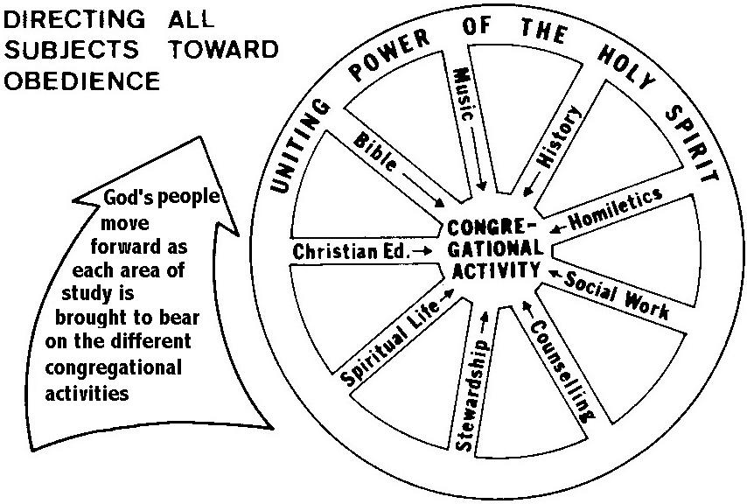
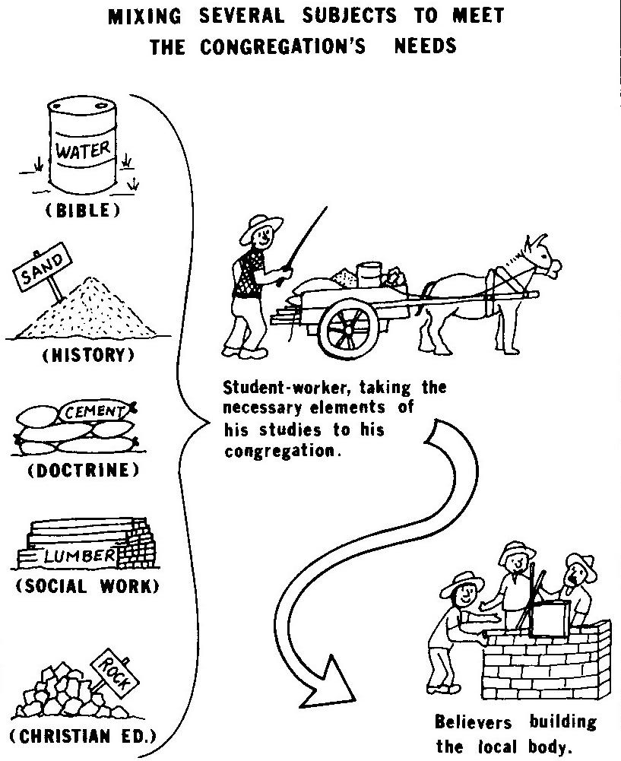
The one supplying the masons with building material does not take the brick-layers a several months' supply of water all at once. This would be something like a trainer conducting a six months' detailed study of Ecclesiastes with the student co-workers and expecting them to use all the material immediately with their churches. Again, he does not dump a whole load of sand in their midst, which would be like doing an intensive study of church history from Paul to the present. No, instead he takes them an appropriate mixture: just enough of each of the elements to make a solid wall. He keeps them working from week to week. He gives them what they need at each stage of development.
