Spiritual Counseling
for Personal and Family Problems
Anchor command. “One who prophesies speaks to men for edification and exhortation and consolation.” 1 Corinthians 14:3
Anchor promise. “But the wisdom from above is first pure, then peaceable, gentle, reasonable, full of mercy and good fruits.” James 3:17
Anchor story. The Prophet Nathan brought King David to repent. 2 Samuel 12:1-13.
Anchor Verse. “Speak the truth in love.” Ephesians 4:15
Learning goal. Find how to deal with personal or family problems in a biblical way.
Skill goal. Help persons and families to recognize the root of a problem and deal with it prayerfully and effectively, to restore normal, happy personal or family life.
Outcome goal. Members of your church deal biblically with their own problems.
Basic Study
1. Learn from the prophet Nathan how to help offenders face their own sin or error.
Read the story of Nathan’s dealing with David to make David face his sin.
2 Samuel 12:1-3
2. Plan with coworkers activities to do during the week, to help people with problems as Nathan did.
- Confront people with their sin like Nathan did only when the people have committed an obvious sin.
- When the problem is simply lack of communication, misunderstanding or the need to forgive, make sure the people listen to each other’s complaint. Have them say aloud what they will do to help the situation.
- Ask for wisdom from God, and trust the Holy Spirit to bring about reconciliation.
3. Plan with coworkers the upcoming worship time.
- Deal with the need to confess sin (1 John 1:7-10), forgive and ask forgiveness (Ephesians 4:32), and to correct offenders with a humble spirit (Galatians 6:1)
- Tell how Nathan counselled David, 2 Samuel chapters 11–12.
- Praise God for, or give reports of, recent victories gained through spiritual counselling.
- Let the children present what they have prepared.
- Memorize together 1 Corinthians 14:3.
- To introduce the Lord’s Supper briefly explain the warning in 1 Corinthians 11:28-32.
- Form groups of two or three to pray and plan to give and to receive spiritual counselling.

Advanced study
1. Prepare to give spiritual counselling using these guidelines. To tell the painful truth to those who need correction is the most loving thing you can do for them.
- If a problem is private, then deal with it in private. Otherwise deal with it in a small group, so that others also can exhort and pray for God’s help.
A man asks:  I have a bad habit.  Can you help me get rid of it? | A shepherd replies:  Jesus will help you.  Come into my house where we can talk alone.

- If the problem is an offence against another believer, then find in Matthew 18:15-16 what the offended person should do.
- Counsel people of the opposite sex only where other people are watching you. Never meet with them alone or behind closed doors. We are to avoid even the appearance of evil (1 Thess, 5:22).
I feel so discouraged!  Please help me. | Come to the garden where my wife is.

- Talk about problems only with people who are directly concerned, with the person, family or believers who are being hurt by the problem. Esther did not accuse Haman of his evil plot until she could do it in front of him and the king whom he had deceived (Esther, chapters 5–7).
My husband and I argue too much.  He is so stubborn! | Then tomorrow we should talk about this together with him.
- Listen as people explain a problem. Ask questions until you can discern the underlying root cause. Find in James 1:5 what we should do when we need to understand a problem better.
The problem is that my  husband here does not help me  care for the children. | Yes I do!  The problem is that you scold them too much! You do not let them play like normal children.

- Keep people’s secrets to yourself. Never repeat to other people what you have heard in private. Find what God thinks of gossip in Proverbs 11:13.
What did my cousin tell you when you counselled him? | I cannot say. We must not repeat what people tell us in confidence.

- Apply God's Word to the root of a problem. Try not to deal only with the complaints that you hear at first; those are usually only symptoms of the real problem.
- Correct bad thinking with God’s Word. “Let the word of Christ dwell in you richly as you teach and admonish one another with all wisdom” Colossians 3:16. Find in 1 Timothy 4:1 whose lies faithless men embrace.
I cannot stop my bad habit.  It is too strong. | Satan told you that lie!  You have let him weaken your faith in Jesus’ power. You are an adult and can determine how to behave.
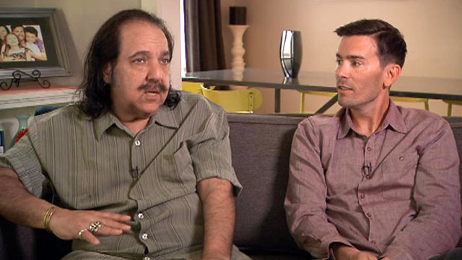
- If one does not yet believe, then help him to repent and seek God’s forgiveness in Christ.
- If one believes but feels unworthy, then study Ephesians chapter 1 together to show him who he is in God’s sight, and what he has got forever in Jesus. Help him to thank God for it.
- If one feels insecure and fears that God does not love him, then study Romans 8 together.
- If one feels that God is distant or that Jesus is angry with him, then show him in Colossians chapters 1, 2 and 3, how Jesus has brought to him the power and invisible things of God.
Help people to define exactly what they must do to correct the problem, and to agree to change their behaviour with the help of God’s Holy Spirit.
I see!  I need to ask my wife to forgive me,  and I must forgive her, and love her like God says. | That is exactly right!  I will keep meeting with you until  God solves the problem completely.

- Counsel only people who want to change. If people do not want to change their behaviour, or if they simply want to talk with you without changing, then stop meeting with them. Do not waste time with people who only want attention. Some people enjoy being a victim. Others think only about themselves. Jesus said, “Do not throw your pearls to pigs” (Matt. 7:6).
- Prepare mature believers to be spiritual counsellors, with the guidelines above.
Visit people who need counselling.

