Getting Started with Paul-Timothy Studies

Choose studies that fit your needs, using the User Menu.
- Ask your coordinator for study #2, User Menu of Training Materials, or download a printable copy from www.paul-timothy.net
- Studies are grouped under 15 Ministries. Choose for each student a study that deals with a current need of the student’s congregation.
- Find the Ministry that contains studies related to a student’s need. For example, if a student wants to develop worship, then find the corresponding studies on the menu under WORSHIP.
- Keep printed studies stored separately for each ministry area, so that you can easily find them.
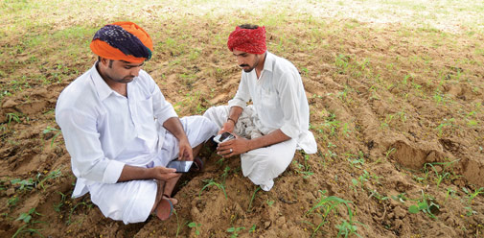

Most studies also have a children’s version.
- Most of the studies have a one lesson for Shepherds and another for Children.
- Both lessons treat the same topic, so that children learn a Bible story related to the topic that the adults will learn. The children can act out the Bible story for the adults during worship time.
- Printed shepherd’s studies have the word ‘Shepherd’ in their top margin, and printed children’s studies have the work ‘Children’ in their top margin.
- Get better results with children by teaching them their lesson before they join the adults for worship, so that they will be prepared to participate along with adults..
- Children’s teachers should read follow #5, “Guidelines for Children’s Teachers.”

Ministries in the User’s Menu include sets of studies for different topics.
- Each Ministry area has several sets of studies. For example, the ministry “Worship” includes sets on Communion, on celebrating Jesus’ resurrection, and on other aspects of worship.
- Some sets also have supplementary studies with additional information on a topic.
- Shepherds’ studies help leaders to plan next week’s activities and the next worship.

Initiate leader training by following the “Getting Started” studies.
- Pastoral trainers follow #3, “Eleven Guidelines for Trainers.”
- Pastoral students follow #4, “Guidelines for Shepherds Being Trained.”
- Children’s teachers follow #5,“Guidelines for Children’s Teachers.”
- Other workers follow #7, “Helping a Congregation’s Body Life.”

Worship leaders follow #8, “Planning and Leading Group Worship.”
- Coordinators who lead workshops to initiate Paul-Timothy training may follow the Paul-Timothy Workshop Manual. You can download it freely from www.Paul-Timothy.net; click on ‘Workshop Manual.’
- Paul-Timothy studies help you to plan interactive, relational worship activities.
- Follow Paul-Timothy studies to prepare for a worship time in which many participate in a family atmosphere that includes children. The Holy Spirit works more powerfully in meetings where participants already have relationships.
- New Paul-Timothy studies can be written to meet your needs. If you will inform the Paul-Timothy writers about other study needs, then they will create a new studies. Let your trainers know your needs, so that they can inform the Paul-Timothy writers at editors@paul-timothy.net
- The Paul-Timothy studies will never become finalized, because new studies will be added, and existing ones improved, according to your reports about the needs of your congregations.
- Paul-Timothy publishes supplementary studies as they become ready. Please visit the web site often to find and download free studies: www.Paul-Timothy.net
- Paul-Timothy studies may be freely copied, translated into any language, stored on any medium and distributed for free or for money. Please, include the following statement:
These materials may be freely copied, translated, stored, distributed and sold.

