11 Guidelines for Those Who Coach Shepherds
“Dear Lord, help us to instruct new shepherds from your Word, so that they will lead the flocks that you have given them to serve, in the power of your Holy Spirit. We ask this in the Name of our Lord and Saviour, Jesus Christ. Amen”
Guidelines
- Train Shepherds by Three Methods
- Choose Studies that Offer What a Trainee’s Flock Lacks
- Give Coaching the Same Emphasis that Scripture Does
- Be Accountable to Someone, and Provide Accountability to Others
- Follow Biblical Guidelines for Multiplication
- Married Leaders Must Care for Their Wives and Children
- Let Trainees Discover ‘Gold’ in God’s Word
- Do Five Things in Coaching Sessions
- Each Paul-Timothy study for New Leaders contains three actions
- Help Trainees Vary the Ways In which they Teach
- Commission New Shepherds in a Biblical Way

Guideline 1.
Train Shepherds by Three Methods
Maintain a balance between modelling, coaching and teaching.

Train new shepherds in ways that ensure their flocks keep multiplying, by keeping a healthy balance between the three training methods, just as Jesus and the apostles did.

Method 1: Model skills for Shepherds

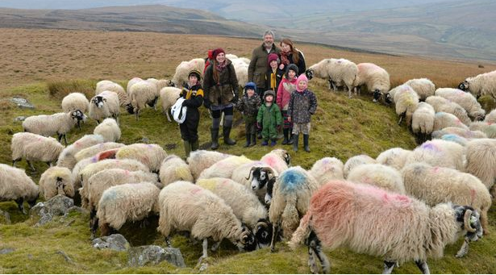
Demonstrate shepherding skills for new leaders during the week.

Method 2: Coach Small Groups
A coach meets with a small number, so he has time to hear everyone’s report.
Meet in small groups, so that you listen to each trainee report on what his flock is doing. Then apply the Word of God to the needs of each flock. Help trainees to plan what they and their flocks will do the next week

Method 3: Teach Big Groups
Teach occasional seminars for larger groups.
Let us explain each of these three methods

Method 1: Model shepherding skills for apprentices who are still learning them.
Demonstrate pastoral care and any other aspect of the work that apprentices still do not know how to do, the same way that Jesus and the apostles modelled shepherding skills for the their disciples while they taught, healed and counselled.
Demonstrate shepherding skills while working during the week, and not merely during worship times. Trainees may sometimes accompany and observe the trainer, when he cares for his own flock. Sometimes the trainer may visit the trainee and helps him to care for his new flock.

Method 2: Coach small groups locally.
Have trainees meet in small groups of two to five persons. Their groups need to be small so that you, the trainer, can listen to each trainee report what his flock is doing and deal with the different needs and opportunities that arise in each congregation. Normally trainees from only one or two, possibly three congregations meet with coaches.

Method 3: Teach general truths that apply to all congregations at bigger meetings.
When possible, gather large groups of shepherds from a large area to teach things that apply to all shepherds.

Write Your Plans
Please, pray for help, then write your plan to balance the three kinds of teaching, the way Jesus and His apostles did.

Guideline 2.
Choose Studies that Offer What a Trainee’s Flock Lacks
Ask your trainer or coordinator for the Paul-Timothy User’s Menu, or download it from www.paul-timothy.net.
Trainers and trainees should meet in small groups and use the Paul-Timothy User’s Menu to select studies that suit the need of each learner’s church or cell.
- Practice selecting appropriate studies now, using the list of Ministries and a few sample studies below, taken from the Paul-Timothy User’s Menu.
Good trainers name and train shepherding elders in new groups of believers. Trainers help trainees to lead their flock in starting to do things that are still lacking in each flock (Titus 1:5). To learn what is lacking in congregations, first listen to your trainees tell you what their flock is doing and not yet doing.
- Paul-Timothy does not follow a ‘linear’ curriculum, in which all student start with the first item and move in a straight line to the second item, and so on to the end. Rather, you are to select options from among different resources, to meet current needs. Jesus urges teachers to use a variety of resources: “Every teacher ... instructed about the kingdom of heaven is like the owner of a house who brings out of his storeroom new treasures as well as old.” Matthew 13:52
“We trainers first listen carefully to those whom we train.”
Ministries and Sample Ministry and Related Studies from the User’s Menu
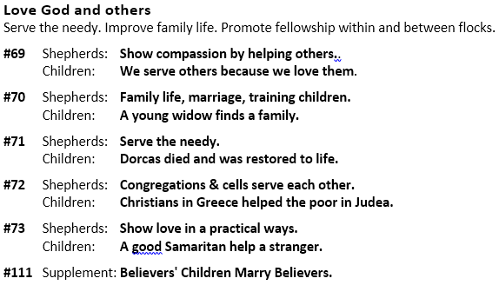
Each numbered set of studies contains a study for New Shepherds and another on the same topic for Children.
Write Your Plans
Whom do you plan to coach, to train them to help you shepherd your flock, or a new flock?

How will you help your apprentices to begin at once to shepherd their own families and others whom they win to Christ?

If someone coaches you, then let him know which needs you ticked above in the list of Ministries. He will then help you get the corresponding studies and skill training.
What is the number of the study that corresponds to the ministry you chose? (Study numbers appear after the study name.) ___________

Guideline 3
Give Coaching the Same Emphasis that Scripture Does
Jesus and Paul are our models of how to train. We follow the guidelines that Jesus and Paul used to train leaders. New shepherds should meet once or twice a month with a coach who will listen to them and find out the needs of the shepherds’ flocks. Coaches should then equip them to deal with those needs, at once. When a flock is new, a trainee may meet more often with a coach.
- Coaching applies mainly to new shepherds. Mature leaders can keep learning by attending occasional seminars, unless they face a special issue that requires an expert’s advice.
- Normally a leader coaches shepherds of new flocks that he or his flock has raised up, as in 2 Timothy 2:2.
- A coach does not have to be an elderly, highly-experienced leader. He might be only one month ahead of the trainees whom he coaches. This works well because the coach can easily sympathize with the same needs that the newer workers have. In this case, the coach should also meet with a more experienced coach, in a coaching ‘chain’.
Coaching with Paul-Timothy studies is easy. Novice shepherds can coach newer shepherds, if you will provide them materials that deal with the needs of new flocks. Use materials like the Paul-Timothy studies. Translate them into your trainees’ language. Coaching normally is temporary. New shepherds of new congregations with new believers are like ‘baby’ leaders of ‘baby flocks.’ They always need some kind of coaching, just as new-born babes need constant care of their urgent needs.
- Coaching new leaders properly takes a good amount of time. This is why you should also hold occasional seminars for larger groups. Paul spent much time coaching Timothy and Titus with fatherly care. When they matured and no longer needed frequent care, Paul left them to train others.
- After Paul’s coaching of Timothy and Titus tapered off, they kept the coaching chain growing by passing on what they learned from Paul to novice leaders. Just as newborn babies need much personal attention, so new leaders and new churches need coaching, until they are doing what the New Testament requires them to do.

Write your Plans
Whom will you begin coaching? ________________________________________
When will you start? ________________________________________

Guideline 4
Be Accountable to Someone, and Provide Accountability to Others
A leader of the Lord’s work must be accountable to other leaders. You and other leaders should examine each other’s ministries, not to control others, but to help each other develop your ministries. Such accountability is joyful for all its participants, if they love one another.
You should meet with other leaders occasionally and report what you have done. To lead people without other leaders examining your work could become a damaging sin of negligence.
Paul was accountable at first to the other leaders in Jerusalem (Galatians 2:1-2).
Later, Paul and Barnabas reported what they had been doing to the congregation in Antioch that had sent them to the nations (Acts 13:1-3 and 14:26-28).
You and other leaders should correct one another (Colossians 3:16) and confess your faults one to another (James 5:16). You should heed the advice of other leaders and listen to their criticisms. All shepherds need such supervision, by which leaders make sure that each other’s activities are biblical. It will help you to grow in your leadership skills and to avoid exercising selfish, abusive control over people.

Write your Plans
Who will coach you? ____________________________
How often will you meet at first? ______________________________________
If you have no coach, arrange it with someone who uses Paul-Timothy. If you cannot find such a person, then begin the coaching ‘chain’ yourself, by starting to train others, as Paul told Timothy to do in 2 Timothy 2:2
Guideline 5
Follow Biblical Guidelines for Multiplication
Wherever the apostles made disciples the way Jesus said, congregations multiplied. God works the same way today, when shepherds lay a foundation of obedience to Jesus’ commands. You must teach your own flock and train new leaders of new flocks, the way Jesus and His apostles did. For example, Paul coached Timothy, who trained faithful men, who trained others also (2 Tim. 2:2); this resulted in many new congregations.
Jesus and His apostles trained new leaders mainly by coaching them. Coaching allows you to train leaders as fast as new congregations multiply, because each novice shepherd trains newer shepherds of the congregations that he or his flock helps to start.
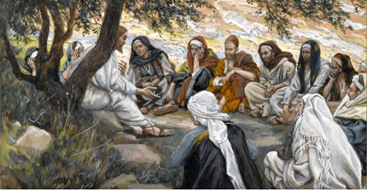
Jesus trained his apostles on-the-job by coaching them, laying plans and hearing their reports.
New shepherds observe a more experienced coach modelling shepherding skills and applying God’s Word at once to the people whom he serves, then imitate him (1 Corinthians. 11:1).
Jesus emphasized that growth and multiplication in His kingdom resembles that of plants. If we sow grain in good ground it reproduces up to 100 times (Mark 4).
Make sure that each trainee soon begins coaching other newer shepherds, to keep the flocks reproducing the normal way. Training goes together with evangelism. With fervent prayer, evangelism and God’s help, you can multiply workers and their new congregations.
Seek to work with receptive people. Where people reject the Good News, Jesus commanded us to ‘shake the dust’ from our feet and to leave there. This usually does not require us to move our residence, but moves us to seek people whom God has prepared. Normally, poorer classes are more receptive to the Good News.
Coaching the way Jesus and the apostles did it, is powerful and helps to keep flocks reproducing. Jesus gave to the apostles a ‘package’ of truths and practices that was light enough to pass on easily to others, like the baton in a relay race.
God uses the caring relationship between coach and trainee to make it easy to pass on the ‘baton’ to develop effective leaders and to multiply congregations.
A good coach trains new leaders with methods that they can quickly and easily imitate, with which they can train other, newer shepherds. Avoid using equipment that your trainees do not have, when you teach or model skills for them.
Coaching in Scripture resulted in ‘chains’ with several generations of coaches, whose apprentices coached others, and so on. Examples include these:
Jethro coached Moses,
Moses coached Joshua and the elders of Israel. God gave the Ten Commandments originally for the newly named elders to use. The shepherding of the people took place in small groups of ten (Exodus chapters 18 – 20).
Joshua coached the other army leaders.
Deborah coached Barak. As a result, Barak won a great military victory for God.
Eli coached Samuel.
Samuel coached Saul and David who became Israel’s greatest king.
Ahithophel and Nathan the prophet also coached David.
David coached his army commanders and government officials, to establish the united nation of Israel.
David also coached his son Solomon.
Solomon coached the Queen of Sheba. She returned to her people with his wisdom in the form of Proverbs that applied God’s law.
Elijah coached Elisha.
Elisha coached king Jehoash and others.
Daniel coached King Nebuchadnezzar. The King later humbled himself before God
Mordecai coached Esther
Esther coached King Artaxerxes. This led to his liberating of God’s people.
Jesus coached his twelve apostles. They started the first Christian congregations.
The twelve apostles coached Paul and hundreds of other leaders.
Paul coached Titus, Timothy and many others
Timothy coached Epaphras and other “faithful men.”
Epaphras and the other faithful men coached “others also” (2 Timothy 2:2) which led to a chain reaction that resulted in dozens of new congregations in Asia.
Philip coached the Ethiopian official. The official received Christ and was baptized in the desert.
Priscilla and Aquila coached Apollos. This resulted in an improved ministry and new flocks.

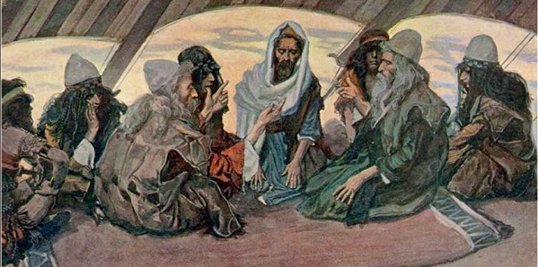
Jethro coached Moses, enabling him and the elders to shepherd 1000s of Israelite.

Write your Plans
If you have never taught people in any other way than the traditional classroom method, then, please, take a moment now to pray and ask the Lord to help you.
If you do not have the ability or time to add coaching to your schedule, please, ask the Lord to show you whom you should assign this responsibility to, so that your flock can sustain the training of leader in the way that Jesus and the apostles did.
According to 2 Timothy 2:2, the same worker can be a trainee receiving training and, at the same time, be a trainer training newer workers. Such training can enable your flock and new flocks to keep on reproducing rapidly with new leaders, to sustain a widespread movement towards Christ. Those whom you train should soon begin training others. Write the names of workers whom they might train, if you know them. If you do not yet know, then, please, find out.

Write the names of others who could also become trainers helping you to train shepherds:

Guideline 6
Married Leaders Must Care for Their Wives and Children
Paul warned that a believer who fails to care for his family has denied the faith and is worse than an unbeliever (1 Timothy 5:8). Thus, a true shepherd will begin his shepherding work by caring for his own family.
Many congregations and families suffer, because some shepherds spend too much time with other people, and neglect their own wives and children.

Write Your Plans
What will you do to make sure that you care properly for your wife and children?

Guideline 7
Let Trainees Discover ‘Gold’ in God’s Word
Help each shepherd to be an active learner rather than a passive ‘hearer only’ or a mere reader. Let each one discover truths that his flock needs, instead of waiting for others to teach him every detail.
Do not teach what a student can learn for himself.
Ask questions that will help him to think about what God wants him and his flock to do. Paul-Timothy studies suggest things for him to find in his Bible.

Guideline 8
Do Five Things in Coaching Sessions
These five important things are to Pray, Listen, Plan, Review and Assign.

Pray before, during and after a training session.
At the start of a session, ask the Lord to guide everyone present.
During the session, pray whenever you deal with a question, decision or problem for which you need special power or wisdom.
At the end of a session, ask the Lord for power for you and your flock to do what you have planned.

Listen to each trainee. Let each one tell what he and his flock have been doing.
Urge the new shepherds to report both successes and failures.
Compare what he reports with the plans he made at the prior session.

Plan each one’s field work.
Help each trainee to plan what he and his flock will do during the next week or month.
Plan to do things that correspond to the needs that the trainee reported.
Write down each item that the trainee agrees to do with his flock.
Avoid wasting time over problems that keep occurring. Always plan new activities.
Do not ‘dance with the devil’ by merely responding to the problems he causes. Keep initiating activities that the flock is not yet doing, or strengthening activities that are still weak. Keep building up the flock by concentrating on positive things.
“Just keep dancing to my tune!”

Both trainer and trainee should keep a copy of these plans, and refer to them at their next session.

Review Studies assigned at the previous coaching session.
Ask what the trainee learned from his reading. Let him talk about it.
If he has not learned a study well, then ask him to read it again. Do not assign him another study, until he has learned the present one well.
Let the student talk about what he has studied.

Assign studies that fit current needs and opportunities to serve.
Do not assign the same study to all trainees. Assign to each trainee a study that fits his flock’s needs and opportunities to serve.
Assign only one study at a time to very new students, unless you will not be able to meet with them for a long time.
Use the Paul-Timothy User’s Menu (Guideline 2).

Write Your Plans
Please memorize the above five things that you will do in a session with your trainees, and write them here by memory:
1. ______________________
2. ______________________
3. ______________________
4. ______________________
5. ______________________
How will you obtain the Paul-Timothy studies for your trainees?

Guideline 9
Each Paul-Timothy study for New Leaders contains three actions
1. Prepare yourself through Bible Study.
2. Plan the coming week’s activities.
3. Plan the up-coming worship time.

Prepare yourself through Bible Study.
Use Scripture as your guide to what you do and how you do it.
Use God’s Word as the guide for how you teach, evangelize, organize and worship, and not only as a source of content for your teaching.
Each study contains a list of things to find in God’s Word. You can teach those things during the next worship time, and ask questions about the things you were told to find.

Plan the coming week’s activities.
Each study contains a list of optional things that you and the other believers can do during the week. Select those activities that meet current needs and fit local customs. Omit the rest.
Announce and explain those plans during worship. Enable all believers to serve Christ through their various ministries.

Your teaching during the worship time should prepare the believers to do those activities. If someone teaches a doctrine without dealing, in a practical way, with its corresponding duty, then he misuses God’s Word (James 1:22; Ephesians 2:8-10; 2 Timothy 3:16-17).
Plan ahead with co-workers what the believers will do during the week to bless:
  - one another (Galatians 5:13),
  - each family (Ephesians 5:21-33; 6:1-4),
  - the community around them (Matt. 5:13-14) and
  - other congregations (Acts 15:41).

Plan the upcoming worship time.
Make sure that everyone in your trainees’ flock, including children, participate during group worship time, and edify one another by using their spiritual gifts. Paul-Timothy studies for children prepare them to dramatize Bible stories, to recite poems and verses from Psalms, and to ask questions
The devil whispers in new shepherd’s ears, “Your group is small, so you do not have to plan well!” Shepherds sin when they fail to prepare well to lead their flock into the presence of Almighty God.
“Your group is small, so you do not have to plan well! Ha ha ha!”

When a PTLT study suggests many worship activities, choose only those that you and your flock need; omit the rest.

Write Your Plans
Which studies have you chosen to use first with your trainees?

What plans have you made for your next worship time?

What plans have your trainees made for their next worship times?

Guideline 10
Help Trainees Vary the Ways In which they Teach
Jesus and His apostles used many forms of teaching. Paul urged all to take part in some way. 1 Corinthians 14:26 reads, “When you come together, everyone has a hymn, or a word of instruction, a revelation, a tongue or an interpretation…” The Holy Spirit works more powerfully through this kind of active participation. Paul-Timothy studies describe a variety of learning activities for the worship time.
Arrange chairs in a circle or half circle, so that all can see each other.
People learn more when you ask questions and let them freely discuss the answers.
Do not let one or two persons do all the talking. Respond like this: “Now, let us listen to someone who has not yet spoken. We want to everybody who would like to say something to express their thoughts, give examples or ask questions.”
Do not embarrass people who are shy. If they want to remain silent, then let them.
In small groups, avoid teaching only by lecturing. Lecturing requires experience and fits big groups. When new shepherds lecture, especially if they are young, they often fall into pride; they scold, become dogmatic and make silly rules.
An effective way to learn Scripture is to read the Bible dramatically. Most New Shepherd’s studies, and all Children’s studies, include at least one Bible story that can be read dramatically or acted out. Let others read and act out, if they are able, the conversations in the Bible story. For example, a narrator may read the story of the Wasteful Son (Luke 15:11-32), except for the words that are spoken. Let others read the words of the father, younger son, older son and servant.
Let folk present brief dramas. People learn better when they watch biblical truths being acted out. They learn even more when they act in the drama themselves.
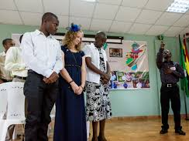
Bible dramas require no costumes and can take only a few minutes.
Do not present elaborate productions that require costumes and much rehearsal. So doing would draw attention to the acting instead of the biblical truth.
When the actors are adults or older children, it is often better that they do not memorize the dialogue that they will say, but simply keep in mind the general idea of what to say and do. For example, when dramatizing the story of the Wasteful Son, the Narrator may read or summarize the story, then say, “Hear what the wasteful son says.” Then the wasteful son will read or say his part in his own words. Two children might play the part of the fattened calf. (Put a blanket over them, and let them walk around and make soft cattle noises).
Consider the most influential and often quoted sermon of all time. After teaching the crowd on the seashore, Jesus climbed a mountain with His twelve disciples, where there was no pulpit or chairs. He sat down and held an intimate conversation that came to be known as the famous Sermon on the Mount (Matthew chapters 5-7).

Write Your Plans
What do you plan to teach when your flock meets next time?

In what ways will you teach in your next worship time, so that the believers, including children, will participate actively in presenting God’s Word?

Guideline 11
Commission New Shepherds in a Biblical Way
The biblical way to commission new shepherds is to lay on hands on them and pray for God’s lasting power.
They should be elder-types who meet the qualifications listed in 1 Timothy 3:1-7, which include not being a new convert. They should be proven before commissioning them as permanent shepherding elders.
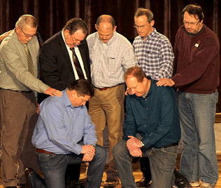
Leaders lay hands on new shepherds in a ceremony before a large gathering.
Some churches have named as shepherds youths who have learned theology in a Bible college but are not proven and lack the respect of the community, as Scripture requires.
Bad things result when men add man-made requirements for new leaders, or fail to follow biblical requirements. Both of these errors bring misery to God’s people.

Train new leaders, even though they do not yet meet the biblical requirements for the laying on of hands as formal commissioning, because they may never meet the requirements without some kind of training. Under the supervision of a more experienced leader, such leaders-in-training can shepherd their own families and small groups of seekers or new believers who join their new congregations. While still unqualified, such men should not be recognized formally as official elders, but merely serve as temporary, provisional shepherds.

Write Your Plans
Who among the new shepherds that you are training might be ready for formal commissioning?

