A Teacher Who Did Not Want to Teach
Dear Lord, please help the children understand your love for people of all lands, even for bad people, and why you send workers to help them change.
Choose any of these children's learning activities that fit their ages and needs.
- Let an older child or teacher read or tell by memory the story of Jonah,
from Jonah chapter 1, chapter 2 verses 1 & 10, and chapter 3.
Explain that God sent Jonah as a teacher to another country to convince bad people to change. God loved those people even though the teacher did not.
Ask these questions [Answers appear after each question.]
- Why did God send a storm? [See Jonah 1:3–4]
- What did Jonah tell the sailors to do about the storm? [Jonah 1:12]
- Why did Jonah not drown in the sea when the sailors threw him in? [Jonah 1:17]
- What did the king of Nineveh do when he heard Jonah’s message?
[Jonah 3:6-8. The king repented and told his people to repent; to repent means to turn away from sin and to obey God. His Holy Spirit helps people repent.
- What did God do when the people of Nineveh repented? [Jonah 3: 10]
God made a great fish that swallowed Jonah and kept him alive.
- Dramatize parts of the story of Jonah.
- Arrange with the worship leader for the children to present this brief drama.
- Use your teaching time with the children to prepare the drama.
Let older children help the younger ones prepare.
- If there are not enough children for all of the parts,
then the Narrator can mention whose part it is, and read it.
- Let older children or adults play these parts:
Voice of God, Jonah, Narrator
Younger children play these parts:
Sailors, Whale, King (of Nineveh)

Narrator Tell the 1st part of the story from Jonah 1. Then say,
“Hear what God says.”
Voice of God “Jonah, go tell Nineveh’s people to stop doing such bad things.”
Jonah “I hate those people. I will go on a ship that sails another way.”
(Climb into an imaginary boat beside Sailors, and lie down.)
Sailors Sway as if you were on a ship.
(Some shout) “This is a terrible storm.”
(Others say) “The wind is sinking the boat!”
(Others say) “The waves will drown us!”
Jonah Pretend to wake up from sleeping, and shout,
“God is angry with me. Sailors, throw me into the sea,
then the storm will calm down.”
Whale Pretend to swim over to Jonah. Say,
“This is a funny looking fish, but I am hungry,
so I will eat him.”
Pretend to swallow Jonah. Then say,
“Oh, what a stomach ache I have!
I will have to vomit him back out!”
Narrator Tell briefly the 2nd part of the story (Jonah 2:1-10 & chapter 3, then say, “Hear what God says.”
Voice of God Shout, “Jonah, go to Nineveh!”
Jonah Walk, staggering, to the People of Nineveh. Shout angrily,
“Repent or God will destroy your city!”
King Pretend to rip your clothes. Sit on the ground and shout,
“We repent. All of us!”
Voice of God “I am glad that you repented. I love you.
I did not want to destroy you.”
Narrator or older child Thank everyone who helped with the drama.

- If the children dramatize this story for the adults, then let them also ask the adults the questions under #1 above.
- Let the children draw a picture of a big fish.
Let them show the pictures to the adults during worship and explain that this illustrates
how God loves people of other lands, even if we do not. He sends us to talk to them and
tell them to repent and believe in Jesus.
Some children might like to copy or colour the picture found at the end of this lesson.
- Ask the children to cite other examples of bad people who repented and turned to God.
- Memorize Ezekiel 14:6:
"Thus says the Lord God, Repent and turn away from your idols and turn your faces away from all your abominations.”
- Let four children each recite one of the verses from Jonah 2:2, 3, 5 and 6.
- Let older children write a poem or song about repenting and receiving God’s forgiveness.
- Have an older child pray:
“Lord, you love all the people of the earth, even those who hate us. We pray for them, that you will send messengers to tell them the news about Jesus. Help us to love people who are different from us and to take your message to them.”
A more detailed drama about Jonah, a reluctant teacher, 5 minutes:
http://biblestoryskits.com/006-jonahs-journey-2/

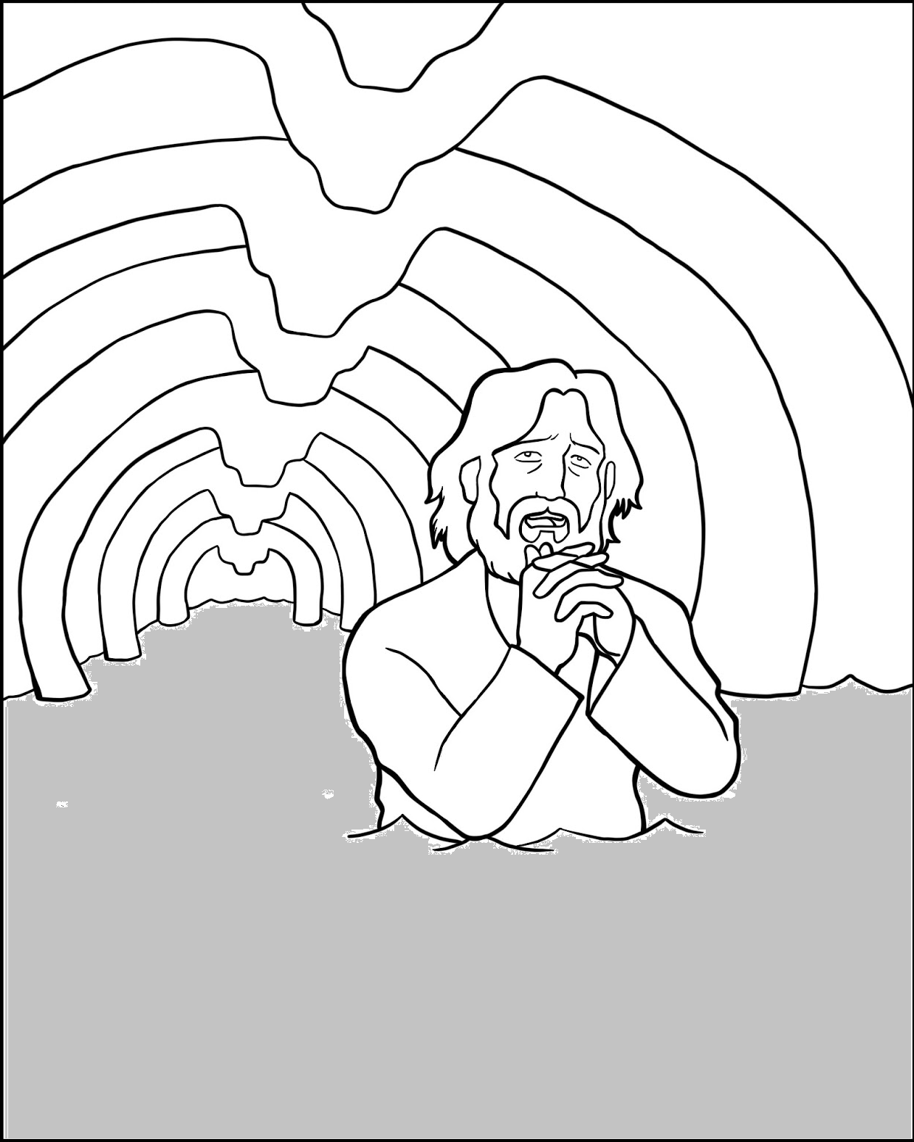Kept alive inside a great fish, Jonah changed his mind and decided to obey the LORD.

