Coach New Leaders
As Jesus and Paul Did
Anchor command. “The things which you have heard from me in the presence of many witnesses, entrust these to faithful men who will be able to teach others also.” 2 Timothy 2:2
Anchor story. Priscilla and Aquila coach Apollos, A powerful leader. Acts 18: 24-28
Anchor verse. Jesus “appointed twelve, so that they would be with Him and that He could send them out to preach, and to have authority to cast out the demons.” Mark 3:14-15
Learning goal. Discover in the Bible how godly leaders coach and mobilize new leaders.
Growth goal. Avoid abstract, classroom-type training when mobilizing new leaders for action.
Skill goal. To mobilize new leaders quickly, coach them as they coach others, in turn.
Outcome goal. Churches multiply fast, as leaders coach their own ‘Timothies.’
Basic Study

Father in heaven, help us to coach new leaders, to help them edify those whom they serve. Help those whom we coach to coach other newer leaders, so that your kingdom on earth will continue to spread.
Learn from how Priscilla and Aquila coached Apollos. Acts 18: 24-28
- What qualities did Apollos have that enabled him to be an effective speaker? Verse 24
- How do we know that Apollos was willing to learn from others? 25-26
- When did Aquila and Priscilla coach Apollos, before or after listening to him to discern his need? 26
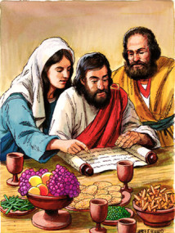
Priscilla and Aquila coached Apollos
- What did Apollos demonstrate from Scripture to some Jews in public? 28
- What did Apollos do, after Aquila and Priscilla coached him in their home? 27-28
- Priscilla and Aquila worked together in harmony as a team to serve Christ. What can you do to help married couples in your flock work together in the same way?
During the week…
- You and your coworkers prayerfully consider any believers who would benefit from coaching, to become effective leaders.
- Begin meeting with these new leaders, and give them ministry responsibilities that they can perform with your guidance.
- Model shepherding skills for the new leaders, while working with people.
- Before advising new leaders, let them first report what they have done and relate any problems that they face. Focus on the people that the new leader is serving.
- Avoid abstract teaching while mentoring leaders. Instead, focus on definite people and projects.
During worship…
- Tell the story of Priscilla and Aquila when they coached Apollos. Acts 18: 24-28. Ask the same questions as above, and urge the believers to discuss the answers.
- Have trainees report significant progress in their ministries, and pray for them.
- Ask the children to present what they have prepared.
- Memorize together 2 Timothy 2:2.
Advanced Study
- Train leaders in two ways:
  - Speaking to a group like Jesus did when He taught the crowds,
  - Mentoring a small group like Jesus did to prepare His apostles.
Keep these two training methods in balance.
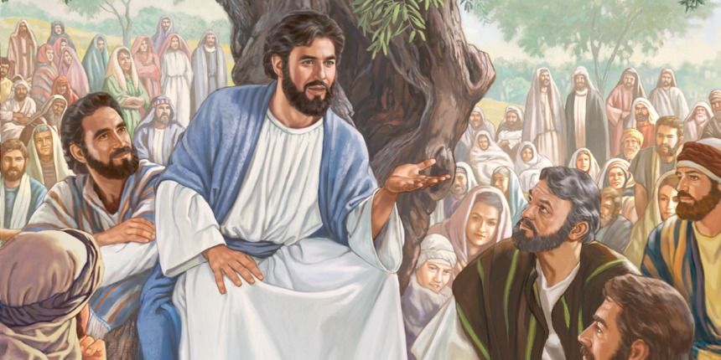
Jesus taught big crowds. He also coached small groups of workers.
- When to provide coaching.
- New leaders and new congregations, like newly born babies, have urgent needs. They need someone with a little more experience to mentor them.
- Older congregations and mature leaders no longer require so much attention. Paul, like Jesus, stopped mentoring his trainees as soon as they could continue serving without his constant help.
- Provide workshops and short courses for those who need them. However, these do not meet all the needs of new leaders, so mentor them the same way Jesus and Paul mentored their trainees, on the job while working with people.
- How does one leader coach another?
Memorize these eight things to do:
- Keep the group small, so that you will have time to deal with each trainee.
- Model shepherding skills while working with people, in a way that is easy to imitate.
- Listen to each trainee’s report. Each trainee must report on what he and his flock have done since your last meeting. Each one must also describe what are the needs of his flock.
- Help each trainee to plan activities. Write down what he and his flock will do to meet their needs. Introduce activities that the New Testament requires and are still lacking or are weak.
- Avoid spending much time on solving problems. Aim in every mentoring meeting to add something new that builds up the new congregation.
- Ask trainees to tell to you what they have studies. Find what they learned from the reading assigned in the previous meeting.
- Assign new reading. Look carefully over the list of available studies and choose studies that fit each student’s plans. The learners will not all study the same thing.
- Pray for each other. Pray for guidance and power, and for the people you are serving.
- Develop biblical mentoring “chains.” (Arrows → show who mentored whom.)
Jethro → Moses → Israel's elders who shepherded a nation
Moses → Joshua → his soldiers that would conquer the Promised Land
Deborah → Barak → his soldiers that would defeat idolatrous Canaanites
Eli → Samuel → King Saul and King David
Nathan → David → Solomon → Queen of Sheba
Elijah → Elisha → King Jehoash
Daniel → Nebuchadnezzar
Mordecai → Esther
Jesus → His apostles → elders of new congregations
Philip → Ethiopian official
Priscilla and Aquila → Apollos
Paul → Timothy → “faithful men” → “others also” (2 Tim. 2:2)
- Plan with your co-workers additional activities to do during the week.
- If other congregations in the area have leaders who need mentoring, then visit them to arrange it.
- Visit any believers or friends who need instruction of any kind. Listen to them to discern their needs and opportunities for serving.
- Plan with your co-workers additional, optional activities to do during worship
- Explain how to balance the two ways of training (#1, above) and tell about some of the people in the Bible who mentored others (#4).
- Demonstrate the Paul–Timothy mentoring chain.
- Ask everyone to stand and form four groups, separate from each other. Explain that each group is a separate city.
- Ask someone to read 2 Timothy 2:2. Explain that this verse reveals four links in this chain of reproducing new congregations:
1) Paul in Antioch,
2) Timothy in Ephesus,
3) ‘faithful men,’ some of whom were in Colosse,
4) ‘others also,’ some of whom lived in Laodicea.
- Act out what actually happened historically:
1) Antioch. Paul and Barnabas carried God’s Word first from Antioch. Ask two people from the first group to carry a Bible to the second group, which is Ephesus.
2) Ephesus. Paul mentored Timothy, whom he left in Ephesus to carry on God’s work. Two from Ephesus carry the Bible to Colosse.
3) Colosse. Timothy mentored “faithful men.” These were other elders in Ephesus and in Colosse, including Epaphras (Colossians 1:1–8). Two from Colosse carry the Bible to Laodicea.
4) Laodicea. Epaphras from Colosse mentored “others also” in Laodicea (Colossians 4:12–13).
- Ask for reports of mentoring that believers have done recently.
- Discuss plans in groups of two or three. Pray, plan mentoring and encourage each other.
- To introduce the Lord’s Supper, read Romans 16:3–5 and explain that Aquila and Priscilla hosted congregations in their home in Rome, in Ephesus (1 Cor. 16:19) and probably in Corinth. This reminds us of where the believers in the apostles’ time celebrated the Lord’s Supper. They broke bread in small groups where each believer could have close fellowship with everyone else.

