God Provided a ‘Lamb’ to Save Us
Help children appreciate the Lord’s Supper.
Choose any of these children's learning activities.
- Older child or teacher: Read or tell by memory the story of Abraham and Isaac, Genesis 22:1-18.
This story tells how God provided a lamb to save a young boy’s life.
After telling the story, pose these queries and let several children reply:
- How did God test Abraham’s faith? [Answer, see verse 2]
- How well did Abraham obey God? [3]
- What question did Isaac ask while they travelled? [7]
- What did Abraham answer Isaac? [8]
- How did God stop Abraham from killing Isaac? [11]
- What did God provide for the sacrifice? [13]
- What blessing did God give Abraham as a reward for his obedience? [16-18]
- Let the children view, copy or colour the picture found at the end of this lesson.
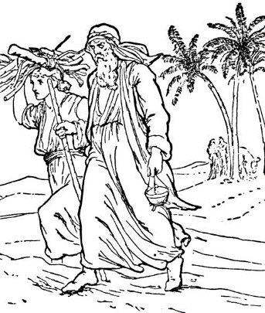
Abraham carried fire and Isaac firewood.
- Explain: In the Lord’s Supper we participate in the body and blood of the Lamb of God,
who died in our place like the sheep died in the place of Isaac.
The Lord’s Supper (Communion) helps us remember that Jesus is the Lamb of God that takes away the sin of the World. It is the Christian counterpart to the Old Testament Jewish Passover that recalls the lamb’s blood painted on the doorposts, so the death angel would spare the oldest sons among God’s people.
- Dramatize parts of the story of Abraham and Isaac, from Genesis 22:1-18.
- Arrange with the leader of the congregation for the children to present the drama also to the adults during the worship time.
Arrange also for the children to present the poem (below) and show the pictures that they have prepared.
- Older children or adults play these parts:
Narrator
Angel
Abraham. Has a knife and rope (or pretends to use them).
Younger children play these parts:
Isaac
Lamb. Walk on hands and knees.
Servants. Have a small armload of sticks.
Narrator Tell the first part of the story from verses 1-6. Then say,
“Hear what God said to Abraham.”
Angel “The Almighty commands you to sacrifice your son on Mount Moriah.”
Abraham Look up and say, “Yes, Lord.”
Then say to Servants,
“Servants, bring Isaac. Also bring firewood and a knife.”
Servants Leave and come back with Isaac and sticks and knife (or pretend to).
Hand them to Abraham.
Abraham Put the sticks on Isaac’s back (or pretend to) and pick up the knife.
Walk with Isaac following you.
Narrator Tell the second part of the story, Genesis 22:7-10. Then say,
“Hear what Isaac says.”
Isaac “Father, where is the lamb for the sacrifice?”
Abraham “God will provide the lamb.”
Isaac Lie down on a table or chair (the altar).
Abraham Tie Isaac with the rope (or pretend to). Hold the knife high.
Angel (Shout) “Stop! Do not kill him.
I know that you fear God since you did not withhold your son from Him.”
Narrator Tell the third part of the story, Genesis 22:11-18.
Lamb Bleat loudly, on the other side of the room.
Isaac “Look, father! A ram is caught in the bushes.
God provided a sacrifice for us.”
Abraham Untie Isaac and say,
“Get the lamb. Lead it to the altar, and tie it up.”
Angel “Abraham, hear God’s eternal promise. He will bless you for obeying.
You will have many descendants.
Through one of them He will bless all nations.”
Narrator Thank everyone who helped with the drama.
- Draw a picture of a lamb.
- Let the children show their pictures to the adults at the next worship time and explain that it illustrates how Jesus became the Lamb of God for us, to take away our sins. Let older children help the younger.
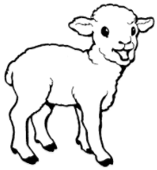
- Ask the children how God’s promise to Abraham came true in Jesus Christ for us today.
- Memorize Romans 6:23: “For the wages of sin is death, but the free gift of God is eternal life in Christ Jesus our Lord.”
- Poem: Let four children each recite verses from Psalm 27, verses 1, 2, 13 & 14:
The Lord is my light and my salvation, whom will I fear?
The Lord is the stronghold of my life, of whom shall I be afraid?
One thing I ask of the Lord, this is what I seek:
That I may dwell in the house of the Lord all the days of my life
to gaze upon the beauty of the Lord and to seek him in his temple.
I am still confident of this:
I will see the goodness of the Lord in the land of the living.
Wait for the Lord;
be strong and take heart and wait for the Lord.
- Let older children write a poem or song about God providing a Lamb to save us.
They might do this during the week.
- Have an older child pray:
“Loving Father, thank you for providing your son, the Lamb of God, to die for us. His sacrifice is great enough for you to forgive us all of our sins. Help us to remember this when we eat the Lord’s Supper. Help us to obey you like Abraham did.”
A more detailed drama dealing with Abraham offering his only son to God:
http://biblestoryskits.com/007-abraham-passes-a-severe-test-of-faith/

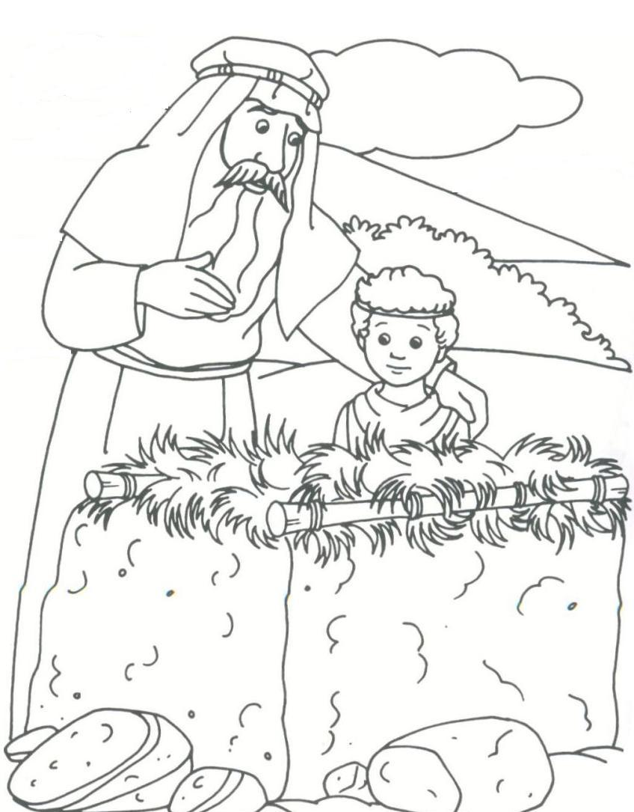
Abraham obeyed God and offered up his son Isaac, but God stopped Abraham
and provided a sheep for the sacrifice, instead of Isaac.

