A Woman Washed Jesus’ Feet
Children Learn to Worship
Lord Jesus, you remain worthy of our worship, for you have redeemed us and saved us from sin and from death. You have made us your brothers and sisters, and you are preparing a home where we shall dwell with you forever.
Choose learning activities that fit the children's ages and needs.
- A teacher or older child reads or tells by memory the story of the woman who washed Jesus’ feet with her tears, Luke 7:36-50.
She showed how we, too, should give our best to Jesus and worship Him from our heart.
Ask these questions. Answers appear after each question.
- What kind of woman came to see Jesus? [See Luke 7:37]
- How did the woman show her love for Jesus? [See Luke 7:38]
- What did the Pharisees want Jesus to do about the woman?
[Condemn her and send her away, Luke 7:39]
- Who loved Jesus more, the Pharisee or the woman? [See Luke 7:40-43]
- What did Jesus do for the woman? [See Luke 7:48]
Jesus forgave a woman all of her sins. She was so happy that she came and
washed Jesus’ feet with her tears.
- Dramatize parts of the story of the worshipping woman, Luke chapter 7.
- Arrange for the children to present this drama for the adults.
- Use your time with the children to prepare the drama.
- They do not have to act out all the parts. If there are not enough people to play all the parts, then the Narrator can simply mention the person in the drama and say what the person says.
- Older children or adults play these parts:
Jesus
Narrator
Younger children play these parts:
Simon
Pharisees
Woman. Has a bottle representing perfume (or pretends to have it).
Narrator Tell the first part of the story, Luke 7:36-39. Then say,
“Hear what Simon says.”
Simon “Jesus, I am so glad that you came to eat with us. Come. Sit down.”
Jesus, Simon and Pharisees:
(Sit.)
Pharisees (Some say) “Look. Jesus must not be very important.”
(One shouts) “Simon did not greet him with a kiss.”
(Another shouts) “And he did not wash Jesus’ feet.”
(Others say) “He did not pour perfume on him.”
Woman Go to Jesus and kneel, weeping.
Pretend to pour perfume on His feet and wipe them with your hair.
Pharisees (Some say) “Smell that wonderful perfume!”
(One says) “That is very expensive perfume.”
(Others shout) “How wasteful!”
Simon “Jesus, listen to me. That woman has lived a bad life.
You must not let her touch you. Send her away!”
Narrator Tell the second part of the story, Luke 7:40-47. Then say:
“Hear what Jesus says.”
Jesus “Simon, two men owed money.
One owed a very little, the other owed very much.
Neither man could pay the lender, so he forgave both their debts.
He cancelled all that they both owed.
Which man do you think loved the forgiving lender more?”
Simon “The one who was forgiven more.”
Jesus “You are right.
I came to your house, but you did not show me much love.
However, this woman has shown me great love.”
Narrator Tell the third part of the story, Luke 7:48-50. Then say:
“Hear what Jesus says.”
Jesus “Woman, I forgive your sins.”
Pharisees (Angrily) “How can this man forgive sins?”
Jesus “Woman, your faith has saved you. Go in peace.”
Narrator Thank everyone who helped with the drama.
- If the children dramatize this story for the adults, then let them also ask the adults the questions under #1 above.
- Children draw pictures of perfume bottles.
- Older children help the younger.
- They can show their pictures to the adults at the worship time and explain that the perfume illustrates how we worship Jesus with the best that we have.
- We worship him from our hearts.
- Some children might like to copy or colour the picture found at the end of this lesson.
- Ask the children to give examples of ways that we show Jesus our love for Him.
One way is to sing praises to him. Have the children sing praise songs to Jesus.
- Memorize Romans 12:1.
- Let three children each recite two verses from Psalm 150:1-6.
- Older children write a short poem or song about their love for Jesus.
They can do this during the week.
- Have an older child pray:
“Dear Lord, you put in our hearts a great love for you. We want to show our love for you. We worship you. We want to serve you. Thank you for forgiving us and making us your children.”
A more detailed drama dealing with forgiving others, about five minutes:
http://biblestoryskits.com/014-jesus-tells-peter-how-many-times-to-forgive-2/

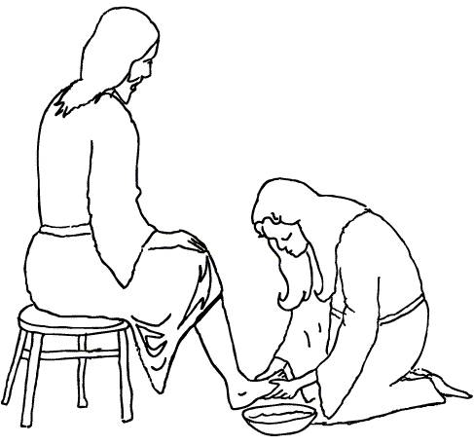

Jesus forgave a woman all of her sins. She was so happy that she came and
washed Jesus’ feet with her tears.

