Worship the Almighty
Anchor command. “Hear, O Israel! The Lord is our God, the Lord is one! You shall love the Lord your God with all your heart and with all your soul and with all your might.”
Deuteronomy 6:4-5
Anchor story. Elijah and the priests of Ba’al. 1 Kings 18:17-45
Anchor verse. “Come, let us worship and bow down, Let us kneel before the Lord our Maker, for he is our God, and we are the people of his pasture and the sheep of His hand.” Psalm 5:6-7 ¶
Learning goal. Know what Scripture teaches about true worship, and its forms in both the Old and New Testaments.
Growth goal. Develop wholesome patterns and practices of worship.
Skill goal. Lead other believers in heartfelt worship that pleases the Lord.
Outcome goal. Learners and those whom they instructs devoutly worship the Almighty.
Basic Study
Learn from the story of Elijah and the prophets of Baal the right way to worship the Almighty. 1 Kings 18:17-45.
- Who was the idolatrous king of Israel that sought to kill Elijah?
- Who were the Israelites worshipping instead of the one true God?
- What was Elijah’s challenge to the idolatrous prophets of Baal?
- Describe the way Baal’s prophets worshipped.
- Describe the contrasting way in which Elijah led the people in worship.
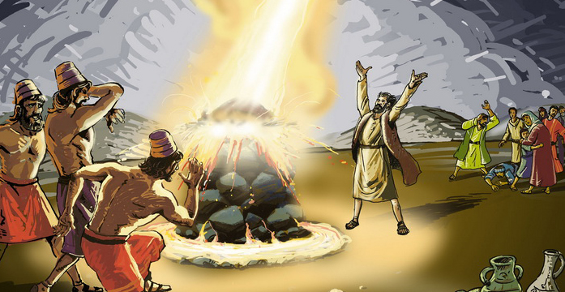
The God of Israel answered Elijah’s prayer by sending fire from the sky.
Plan with coworkers the upcoming worship time. Select activities that will fit the occasion and local customs.
- Tell the story of Elijah and Baal’s prophets, and explain key points.
- Memorize John 4:24;“God is spirit, and those who worship Him must worship in spirit and truth.”
Advanced Study
- Learn about worship from Israel’s ancient High Priest and his duties.
- Israel’s first high priest was Aaron, Moses’ brother. Aaron offered sacrifices to God because of the sins of the people. He sacrificed sheep and other ‘clean’ animals that God approved as food, males without blemish. He slit their throats, burned them and offered their blood to God to make atonement for sins. Today, Jesus is our ‘Lamb of God’. He is without blemish of sin, and He was slain to atone for our sins.
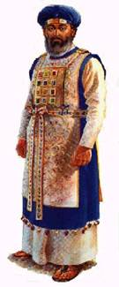
Jewish high priest in his special costume.
- Learn seven basic elements of worship.
Nearly all Christian congregations practice these seven worship activities. They do them in different ways and in different order. Some do them weekly, others less often.
1) Praise and give thanks
2) Pray
3) Learn the Word
4) Give
5) Confess our sins and be assured of God’s forgiveness,
6) Break bread (the Lord’s Supper)
7) Enjoy fellowship.
- Ask these questions and discuss their answers.
- Which worship activity did Jesus command in Luke 6:38?
- Which did Abraham do in Genesis 18:20-33?
- David in 2 Samuel 22:47?
- The Israelites in Nehemiah 8:1-3?
- The Israelites in Nehemiah 9:2?
- Which activity is illustrated in Exodus 12:1-14?
- Which do you find in Psalm 133?
Answers: 1) Give, 2) Pray, 3) Praise, 4) The Word, 5) Confess sins, 6) Lord’s Supper, 7) Fellowship
- God’s people have practiced these worship activities throughout the centuries. The Old Testament Jews practiced them, in their synagogues before Jesus came into the world.
- Jesus and the Holy Spirit gave them deeper meaning in the New Testament.
- Congregations that neglect these activities crumble or die when men offer false teaching or other trouble comes.
- In Scripture, people praised God with song, dance, raised hands, clapping, standing, kneeling, lying face down, silently, noisily, with testimonies, drama, symbols, chants and sacrifices. God does not care about the external form, as long as we worship him from the heart.
- As part of worship, ask for testimonies and reports of work done last week.
- Help one another in groups of two or three. Let them pray, confirm their plans and encourage one another.
- Some churches do these things in a formal ‘liturgical’ way, with robes, incense and chants. Others do them in a ‘free’ way.
- Many congregations read or sing Psalms to begin praising God. You may read verses that focus on God and honor Him for His deeds, power, justice, love, kindness, faithfulness and holiness.
- Announce the activities that you and your coworkers have planned to do during the week.
- Let all members use their different spiritual gifts, especially those that apply to worship.
- Here are verses from the Psalms that help us to praise God; you can use them to call people to worship: Ps. 8:1, 9:1-2, 29:1-2, 47:1, 66:1-4, 81:1-2, 93:1-2, 95:1-3 98:1-3, 100:1-3, 103:1-6, 106:1-2 111:1-4, 117:1-2, 136:1-26, 148:1-14
- Plan with coworkers things to do during the week, such as…
- Invite new people to a meal after the worship.
- Ask children to help present a drama, even those who do not yet attend congregational worship meetings.
- Prepare a banner with words of worship to display at meetings.
- Pray and praise God in homes of friends who do not yet attend congregational worship meetings.
- Demonstrate what worship was like before Jesus came into the world:
Explain that you will demonstrate Old Testament worship.
- Ask a helper to go outside with you. When you come back in, he is a sheep, crawling on hands and knees and crying ‘baa.’ Act like you are pulling him with a rope.
- Ask “Priest” (anyone) to sharpen his knife, prepare the fire and tie the sheep on the altar. With Aaron’s help, place the sheep face down on a chair.
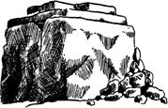
Israelite uncut stone altar
- Lay your hands on its head and say, “I confess my sins and those of my family!”
- Tell Aaron to slit its throat. When he pretends to do so, shout that blood is spurting all over you; shake it off your hands and shout:
“Oh! Blood, flies, everywhere!”
“Hear the bleating of the frightened animals!”
“Smell the blood and the manure!”
“The smoke gets in your eyes!”
- Ask the people: “Was this worship?” (Let them reply.)
- It was worship. It was shocking and repugnant! Why? Our sins are shocking and repugnant to the most holy God. This has not changed. God still requires the blood of an innocent victim, to cover our sins.
- Ask: “Why do we not take a sheep now to our meetings?” Let the believers reply. If they fail to answer correctly, explain in your own words: “Jesus is the eternal Lamb of God that takes away the sins of the world. We participate in the body and blood of the innocent, holy Lamb of God when we partake of the bread and cup of the Lord’s Supper, as 1 Corinthians 10:16 reveals.
- To introduce the Lord’s Supper, tell the story of the man who came to a King’s wedding feast without proper clothes (Matthew 22:1-14). T
- The special clothing symbolizes that God covers us believers with His holiness. We wear God’s covering whenever we confess our sins and receive His forgiveness. We should do so before we eat the Lord’s Supper.
- Taking communion also looks forward to the great feast when we, God’s people, are to be wedded to Christ for all eternity.
- Those who teach children should read study #108 for children.

