Rejoice at Harvest Time
Boaz showed gratitude for the harvest by
sharing it with others.
Dear Lord, help us all to thank you for harvests and other blessings. Help us show our gratitude by sharing your blessings with others, as Boaz did.
Choose any of these learning activities.
- A teacher or older child reads or tells from memory about Ruth, Ruth chapter 2.
It tells how Boaz treated Ruth with kindness during Harvest.
- Have children mention things for which they thank God.
- Let the children pray and thank God for these blessings.

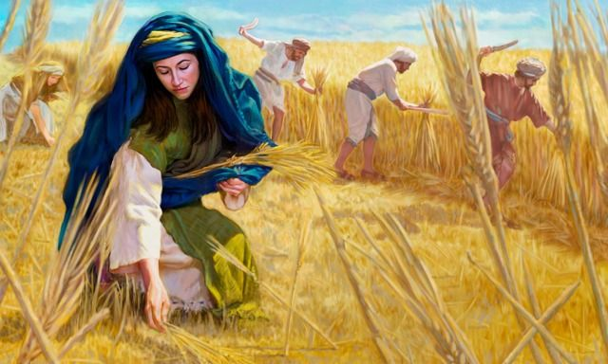
Boaz allowed Ruth and other poor folk to glean food from his field during the barley harvest.
- Dramatize the story of how Boaz showed thanks to God by sharing with others.
- Arrange for the children to present the drama to the adults.
You may do only parts of the drama.
- Prepare the drama while you teach the children.
Let older children help smaller ones.
- If there are not enough people for all of the parts, let the Narrator tell whose part it is and read it.
Adults or older children play these parts: Boaz, Ruth Carry a big sack or other container in which to gather grain, Naomi, Servant, Narrator.
Smaller children play Harvesters.
Some pretend to use scythes (blades fastened to a long handle that the harvesters swing to cut stalks of grain).
Narrator “Ruth chapter 2 shows how Boaz, a farmer, showed kindness to Ruth,
a widow, during harvest.”
Harvesters (Some pretend to cut grain with scythes.
Others pretend to tie them into bundles,
carry them to one side and stack them.
Do this while the two women talk.)
Ruth Point toward the harvesters and speak to Naomi:
“Naomi, my dear mother-in-law,
please, let me go to the fields and glean some ears of grain,
where I may find favor with the farmer.”
Naomi “Go, my daughter.”
Ruth (Follow the harvesters around for a few moments;
pretend to pick up ears of grain from the ground
and place them in the sack.)
Boaz “Good morning, harvesters! May the Lord be with you!”
Servant (Stand near the Harvesters.) Good morning, Boaz! May the Lord bless you!”
Harvester ”May the Lord bless you!”
Boaz Watch Ruth for a while, then ask Servant,
“Whom is this young lady related to?”
Servant “She is the young Moabite woman who returned with Naomi from Moab.
She said, ‘Please let me glean and gather after the reapers
among the sheaves.’”
Boaz (Speak to Ruth) “Listen carefully, my daughter.
Do not go to glean in another field; stay here with my maids.
Let your eyes be on the field which the men reap,
and go after them. I told them not to bother you.
When you are thirsty, go to the water jars and
drink from what the servants draw.”
Ruth Bow to the ground before Boaz, then rise and say
“Why have I found favor in your sight
that you should take notice of me, since I am a foreigner?”
Boaz “What you have done for your mother-in-law, since your husband died,
has been reported to me, and how you left your parents
and the land of your birth, and came to people that you did not know.
May the Lord reward your work, and your wages be full from the Lord,
the God of Israel, under whose wings you have come to seek refuge.”
Ruth “I have found favor in your sight, my lord; you have comforted me
and indeed have spoken kindly to your maidservant,
though I am not like one of your maidservants.”
Boaz “Come here, and dip your bread in the vinegar.”
Narrator “So Ruth sat beside the reapers; and Boaz served her roasted grain,
and she ate and was satisfied and had some left.”
Boaz (Walk over to the Servant and say to him)
“Let her glean even among the sheaves, and do not bother her.
Also you shall purposely let handfuls fall from the bundles
so that she may glean.”
Narrator “So Ruth gleaned in the field until evening.
Then she beat out what she had gleaned, and it was about a bushel of barley. She took it into the city, and her mother-in-law saw what she had gleaned.”
Naomi “Where did you glean today and in whose field did you work?
May he who took notice of you be blessed!
The Lord has not withdrawn his kindness to the living and to the dead.”
Narrator Thank all who helped, then explain,
“Boaz and Ruth became married. Their child Obed became the father of Jesse, who was the father of King David. David was the greatest king of Israel,
about whom the Bible has more to say than about any other human person except Christ. Jesus is a descendant of Boaz and Ruth.”
- Children draw a picture of a sheaf of grain
Some children might like to colour the picture found at the end of this lesson.
Children show their pictures to the adults and explain that we give thanks to God for harvests and other blessings.
- Memorize Ruth 2:12: “May the Lord reward your work, and your wages be full from the Lord, the God of Israel, under whose wings you have come to seek refuge”
- Two children recite Isaiah 9:3 and 2 Corinthians 9:11.
- Older children write a song, poem or brief drama that shows people giving thanks to God for harvests and his many other blessings.
More detailed drama dealing with the story of Ruth and Boaz, about five minutes;
http://biblestoryskits.com/002-love-draws-ruth-a-pagan-moabitess-to-the-god-of-israel-2/

