Start Churches Easily
Anchor command. “Whatever house you enter, … if a son of peace is there, your peace will rest on him. … And remain in the same house.” Luke 10:5-7
Anchor promise: “Where two or three are gathered in my name, I am there in the midst of them.” Matthew 18:20
Anchor story. Lydia. Acts 16:11-15, 40.
Anchor verse: “I will build my church, and the gates of Hades will not overpower it!” Matthew 16:18
Learning goals. Learners will know Jesus’ instructions for evangelizing households
Growth goals. Learners will feel confident in their authority to plant tiny, new churches.
Skill goal. Learners will take steps to help new gatherings become house churches.
Outcome goal. Learners will multiply churches that love Jesus and obey his commandments.
Basic Study
1. Find in Luke 10:5-9 Jesus’ instructions to his apostles, on how to enter homes.
- What kind individuals should you look for?
(Answer: a ‘son of peace,’ that is, one who welcomes you to stay a while without dispute.)
- What should you do in their home? (Answer: Heal the sick and tell the Good News. Let them invite others to come for healing and to hear the Good News.)
2. Find in Acts 16:11-15, 40 how the apostles started a new church in the home of a new believer.
- How long would the apostles stay in that town? (Answer: a few days.)
- How did the apostles recognize a ‘person of peace’?
(Answer: Lydia was reverent towards God and proved willing to listen to the apostles.)
- Where did the apostles stay for the next few days? (Answer: At Lydia’s house.)
- What did the apostles to with Lydia’s household?
(Answer: They baptized her and her household.)
- What does the Bible call Lydia, her household and any other new believers?
(Answer: “the brothers,” that is, a new, little house church.)
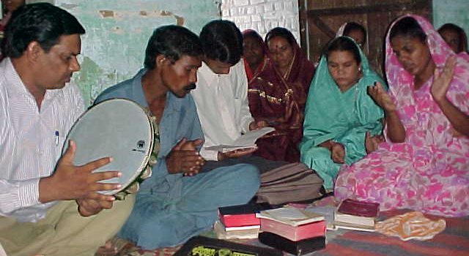
3. Plan with co-workers activities to do this week. Some possible activities include the following:
- Take some believers on a walk, praying and seeking new persons of peace.
- Ask believers to name persons of peace in whose home they could pray for others’ needs and share the Good News about Jesus.
- Arrange with seekers and new believers to invite friends and family to come for prayer and to hear the Good News.
- Lead new believers and their household to be baptized (if possible) and start a new little church in their home.
- Teach part of this study to existing house churches. Pray with them that the Lord will allow them to start new house churches.
4. Plan with coworkers the upcoming worship time.
- Lead believers through this study. You may have to plan to do parts of this study over several weeks.
- Form small groups and pray to the Lord to give them opportunities to start new house churches.
- Celebrate the Lord’s Supper in tiny groups in a way that they could do so in others’ homes. See Paul-Timothy study #105.
Advanced Study
1. Discover from Matthew three promises of Jesus for those who start new churches.
Find in Matthew 16:18-20 something that Jesus promised to do, and something that Peter was to do. (Answer: Jesus will build his church. Jesus gave to Peter “keys” with authority to open the Kingdom of heaven.)
Find in Matthew 18:18-20 something that Jesus promised to do, and something that the apostles were to do. (Answer: Jesus would be present where believers gather in his name. The apostles were to pray with the same authority that Jesus had given to Peter.)
Find in Matthew 28:18-20 something that Jesus promised to do, and something that the apostles were to do. (Answer: Jesus would remain present with his followers till the end of the age. His followers are to make obedient disciples everywhere.)
2. Discover from Acts chapter 2 the steps the apostles took to start many new house churches.
Find in Acts 2:23-24, 32, 36 the main points of the message the apostles announced about Jesus. (Answer: Jesus is Lord and Messiah. Evil men killed him by crucifixion. God raised him back to life. Eye-witnesses saw these things happen.)
Find in Acts 2:37-41 what the apostles did, in order to add new believers to their group. (Answer: They instructed everyone to repent and to be baptized, promising them forgiveness of sins and the gift of the Holy Spirit. They then baptized them and added them.
Find in Acts 2:42 four main activities of new churches. (Answer: (1) learn what the apostles taught about Jesus’ commandments; (2) share together to meet needs; (3) celebrate the Lord’s Supper; and (4) pray together.)
Find in Acts 2:46 two kinds of locales in which new churches gathered. (Answer: (1) occasionally at temple, and (2) regularly in homes.)
3. Memorize the following steps that the apostles took, in starting many new little churches.
- Announce the Good News about Jesus to any group who are willing to listen.
Acts 10:33; 1 Corinthians 15:1
- Promise the forgiveness of sins and the Holy Spirit to those who want to be saved.
Luke 24:47-49; Acts 2:38
- Baptize those who repent and welcome them into small gatherings.
Matthew 28:19; Acts 2:41
- Have each small gathering pray to the Lord Jesus, inviting him into their midst. Matthew 18:20; Revelation 3:20
- Begin practising together the commandments of Jesus, including the Lord’s Supper.
Luke 22:19; 1 Corinthians 11:25
- Inform each gathering of obedient disciples that they are a church by the authority of the Lord Jesus Christ. 1 Corinthians 1:2; Philemon 1:2
4. Plan with co-workers activities to do this week. Some possible activities include the following:
- Start coaching believing heads of household and other leaders of small gatherings, in following the steps the apostles took in starting many new little churches.
- Plan a training seminar for those who start or lead small gatherings, in order to plan with them to make gatherings into little churches.
- Draw up a map of existing gatherings and house churches. Indicate on the map places where the Holy Spirit wants new gatherings and new house churches to start.
4. Plan with coworkers the upcoming worship time.
- Teach all or parts of this study. This may take several weeks.
- In big gatherings, form small groups to pray to the Lord to start new house churches, to pray for each other, and to celebrate the Lord’s Supper in a manner that fits small numbers.
- Show the map that you have drawn. Invite believers and seekers to start new gatherings that could soon become little churches.
- Offer to coach those who will follow your instruction in starting gatherings and churches.
- Memorize together this definition of a church: “A church is the Lord Jesus Christ in the midst of believers who love him and obey his commandments.

